CSE 102 – Computer Programming

Spring 2016

Homework #2

Due Date: March 2, 23:55

In this homework you will write simple programs to exercise with functions. Please do not forget that your program should work ***exactly*** as the example runs given below the part definitions.

PART I

In the previous homework you wrote a program that calculates the overall grade of the students. In this part of homework you will write a program which consists of one main function and one helper function for this job. Assume that there is only one midterm, one homework and one final exam and your program will calculate the grade of ***three students***.

The helper function should be in the form:

void calculateLastGrade()

{

}

andthere will be ***no input/output operations*** in the main function.

Example run:

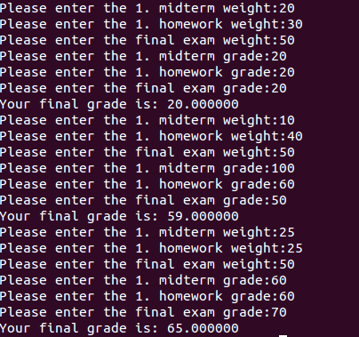

PART II

Write a program that calculates the area and perimeter of certain geometric shapes. You will write helper functions for each shape type that calculates the area or perimeter and return the result. Example functions are shown below. In the main function you will ask the user to enter the necessary parameters of one rectangle, one square and one circle, respectively and print out the result.

int areaofRectangle(int width, int height)

{

}

...

int perimeterOfCircle(int radius)

{

}

Example run: