**Create a Twitter Developer account and obtain the**

**“Consumer Key” / “Consumer Secret” / “Access Token” / “Access Token Secret”**

1. Join the Twitter Developer Community [[Click here to go](https://dev.twitter.com/)] > Click on **Join :**

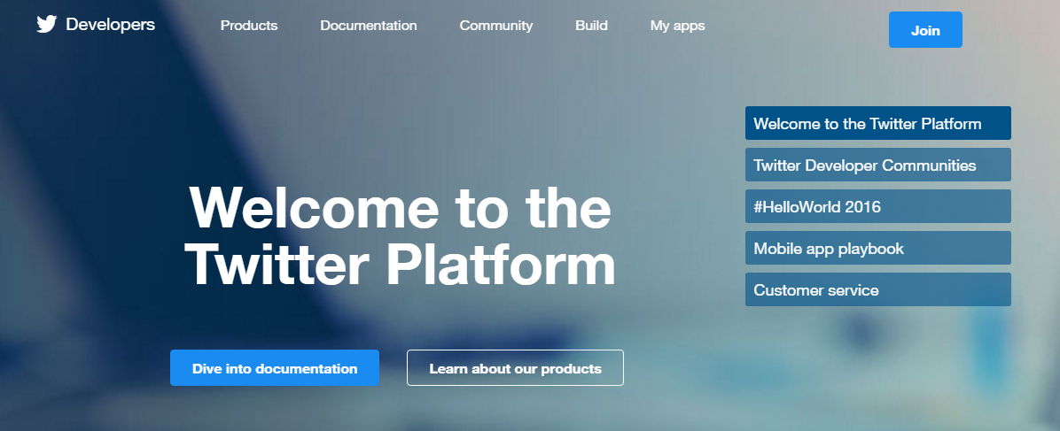

2. You need to enter the following information to register:

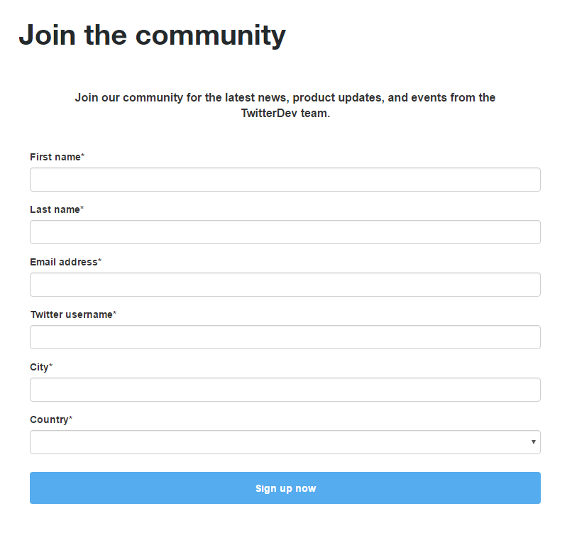

3. Click on  **My apps**  to go to the portal where you can create your apps:

4. Choose **Create New App**:

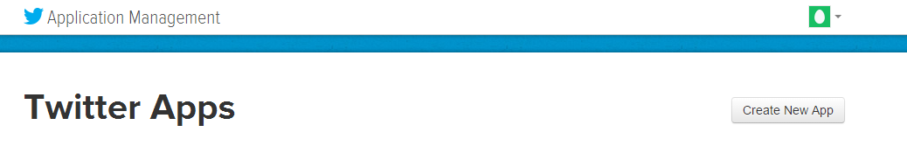

5. You give a brief description of your project, and accept the Developer Agreement then click on **Create your Twitter application**:

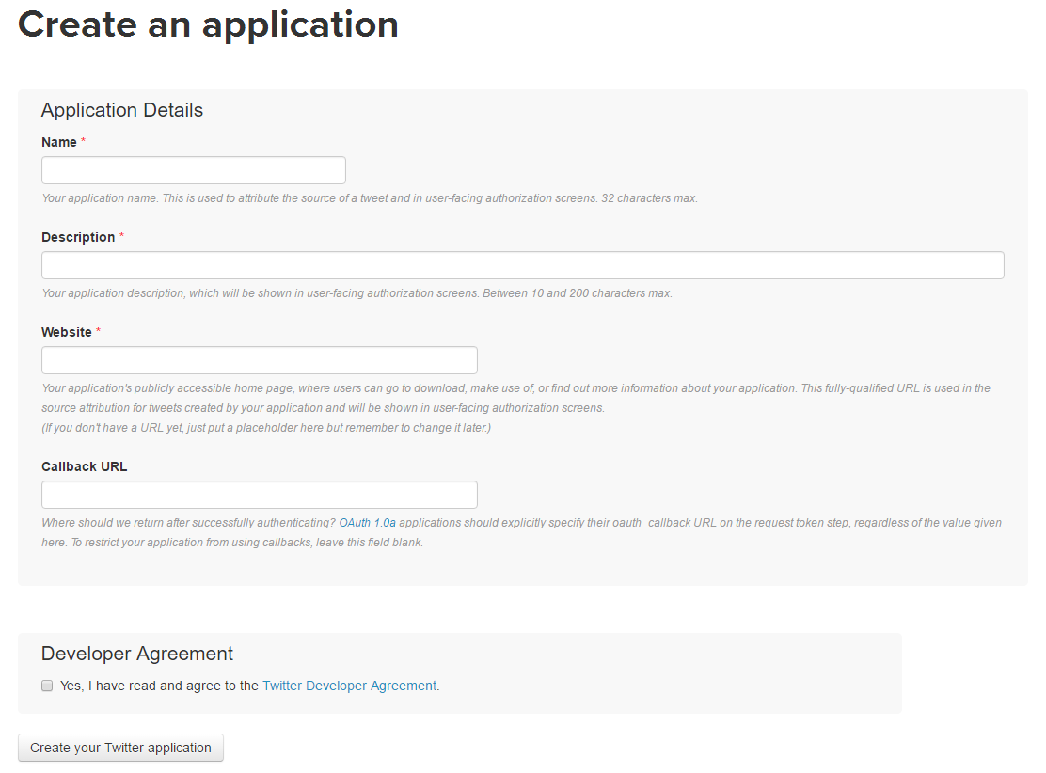

Note that you need to have your Twitter account activated using a phone number to continue to the next set.

You can go to <https://support.twitter.com/articles/110250> to see how to add a phone number to your Twitter account.

6. Go to the tab **Keys and Access Tokens**, and click on **Create my access Token**:

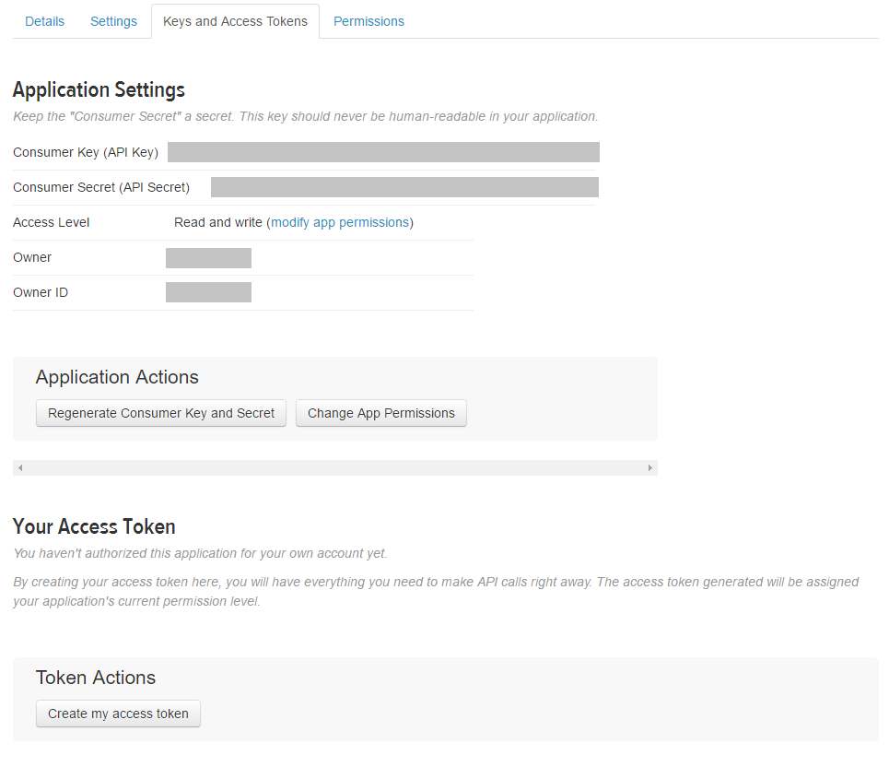

7. Your Consumer Key, Consumer Secret, Access Token and Access Token secret will be displayed. Copy them and used them to authenticate (you need them to authenticate the first time you create an account, and you won’t be asked to enter them again).