**Fig.1 – Data Chart**

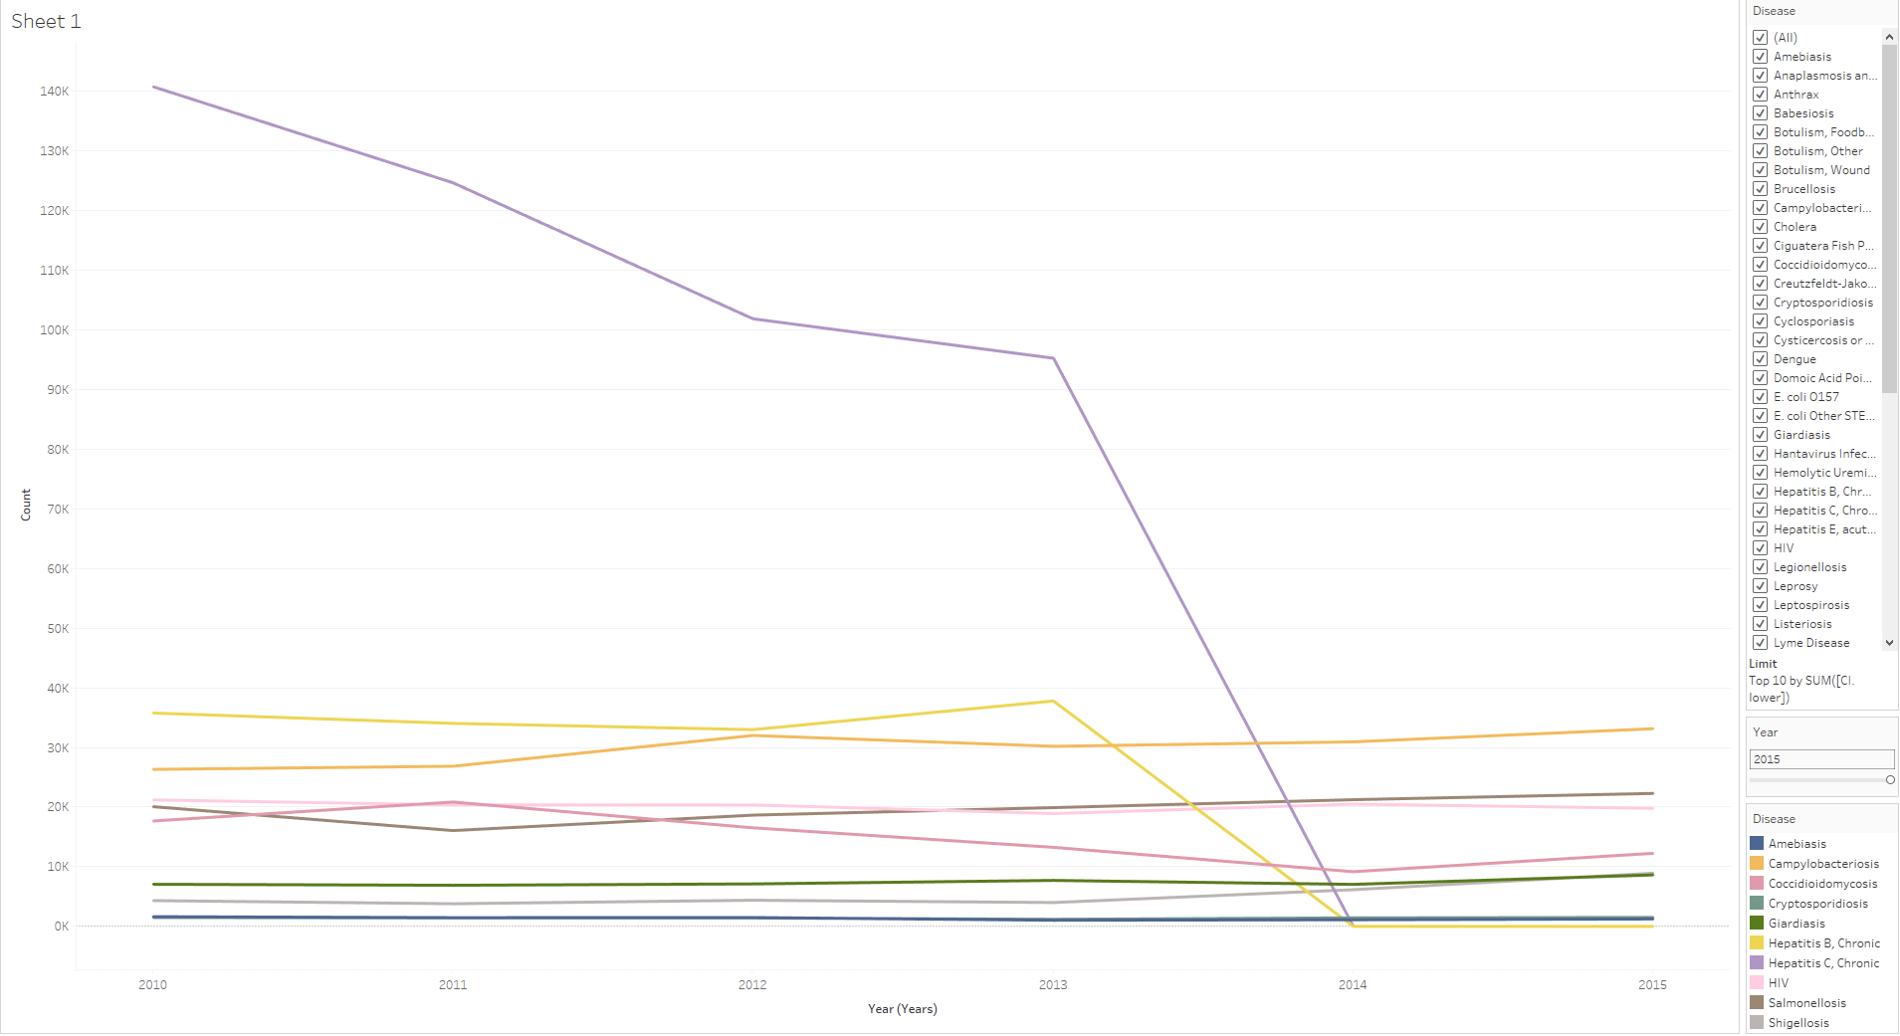

**Fig 2 – Filter [Year (Years)]**

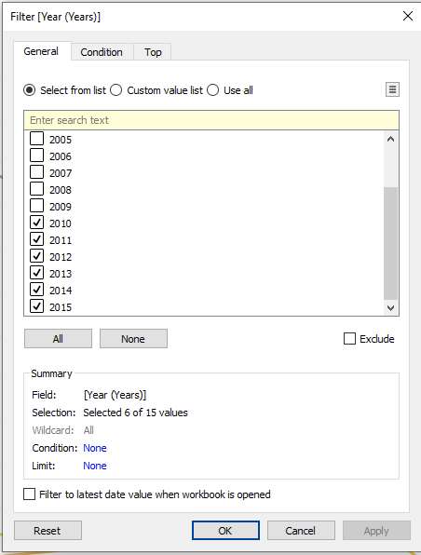

**Fig 3 – Filter [Disease]**

