At the start, therewas an orientation day where sponsors presernted their potential project to each group of students.

I’m a graduaate of Camosun’s Computer Engineering Technology program, and was happy to help them out, in addition to potentially helping out our PiMakers group.

One of the groups, called “Code Carnival” chose my Weather Station project.

The idea was to monitor temp, humidity and pressure and send it to a website running on a raspberry Pi. I wanteed the monotiring to be remote, such as my trailer.

They liked the idea that it was a “full stack” project, although they admitted that the project wasn’t their first choice.

I supplied a Raspberry Pi, two Pi Pico W’s, and two BME 280 Temperature/Pressure/Humidity sensors. One of the students ended up buying his own through the course of the project.

The three students were keen and interested. They figured things out quickly (faster than I though they would). They could have tackled a harder project.

There were some techinical issues to sort out. They had quite a bit of leeway in sorting things out. Some areas where they had to make techinical decisions involved the framework, database, and web server. They quickly found that the database they wanted to use was not going to work for them (MongoDB), so they settled on sqlite which works well with the Flask framework and Apache.

They added quite a bit of Javascript for the final front-facing website.

We met every week. Sometimes it was in person, sometimes online. They made quite a bit of use of Discord for chatting, meetings, and keeping track of milestones and “to do’s”.

We all learned the importance of communication when there was a misunderstanding about when we were to have one of our meetings. It was important to remember that these were fairly young, inexperienced young people.

I encouraged them to use GitHub as a code/project repository, which they did.

It was really itneresting gettitng ready for this talk. I had to go over the code, which I knew had worked for the demo day.

I found some interesting reasons why it wasn’t working.

Even though there was a .toml file with the wi-fi info, they had hard coded the SSID and password.

The sensor could not be read at first. I found where the code was defining the IP address of the website, but there were .js files that also had that IP address hard coded

I should have had my own setup right from the start so I could follow along with them. It would have caused a lot less confusion.

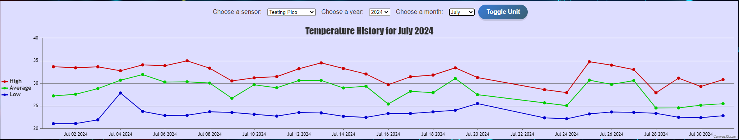

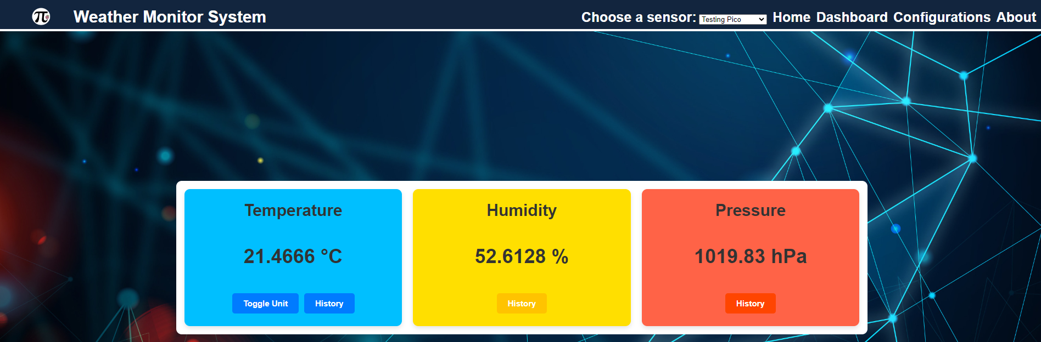

End result web page

They took some care in optimizing the data for size of file, # or writes, and wi-fi traffic. Power was not a consideration, as I assumed that the sensor board would be connected to something that could supply lots of power, either AC or a battery/solar panel arrangement.

I also had as a parameter that everything had to be “contained”, no web account needed, no extra cost,

The “no online services” didn’t quite work out the way I thought it would. There were many places where IP addresses were “hard coded”, and one of the team – cleverly – set it up so the other team members could access his pi from the internet. This made trasitioning the project to a new system probelmatic.

There were some things that I figured would be difficult that turned out to be straightforward, and some things that I thought were intuitive, the team made complicated.

Mistakes I made:

not running my own version of the system soon enough. I should have done that right away

I had a feeling that managing the timestamps on the Pi Pico would be problematic, but I didn’t push it hard enough. The time should have been taken care of on the Raspberry Pi. They had the Pico send the timestamp as part of the json request, then the timestamp got added to the database on the Raspberry Pi.

That meant that strings couldn’t be sent to the Raspberry Pi manually for troubleshooting, without calculating and figuring out a timestamp manually.

