=== VSCODE Tour ===

* VSCode is an IDE (Integrated Development Environment) that is

free – no cost to download,

open source – source code available on github
multi language – lots including Python, Java, C variants, Arduino, PHP, Go, Lua, …..
multi platform – Windows, Mac, Ubuntu, Debian, Red Hat variants
fairly lightweight
tons of extensions and add-ons available
learning curve is not as steep as some other full-featured IDEs

* Start with Raspberry Pi OS (I used August 2020 version)

* Git is installed by default

* Python 3 is installed by default

==== Install VSCode ( code-oss) ====

* Code-OSS is available for 32 bit ARM processors

* Instructions available at code.headmelted.com

wget -O – https://code.headmelted.com/installers/apt.sh

* The .deb package can also be downloaded directly, choose armhf.deb for 32 bit version to work with Raspberry Pi
==== Start/Setup Code-OSS ====

* Code-OSS start icon available under Raspberry Pi icon (top left) under Programming

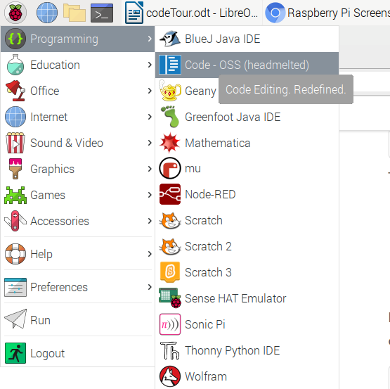

==== VSCode Starts ====

==== Some HouseKeeping ====

* I personally don’t like the Dark theme, so I change it

* Select File → Preferences → Settings → Workbench → Apperarance

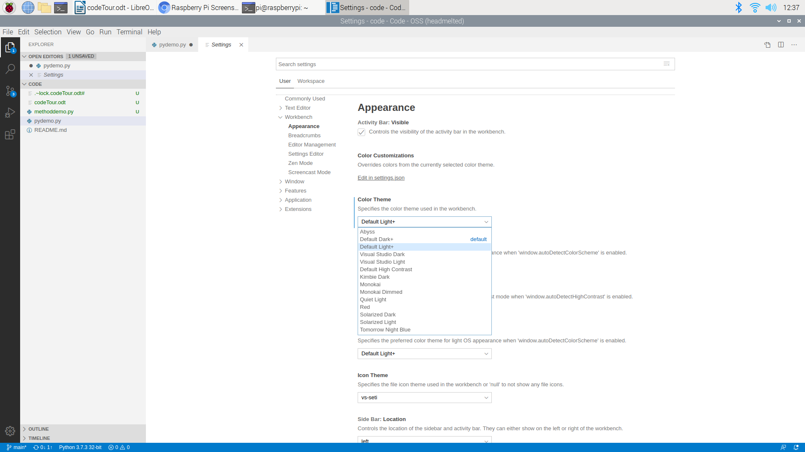
* There are tons of other settings here (font, screen size, tab spacing, etc, etc)

* I mentioned that Git is supported out of the box, but Python needs to be added

* I’ll start with the Python extension from Microsoft, which has everything I need for now.

* The extensions icon is the one with four blocks. Click on it, and search for what you want. In this case, I search for Python. The one I want comes up first, I click “Install”.

* note that language and language features need to be installed in OS first

==== Start Coding ====

* close VSCode

* start a command prompt

* create directory you want your project in

* still on the command line, cd to project directory

code-oss .

That is, code dash oss space dot

* VSCode opens your new project. Workspace is automatically set up.

* file icon is top left

* file plus icon starts a new file

* give it a name

* start typing

==== Snippets, etc ====

* Python extension adds syntax highlighting

* snippets give syntax reminders/examples

if/else

try/catch

