Time Series

Ralf Martin

# spurious relations over time: the case of covid and weekly economic activity

## "","x"  
## "1","timeseries.csv"

So we got ourselves some time series data:

head(df)

## week WEI Index cases deaths lnindex lockshare  
## 1 2008-01-05 1.42 1.00000 0 0 0.0000000000 0  
## 2 2008-01-12 1.46 1.00028 0 0 0.0002799608 0  
## 3 2008-01-19 1.40 1.00055 0 0 0.0005498488 0  
## 4 2008-01-26 0.96 1.00073 0 0 0.0007297337 0  
## 5 2008-02-02 0.73 1.00088 0 0 0.0008796130 0  
## 6 2008-02-09 0.78 1.00103 0 0 0.0010294699 0

library(ggplot2)  
library(scales)  
  
  
 scaler=max(df$cases,na.rm=TRUE)/max(df$Index,na.rm=TRUE)  
   
 ggplot(df,aes(x=week)) + theme_minimal() + xlab("Weekly Data") +  
 theme(axis.text.x = element_text(angle = 90, hjust = 1))+  
 scale_x_date(breaks = date_breaks("12 months"),labels = date_format("%Y")) +  
 geom_line(aes(y = Index*scaler, colour = "Economic Activity Index"))+  
 geom_line(aes(y = cases, colour = "Total Covid Cases per 100K"))+ylab("Covid Cases")+  
 scale_y_continuous(sec.axis = sec_axis(label=comma, trans=~./(scaler),  
 name = "Economic Activity Index"),labels=comma)

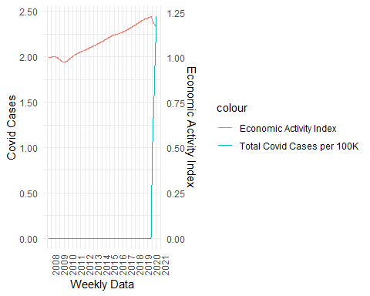

## Illustration of time trend

lm(lnindex~cases,df) %>% summary()

##   
## Call:  
## lm(formula = lnindex ~ cases, data = df)  
##   
## Residuals:  
## Min 1Q Median 3Q Max   
## -0.108375 -0.064942 -0.002043 0.055871 0.121388   
##   
## Coefficients:  
## Estimate Std. Error t value Pr(>|t|)   
## (Intercept) 0.082359 0.002731 30.156 < 2e-16 ***  
## cases 0.050575 0.007800 6.484 1.74e-10 ***  
## ---  
## Signif. codes: 0 '***' 0.001 '**' 0.01 '*' 0.05 '.' 0.1 ' ' 1  
##   
## Residual standard error: 0.06928 on 669 degrees of freedom  
## Multiple R-squared: 0.05913, Adjusted R-squared: 0.05772   
## F-statistic: 42.04 on 1 and 669 DF, p-value: 1.737e-10

df=df %>% mutate(t=1:n())  
lm(lnindex~cases+t,df) %>% summary()

##   
## Call:  
## lm(formula = lnindex ~ cases + t, data = df)  
##   
## Residuals:  
## Min 1Q Median 3Q Max   
## -0.024859 -0.004965 -0.001175 0.003861 0.038124   
##   
## Coefficients:  
## Estimate Std. Error t value Pr(>|t|)   
## (Intercept) -3.850e-02 9.170e-04 -41.98 <2e-16 ***  
## cases -2.262e-02 1.393e-03 -16.23 <2e-16 ***  
## t 3.752e-04 2.466e-06 152.11 <2e-16 ***  
## ---  
## Signif. codes: 0 '***' 0.001 '**' 0.01 '*' 0.05 '.' 0.1 ' ' 1  
##   
## Residual standard error: 0.01161 on 668 degrees of freedom  
## Multiple R-squared: 0.9736, Adjusted R-squared: 0.9735   
## F-statistic: 1.232e+04 on 2 and 668 DF, p-value: < 2.2e-16

## The case of Panel data

statsbyday=read.csv("https://www.dropbox.com/s/e26qs4vfl4xjy99/statsbydlong.cvs?dl=1") %>% mutate(date=as_date(date),week=round_date( date, unit = "week"))  
 #mutate(hoaxsh=hoax/tweets)  
  
statsbyweek= statsbyday %>% group_by(state,week) %>%   
 summarise(hoax=sum(hoax),   
 tweets=sum(tweets),  
 cases=max(cases),  
 deaths=max(deaths)) %>%  
 mutate(hoaxsh=hoax/tweets*100) %>%   
 filter(week<max(week))   
 # we get rid of the last week because it is not a full week so not comparable with the others  
  
  
# Let's also compute extra cases and deaths per day as opposed to cumulative ones.  
# To implement that we order ther dataframe by week and then take the difference  
# between current and lagged cases and death figures.  
statsbyweek = statsbyweek %>% arrange(state,week) %>% group_by(state) %>%   
 mutate(Dcases=cases-dplyr::lag(cases,1),  
 Ddeaths=deaths-dplyr::lag(deaths,1))

head(statsbyweek %>% arrange(state,week))

## # A tibble: 6 x 9  
## # Groups: state [1]  
## state week hoax tweets cases deaths hoaxsh Dcases Ddeaths  
## <chr> <date> <int> <int> <int> <int> <dbl> <int> <int>  
## 1 Alabama 2020-03-08 1 443 12 0 0.226 NA NA  
## 2 Alabama 2020-03-15 13 2098 131 0 0.620 119 0  
## 3 Alabama 2020-03-22 57 5824 720 4 0.979 589 4  
## 4 Alabama 2020-03-29 10 4750 1632 44 0.211 912 40  
## 5 Alabama 2020-04-05 16 4477 3262 93 0.357 1630 49  
## 6 Alabama 2020-04-12 6 4180 4723 151 0.144 1461 58

statsbyweek %>% group_by(state) %>% summarise(n())

## # A tibble: 50 x 2  
## state `n()`  
## <chr> <int>  
## 1 Alabama 29  
## 2 Alaska 29  
## 3 Arizona 35  
## 4 Arkansas 29  
## 5 California 36  
## 6 Colorado 30  
## 7 Connecticut 29  
## 8 Delaware 29  
## 9 Florida 30  
## 10 Georgia 30  
## # ... with 40 more rows

statsbyweek=statsbyweek %>% arrange(state,week) %>%   
 group_by(state) %>%   
 mutate(cumhoax=cumsum(hoax),cumtweets=cumsum(tweets),  
 cumhoaxsh=cumhoax/cumtweets*100,  
 Dcumhoaxsh=cumhoaxsh-dplyr::lag(cumhoaxsh),  
 Dcases=cases-dplyr::lag(cases),  
 Ddeaths=deaths-dplyr::lag(deaths))

tsplotter(statsbyweek %>% filter(state=="New York"),label="New York")

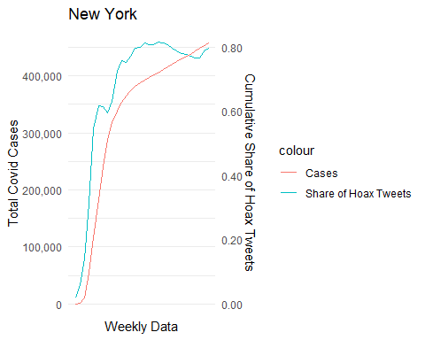

tsplotter(statsbyweek %>% filter(state=="California"),label="California")

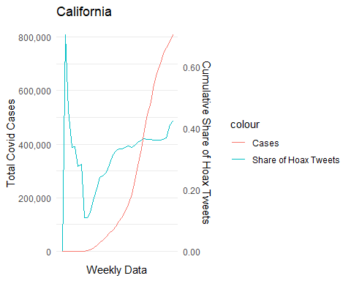

tsplotter(statsbyweek %>% filter(state=="Texas"),label="Texas")

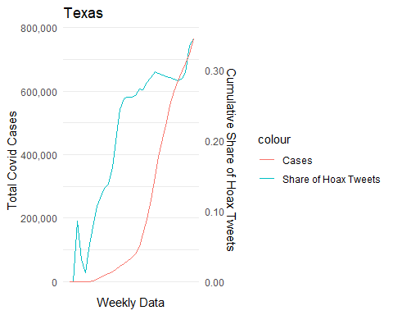

statsbyweek=as.data.frame(statsbyweek)

lm(cases~cumhoaxsh, statsbyweek) %>% summary()

##   
## Call:  
## lm(formula = cases ~ cumhoaxsh, data = statsbyweek)  
##   
## Residuals:  
## Min 1Q Median 3Q Max   
## -294697 -38574 -24113 3608 735732   
##   
## Coefficients:  
## Estimate Std. Error t value Pr(>|t|)   
## (Intercept) 22072 4127 5.348 1.02e-07 ***  
## cumhoaxsh 121120 11220 10.796 < 2e-16 ***  
## ---  
## Signif. codes: 0 '***' 0.001 '**' 0.01 '*' 0.05 '.' 0.1 ' ' 1  
##   
## Residual standard error: 103100 on 1518 degrees of freedom  
## Multiple R-squared: 0.0713, Adjusted R-squared: 0.07069   
## F-statistic: 116.5 on 1 and 1518 DF, p-value: < 2.2e-16

lm(cases~cumhoaxsh+factor(week), statsbyweek) %>% summary()

##   
## Call:  
## lm(formula = cases ~ cumhoaxsh + factor(week), data = statsbyweek)  
##   
## Residuals:  
## Min 1Q Median 3Q Max   
## -182000 -36269 -9070 5947 665628   
##   
## Coefficients:  
## Estimate Std. Error t value Pr(>|t|)   
## (Intercept) 1 55848 0.000 1.0000   
## cumhoaxsh 72056 11578 6.224 6.31e-10 ***  
## factor(week)2020-01-26 -10172 70662 -0.144 0.8856   
## factor(week)2020-02-02 -5521 68406 -0.081 0.9357   
## factor(week)2020-02-09 -3486 66754 -0.052 0.9584   
## factor(week)2020-02-16 -3073 65490 -0.047 0.9626   
## factor(week)2020-02-23 -17368 63738 -0.272 0.7853   
## factor(week)2020-03-01 -3010 58410 -0.052 0.9589   
## factor(week)2020-03-08 -4210 57537 -0.073 0.9417   
## factor(week)2020-03-15 -5968 57509 -0.104 0.9174   
## factor(week)2020-03-22 -4942 57512 -0.086 0.9315   
## factor(week)2020-03-29 -7466 57541 -0.130 0.8968   
## factor(week)2020-04-05 -3354 57543 -0.058 0.9535   
## factor(week)2020-04-12 -1128 57555 -0.020 0.9844   
## factor(week)2020-04-19 2873 57556 0.050 0.9602   
## factor(week)2020-04-26 5676 57564 0.099 0.9215   
## factor(week)2020-05-03 6534 57586 0.113 0.9097   
## factor(week)2020-05-10 6570 57615 0.114 0.9092   
## factor(week)2020-05-17 9034 57622 0.157 0.8754   
## factor(week)2020-05-24 11568 57626 0.201 0.8409   
## factor(week)2020-05-31 14591 57626 0.253 0.8001   
## factor(week)2020-06-07 17484 57628 0.303 0.7616   
## factor(week)2020-06-14 20535 57634 0.356 0.7217   
## factor(week)2020-06-21 25943 57631 0.450 0.6527   
## factor(week)2020-06-28 32184 57637 0.558 0.5767   
## factor(week)2020-07-05 39753 57640 0.690 0.4905   
## factor(week)2020-07-12 48568 57644 0.843 0.3996   
## factor(week)2020-07-19 57909 57643 1.005 0.3153   
## factor(week)2020-07-26 66769 57641 1.158 0.2469   
## factor(week)2020-08-02 74272 57641 1.289 0.1978   
## factor(week)2020-08-09 81659 57640 1.417 0.1568   
## factor(week)2020-08-16 87835 57638 1.524 0.1277   
## factor(week)2020-08-23 93779 57637 1.627 0.1039   
## factor(week)2020-08-30 99461 57638 1.726 0.0846 .   
## factor(week)2020-09-06 103676 57643 1.799 0.0723 .   
## factor(week)2020-09-13 107481 57664 1.864 0.0625 .   
## factor(week)2020-09-20 113001 57672 1.959 0.0503 .   
## ---  
## Signif. codes: 0 '***' 0.001 '**' 0.01 '*' 0.05 '.' 0.1 ' ' 1  
##   
## Residual standard error: 96730 on 1483 degrees of freedom  
## Multiple R-squared: 0.2017, Adjusted R-squared: 0.1823   
## F-statistic: 10.41 on 36 and 1483 DF, p-value: < 2.2e-16

lm(cases~cumhoaxsh+factor(state)+factor(week),statsbyweek) %>% summary()

##   
## Call:  
## lm(formula = cases ~ cumhoaxsh + factor(state) + factor(week),   
## data = statsbyweek)  
##   
## Residuals:  
## Min 1Q Median 3Q Max   
## -244737 -21562 1446 21041 463246   
##   
## Coefficients:  
## Estimate Std. Error t value Pr(>|t|)   
## (Intercept) -109303 41227 -2.651 0.008107 **   
## cumhoaxsh 61619 19128 3.221 0.001304 **   
## factor(state)Alaska -96560 22677 -4.258 2.20e-05 ***  
## factor(state)Arizona 34689 16951 2.046 0.040899 *   
## factor(state)Arkansas -9094 18337 -0.496 0.620015   
## factor(state)California 224047 17120 13.087 < 2e-16 ***  
## factor(state)Colorado -8425 17692 -0.476 0.634008   
## factor(state)Connecticut 4626 18572 0.249 0.803343   
## factor(state)Delaware -31191 17875 -1.745 0.081207 .   
## factor(state)Florida 206617 17752 11.639 < 2e-16 ***  
## factor(state)Georgia 76649 18631 4.114 4.11e-05 ***  
## factor(state)Hawaii -19376 19427 -0.997 0.318753   
## factor(state)Idaho -19743 18621 -1.060 0.289211   
## factor(state)Illinois 84270 16937 4.976 7.29e-07 ***  
## factor(state)Indiana 4917 17563 0.280 0.779530   
## factor(state)Iowa 5676 19461 0.292 0.770594   
## factor(state)Kansas -8412 18806 -0.447 0.654735   
## factor(state)Kentucky -7109 18628 -0.382 0.702779   
## factor(state)Louisiana 17779 17544 1.013 0.311053   
## factor(state)Maine -31421 18450 -1.703 0.088780 .   
## factor(state)Maryland 32942 18957 1.738 0.082479 .   
## factor(state)Massachusetts 61821 18266 3.385 0.000732 ***  
## factor(state)Michigan 25081 17818 1.408 0.159450   
## factor(state)Minnesota 4957 18442 0.269 0.788111   
## factor(state)Mississippi 3375 18627 0.181 0.856241   
## factor(state)Missouri 2323 18217 0.128 0.898538   
## factor(state)Montana -24047 19265 -1.248 0.212145   
## factor(state)Nebraska -6853 18268 -0.375 0.707625   
## factor(state)Nevada -11638 17725 -0.657 0.511535   
## factor(state)New Hampshire -28796 18150 -1.587 0.112843   
## factor(state)New Jersey 104398 18131 5.758 1.04e-08 ***  
## factor(state)New Mexico -18232 18799 -0.970 0.332293   
## factor(state)New York 267417 17604 15.191 < 2e-16 ***  
## factor(state)North Carolina 41467 18433 2.250 0.024622 *   
## factor(state)North Dakota -43106 17584 -2.451 0.014348 *   
## factor(state)Ohio 23614 18305 1.290 0.197232   
## factor(state)Oklahoma -12340 17969 -0.687 0.492354   
## factor(state)Oregon -26289 17531 -1.500 0.133956   
## factor(state)Pennsylvania 48666 18260 2.665 0.007781 **   
## factor(state)Rhode Island -12495 18916 -0.661 0.509023   
## factor(state)South Carolina 21829 18843 1.158 0.246881   
## factor(state)South Dakota -25593 18607 -1.375 0.169209   
## factor(state)Tennessee 25508 17914 1.424 0.154677   
## factor(state)Texas 205457 18000 11.414 < 2e-16 ***  
## factor(state)Utah -4211 18321 -0.230 0.818222   
## factor(state)Vermont -16486 20098 -0.820 0.412192   
## factor(state)Virginia 33367 18986 1.757 0.079054 .   
## factor(state)Washington 19594 17729 1.105 0.269267   
## factor(state)West Virginia -25650 19240 -1.333 0.182699   
## factor(state)Wisconsin 13584 17824 0.762 0.446093   
## factor(state)Wyoming -44944 17629 -2.549 0.010892 *   
## factor(week)2020-01-26 15721 48990 0.321 0.748331   
## factor(week)2020-02-02 31581 47462 0.665 0.505899   
## factor(week)2020-02-09 14400 46358 0.311 0.756128   
## factor(week)2020-02-16 27100 45524 0.595 0.551740   
## factor(week)2020-02-23 33841 44606 0.759 0.448175   
## factor(week)2020-03-01 64479 40881 1.577 0.114963   
## factor(week)2020-03-08 83502 40294 2.072 0.038414 *   
## factor(week)2020-03-15 83018 40308 2.060 0.039620 *   
## factor(week)2020-03-22 84182 40325 2.088 0.037013 *   
## factor(week)2020-03-29 82566 40477 2.040 0.041552 *   
## factor(week)2020-04-05 86711 40484 2.142 0.032372 *   
## factor(week)2020-04-12 89193 40540 2.200 0.027956 *   
## factor(week)2020-04-19 93225 40547 2.299 0.021637 *   
## factor(week)2020-04-26 96182 40583 2.370 0.017921 *   
## factor(week)2020-05-03 97424 40683 2.395 0.016761 *   
## factor(week)2020-05-10 97909 40814 2.399 0.016571 *   
## factor(week)2020-05-17 100467 40843 2.460 0.014019 *   
## factor(week)2020-05-24 103055 40861 2.522 0.011773 *   
## factor(week)2020-05-31 106088 40864 2.596 0.009525 **   
## factor(week)2020-06-07 109001 40870 2.667 0.007740 **   
## factor(week)2020-06-14 112130 40896 2.742 0.006186 **   
## factor(week)2020-06-21 117499 40883 2.874 0.004113 **   
## factor(week)2020-06-28 123818 40909 3.027 0.002517 **   
## factor(week)2020-07-05 131427 40923 3.212 0.001349 **   
## factor(week)2020-07-12 140298 40941 3.427 0.000628 ***  
## factor(week)2020-07-19 149629 40938 3.655 0.000266 ***  
## factor(week)2020-07-26 158464 40930 3.872 0.000113 ***  
## factor(week)2020-08-02 165968 40930 4.055 5.28e-05 ***  
## factor(week)2020-08-09 173336 40924 4.236 2.42e-05 ***  
## factor(week)2020-08-16 179489 40916 4.387 1.23e-05 ***  
## factor(week)2020-08-23 185412 40909 4.532 6.32e-06 ***  
## factor(week)2020-08-30 191114 40916 4.671 3.28e-06 ***  
## factor(week)2020-09-06 195392 40937 4.773 2.00e-06 ***  
## factor(week)2020-09-13 199458 41028 4.861 1.29e-06 ***  
## factor(week)2020-09-20 205070 41062 4.994 6.63e-07 ***  
## ---  
## Signif. codes: 0 '***' 0.001 '**' 0.01 '*' 0.05 '.' 0.1 ' ' 1  
##   
## Residual standard error: 66770 on 1434 degrees of freedom  
## Multiple R-squared: 0.6322, Adjusted R-squared: 0.6104   
## F-statistic: 28.99 on 85 and 1434 DF, p-value: < 2.2e-16

# Another command doing the same but quicker  
library(fixest)  
feols(cases ~ cumhoaxsh | week + state,statsbyweek)

## OLS estimation, Dep. Var.: cases  
## Observations: 1,520   
## Fixed-effects: week: 36, state: 50  
## Standard-errors: Clustered (week)   
## Estimate Std. Error t value Pr(>|t|)   
## cumhoaxsh 61618.9 19364.9 3.182 0.0030627 **   
## ---  
## Signif. codes: 0 '***' 0.001 '**' 0.01 '*' 0.05 '.' 0.1 ' ' 1  
## RMSE: 64,856.6 Adj. R2: 0.610369  
## Within R2: 0.007185

## Unit roots

library(ggplot2)  
set.seed(12356.2231)  
obs=100  
eps=rnorm(obs)  
y99=eps  
y100=eps  
yM100=eps  
  
for(i in 2:obs){  
   
 y99[i] = y99[i-1] *.95 +eps[i]  
 yM100[i]=-yM100[i-1]*1+eps[i]  
 y100[i]= y100[i-1]*1+eps[i]  
   
}  
  
  
sdf=data.frame(y99,y100,yM100,eps,period=1:obs)   
  
#library(latex2exp)  
ggplot(sdf,aes(x=period))+geom_line(aes(y=y99,color="rho=0.99"))+  
 geom_line(aes(y=y100,color="rho=1"))+  
 geom_line(aes(y=yM100,color="rho=-1"))+  
 theme_minimal()+ylab("y")

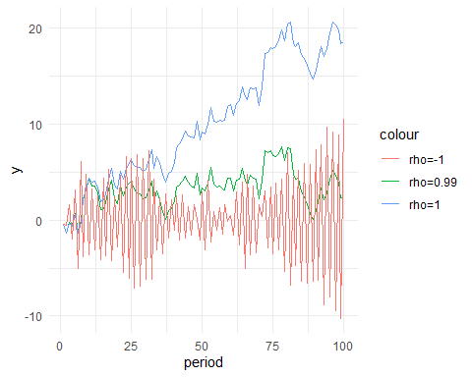

library(urca)  
 ur.df(df$lnindex) %>% summary()

##   
## ###############################################   
## # Augmented Dickey-Fuller Test Unit Root Test #   
## ###############################################   
##   
## Test regression none   
##   
##   
## Call:  
## lm(formula = z.diff ~ z.lag.1 - 1 + z.diff.lag)  
##   
## Residuals:  
## Min 1Q Median 3Q Max   
## -8.343e-04 -2.643e-05 4.240e-06 4.131e-05 1.922e-04   
##   
## Coefficients:  
## Estimate Std. Error t value Pr(>|t|)   
## z.lag.1 -2.155e-05 2.703e-05 -0.797 0.426   
## z.diff.lag 9.924e-01 5.596e-03 177.334 <2e-16 ***  
## ---  
## Signif. codes: 0 '***' 0.001 '**' 0.01 '*' 0.05 '.' 0.1 ' ' 1  
##   
## Residual standard error: 7.414e-05 on 667 degrees of freedom  
## Multiple R-squared: 0.9812, Adjusted R-squared: 0.9811   
## F-statistic: 1.739e+04 on 2 and 667 DF, p-value: < 2.2e-16  
##   
##   
## Value of test-statistic is: -0.7971   
##   
## Critical values for test statistics:   
## 1pct 5pct 10pct  
## tau1 -2.58 -1.95 -1.62

ur.df(diff(df$lnindex)) %>% summary()

##   
## ###############################################   
## # Augmented Dickey-Fuller Test Unit Root Test #   
## ###############################################   
##   
## Test regression none   
##   
##   
## Call:  
## lm(formula = z.diff ~ z.lag.1 - 1 + z.diff.lag)  
##   
## Residuals:  
## Min 1Q Median 3Q Max   
## -8.236e-04 -3.079e-05 3.980e-06 4.133e-05 1.963e-04   
##   
## Coefficients:  
## Estimate Std. Error t value Pr(>|t|)   
## z.lag.1 -0.010977 0.005233 -2.098 0.0363 *   
## z.diff.lag 0.195464 0.038082 5.133 3.75e-07 ***  
## ---  
## Signif. codes: 0 '***' 0.001 '**' 0.01 '*' 0.05 '.' 0.1 ' ' 1  
##   
## Residual standard error: 7.28e-05 on 666 degrees of freedom  
## Multiple R-squared: 0.04215, Adjusted R-squared: 0.03927   
## F-statistic: 14.65 on 2 and 666 DF, p-value: 5.92e-07  
##   
##   
## Value of test-statistic is: -2.0976   
##   
## Critical values for test statistics:   
## 1pct 5pct 10pct  
## tau1 -2.58 -1.95 -1.62

df=df %>% arrange(week) %>% mutate( Dlnindex=lnindex - dplyr::lag(lnindex) ,Llnindex=dplyr::lag(lnindex) )  
  
  
lm(Dlnindex~cases+t,df) %>% summary()

##   
## Call:  
## lm(formula = Dlnindex ~ cases + t, data = df)  
##   
## Residuals:  
## Min 1Q Median 3Q Max   
## -2.175e-03 -6.473e-05 7.992e-05 1.627e-04 1.327e-03   
##   
## Coefficients:  
## Estimate Std. Error t value Pr(>|t|)   
## (Intercept) 1.729e-04 3.019e-05 5.726 1.55e-08 ***  
## cases -9.290e-04 4.573e-05 -20.314 < 2e-16 ***  
## t 3.831e-07 8.113e-08 4.723 2.84e-06 ***  
## ---  
## Signif. codes: 0 '***' 0.001 '**' 0.01 '*' 0.05 '.' 0.1 ' ' 1  
##   
## Residual standard error: 0.0003811 on 667 degrees of freedom  
## (1 observation deleted due to missingness)  
## Multiple R-squared: 0.3856, Adjusted R-squared: 0.3838   
## F-statistic: 209.3 on 2 and 667 DF, p-value: < 2.2e-16

lm(Dlnindex~cases,df) %>% summary()

##   
## Call:  
## lm(formula = Dlnindex ~ cases, data = df)  
##   
## Residuals:  
## Min 1Q Median 3Q Max   
## -2.081e-03 -1.559e-05 1.021e-04 1.735e-04 1.278e-03   
##   
## Coefficients:  
## Estimate Std. Error t value Pr(>|t|)   
## (Intercept) 2.965e-04 1.528e-05 19.41 <2e-16 ***  
## cases -8.544e-04 4.359e-05 -19.60 <2e-16 ***  
## ---  
## Signif. codes: 0 '***' 0.001 '**' 0.01 '*' 0.05 '.' 0.1 ' ' 1  
##   
## Residual standard error: 0.0003872 on 668 degrees of freedom  
## (1 observation deleted due to missingness)  
## Multiple R-squared: 0.3651, Adjusted R-squared: 0.3641   
## F-statistic: 384.1 on 1 and 668 DF, p-value: < 2.2e-16

lm(Dlnindex~cases+lockshare+t,df) %>% summary()

##   
## Call:  
## lm(formula = Dlnindex ~ cases + lockshare + t, data = df)  
##   
## Residuals:  
## Min 1Q Median 3Q Max   
## -9.141e-04 -1.092e-04 2.947e-05 1.456e-04 1.104e-03   
##   
## Coefficients:  
## Estimate Std. Error t value Pr(>|t|)   
## (Intercept) 1.209e-04 2.266e-05 5.335 1.31e-07 ***  
## cases 5.646e-04 7.334e-05 7.698 5.00e-14 ***  
## lockshare -2.772e-05 1.205e-06 -23.014 < 2e-16 ***  
## t 6.278e-07 6.152e-08 10.205 < 2e-16 ***  
## ---  
## Signif. codes: 0 '***' 0.001 '**' 0.01 '*' 0.05 '.' 0.1 ' ' 1  
##   
## Residual standard error: 0.0002847 on 666 degrees of freedom  
## (1 observation deleted due to missingness)  
## Multiple R-squared: 0.6578, Adjusted R-squared: 0.6562   
## F-statistic: 426.7 on 3 and 666 DF, p-value: < 2.2e-16

lm(Dlnindex~cases+lockshare,df) %>% summary()

##   
## Call:  
## lm(formula = Dlnindex ~ cases + lockshare, data = df)  
##   
## Residuals:  
## Min 1Q Median 3Q Max   
## -1.076e-03 -3.670e-05 7.766e-05 1.463e-04 1.130e-03   
##   
## Coefficients:  
## Estimate Std. Error t value Pr(>|t|)   
## (Intercept) 3.214e-04 1.213e-05 26.491 < 2e-16 ***  
## cases 5.688e-04 7.881e-05 7.217 1.45e-12 ***  
## lockshare -2.560e-05 1.275e-06 -20.078 < 2e-16 ***  
## ---  
## Signif. codes: 0 '***' 0.001 '**' 0.01 '*' 0.05 '.' 0.1 ' ' 1  
##   
## Residual standard error: 0.0003059 on 667 degrees of freedom  
## (1 observation deleted due to missingness)  
## Multiple R-squared: 0.6043, Adjusted R-squared: 0.6031   
## F-statistic: 509.2 on 2 and 667 DF, p-value: < 2.2e-16