Clean tech across the world

Ralf Martin

2021-01-15

## `geom_smooth()` using formula 'y ~ x'  
## `geom_smooth()` using formula 'y ~ x'

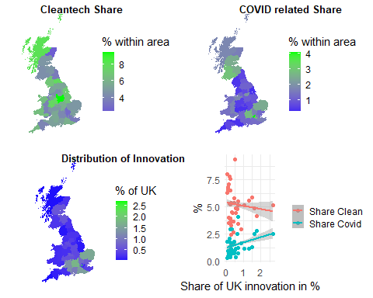

Clean and COVID related innovation in the UK

## The figures separately so they can easily be re-arranged:

p1

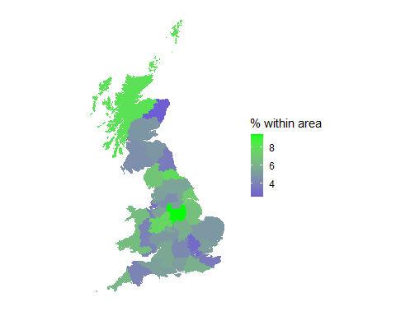

p2

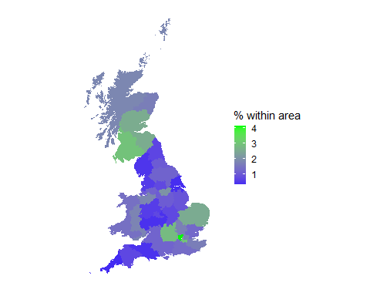

p3

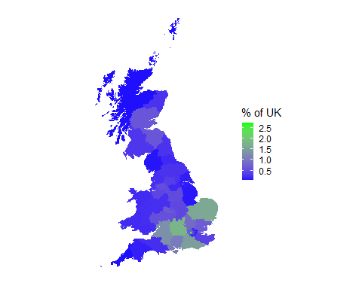

p4

## `geom_smooth()` using formula 'y ~ x'  
## `geom_smooth()` using formula 'y ~ x'

