IMT 563: Advanced Relational Database Management Systems
Movie and Theater Data Warehouse: OLAP and Window Function Query Deliverable
Group Members: Jihan Yang, Raymond Xu

Abstract
This project develops and uses a movie and theater data warehouse to support decision-oriented analysis of movie demand, theatrical attendance, operating performance, market concentration, and company-level financial capacity. The current deliverable extends the warehouse by implementing ten complex SQL queries, with five queries written by Jihan Yang and five queries written by Raymond Xu. The queries use common table expressions, temporary tables, aggregate functions, SET operators, ranking functions, value window functions, moving averages, and running totals. The resulting outputs are designed to support dashboards and managerial interpretation for movie distribution strategy, theater capacity planning, market investment, programming decisions, and industry benchmarking.

I. Introduction
The movie exhibition industry is shaped by changing audience behavior, market-level demand, ticket sales, theater attendance, capacity utilization, and the financial position of firms that participate in the broader movie ecosystem. A data warehouse is useful for this context because it separates measurable business events from descriptive dimensions and allows analysts to summarize performance across time, market, movie, theater, city, company, and sector.
This project focuses on turning movie and theater data into information that can support decision making. The main questions include: Which movies dominate market-year revenue? Which markets are growing or declining over time? Which cities show stable or rising theater demand? Which theaters contribute strongly to cumulative annual performance? Which companies have stronger financial capacity within their sectors? The rest of this document follows the project outline structure: data sources and dimensional model, conceptual data architecture, data processing, SQL queries and visualization narratives, and conclusion.

II. Data Sources, Dimensional Model, and Data Architecture

Main Data Sources
The warehouse is based on raw CSV sources and transformed warehouse tables for movie catalog information, theater locations, weekly theater operations, market-level performance, and company-level financial metrics. The raw data sources support different analytical perspectives, but the ETL process standardizes them into a shared dimensional warehouse structure.
Data Source | Main Fields or Measures | Analytical Use
raw_movie_catalog_a.csv and raw_movie_catalog_b.csv | movie title, content rating, language, runtime, year, content type, synopsis or descriptive text | Provides movie descriptors used to group, filter, and interpret movie performance.
raw_theater_locations.csv | theater source id, theater name, address, current location name, city | Provides theater and city context for operational analysis.
raw_weekly_theater_operations.csv | theater, date, attendance, estimated revenue, capacity utilization percentage | Supports theater attendance, revenue, capacity, moving-average, and running-total analysis.
Market and company metric staging data | market name, company name, sector, annual revenue, annual profit | Supports market-level demand analysis and industry/company financial benchmarking.

Data Enrichment and Integration
The project integrates multiple sources rather than relying on a single movie table. Movie performance is linked to market and time dimensions, theater operation records are linked to theater and time dimensions, and company financial records are linked to company and time dimensions. This integration supports a broader story about demand, access, operations, and investment capacity. The enriched warehouse allows SQL queries to compare movie-market revenue, theater-level attendance, city-level demand, market concentration, and company financial trends within a single analytical environment.

Dimensional Model
The current warehouse uses a fact ER diagram because it contains three related fact tables that share some dimensions while preserving different analytical grains. The fact_movie_performance table captures movie performance at the grain of one movie in one market during one time period. The fact_theater_operations table captures theater operations at the grain of one theater during one time period. The fact_industry_metrics table captures company financial metrics at the grain of one company during one time period. The shared dim_time table supports trend analysis, moving averages, running totals, and year-over-year comparisons across all three fact tables.
Table | Type | Grain or Role | Key Measures / Attributes
fact_movie_performance | Fact | One movie-market-time record | box_office_rev, tickets_sold
fact_theater_operations | Fact | One theater-time record | revenue_est, attendance, capacity_pct
fact_industry_metrics | Fact | One company-time record | annual_revenue, annual_profit
dim_time | Shared Dimension | Calendar/time context | full_date, day, month, quarter, year, decade
dim_movie | Dimension | Movie descriptive context | movie_title, runtime_minutes, language, content_rating, content_type
dim_market | Dimension | Market descriptive context | market_name
dim_theater | Dimension | Theater and location context | theater_name, address, current_location_name, location_city

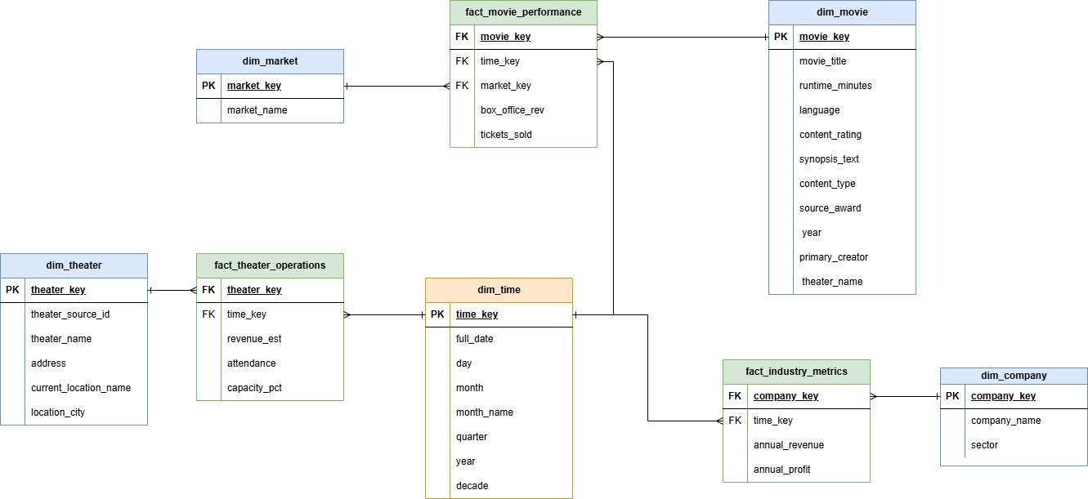
Figure 1. Dimensional model for the movie and theater data warehouse.

Conceptual Data Architecture
The ETL workflow extracts raw CSV datasets, cleans and standardizes fields, creates dimension records with surrogate keys, loads fact tables at consistent grains, and then supports analytical SQL queries in PostgreSQL. The queries in the integrated SQL file are designed as dashboard-ready outputs and can be exported to Excel, Tableau, Power BI, or Python visualization libraries.
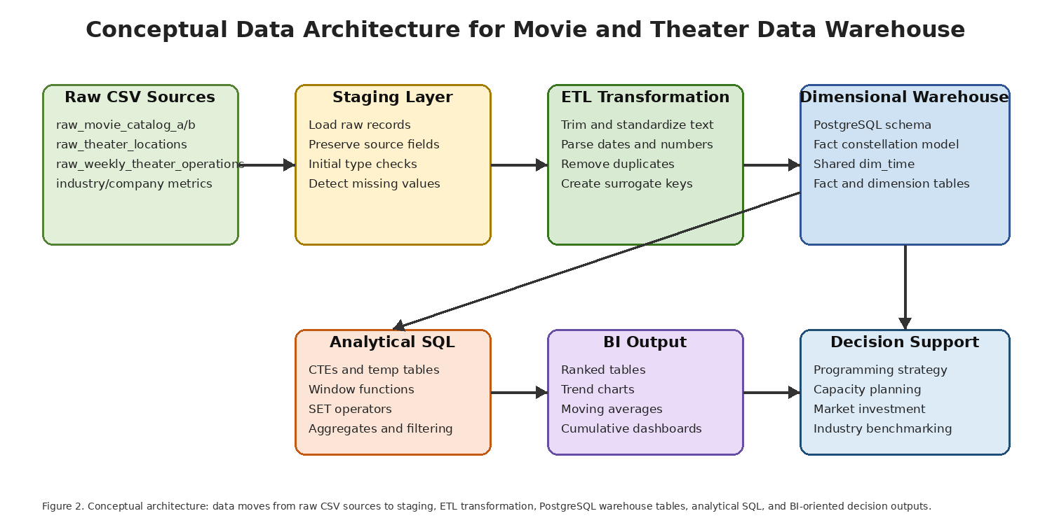
Figure 2. Conceptual data architecture for ETL, warehouse implementation, analytical SQL, and BI output.

III. Data Processing
The ETL process was designed to move data from raw CSV files into a dimensional warehouse that supports OLAP-style queries. The process uses staging, transformation, dimension loading, fact loading, and validation. This order is important because fact tables depend on surrogate keys from the dimension tables.
ETL Phase | Activities Performed | Reason / Benefit
Extract | Loaded raw movie catalog, theater location, weekly operation, market, and company metric data into staging structures. | Preserves the original records and provides a controlled area for cleaning.
Clean and standardize | Trimmed text values, standardized city and market labels, parsed date fields, converted numeric measures, and handled blank or missing values. | Improves consistency for joins, grouping, filtering, and window analysis.
Create dimensions | Created dim_time, dim_movie, dim_market, dim_theater, and dim_company using surrogate keys and descriptive attributes. | Provides stable descriptive context and avoids repeatedly cleaning raw text fields.
Load facts | Loaded fact_movie_performance, fact_theater_operations, and fact_industry_metrics at their defined grains. | Keeps measurable business events separate from descriptive dimensions.
Validate | Checked row counts, key relationships, duplicate records, non-null measures, and whether analytical queries returned usable results. | Improves reliability and ensures the warehouse can support decision-oriented queries.

During testing, some original query filters were too restrictive and returned no rows. Those queries were revised to better match the actual warehouse grain and available data. For example, city-level attendance trends were used instead of theater-level trends when individual theaters did not contain enough repeated time records. The revised queries still meet the window-function requirements while producing outputs that are easier to interpret.

IV. Queries, Visualizations, and Telling a Data Story
The integrated SQL file contains ten complex analytical queries. Jihan Yang wrote five queries and Raymond Xu wrote five queries. Each query includes comments explaining its purpose, interpretation, and managerial or policy implication. The query outputs are intended for visualizations such as ranked bar charts, trend lines, moving-average line charts, cumulative revenue charts, and performance benchmark tables.
Query | Title | Main SQL Technique | Suggested Visualization | Decision Insight
1 | Top movie performers by market-year | Ranks movies by annual market revenue using DENSE_RANK. | Ranking bar chart by market and year. | Shows whether revenue depends on a few blockbuster titles.
2 | Year-over-year market growth | Uses LAG to calculate revenue and ticket growth over time. | Market trend line or growth-rate table. | Distinguishes audience growth from price-driven revenue growth.
3 | City-level moving average | Calculates three-month moving averages for attendance and revenue. | Moving-average line chart by city. | Identifies stable increases or declines in local theater demand.
4 | Theater running totals | Calculates cumulative yearly revenue and attendance by theater. | Cumulative line chart by theater. | Shows which theaters contribute quickly or slowly to annual outcomes.
5 | Combined area demand signal | Uses a temporary table and UNION ALL to combine movie-market and theater-operation revenue. | Ranked area demand table or map. | Identifies priority markets/cities for programming and investment.
6 | Company financial ranking | Ranks companies by revenue and profit margin within sector and year. | Sector ranking table. | Benchmarks company financial capacity for future investment.
7 | Next-Period City Attendance Growth Using LEAD | Uses LEAD to compare current and next-week attendance/capacity. | Capacity-risk watchlist. | Supports proactive staffing, scheduling, and programming decisions in cities where demand is increasing.
8 | Company moving averages | Calculates four-period moving averages for revenue and profit. | Company financial trend chart. | Separates longer-term financial direction from one-period volatility.
9 | Running market share | Calculates cumulative annual box-office share by market. | Pareto-style cumulative share chart. | Reveals whether revenue is geographically concentrated.
10 | Balanced High-Performing Theaters Using INTERSECT and EXCEPT | Uses INTERSECT and EXCEPT to find high-revenue, high-attendance theaters while excluding low utilization. | Benchmark theater table. | Identifies reliable top performers for operational benchmarking.
11 | Hybrid search for relevant movie demand | Full-text search + ts_rank_cd + revenue rank | Hybrid relevance/revenue table | Combines semantic relevance with market demand.
12 | Hybrid search trend analysis | Full-text search + LAG + growth rank | Thematic growth trend table | Shows whether relevant movie themes gain or lose demand over time.

Query 1: Top movie performers by market-year
Purpose: Ranks movies by annual market revenue using DENSE_RANK.
Interpretation and implication: Shows whether revenue depends on a few blockbuster titles.
Visualization suggestion: Ranking bar chart by market and year.

Query 2: Year-over-year market growth
Purpose: Uses LAG to calculate revenue and ticket growth over time.
Interpretation and implication: Distinguishes audience growth from price-driven revenue growth.
Visualization suggestion: Market trend line or growth-rate table.

Query 3: City-level moving average
Purpose: Calculates three-month moving averages for attendance and revenue.
Interpretation and implication: Identifies stable increases or declines in local theater demand.
Visualization suggestion: Moving-average line chart by city.

Query 4: Theater running totals
Purpose: Calculates cumulative yearly revenue and attendance by theater.
Interpretation and implication: Shows which theaters contribute quickly or slowly to annual outcomes.
Visualization suggestion: Cumulative line chart by theater.

Query 5: Combined area demand signal
Purpose: Uses a temporary table and UNION ALL to combine movie-market and theater-operation revenue.
Interpretation and implication: Identifies priority markets/cities for programming and investment.
Visualization suggestion: Ranked area demand table or map.

Query 6: Company financial ranking
Purpose: Ranks companies by revenue and profit margin within sector and year.
Interpretation and implication: Benchmarks company financial capacity for future investment.
Visualization suggestion: Attendance growth watchlist.

Query 7: Next-Period City Attendance Growth Using LEAD
Purpose: Uses LEAD to compare current and next-period city-level theater attendance and identify cities with increasing attendance.
Interpretation and implication: Supports proactive staffing, scheduling, and facility planning.
Visualization suggestion: Capacity-risk watchlist.

Query 8: Company Four-Period Moving Average
Purpose: Calculates a four-period moving average for company revenue and profit based on the available time records.
Interpretation and implication: Separates long-term direction from one-period volatility.
Visualization suggestion: Company financial trend chart.

Query 9: Running market share
Purpose: Calculates cumulative annual box-office share by market.
Interpretation and implication: Reveals whether revenue is geographically concentrated.
Visualization suggestion: Pareto-style cumulative share chart.

Query 10: Balanced High-Performing Theaters Using INTERSECT and EXCEPT
Purpose: Uses INTERSECT and EXCEPT to find theaters that are above average in both revenue and attendance while excluding invalid or incomplete records.
Interpretation and implication: Identifies reliable top performers for operational benchmarking.
Visualization suggestion: Benchmark theater table.

Query 11: Hybrid search for relevant movie demand
Purpose: Full-text search + ts_rank_cd + revenue rank.
Interpretation and implication: Combines semantic relevance with market demand.
Visualization suggestion: Hybrid relevance/revenue table

Query 12: Hybrid search trend analysis
Purpose: Full-text search + LAG + growth rank.
Interpretation and implication: Shows whether relevant movie themes gain or lose demand over time.
Visualization suggestion: Thematic growth trend table

V. Conclusion
This deliverable demonstrates how the movie and theater data warehouse can support decision making beyond simple reporting. Ranking functions identify top performers, value functions reveal changes over time, moving averages clarify trends, running totals show cumulative contribution, and SET operators help define more precise decision groups. Together, the queries support managerial decisions about programming, investment, capacity planning, market strategy, and industry benchmarking.

References
Akarn, M. (n.d.). Broadway Datasets
Kaggle. https://www.kaggle.com/datasets/maggieakarn/broadway-datasets
PostgreSQL Global Development Group. (2025). PostgreSQL documentation: Window functions. https://www.postgresql.org/docs/current/functions-window.html
PostgreSQL Global Development Group. (2025). PostgreSQL documentation: Queries with common table expressions. https://www.postgresql.org/docs/current/queries-with.html
PostgreSQL Global Development Group. (2025). PostgreSQL documentation: Combining queries. https://www.postgresql.org/docs/current/queries-union.html

