Kingdom of Saudi Arabia
Academic / Cooperative Training Project Report
Malaeb Hail Platform
Booking and Management of Municipal Sports Facilities
Smart City Initiatives – Hail Region Municipality
Initial Access via Tawakkalna My Services
Shahad Fahad Al-Shammari
https://amanathail.gov.sa/new_portal/

Abstract
This report presents the Malaeb Hail platform for booking municipal sports facilities in Hail City. The system provides an interactive map with location pins, a reservation schedule, and an employee dashboard. As an initial stage, user access is simulated through Tawakkalna My Services for Hail Region Municipality, preparing for full official integration later.
Keywords
Smart City; Hail Municipality; Tawakkalna; My Services; sports booking; Flask; SQLite; Google Maps.
1. Introduction
The platform supports municipal digital transformation by offering electronic booking of sports facilities and routing beneficiaries through Tawakkalna My Services as the initial entrance to the Hail Municipality service.
2. Project Objectives
- Enable electronic booking by park, date, and time.
- Show park location on the map with a pin.
- Provide an employee dashboard for bookings and park management.
- Offer initial login through Tawakkalna My Services for Hail Municipality.
3. Tawakkalna Access Path
In the current prototype, login follows this path: Tawakkalna → My Services → Hail Region Municipality → Malaeb Hail. This demonstrates that the service belongs to digital municipal channels, and can later be replaced by full SSO.
4. Use Cases
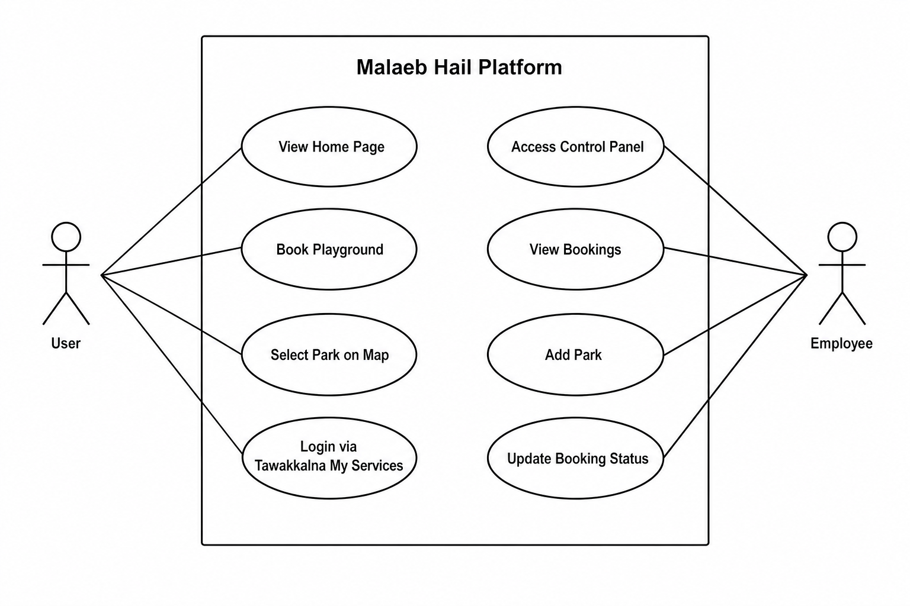
Figure 1. Use Case Diagram of Malaeb Hail Platform
ID | Use Case | Actor
UC01 | View Home Page | User
UC02 | Book Playground | User
UC03 | Select Park on Map | User
UC04 | Login via Tawakkalna My Services | User
UC05 | Access Control Panel | Employee
UC06 | View Bookings | Employee
UC07 | Add Park | Employee
UC08 | Update Booking Status | Employee

5. Booking Flow and Map
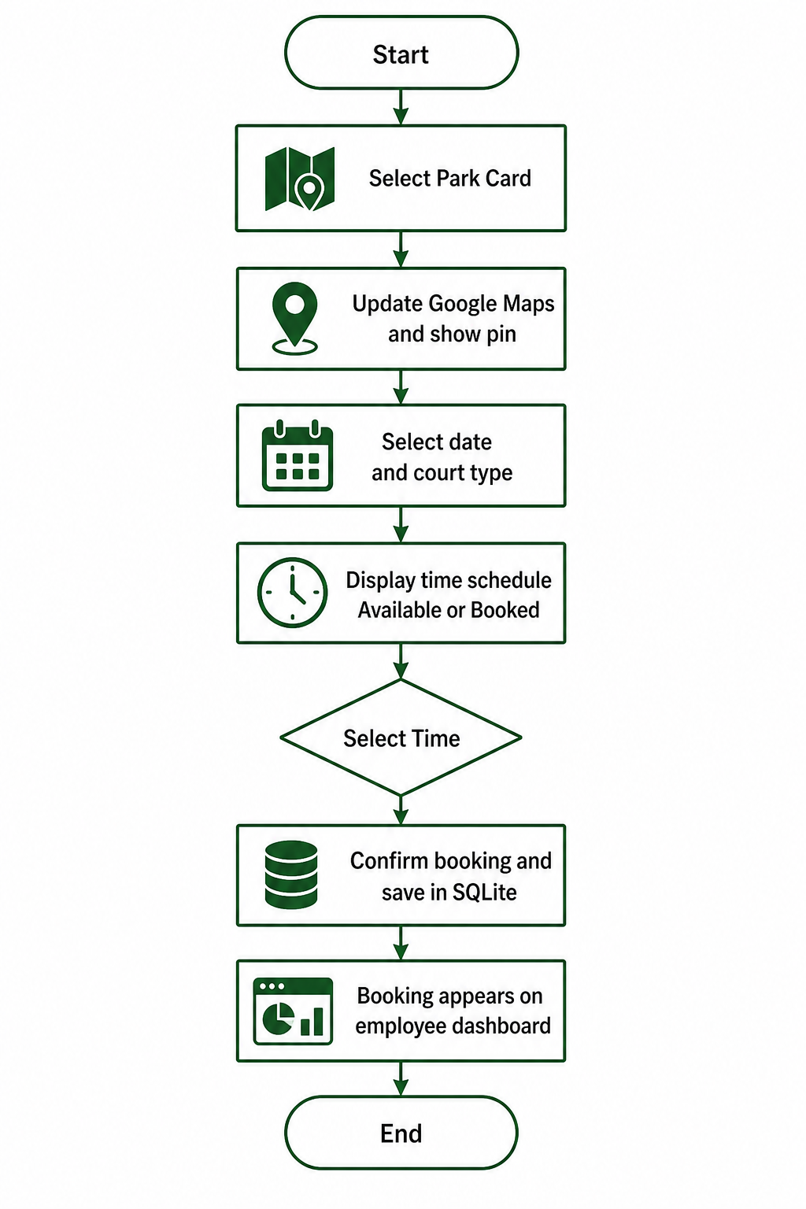
Figure 2. Booking Flow Diagram
The process starts by selecting a park card, updating Google Maps and showing the pin, choosing date and court type, displaying available/booked times, selecting a slot, confirming and saving the booking in SQLite, then showing it on the employee dashboard.
6. System Architecture
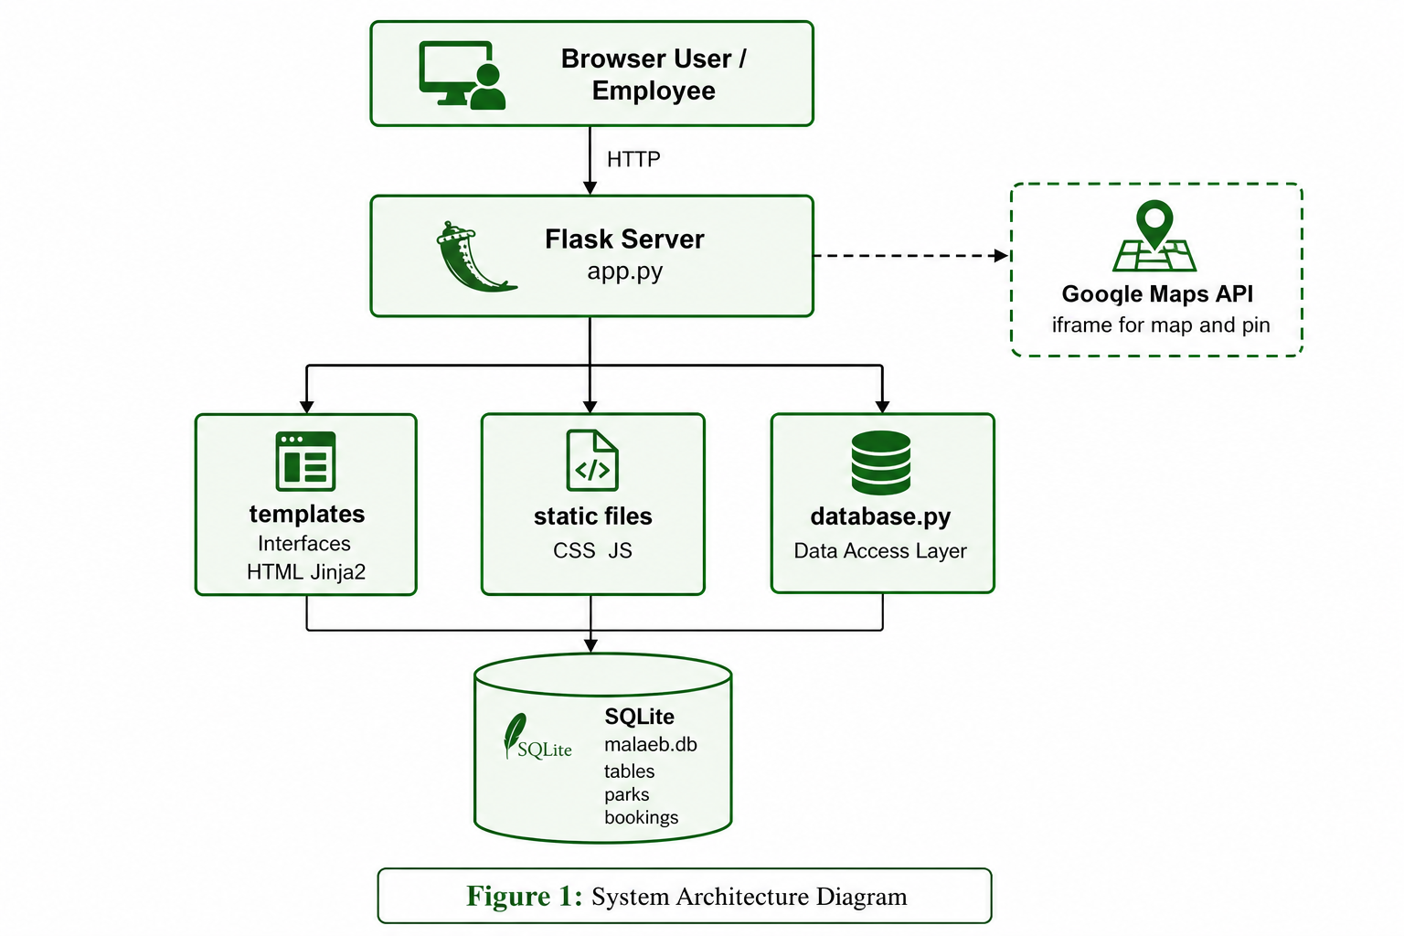
Figure 3. System Architecture Diagram
Component | Role
Flask (app.py) | Server and routes
templates / static | Interfaces and interaction
database.py + SQLite | Parks and bookings storage
Google Maps | Map and location pin
Tawakkalna My Services | Initial access gateway

7. System Interfaces
- Home: platform introduction and Smart City section.
- Booking: park cards, map/pin, schedule, confirmation.
- Login: Tawakkalna My Services gateway (prototype).
- Employee dashboard: bookings and add-park operations.
8. Conclusion
Malaeb Hail provides a practical booking model with map support and staff operations, while starting user access from Tawakkalna My Services as a foundation for official integration.
References
- Hail Region Municipality: https://amanathail.gov.sa/new_portal/
- Flask Documentation
- SQLite Documentation

