Malaeb Hail Platform
Academic Section: Technologies, System Diagrams, and Use Cases

1. Technologies Used
This section presents the technologies adopted in the Malaeb Hail platform, classified by development domain.
1.1 Web Development
- Python – backend programming language
- Flask – lightweight web framework
- HTML5, Jinja2, JavaScript – interfaces and interaction
1.2 Database
- SQLite (malaeb.db) with parks and bookings tables
- Python sqlite3 module for data access
1.3 UI Design
- CSS3, RTL layout, Cairo font
- Green palette inspired by Hail Municipality branding
- Google Maps embed for location pin
1.4 Version Control
- Git for source code tracking
1.5 Local Server
- Flask Development Server at http://127.0.0.1:5000
Category | Technology | Role
Web Development | Python + Flask | Server and routes
Database | SQLite | Store parks and bookings
UI Design | CSS3 + RTL + Maps | Arabic interface and map
Version Control | Git | Version tracking
Local Server | Flask Server | Local runtime

2. Use Cases
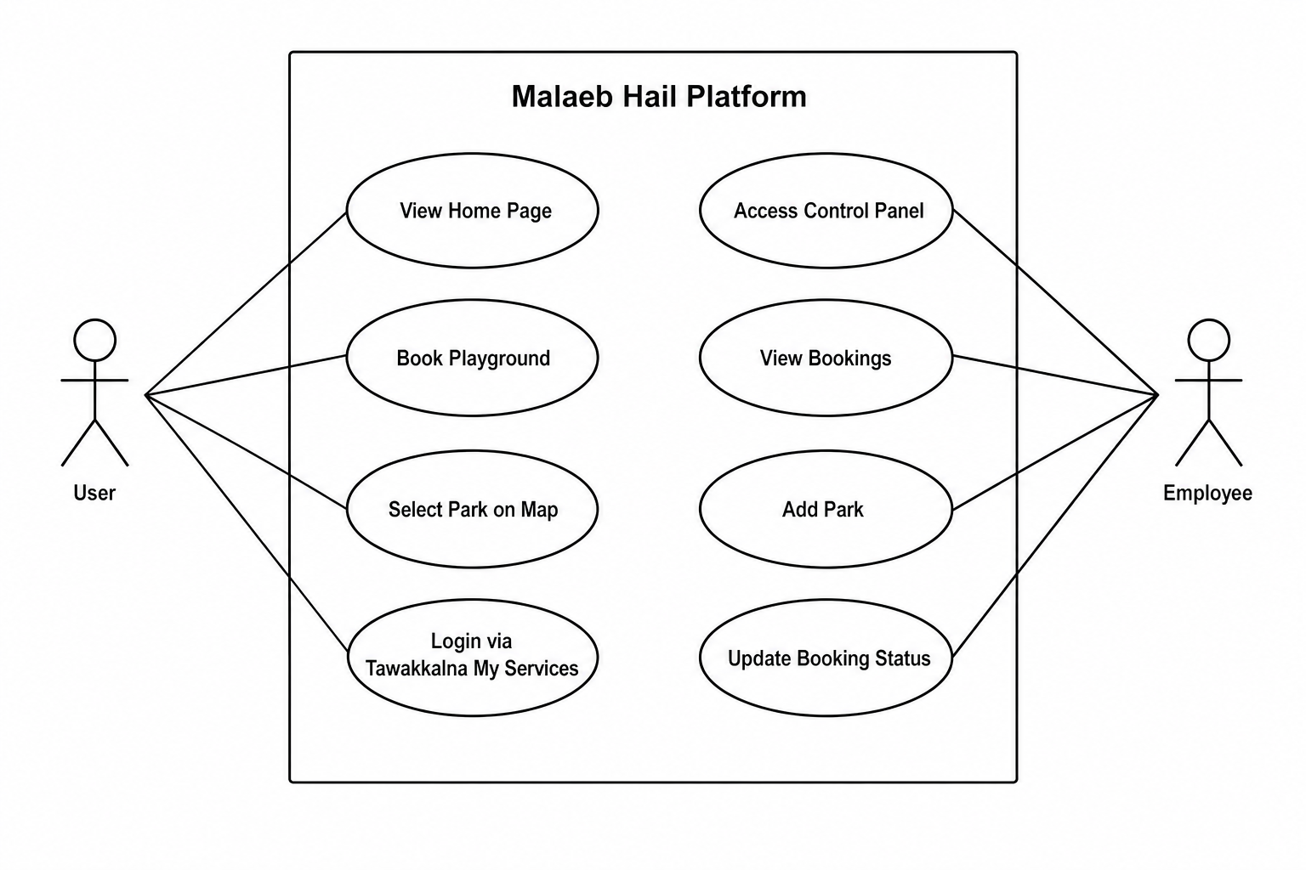
Figure 1. Use Case Diagram
ID | Use Case | Actor
UC01 | View Home Page | User
UC02 | Book Playground | User
UC03 | Select Park on Map | User
UC04 | Login via Tawakkalna | User
UC05 | Access Dashboard | Employee
UC06 | View Bookings | Employee
UC07 | Add Park | Employee
UC08 | Update Booking Status | Employee

3. System Architecture
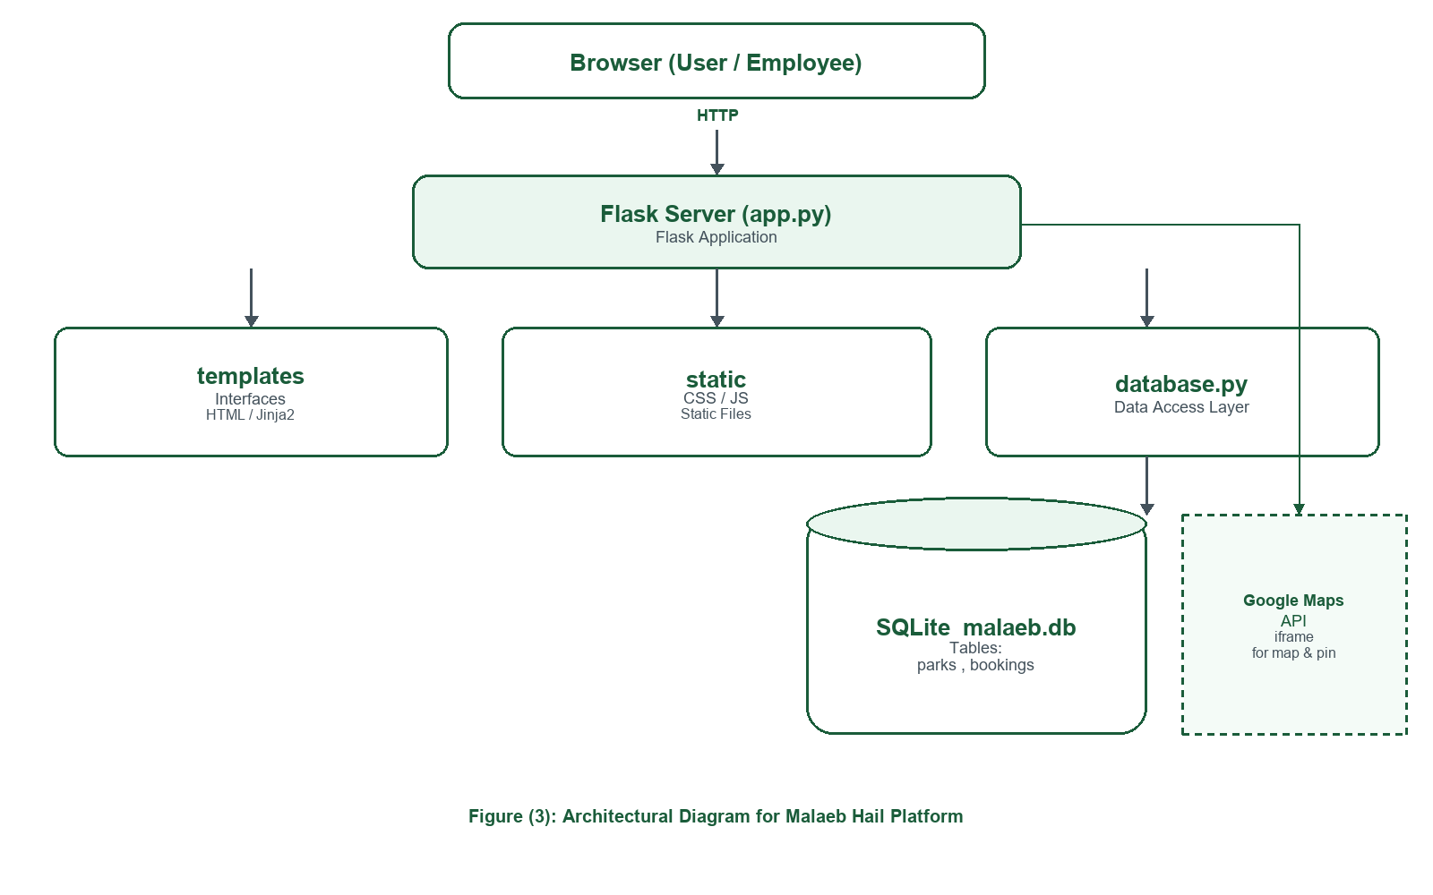
Figure 2. System Architecture Diagram
The platform follows a Client–Server model: Browser → HTTP → Flask → templates/static/database.py → SQLite + Google Maps.

4. Booking Flow
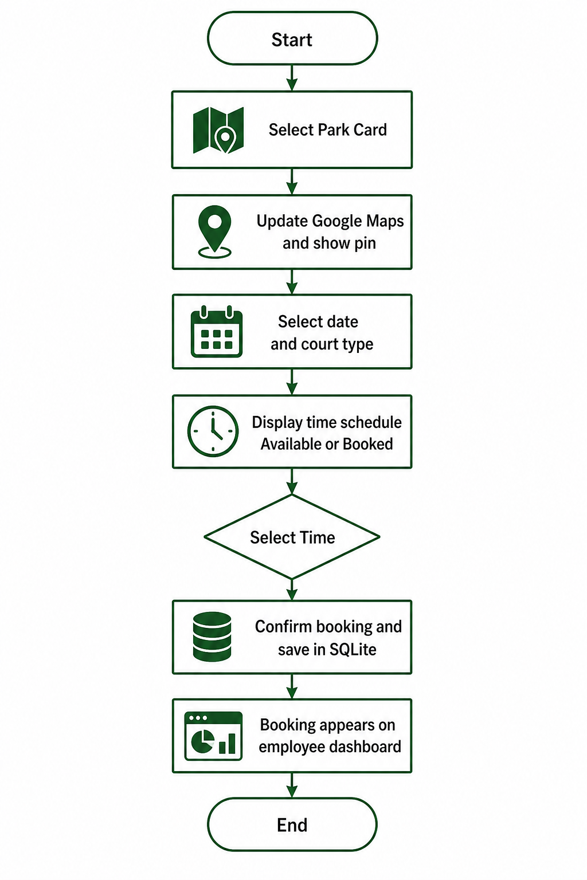
Figure 3. Booking Flow Diagram
The flow covers park selection, map update, schedule selection, booking confirmation, and employee dashboard visibility.
5. Conclusion
The selected technologies and diagrams demonstrate a structured academic design suitable for Smart City municipal sports booking.

