**MB Recruit - Recruitment Website**

Welcome to the MB Recruit website read.me, this website was created for milestone project 1 (Web Development Diploma with Code Institute) and it showcases a , website for a recruitment company. The website features four sections:

**Header** - The header has a logo, links to different parts to the website and an email button which enables user to directly email the company.

**Home** - Includes a hero image with an overlay on top, and a download button to download latest Salary Guide information for the intended user. Also a brief introduction to MB Recruit and what the company is about.

**Services** - Showcases all the services provided. The cards have text on them which aims to give end user an insight into the divisions of recruitment the website covers.

**Team** - Here you will find cards to showcase each member of the team with their social links at the bottom of the page. These link to individuals socials.

**Contact** - This part of the website allows end user to input their details and submit a query of their liking. The form includes text boxes to input name, email, business name and nature of query.

**User** **Experience (UX)**

**Project Goal**

The website is the online representation of the company MB Recruit which aims to provide its users information about the company, its services and specialisms within the recruitment market. The sites pages aims to pop and hook the client to download useful information about the market, read about services, meet the team and get in touch for further information regarding recruiting for their businesses.

The website aims to provide a chance for the client to email the company, visit social links to their team members and submit a query to which they will get a response.

**User stories**

**First Time Visitor Goals:**

I want to find out more about the company and what it offers

I want to find the location of the business.

I want to see what the business offers and if it is somewhere where I see myself using the services. I should be able to use the sticky navigation bar to easily access different parts of the website.

**Returning Customer Goals:**

As a returning customer, I want to view new information about the market through various download articles.

As a returning Customer, I want to be able to see any changes to the menu. I want to email and send an enquiry using a simple and efficient submission process.

I want to be able to find the contact information and location of the business easily.

**Frequent Customer Goals:**

I want to view the upcoming trends and new information about the market.

I want to see the changes to the menu.

I want to submit a query about the market and how to use the services.

**Design**

**Colour Scheme**

The main colours of the website are dark and light contrasting colour that give a corporate look to the website.

Dark blue, purple and charcoal in some of the content, elements and buttons to add a vibrant feel to the website as well as contrast.

I used Colour Mind to decide which colours would look well together.

**Typography**

The Sora font is the main font used throughout the whole website with Sans Serif as the fallback font.

I think that this font contrasts well with the headings as it displays authority and reliability.

This font adds a corporate/ trustable feel to the website and it is very bold meaning that it stands out, I think that this is good for headings and paragraphs.

**Wireframes and Structure**

I used mydraft.cc to create my wireframes. These were a rough idea of what I wanted to achieve.

As shown below, the home page was designed first then, followed by services, team and contact pages.

I designed the footer last and decided to use a sticky navigation bar to ensure ease of use.

**Desktop Wireframes**

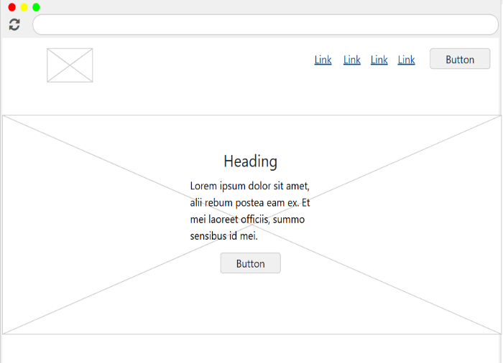

**Mobile Wireframes**

**Tablet Wireframes**

**Features**

**Header:**

In the Header I have placed an Email button so that the user can click to open their email app and directly contact company's mail email address.

I used a sticky navigation to ensure at any time the user can navigate to whichever section they want to. I applied a box shadow effect under the navigation bar to ensure it stood out when scrolling down the page and for better ease of visibility.

I used links which change colour when hovered over to let user know which link they are about to chose.

I have linked the logo back to home page as well for ease of use.

**Footer**:

I used links that take the user to where they want to go to in the page. I also included social links which change colour when hovered over them for better visibility. In the footer I included brand logo for continuity.

**Home Page:**

I used a hero image for the background which stays static as user scrolls down. I used an overlay on the hero image to give it a filtered effect and to help txt stand out. I included a download button where user can click to obtain a document with relevant information about the salaries across industries.

**Services Page:**

Here I used card like effect so that the information stands out as user scrolls past to create intrigue. The cards shift down vertically and change colour when hovered over them.

**Team Page:**

Here I used card effect to help the team members to stand out. This was achieved through using a box shadow effect. When user hovers over the relevant team member the card loses its effect and helps user to know which team member they are hovering over. I included social links which change colour when hovering over them to help them stand out.

**Contact Page:**

In the contact page I used a form which prompts user to enter information into the relevant sections and two buttons, one to submit the query and one to reset the form. The buttons change colour when hovered over.

**Technologies**

Languages - HTML5, CSS3

**Frameworks and Libraries –**

Bootstrap v.5.2.3 - Bootstrap was used to make sections of the website responsive by using the bootstrap grid system. Bootstrap was also used for styling some of the sections of the website such as the nav.

mydraft.cc - mydraft.cc was used to create the wireframes for the different device sizes.

readme.so - readme.so was used for the responsive image in the Readme.

Google Fonts - The following fonts were imported from google fonts: Sora

Font Awesome - Font Awesome was used to import icons used throughout the website.

Github - Github was used to store the project.

Git - Git was used for version control by utilizing the Gitpod terminal to commit to Git and Push to GitHub.

**Testing**

| **First Time Visitor Goals** | **Solution** | **Outcome** |
| --- | --- | --- |
| I want to find out more about the recruitment. | The home page featured an easily visible introduction and a download button which enables the download of a document which talks about the recruitment market. | Passed |
| I want to see the location of the business | The location of the business is easily visible in the footer where there full address is shown. | Passed |
| I want to see what services are on offer to my business recruitment-wise. | The services are listed in the services section with descriptions of each service in detail | Passed |
| I want to make an enquiry regarding the services | There is a contact page where the client can submit their queries.  There is an email button on the navigation bar which directly emails the business | Passed |

|  |  |  |
| --- | --- | --- |
| **Returning/ Frequent Visitor Goals** | **Solution** | **Outcome** |
| I want to view the individual consultants/team members | The User can view the team members on the Teams page where they can contact them using social media links. | Passed |
| I want to be able to see any changes to the market | The main page features a download button with the latest market surveys | Passed |
| I want to submitting a query straightforward for returning customers | The contact form is easily accessible and allows user to submit a query | Passed |
| I want to be able to find the contact information and location of the business easily. | All contact information is included in the footer making it very easily accessible. | Passed |

**Summary**

Overall, the website is easy to navigate as it has a simple navigation at the top of every page along with a footer which provides important information. The interactive elements keep to users engaged and they also make it easier to access information. The buttons encourage the user to stay engaged and view the menu. The contact form has been placed in accordance to encourage users to get in touch with a query.

**Links and Functions**

| **Page** | **Testing** | **Outcome** |
| --- | --- | --- |
| All | Navigation links go to the correct page | Passed |
| All | Header links back to the home page | Passed |
| All | Social Media links to relevant platforms | Passed |
| All | All content is responsive | Passed |
| Get In Touch | Contact form works as intended- Required fields | Passed |
| Services | The Services button takes you to the services section | Passed |
| Home | This button takes you to the menu | Passed |
| Submit | This button should take you to the thank you message page | Passed |

**Deployment**

* Log into GitHub account
* Head to the project repository
* Click on the "settings" tab near the top right of the page
* Then to "pages" on the setting menu-left hand side
* Source select "deploy from a branch"
* Branch select "main" & "root"
* Hit save
* After a couple of minutes the site is now live.

**Browser Testing**

The website has been tested on Chrome, Mozilla, Edge & Safari (mobile.) The responsiveness has been tested using the screen device size on devtools. I have also made sure that all links and images are visible and working as they should be.

**Devices:**

* The website was tested on a mobile phone (iPhone), a laptop and a large desktop monitor.
* Please note that the website has also been tested by family and friends who have reported no problems.

**Google Dev Tools & Lighthouse**

* [Google DevTools](https://developer.chrome.com/docs/devtools/) and Lighthouse have been used for testing and amending the project.

**Page Performance**

**Home Page Performance**

**Services Page Performance**

**Team Page Performance**

**Contact page Performance**

The Value solid was removed from border radius after spotting this error. The changes were seen as this was a dormant piece of code.

Here the form element was in the wrong place which caused the error as well as displaced div tags.

**Credits**

**Code**

General coding advice W3School

Font Awesome for icons

Code institute "love running" project, I used the Font Awesome code to create my own in my website.

**Acknowledgments**

I want to say a big thank you to my mentors **Chris Quinn, Julia Konovalova** and course m for all your help and great ideas. Also, thank you to my tutor **Miguel Ortega Legorreta** for all your support and help throughout the project.