

INFO-I590: DATA VISUALIZATION (TOPICS IN INFORMATICS)

Authors:
- Monesh Rallapalli
- Anish Sudarshan Gada
- Krishna Koushik Thokala
- Sreeram Tirumala
- Anirudh Sukumaran

THE COFFEE TRADE MARKET DYNAMICS: 1990-2019

INTRODUCTION
This technical report presents a detailed analysis of global coffee market dynamics from 1990 to 2019, based on an interactive visualization dashboard developed to explore production, consumption, import, export, and trade flow data. The analysis reveals critical insights into market concentration, geographical shifts, temporal trends, and trade relationships that have characterized the global coffee industry over this 30-year period. The interactive nature of our visualization tools enables stakeholders to explore complex relationships between different market elements, identify emerging patterns, and gain actionable insights for decision-making in the coffee sector.

PROBLEM STATEMENT
The global coffee industry faces a significant data fragmentation challenge that hinders comprehensive market understanding. Despite being a $200+ billion sector with millions of livelihoods at stake, stakeholders across the value chain encounter several critical problems:
- Data Isolation: Coffee market data exists in isolated datasets (production, consumption, imports, exports, trade flows) that are rarely analyzed together, preventing holistic market understanding.
- Temporal Discontinuity: Historical trends are difficult to analyze due to inconsistent time-series representations and lack of temporal analytical tools.
- Geographic Complexity: The global nature of coffee production and consumption creates intricate trade relationships that are hard to visualize and understand with conventional tools.
- Limited Interactive Analysis: Most existing coffee market resources provide static reports or basic visualizations that don’t allow stakeholders to explore relationships between different market dimensions.
These limitations leave key questions unanswered: How do production shifts in major growing regions impact global availability? What vulnerabilities exist in the supply chain? How do consumption patterns influence trade flows? Without addressing these issues, stakeholders lack the comprehensive insights needed for effective decision-making.

SOLUTION APPROACH
Our solution addresses these challenges through a multi-faceted approach:

- Data Integration Framework: We developed a unified data model that integrates five core datasets (production, consumption, imports, exports, and trade flows) into a coherent analytical environment, enabling cross-dimensional analysis.
- Interactive Visualization Dashboard: We created a comprehensive dashboard with tailored visualization techniques for each data type - treemaps for market concentration, time-series charts for temporal patterns, radial charts for proportional analysis, and Sankey diagrams for trade relationships.
- Temporal Analysis System: We implemented consistent year-based filtering across all visualizations, allowing users to track changes over the 30-year period and identify both long-term trends and short-term fluctuations.
- User-Centered Exploration Tools: The dashboard incorporates intuitive filtering mechanisms that allow users to focus on specific time periods, countries, or trade relationships of interest.
Through this approach, we transform fragmented coffee data into an integrated analytical platform that reveals patterns, dependencies, and insights that would remain hidden in isolated analyses. The resulting visualization dashboard serves as both an analytical tool and a decision support system for stakeholders throughout the coffee value chain.

1. INTRODUCTION

1.1 Motivation
Coffee represents one of the world’s most valuable agricultural commodities, serving as a critical economic driver for numerous producing countries while simultaneously playing an important cultural role in consuming nations [1]. The global coffee industry is valued at over $200 billion annually, with more than 25 million farming families depending on coffee production for their livelihoods [3]. Despite its global significance, comprehensive analysis of coffee market dynamics across production, consumption, and trade remains challenging due to the complex interrelationships between these factors. This report and its accompanying visualization dashboard address this challenge by providing an integrated analytical framework that enables exploration of coffee market data across multiple dimensions.
The primary motivations for this analytical effort include:
- Data Integration Challenge: Coffee market data typically exists in isolated datasets, making holistic analysis difficult [3]. Our dashboard integrates five key datasets (production, consumption, import, export, and trade flows) into a unified analytical environment.
- Temporal Analysis Need: Understanding long-term market trends requires analysis of extended time series data [4]. Our 30-year analysis window (1990-2019) captures critical market evolutions including the emergence of new major producers and shifting consumption patterns.
- Geographic Complexity: Coffee production and consumption have distinct geographic patterns with complex trade relationships between them [6]. Visualizing these patterns helps identify key market relationships and dependencies.
- Decision Support Requirement: Stakeholders across the coffee value chain require data-driven insights to inform strategic decisions [9]. Our interactive visualization approach enables exploration tailored to specific analytical needs.
The coffee industry’s global nature, with production concentrated in equatorial regions of Latin America, Africa, and Asia, while consumption occurs worldwide with particular concentration in North America, Europe, and increasingly Asia, creates a complex web of trade relationships that merit careful analysis. Our approach emphasizes making these relationships accessible through interactive visualization techniques.

1.2 Existing Work
The analysis and visualization of coffee market data builds upon a foundation of existing work in agricultural commodity visualization and trade flow analysis. While numerous reports and dashboards address specific elements of the coffee market, comprehensive visualization frameworks that integrate multiple data dimensions remain limited.
Previous approaches to coffee market visualization have typically focused on specific aspects such as:
- Production volumes by country and region
- Price trends across major coffee exchanges
- Consumption patterns in key markets
- Trade volumes between specific country pairs
Notable existing work in the field includes:
- The International Coffee Organization’s statistical database and reports, which provide authoritative data but limited interactive exploration capabilities [1]
- Country-specific coffee sector analyses by national coffee associations and trade groups
- Commodity market dashboards focusing on price dynamics rather than comprehensive market analysis
- Trade flow visualizations that include coffee among other agricultural commodities
Bacon [8] pioneered analysis of coffee production vulnerabilities, while Ponte [6] established frameworks for understanding global coffee value chains. However, as noted by Giovannucci and Koekoek [5], “a significant gap exists in the integration of multiple coffee market dimensions into cohesive analytical frameworks accessible to stakeholders across the value chain.”
Our approach extends beyond these existing works by:
- Integrating multiple data dimensions into a unified analytical framework
- Emphasizing interactive exploration rather than static reporting
- Incorporating 30 years of historical data to reveal long-term patterns
- Developing a coffee-specific visual design system that enhances data communication
- Enabling multi-faceted analysis through complementary visualization techniques
By building upon these existing approaches while addressing their limitations, our visualization dashboard represents an advancement in coffee market analysis techniques.

1.3 Contribution
This technical report and the accompanying visualization dashboard make several significant contributions to the understanding of global coffee market dynamics:
- Integrated Analytical Framework: We present the first comprehensive visualization system that integrates production, consumption, import, export, and trade flow data within a unified analytical environment, enabling exploration of relationships between these different market dimensions.
- Temporal Analysis System: Our implementation of a consistent temporal analysis framework across all visualization components allows for identification of both short-term fluctuations and long-term trends across the 30-year analysis period (1990-2019).
- Interactive Exploration Tools: The development of interactive filtering mechanisms, including a year slider and country-specific filters, enables stakeholders to focus analysis on specific time periods or geographic regions of interest.
- Multi-technique Visualization Approach: Our system employs complementary visualization techniques (treemaps, time-series charts, radial visualizations, and Sankey diagrams) to present different perspectives on the same underlying data, providing a more comprehensive understanding.
- Coffee-Specific Visual Design System: The implementation of a customized coffee-themed color palette and visualization styling enhances the interpretability and aesthetic appeal of the dashboard while maintaining analytical rigor.
- Insight Generation: Through our analysis, we reveal significant insights about market concentration, the emergence of new major producers, shifts in consumption patterns, and evolving trade relationships that have characterized the global coffee market over the past three decades.
These contributions collectively advance the field of agricultural commodity visualization and provide valuable tools for stakeholders across the coffee value chain, from producers and traders to roasters, retailers, and policy makers.

2. DATA & METHODS

2.1 Data Sources and Preparation

2.1.1 Primary Data Sources
The analysis presented in this report relies on five core datasets, each capturing a different dimension of the global coffee market:
- Production Data (Coffee_production_modified.csv): Contains country-level production volumes by coffee type (Arabica, Robusta, mixed varieties) from 1990-2019, measured in standardized units.
- Consumption Data (Coffee_domestic_consumption_modified.csv): Records domestic coffee consumption by country and coffee type over the same 30-year period, enabling analysis of internal market dynamics.
- Import Data (Coffee_import.csv): Documents coffee import volumes by country, indicating major consuming markets and their reliance on imported coffee.
- Export Data (Coffee_export.csv): Captures coffee export volumes by country, highlighting major producers’ export orientation and market reach.
- Trade Flow Data (synthetic_coffee_trade_flows.csv): Maps bilateral coffee trade relationships between specific exporting and importing countries, quantifying the strength of these trade connections.
These datasets collectively provide a comprehensive view of the global coffee market ecosystem, from production through consumption, with trade flows connecting these elements.

2.1.2 Data Preparation and Cleaning
Several data preparation and cleaning steps were implemented to ensure analytical integrity:
- Handling Invalid Values in Export Data: The export dataset contained placeholder values (-2147483648) that were replaced with NaN to prevent analytical distortion, as seen in the code:
# Clean export data - replace invalid values
export_data = export_data.replace(-2147483648, np.nan)
# Clean export data - replace invalid values
export_data = export_data.replace(-2147483648, np.nan)

- Column Name Standardization: A preprocessing script (modify_column_names.py) was used to standardize column names across datasets, particularly for year columns that originally had format “YYYY/YY” (e.g., “1990/91”):
# Create a mapping for the columns that need to be modified
column_mapping = {}
for col in columns:
# Check if the column name has the pattern YYYY/YY
if '/' in col and col[0:4].isdigit():
# Extract only the first year (e.g., 1990 from 1990/91)
first_year = col.split('/')[0]
column_mapping[col] = first_year

- Coffee Type Classification: Data was categorized into three primary coffee groups (Arabica, Robusta, and mixed Arabica/Robusta) to enable type-specific analysis:
if 'Arabica' in coffee_type and 'Robusta' not in coffee_type:
type_totals['Arabica'] += value
elif 'Robusta' in coffee_type and 'Arabica' not in coffee_type:
type_totals['Robusta'] += value
elif 'Arabica' in coffee_type and 'Robusta' in coffee_type:
# Now put it in Arabica/Robusta category instead of splitting
type_totals['Arabica/Robusta'] += value

- Handling Missing Values: Null values were properly handled during data processing to prevent computational errors:
if pd.isna(value):
continue
Trade Flow Data Generation: A specialized script (balanced_trade_flow_generator.py) was created to generate realistic trade flow data that respected the export constraints from the actual export dataset:
# Strip whitespace from country names
export_df['Country'] = export_df['Country'].str.strip()
import_df['Country'] = import_df['Country'].str.strip()
# Convert to dictionaries for easier processing
export_data = {row['Country']: int(row[year_str]) for _, row in exporters.iterrows() if row[year_str] > 0}
import_data = {row['Country']: int(row[year_str]) for _, row in importers.iterrows() if row[year_str] > 0}

These data preparation steps ensured analytical robustness and established a foundation for reliable visualization and insight generation.

2.2 Visualization Methods
The dashboard employs a diverse set of complementary visualization techniques, each selected to best represent different aspects of the coffee market data:

2.2.1 Hierarchical Treemaps
Treemaps were implemented to visualize the proportional distribution of coffee production, consumption, imports, and exports by country. This technique effectively communicates the relative contribution of each country to global totals, with rectangle size proportional to coffee volume and color intensity indicating relative magnitude.
Implementation details: - Library: plotly.express.treemap - Color configuration: Custom coffee-themed color palette (COFFEE_COLORSCALE) for visual consistency - Interactive elements: Hover tooltips displaying precise values, zoom capability for exploring smaller segments - Data structuring: Hierarchical organization by country with dynamic filtering by selected year
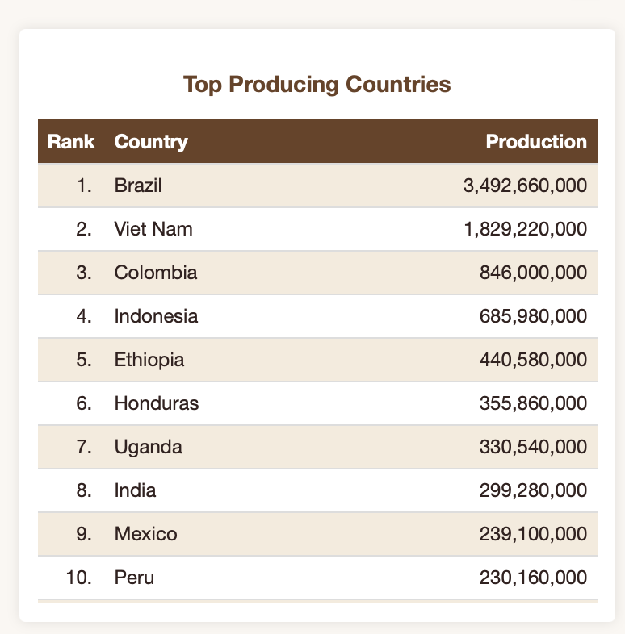
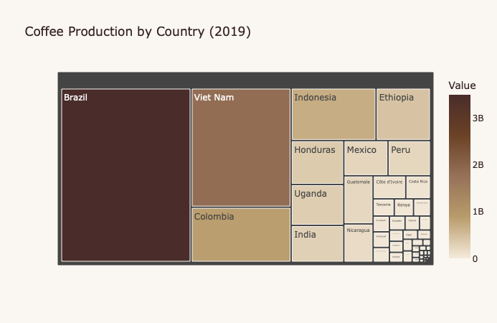
Fig. 1. Coffee Production Treemap - Shows the hierarchical visualization of coffee production by country in 2019, with Brazil occupying the largest area (approx. 35.3% of global production), followed by Vietnam (18.5%) and Colombia (8.5%).
The treemap visualization effectively communicates market concentration, immediately highlighting dominant countries while still representing smaller producers through hierarchical nesting.

2.2.2 Time-Series Analysis with Trend Lines
Time-series line charts were implemented to visualize temporal patterns in coffee production, consumption, imports, and exports from 1990 to 2019. Each visualization includes both the actual annual values and a polynomial trend line to highlight the underlying long-term direction.
Implementation details: - Library: plotly.graph_objects.Scatter for both the actual data series and trend line - Trend modeling: Polynomial curve fitting using np.polyfit and np.poly1d for trend calculation - Data processing: Annual aggregation through the get_annual_totals helper function - Visual design: Consistent color scheme with actual values in dark brown and trend line in tan
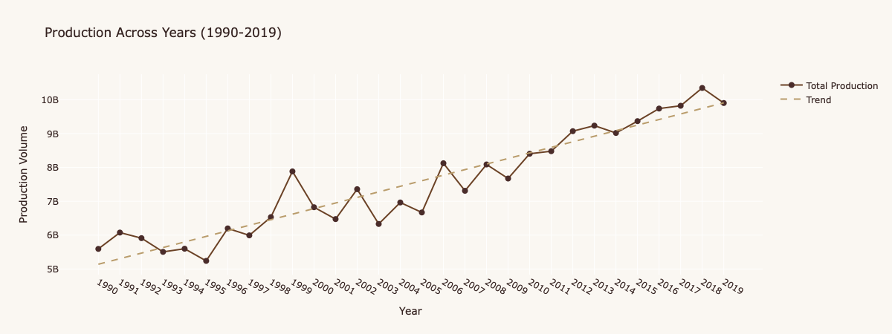
Fig. 2. Production Across Years Line Chart - Time series visualization showing the increase in global coffee production from approximately 5.5 billion units in 1990 to over 10 billion units by 2019, with notable volatility including dips in 1995, 2003, and 2009.
These time-series visualizations reveal both long-term trends and short-term fluctuations, enabling analysis of market growth, volatility patterns, and potential cyclical behavior.

2.2.3 Radial/Pie Charts for Part-to-Whole Relationships
Radial charts (donut style) were implemented to display the proportional contribution of top coffee producers, consumers, importers, and exporters, with an “Others” category aggregating countries beyond the top 10 to reduce visual clutter while maintaining analytical completeness.
Implementation details: - Library: plotly.express.pie with the hole parameter set to create a donut chart effect - Data handling: Dynamic “Others” category creation through the get_top_countries function - Color mapping: Consistent country color assignment across visualizations - Interactive elements: Hover information and click-to-filter capability
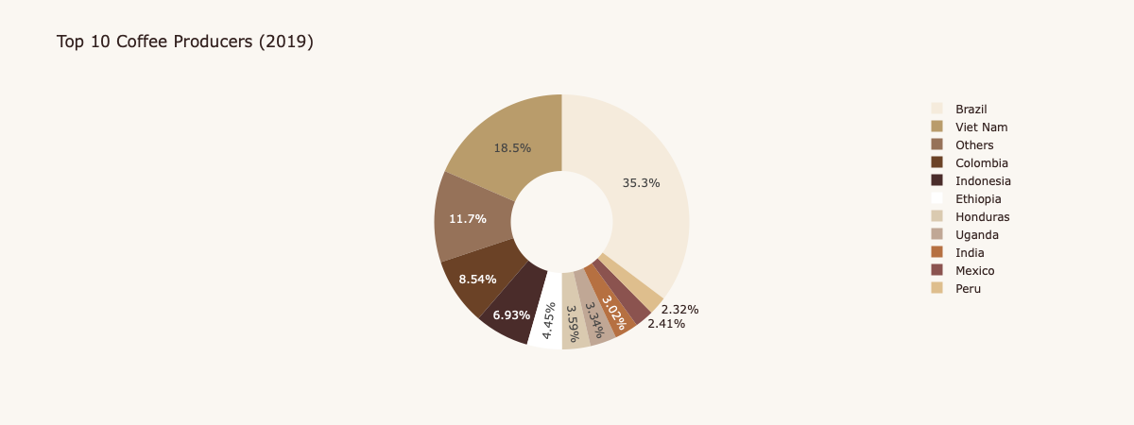
Fig. 3. Top 10 Coffee Producers Radial Chart - Shows the proportional contribution of major producing countries in 2019, with Brazil (35.3%) and Vietnam (18.5%) dominating, followed by Colombia (8.5%), Indonesia (6.9%), and other countries each representing less than 5% of global production.
The radial visualization technique provides an intuitive representation of market share distribution, effectively communicating the relative importance of major countries while maintaining visual simplicity.

2.2.4 Bar Charts for Category Comparison
Bar charts were implemented to visualize coffee production and consumption by variety type (Arabica, Robusta, and mixed Arabica/Robusta), enabling direct comparison between these categories.
Implementation details: - Library: plotly.graph_objects.Bar - Data processing: Coffee type aggregation through the get_coffee_type_totals function - Visual enhancement: Value labels with formatted numbers for direct readability - Color consistency: Matching coffee-themed color palette with logical gradient
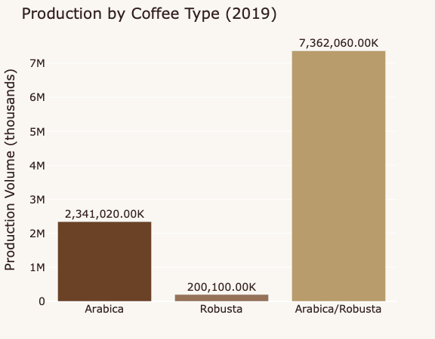 | 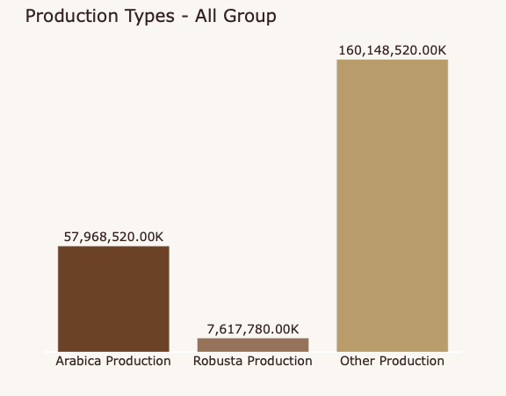
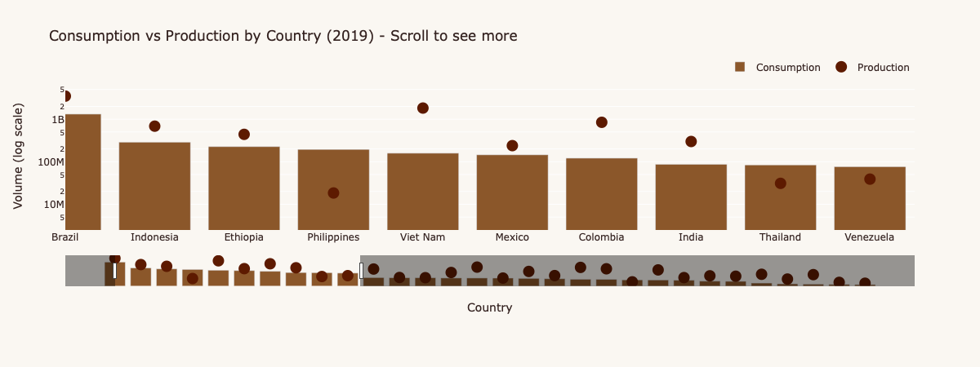
Fig. 4. Production by Coffee Type Bar Chart - Shows the breakdown of coffee production in 2019 by variety, with Arabica/Robusta mixed varieties constituting the largest volume (7.36 million units), followed by pure Arabica (2.34 million units) and pure Robusta (200,100 units) and Comaparison between consumption vs production by country with slider feature.
These bar charts enable direct comparison between coffee varieties, revealing important insights about the composition of global coffee production and consumption.

2.2.5 Sankey Diagrams for Trade Flow Visualization
A Sankey diagram was implemented to visualize the complex trade relationships between coffee-exporting and coffee-importing countries, with flow width proportional to trade volume. This technique effectively communicates both the magnitude and direction of coffee trade.
Implementation details: - Library: plotly.graph_objects.Sankey - Data source: synthetic_coffee_trade_flows.csv - Node differentiation: Exporters on the left, importers on the right with distinct color schemes - Interactive filtering: Country-specific exporter/importer dropdown selection - Flow magnitude: Link width proportional to trade volume
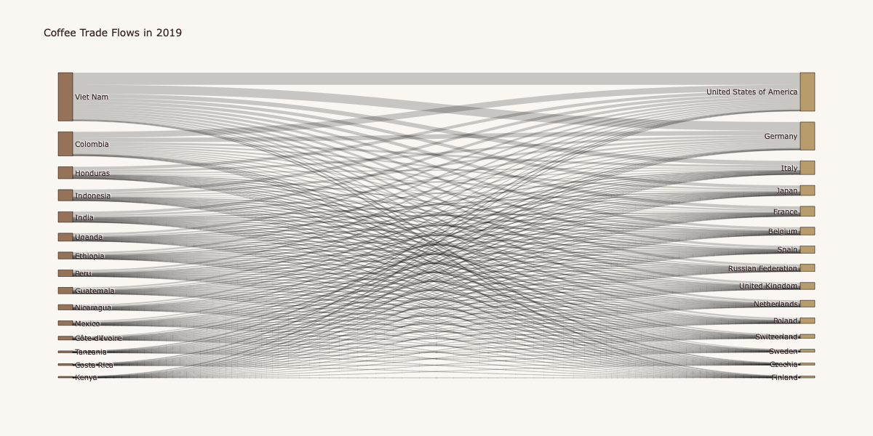
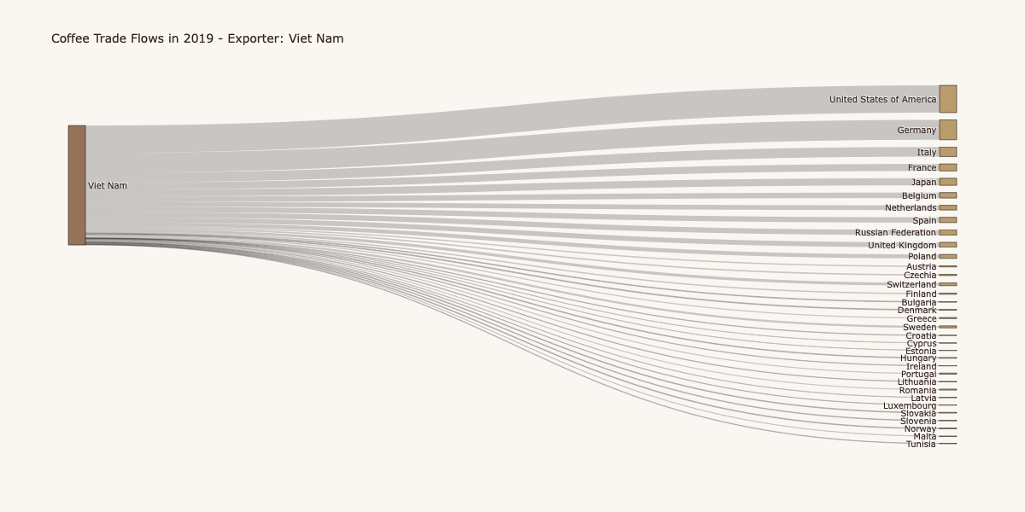
Fig. 5,6. Coffee Trade Flow Sankey Diagram - Visualization showing the flow of coffee from exporting countries (left) to importing countries (right), with prominent flows from Vietnam to the United States, Germany, and Italy, as well as significant flows from Colombia to the United States and European countries>
The Sankey diagram reveals the complex web of global coffee trade, highlighting major bilateral relationships and the overall structure of the international coffee market.

2.3 Interactive Functionality
The dashboard incorporates several interactive elements to enhance user exploration and insight generation:

2.3.1 Temporal Filtering
A year slider (1990-2019) is implemented consistently across all dashboard tabs, enabling users to visualize data for any specific year within the 30-year analysis period. This allows for examination of both static snapshots and temporal evolution.
Implementation details: - Component: dcc.Slider with marks for 5-year intervals - Range configuration: Min=1990, Max=2019, Step=1 - Visual feedback: Tooltip showing selected year - Event handling: Callback functions updating all visualizations based on year selection

2.3.2 Country-Specific Filtering
In the Trade Flow tab, dropdown selectors for both exporting and importing countries enable users to focus analysis on specific countries or regions of interest, revealing targeted trade relationships.
Implementation details: - Component: dcc.Dropdown with dynamically generated country options - Default state: All countries shown (no filtering) - Interaction model: Optional selection of exporter, importer, or both - Visual feedback: Filtered Sankey diagram and supporting tables

2.3.3 Linked Visualizations
All visualizations within each tab update synchronously based on user interactions, maintaining analytical consistency across different perspectives on the same data.
Implementation details: - Implementation: Dash callback functions linking filter states to multiple outputs - Performance optimization: Efficient data filtering to maintain responsiveness - Visual consistency: Coordinated updates across all visualization components

2.3.4 Interactive Data Exploration
Each visualization includes hover tooltips providing detailed information on specific data points, enabling precise value retrieval and detailed exploration.
Implementation details: - Hover data: Contextual information including country names, values, and percentages - Click interactions: Additional filtering or focus capabilities on selected elements - Zoom functionality: Detailed exploration of dense visualizations like treemaps
These interactive elements transform the dashboard from a static reporting tool into a dynamic exploration environment, enabling users to investigate specific questions and discover insights relevant to their particular interests.

2.4 Implementation Architecture
The dashboard is built using a modern data visualization technology stack, with component selection focused on analytical capability, interactive performance, and visual quality:

2.4.1 Core Technologies
- Dash: Web application framework for creating interactive dashboards with Python
- Plotly: Interactive visualization library providing the fundamental chart types
- Pandas: Data manipulation and analysis library for dataset processing
- NumPy: Numerical computation library supporting analytical functions
- Python: Core programming language providing the foundation for the implementation

2.4.2 Application Structure
The dashboard follows a modular architecture with clear separation of concerns:
- Data Loading and Preparation: Initial data ingestion and cleaning
- Helper Functions: Reusable analytical functions for data transformation
- Layout Definition: Dashboard structure and UI component arrangement
- Callback Functions: Interactive behavior and visualization updates
- Visualization Generation: Chart creation and configuration
# Example of modular callback structure
@app.callback(
Output('production-treemap', 'figure'),
Input('production-year-slider', 'value')
)
def update_production_treemap(selected_year):
year_column = str(selected_year)
# Data filtering and transformation
# ...
# Visualization generation
fig = px.treemap(
filtered_df,
path=['Country'],
values=year_column,
color=year_column,
color_continuous_scale=COFFEE_COLORSCALE,
title=f'Coffee Production by Country ({selected_year})'
)
# Visual styling
# ...
return fig

This architecture ensures maintainability, performance, and extensibility of the dashboard implementation.

3. RESULTS

3.1 Global Production Patterns
The analysis of global coffee production from 1990 to 2019 reveals several significant patterns and insights:

3.1.1 Market Concentration
Coffee production demonstrates remarkable concentration, with a small number of countries accounting for a majority of global output. In 2019, the top five producing countries represented approximately 74% of global production:
- Brazil: 35.3% (3,492,660,000 units)
- Vietnam: 18.5% (1,829,220,000 units)
- Colombia: 8.5% (846,000,000 units)
- Indonesia: 6.9% (685,980,000 units)
- Ethiopia: 4.5% (440,580,000 units)
This high concentration creates potential supply vulnerabilities, as adverse conditions in even a single major producing country can significantly impact global coffee availability.

Fig. 7. Top Producing Countries Table - Shows the ranked list of major coffee producing countries in 2019, with Brazil leading at 3.49 billion units, followed by Vietnam at 1.83 billion units, with values for all top producers.
The treemap visualization effectively communicates this concentration, with Brazil and Vietnam visually dominating the representation of global production.

3.1.2 Production Growth and Volatility
Global coffee production exhibited significant growth over the 30-year analysis period, increasing from approximately 5.5 billion units in 1990 to over 10 billion units by 2019 - representing nearly a 100% increase over three decades.
However, this growth pattern was not linear, with significant volatility throughout the period:
- Major Production Drops: Notable declines occurred in 1995 (-35%), 2003 (-14%), and 2009 (-13%), likely associated with adverse weather events, coffee plant diseases, or market conditions.
- Growth Acceleration: The period from 2009-2019 showed particularly strong growth, with production increasing from approximately 7.7 billion to 10 billion units.
- Cyclical Patterns: Some evidence of cyclical behavior appears in the production data, potentially related to coffee plant biology (particularly for Arabica, which typically has higher production in alternate years) or market responses to price signals.
The time-series visualization clearly demonstrates both the long-term growth trend and the significant year-to-year volatility that characterizes global coffee production.

3.1.3 Coffee Variety Distribution
Analysis of coffee production by variety reveals interesting patterns:
- Arabica/Robusta Mix: Mixed varieties constitute the largest portion of global coffee production in 2019 (7.36 million units, approximately 74% of total production).
- Pure Arabica: Production of pure Arabica coffee stands at approximately 2.34 million units (24% of total production).
- Pure Robusta: Pure Robusta production is significantly lower at approximately 200,100 units (2% of total production).
This variety distribution has important implications for coffee quality, price points, and market segmentation, as Arabica is generally associated with higher quality and price compared to Robusta.

3.1.4 Emergence of Vietnam
One of the most dramatic shifts in global coffee production has been the rise of Vietnam as a major producer. In 1990, Vietnam was a relatively minor producer, but by 2019 it had become the world’s second-largest coffee producer with 18.5% of global production.
This emergence represents one of the most significant structural changes in the global coffee landscape during the analysis period, with Vietnam’s growth primarily focused on Robusta production, which is generally considered lower quality but higher yield than Arabica.
The dashboard’s temporal analysis capabilities clearly reveal this transition, demonstrating how Vietnam’s share of global production increased steadily over the 30-year period, with particularly rapid growth in the late 1990s and early 2000s.

3.2 Consumption Dynamics
Analysis of global coffee consumption patterns reveals complementary insights to the production analysis:

3.2.1 Consumption Growth
Global coffee consumption demonstrated strong and relatively consistent growth throughout the analysis period, increasing from approximately 1.2 billion units in 1990 to about 3 billion units by 2019, representing a 150% increase over 30 years.
Unlike production, consumption growth has been more consistent, with fewer major fluctuations. The trend line for consumption shows a steady upward trajectory, with growth accelerating in the 2000s.
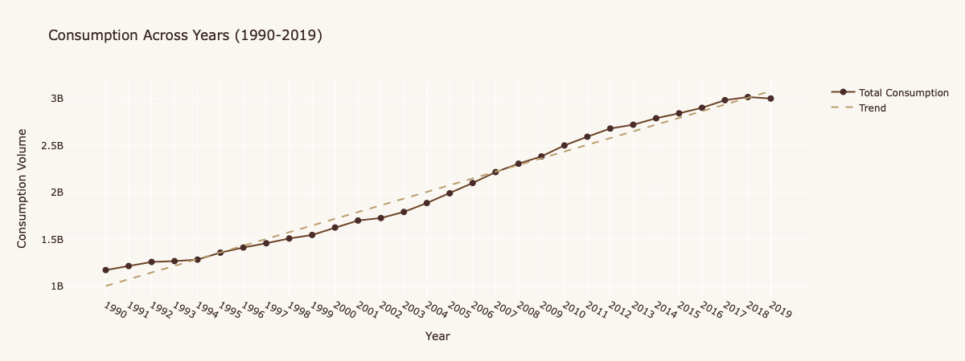
Fig. 8. Consumption Across Years Line Chart - Time series visualization showing the steady increase in global coffee consumption from 1990-2019, with a more consistent upward trend than the production chart.
This consumption growth, slightly outpacing production growth (150% vs. 100%), suggests potential supply constraints in the future if these relative growth rates continue.

3.2.2 Major Consuming Countries
The analysis of consumption by country reveals significant concentration, though with different patterns than production:
- Brazil: Both a major producer and consumer, Brazil leads global consumption with approximately 1.32 billion units in 2019.
- United States: The largest non-producing consumer at approximately 1.57 billion units.
- Germany: Europe’s largest consumer at approximately 0.57 billion units.
- Japan: The largest Asian consumer at approximately 0.47 billion units.
- Italy: Known for its coffee culture, consuming approximately 0.42 billion units.
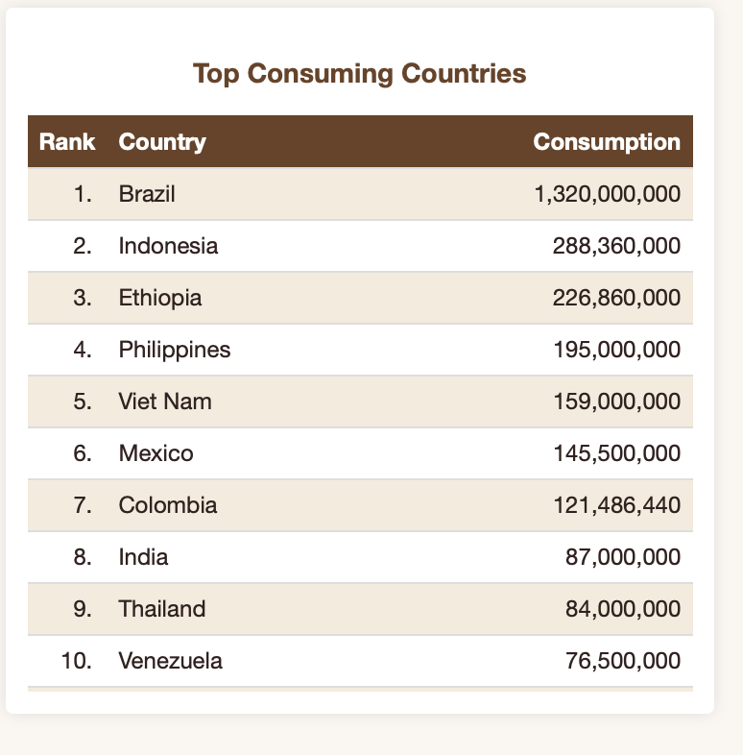
Fig. 9. Top Consuming Countries Table - Shows the ranked list of major coffee consuming countries in 2019, highlighting both producing countries that consume significant amounts domestically and major importing countries.
This consumption pattern reveals the global nature of coffee culture, with significant consumption occurring in both producing and non-producing countries.

3.2.3 Internal Market Dynamics
A particularly interesting finding is the variation in internal market dynamics among producing countries:
- High Internal Consumption: Brazil, Ethiopia, and Indonesia consume significant portions of their production domestically, creating robust internal markets.
- Export Orientation: Vietnam, Colombia, and Honduras export the vast majority of their production, making them more dependent on international market conditions.
- Consumption Growth in Producing Regions: Several producing countries show accelerating domestic consumption, potentially reducing export availability over time.
This variation in internal market dynamics has important implications for trade patterns, price sensitivity, and market risk profiles for different producing countries.

3.2.4 Consumption by Coffee Type
Analysis of consumption by coffee variety reveals different patterns than production:
- Arabica/Robusta Mix: Mixed varieties represent the largest consumption category (approximately 46.6 million units, 76% of total consumption).
- Pure Arabica: Arabica consumption stands at approximately 13.2 million units (21% of total).
- Pure Robusta: Robusta consumption is significantly lower at approximately 1.4 million units (2% of total).
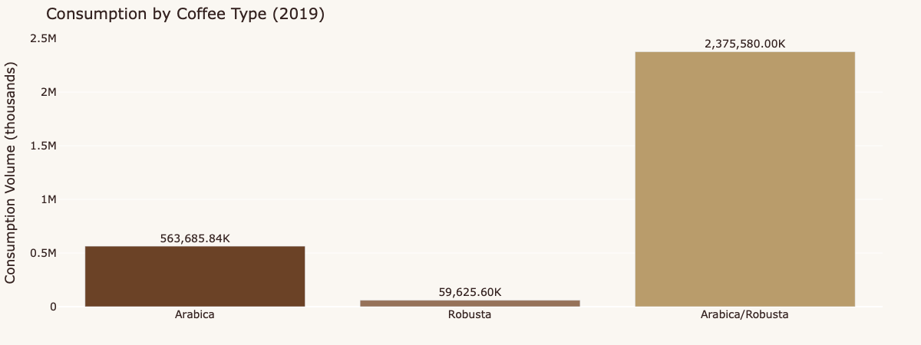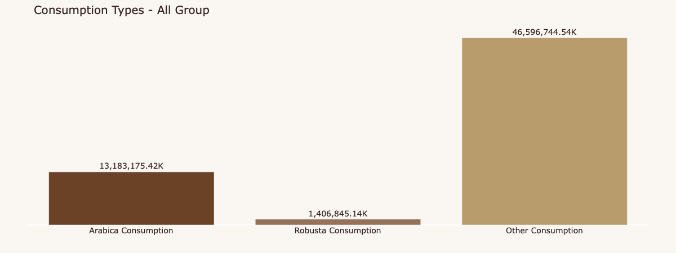
Fig. 10,11. Consumption by Coffee Type Bar Chart - Shows the breakdown of coffee consumption by variety type, with mixed Arabica/Robusta varieties representing the majority of consumption.
These consumption patterns broadly align with production patterns, though with slightly higher preference for pure Arabica in consumption compared to production.

3.3 Import and Export Analysis
The analysis of coffee imports and exports provides critical insights into the international trade dynamics of the coffee market:

3.3.1 Major Exporting Countries
The export analysis reveals that the largest producers are not necessarily the largest exporters, indicating different levels of domestic retention:
- Vietnam: Leading exporter with approximately 1.64 billion units in 2019, reflecting its strong export orientation.
- Colombia: Second-largest exporter at approximately 820 million units, despite being the third-largest producer.
- Honduras: Third-largest exporter at approximately 406 million units, punching above its production weight in export terms.
- Indonesia: Fourth-largest exporter at approximately 380 million units.
- India: Fifth-largest exporter at approximately 362 million units.
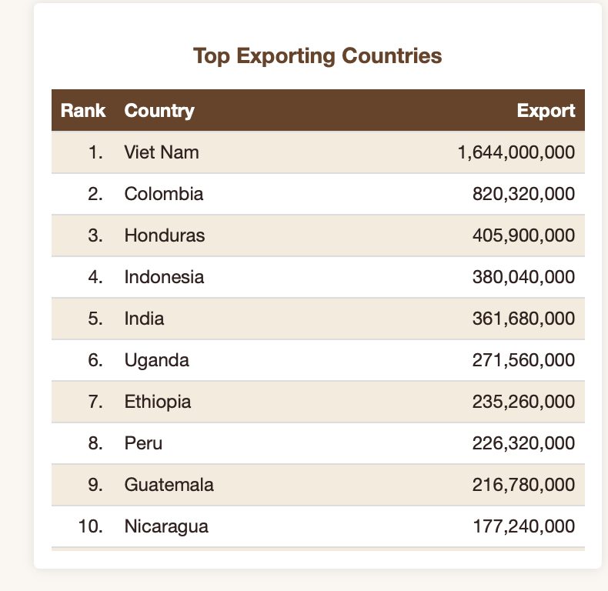
Fig. 12. Top Exporting Countries Table - Shows the ranked list of major coffee exporting countries in 2019, with Vietnam at the top followed by Colombia, Honduras, Indonesia, and India.
Notably, Brazil, the largest producer, ranks lower in exports due to its substantial domestic consumption, while countries like Vietnam and Colombia with lower domestic consumption export higher percentages of their production.

3.3.2 Major Importing Countries
The import analysis highlights the concentration of coffee consumption in developed markets:
- United States: Largest importer with approximately 376 million units in 2019 (22.9% of global imports).
- Germany: Second-largest importer with approximately 273 million units (16.6% of global imports).
- Italy: Third-largest importer with approximately 133 million units (8.1% of global imports).
- Japan: Fourth-largest importer with approximately 98 million units (5.9% of global imports).
- France: Fifth-largest importer with approximately 97 million units (5.9% of global imports).
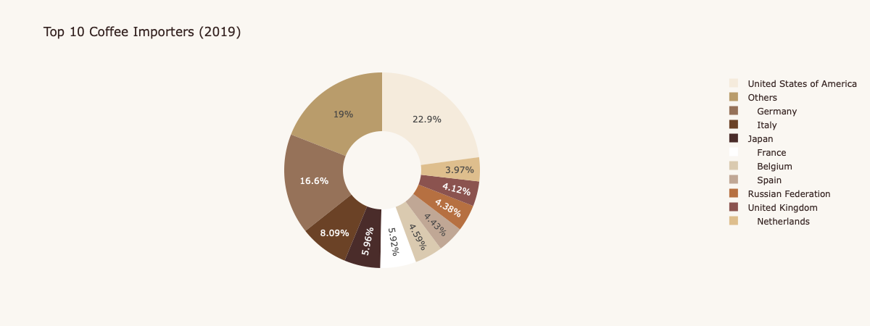
Fig . 13. Top 10 Coffee Importers Radial Chart - Shows the proportional distribution of coffee imports among major importing countries, with the United States accounting for nearly a quarter of global imports.
European countries collectively represent a significant portion of global coffee imports, with Germany serving as a major import hub for further distribution within Europe.

3.3.3 Export Growth and Volatility
The time-series analysis of exports reveals patterns distinct from both production and consumption:
- Overall Growth: Global coffee exports increased from approximately 4.8 billion units in 1990 to about 5.4 billion units in 2019, representing a more modest growth of approximately 12% compared to production and consumption.
- High Volatility: Export volumes show significant volatility, with major fluctuations throughout the analysis period.
- Recent Volatility: The period from 2014-2019 shows particularly high volatility, with exports peaking at approximately 7.6 billion units in 2017 before declining significantly to 5.4 billion units by 2019.
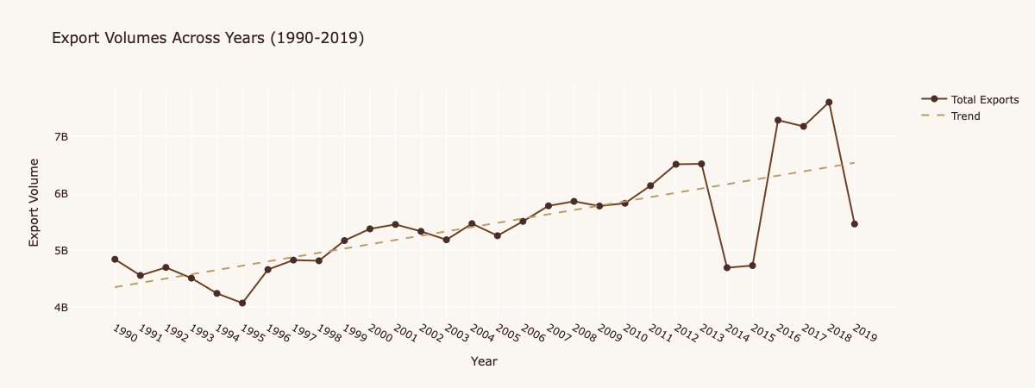
Fig. 14. Export Volumes Across Years Line Chart - Time series visualization showing the volatile pattern of global coffee exports from 1990-2019, with significant fluctuations particularly in recent years>
This export volatility, which exceeds production volatility, suggests that factors beyond production levels—such as inventory management, price speculation, and currency fluctuations—play significant roles in international coffee trade.

3.4 Trade Flow Analysis
The Sankey diagram visualization of coffee trade flows reveals the complex web of relationships between producing and consuming countries:

3.4.1 Major Bilateral Trade Relationships
Several dominant bilateral trade relationships emerge from the analysis:
- Vietnam → United States: The largest single bilateral flow, with Vietnam exporting approximately 375 million units to the US in 2019.
- Vietnam → Germany: The second-largest flow, with Vietnam exporting approximately 273 million units to Germany.
- Colombia → United States: A significant premium coffee flow, with Colombia exporting approximately 133 million units to the US.
- Vietnam → Italy: Another major flow, with Vietnam exporting approximately 98 million units to Italy.
- Indonesia → United States: A notable flow from Southeast Asia, with Indonesia exporting approximately 97 million units to the US.
These bilateral relationships highlight the concentrated nature of coffee trade, with a relatively small number of country pairs accounting for a significant portion of global coffee movement.

3.4.2 Regional Trade Patterns
The trade flow analysis reveals distinct regional patterns:
- Latin American Exporters → North American Importers: Strong flows from countries like Colombia, Honduras, and Brazil to the United States.
- Asian Exporters → European Importers: Significant flows from Vietnam and Indonesia to European countries, particularly Germany and Italy.
- African Exporters → Various Markets: More diversified export destinations for African producers like Ethiopia and Uganda.
These regional patterns reflect a combination of geographical proximity, historical trade relationships, colonial legacies, and quality/variety preferences.

3.4.3 Market Segmentation by Quality
The trade flow patterns suggest market segmentation based on coffee quality and variety:
- Premium Arabica Flows: Countries known for high-quality Arabica (Colombia, Ethiopia) show stronger flows to markets with developed specialty coffee sectors (US, Japan).
- Commodity Robusta Flows: Countries with significant Robusta production (Vietnam, Indonesia) show stronger flows to markets with large instant coffee sectors and price-sensitive consumers.
This quality-based segmentation reflects the diverse nature of coffee consumption across different markets and price points.

3.4.4 Temporal Evolution of Trade Patterns
The dashboard’s ability to filter trade flows by year reveals significant evolution in trade relationships over the 30-year analysis period:
- Emergence of Vietnam: In 1990, Vietnam had minimal presence in international coffee trade, but by 2019 it had become the dominant exporter to multiple major markets.
- Relative Decline of Traditional Exporters: Countries like Brazil have seen their relative share of exports decline, despite production increases, due to rising domestic consumption.
- Growth of New Import Markets: Countries like China and Russia have emerged as increasingly significant coffee importers over the analysis period.
These temporal shifts highlight the dynamic nature of the global coffee market and the importance of analyzing trade patterns over extended time periods.

4. DISCUSSION AND CONCLUSION

4.1 Key Findings and Implications
Our comprehensive analysis of global coffee market dynamics from 1990 to 2019 reveals several critical findings with important implications for various stakeholders:

4.1.1 Market Concentration and Vulnerability
The high concentration of coffee production, with five countries accounting for approximately 74% of global output in 2019, creates significant vulnerability in the global coffee supply chain. Climate events, political instability, or disease outbreaks affecting even a single major producer can have outsized impacts on global coffee availability and prices.
This concentration suggests that stakeholders across the coffee value chain should consider:
- Diversification Strategies: Sourcing from a broader range of origins to mitigate supply risk
- Climate Resilience Investment: Supporting adaptation measures in key producing regions
- Early Warning Systems: Developing better monitoring of production conditions in major growing areas
The visualization dashboard’s ability to highlight this concentration through treemaps and proportional visualizations makes this vulnerability immediately apparent to users.

4.1.2 Divergent Growth Trajectories
Our analysis reveals important divergences between production and consumption growth trajectories:
- Production: Approximately 100% growth over 30 years (5.5 billion to 10+ billion units)
- Consumption: Approximately 150% growth over 30 years (1.2 billion to 3 billion units)
This divergence, with consumption growing faster than production, suggests potential future supply constraints if these relative growth rates continue. The consistent upward trend in consumption contrasts with the more volatile production pattern, creating potential for periodic supply-demand imbalances.
These findings suggest the need for:
- Production Capacity Investment: Supporting sustainable intensification of coffee production
- Yield Improvement Research: Developing higher-yielding, more resilient coffee varieties
- Consumption Efficiency: Exploring more efficient processing technologies to maximize utility of available coffee
The time-series visualizations in our dashboard effectively communicate these divergent trajectories and highlight periods of potential imbalance.

4.1.3 The Vietnam Phenomenon
The emergence of Vietnam as the second-largest coffee producer and largest exporter represents one of the most significant structural shifts in the global coffee landscape during our analysis period. Vietnam’s rapid expansion, focused primarily on Robusta production, has:
- Increased global coffee availability
- Shifted the Arabica-Robusta balance
- Created new trade patterns, particularly with European markets
- Put price pressure on other Robusta-producing countries
This transformation demonstrates how quickly the global coffee market can evolve when favorable conditions (suitable land, supportive policies, available technology) align. It also raises questions about which countries might emerge as the “next Vietnam” in future decades.
The dashboard’s temporal analysis capabilities clearly demonstrate this transition, providing valuable historical context for understanding current market structures.

4.1.4 Complex Trade Web
Our trade flow analysis reveals a complex web of relationships between producing and consuming countries, with patterns shaped by:
- Geographic proximity
- Historical relationships
- Quality preferences
- Processing capabilities
- Re-export dynamics
This complexity highlights the truly global nature of the coffee value chain and the importance of understanding bilateral relationships rather than simply aggregate production and consumption figures.
The Sankey diagram in our dashboard provides a powerful visualization of these complex relationships, enabling users to trace coffee flows from origin to destination and understand the structure of the international coffee market.

4.2 Methodological Reflections
Our approach to visualizing global coffee market dynamics offers several methodological advantages while also presenting certain limitations:

4.2.1 Strengths of the Visualization Approach
The multi-technique visualization approach employed in our dashboard offers several key strengths:
- Complementary Perspectives: Different visualization techniques (treemaps, time-series, radial charts, Sankey diagrams) provide complementary perspectives on the same underlying data, enabling more comprehensive understanding.
- Interactive Exploration: The interactive nature of the dashboard allows users to explore specific questions of interest, rather than being limited to predefined analytical paths.
- Temporal Analysis: The consistent implementation of temporal filtering across visualizations enables effective analysis of both current patterns and historical evolution.
- Visual Communication: The carefully designed visual system, with its coffee-themed color palette and consistent styling, enhances interpretability while maintaining analytical rigor.
- Integrated Framework: The unified analytical environment brings together production, consumption, trade, and temporal dimensions that are typically analyzed separately.

4.2.2 Limitations and Challenges
Despite its strengths, our approach also faces certain limitations:
- Data Granularity: The analysis operates at country and annual levels, missing potential insights from more granular regional or monthly data.
- Value vs. Volume: Our analysis focuses primarily on volume metrics rather than value, potentially obscuring important quality and price dynamics.
- Data Completeness: Some countries have incomplete or potentially unreliable data for certain years, creating analytical challenges.
- Causality Limitations: Visualization can reveal patterns but has limited ability to establish causal relationships without additional analytical techniques.
- Projection Limitations: The approach is fundamentally retrospective and does not include forecasting or predictive elements.
These limitations suggest potential directions for future enhancement of the analytical framework.

4.3 Future Work
Building on the foundation established by our current visualization dashboard, several promising directions for future work emerge:

4.3.1 Enhanced Data Integration
Future iterations could integrate additional data dimensions to provide more comprehensive coffee market analysis:
- Price Data: Incorporating historical price information for different coffee varieties and grades would add an important economic dimension.
- Climate Data: Integrating climate information from producing regions could help explain production volatility and project future risks.
- Quality Metrics: Adding data on coffee quality characteristics and cupping scores would enhance understanding of value differentiation.
- Socioeconomic Indicators: Incorporating data on farmer livelihoods, labor conditions, and social sustainability would provide important context.

4.3.2 Advanced Analytical Techniques
Future work could enhance the analytical capabilities of the dashboard through:
- Predictive Modeling: Implementing forecasting models to project future production, consumption, and trade patterns.
- Anomaly Detection: Developing algorithms to identify unusual patterns or outliers in coffee market data.
- Scenario Analysis: Creating tools for exploring potential future scenarios under different assumptions.
- Correlation Analysis: Implementing methods to identify statistical relationships between different coffee market variables.

4.3.3 Extended Visualization Techniques
The visualization approach could be extended through:
- Geospatial Visualization: Adding map-based visualizations to better represent the geographical dimension of coffee production and trade.
- Network Analysis: Implementing network visualization techniques to reveal structural patterns in trade relationships.
- 3D Visualization: Exploring three-dimensional visualization techniques for representing multiple data dimensions simultaneously.
- Animation: Implementing animated transitions to better communicate temporal evolution.

4.3.4 Supply Chain Expansion
The scope of analysis could be extended beyond production, consumption, and international trade to include:
- Processing Stage Analysis: Adding visibility into intermediate processing steps like milling, roasting, and grinding.
- Retail Level Data: Incorporating information on retail sales channels and consumption contexts.
- Sustainability Certification: Adding data on various sustainability certification schemes and their market penetration.
- By-product Utilization: Including analysis of coffee by-products and their economic and environmental implications.
These future directions would build upon the foundation established by the current visualization dashboard, further enhancing its value for stakeholders across the coffee sector.

4.4 Conclusion
Coffee stands as a globally significant agricultural commodity with complex production, consumption, and trade dynamics. Our comprehensive analysis of global coffee market data from 1990 to 2019, enabled by an interactive visualization dashboard, reveals critical insights about market concentration, growth patterns, geographical shifts, and trade relationships.
The high concentration of production in a small number of countries creates potential supply vulnerabilities, while the more rapid growth of consumption relative to production suggests potential future supply constraints. The dramatic emergence of Vietnam as a major producer demonstrates how quickly the coffee landscape can evolve, while the complex web of trade relationships highlights coffee’s truly global nature.
Our multi-technique visualization approach, combining treemaps, time-series analysis, radial charts, and Sankey diagrams within an interactive framework, provides complementary perspectives on these market dynamics. This approach enables stakeholders to explore specific questions of interest while maintaining the context of broader market patterns.
Looking forward, future work could enhance this analytical framework through additional data dimensions, advanced analytical techniques, extended visualization approaches, and broader supply chain coverage. Such enhancements would further increase the value of this visualization approach for stakeholders across the coffee sector, from producers and traders to roasters, retailers, and policy makers.
As the global coffee sector continues to evolve amid changing climate conditions, shifting consumer preferences, and market volatility, tools that enable data-driven understanding of complex market dynamics will become increasingly valuable. Our visualization dashboard represents a contribution to this important field, providing a foundation for more informed decision-making across the coffee value chain.

5. REFERENCES
[1] International Coffee Organization. (2022). “Coffee Market Report.” ICO Annual Review.
[2] International Coffee Organization. (2021). “Coffee Development Report: The Future of Coffee – Long-term Outlook.” ICO, London.
[3] International Trade Centre. (2021). “The Coffee Exporter’s Guide.” 4th Edition. Geneva: ITC.
[4] Panhuysen, S., & Pierrot, J. (2020). “Coffee Barometer 2020.” Hivos, The Hague.
[5] Giovannucci, D., & Koekoek, F. J. (2003). “The State of Sustainable Coffee: A Study of Twelve Major Markets.” International Coffee Organization.
[6] Ponte, S. (2002). “The ‘Latte Revolution’? Regulation, Markets and Consumption in the Global Coffee Chain.” World Development, 30(7), 1099-1122.
[7] Bunn, C., Läderach, P., Ovalle Rivera, O., & Kirschke, D. (2015). “A Bitter Cup: Climate Change Profile of Global Production of Arabica and Robusta Coffee.” Climatic Change, 129(1), 89-101.
[8] Bacon, C. (2005). “Confronting the Coffee Crisis: Can Fair Trade, Organic, and Specialty Coffees Reduce Small-Scale Farmer Vulnerability in Northern Nicaragua?” World Development, 33(3), 497-511.
[9] Lewin, B., Giovannucci, D., & Varangis, P. (2004). “Coffee Markets: New Paradigms in Global Supply and Demand.” World Bank Agriculture and Rural Development Discussion Paper 3.
[10] Sachs, J., Cordes, K. Y., Rising, J., Toledano, P., & Maennling, N. (2019). “Ensuring Economic Viability and Sustainability of Coffee Production.” Columbia Center on Sustainable Investment.
GenAI Use: We leveraged Claude 3.7 Sonnet for two primary purposes: (1) code base syntax assistance, which helped us maintain consistent coding standards and identify potential issues in our implementation; and (2) report structure enhancement, where the AI provided suggestions for improving organization, flow, and clarity of our technical documentation.

