Beyond – Hashtags Battle

Features:

1. Administration:
   1. Login Screen
   2. Administration Home
   3. Admin Manage Users
   4. Admin Update Users
   5. Hash Tag Battle Manager
   6. Battle Listing
   7. Change Battle
2. Front End:
   1. Battle Listing
   2. Start Crawler / Scheduler
   3. Create Battle Form
   4. Unauthorized Access to Create / Update / Delete
   5. Update / Edit Battles
   6. Update Battle Status
   7. Battle Details / Result
   8. Individual Battle Crawl
3. Scope for improvement
   1. Database structure
   2. Better GUI
   3. Pending Task
   4. Better Code delivery Option

# Administration

### Login Screen

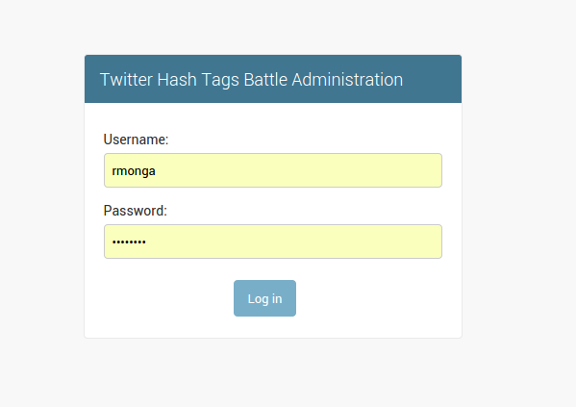

Login using rmonga / [Bynd@123](mailto:Bynd@123) or using cass.surek / Bynd@123

### Admin Home

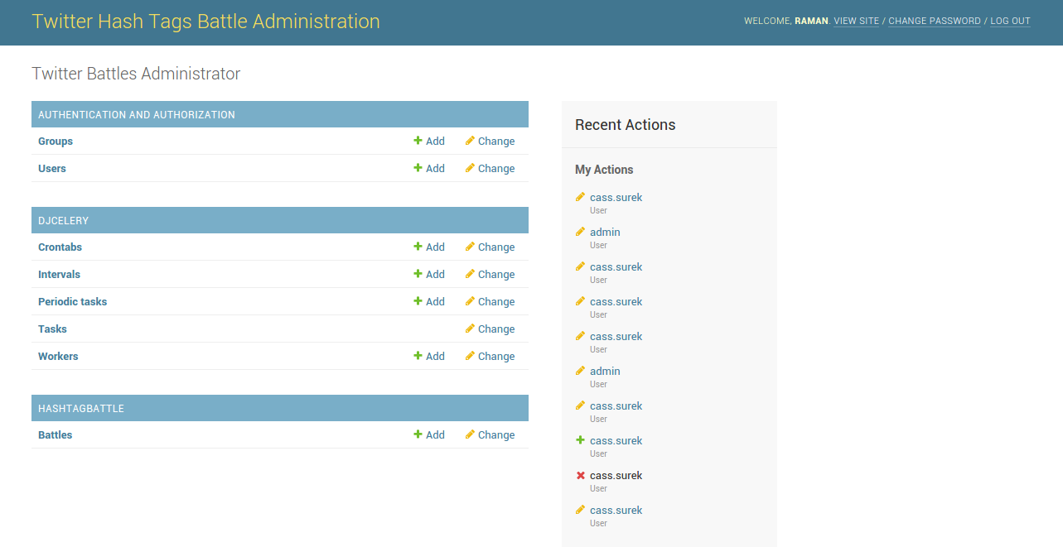

### Admin Manage Users – Add/Update/List

### Update User

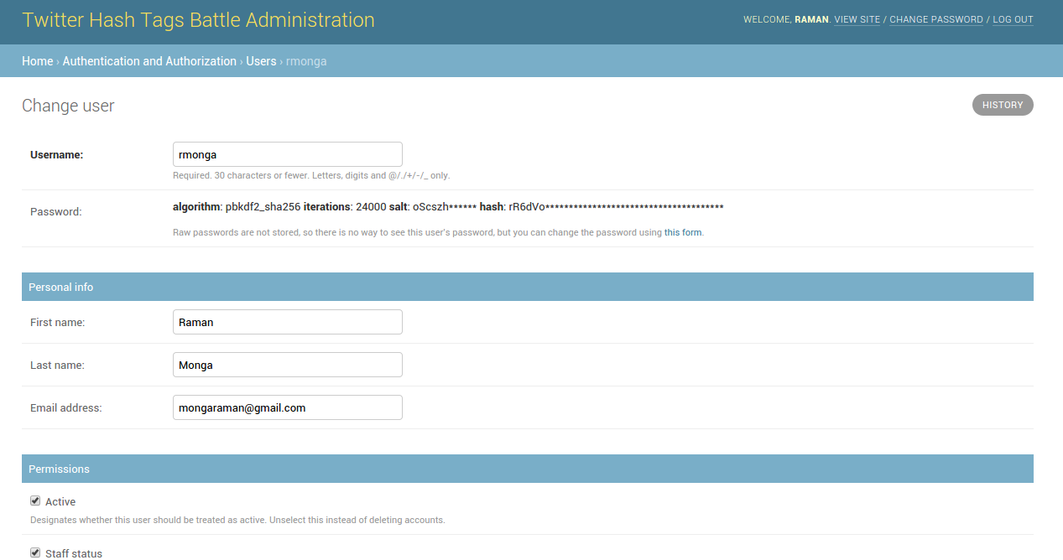

### Hash Tags Battle Administration

### Admin Battle Listing

The above page will have Add/Update/Retrieve feature. User can also use Filters for quick filteration.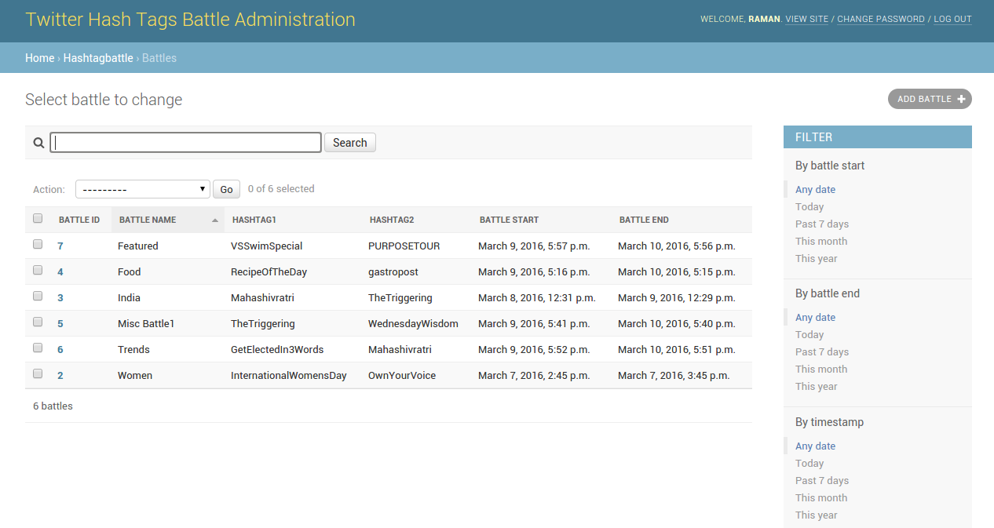

### Change Battle

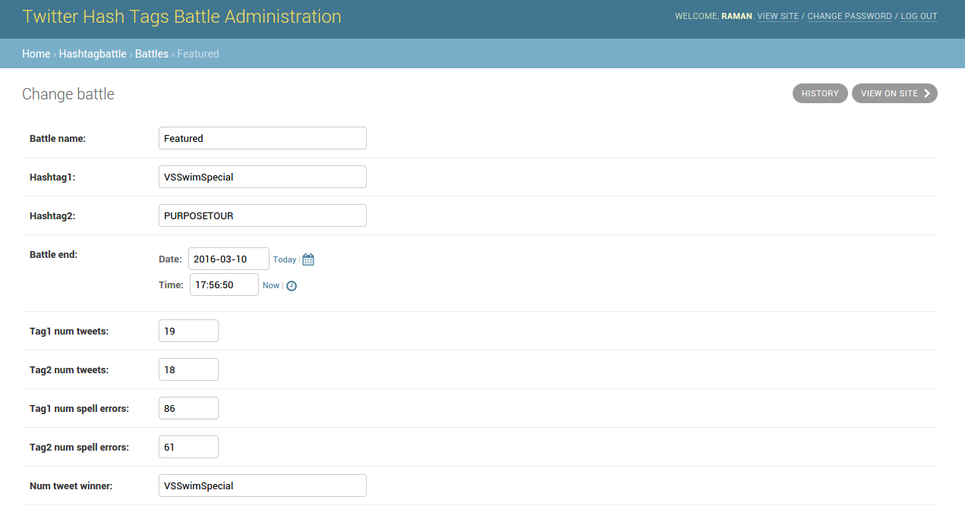

# Front End:

### Battle Listing

1. To Start Crawler Click on link in header – as soon as you start scheduler it will start crawling Twitter website for battle hashtags and will update battle table follwing fields also will update crawl_status field if battle end date is less than or equal to now().
   1. tag1_num_tweets = tag 1 number of tweets
   2. tag2_num_tweets = tag2 number of tweets
   3. tag1_num_spell_errors = tag1 number of spelling mistakes (use pyenchant for spell check)
   4. tag2_num_spell_errors = tag2 number of spelling mistakes
   5. num_tweet_winner = winner tag on the basis of number of tweets
   6. num_spell_winner = winner tag on the basis of less spelling errors
2. This will only crawl battles whose status is R.
3. Scheduler / Crawler is scheduled for every 5 seconds.
4. Click on Name to View Battle Details
5. Click on Edit to update Battle
6. Click on Update Status to Switch between status R (Running) or D (Done).
7. Click Delete to delete battle record.
8. Click on Crawl me link to show individual crawling result.
9. Click on Battle Result to view result.

### Start / Stop Crawler: (apscheduler module is used for scheduler)

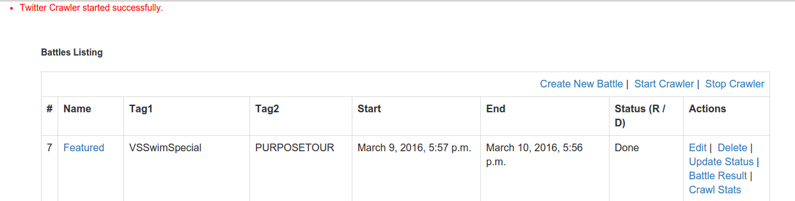

Stop Crawler / Scheduler 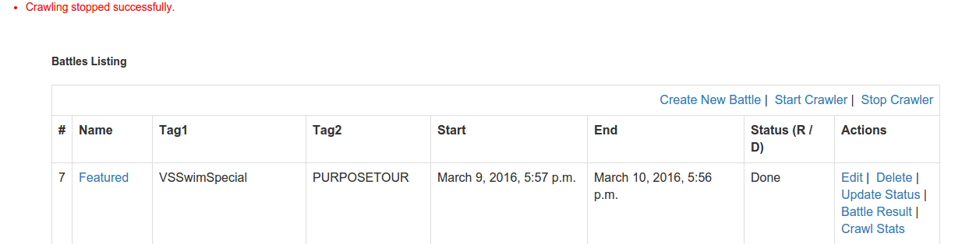

### Individual Battle Result – Crawl me Link:

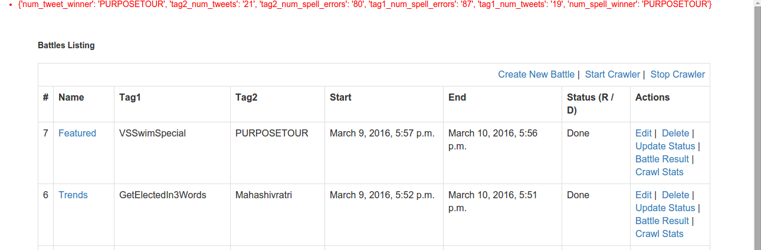

The above screen will display individual crawl result in dict format.

### Create Battle Form

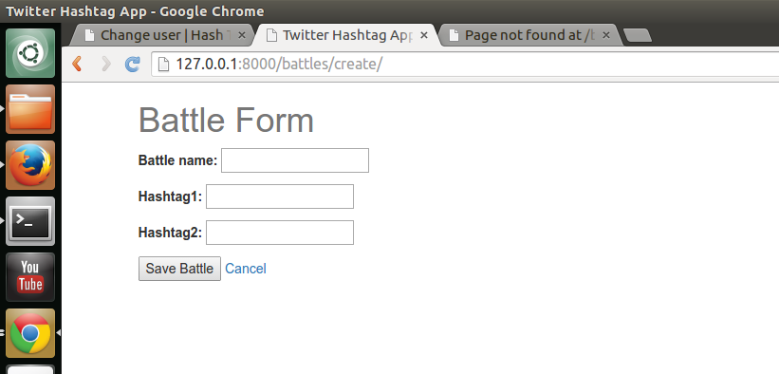

### Unauthorized user – If unauthorized user (not staff or superuser) tries to create

### Update / Edit Battles

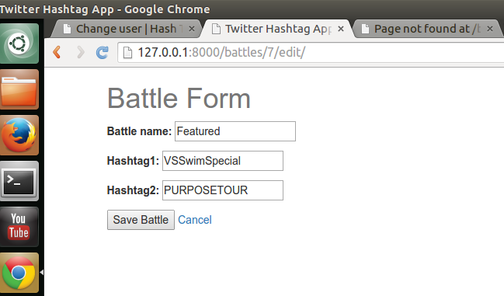

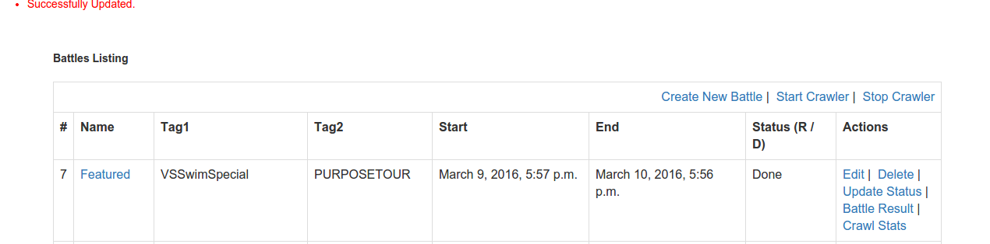

### Battle Details / Result Page:

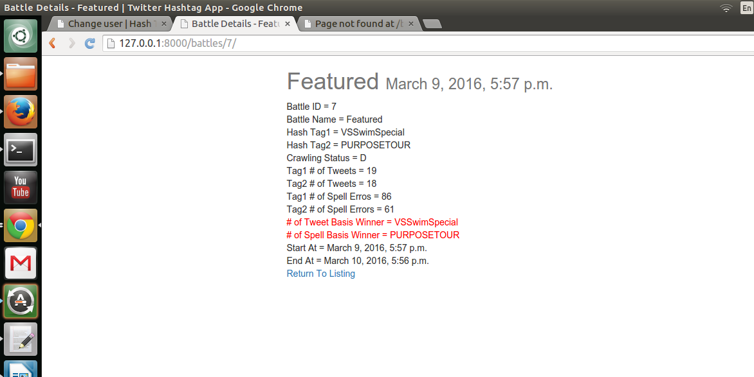

### Update Battle Status – if you want to still crawl any battle, update its status and do crawl stats

### 

### Scope for Improvement:

### 

There is always a scope of improvement so is here in this project.

### Database Structure:

I have stored all data in single model/table. It could be better divided into 2 or multiple tables. Database design could be better.

Current Model

battle_id = models.AutoField(primary_key=True)

battle_name = models.CharField(max_length=120)

hashtag1 = models.CharField(max_length=250)

hashtag2 = models.CharField(max_length=250)

battle_start = models.DateTimeField(auto_now_add=True)

battle_end = models.DateTimeField(default=default_endtime)

tag1_num_tweets = models.IntegerField(default=0)

tag2_num_tweets = models.IntegerField(default=0)

tag1_num_spell_errors = models.IntegerField(default=0)

tag2_num_spell_errors = models.IntegerField(default=0)

num_tweet_winner = models.CharField(max_length=250, default='')

num_spell_winner = models.CharField(max_length=250, default='')

timestamp = models.DateTimeField(auto_now_add=True, auto_now=False)

updated = models.DateTimeField(auto_now_add=False, auto_now=True)

crawl_status = models.CharField(max_length=1, choices=CRAWL_STATUSES,

default='R')

### Better GUI:

I have included Bootstrap and applied styles wherever possible. GUI has a lot of scope of improvement.

### Pending Task:

Data should be returned in json format. I am showing it on a webpage or showing it in dict format as shown above or crawl me result page.

### Better code delivery mode:

Could have used docker or other ways to deliver code with more elborative details.