Store 336

Members: Quynh, Ilona, Geoff, Chris J.

# Description

An online clothing store where people can shop for clothes online.

# Diagram:

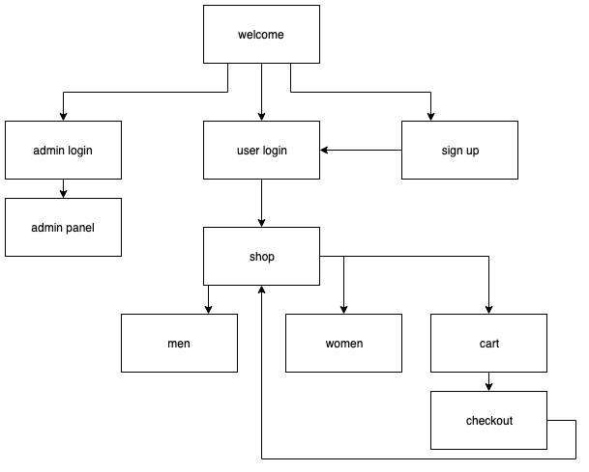

# Mockups:

|  |  |
| --- | --- |
|  |  |
|  |  |
|  |  |
|  |  |
|  |  |

# Screenshots:

|  |  |
| --- | --- |
|  |  |
|  |  |
|  |  |
|  |  |
|  |  |

# Database Schema

|  |  |
| --- | --- |
| CREATE TABLE `admin` (  `username` varchar(16) NOT NULL,  `password` varchar(40) NOT NULL  )  PRIMARY KEY (`username`); | CREATE TABLE `items` (  `id` int(11) NOT NULL AUTO_INCREMENT,  `name` varchar(40) NOT NULL,  `description` varchar(120) NOT NULL,  `gender` varchar(1) NOT NULL,  `type` varchar(30) NOT NULL,  `size` varchar(1) NOT NULL,  `stock` varchar(6) NOT NULL,  `price` int(10) NOT NULL,  `imageURL` varchar(200) NOT NULL  )  PRIMARY KEY (`id`); |
| CREATE TABLE `orders` (  `id` int(11) NOT NULL AUTO_INCREMENT,  `user` varchar(16) NOT NULL,  `totalPrice` int(12) NOT NULL,  `date` timestamp NOT NULL DEFAULT CURRENT_TIMESTAMP ON UPDATE CURRENT_TIMESTAMP  )  ADD PRIMARY KEY (`id`); | CREATE TABLE `users` (  `username` varchar(16) NOT NULL,  `password` varchar(40) NOT NULL,  `email` varchar(60) NOT NULL,  `address` varchar(120) NOT NULL  )  PRIMARY KEY (`username`); |