STRATEGIC POSITIONING

MongoDB for a
Document-First Clinical Data Platform
  - Customer and partner positioning for FHIR-based healthcare solutions
Own the clinical data foundation. Use FHIR as an interoperable access contract.
The position in one sentence MongoDB supplies the data platform; FHIR provides a standards-based interface; kehrnel and HealthcareDataLab accelerate implementation; and the customer or its systems integrator owns, secures, validates, operates and supports the production clinical solution.
Intended audience
Healthcare providers, national or regional health programs, health-technology vendors, systems integrators and specialist interoperability partners
Positioning principle: open data first, interoperability by design, production accountability made explicit.

1. Executive overview
Healthcare organizations often begin with separate FHIR environments for each hospital or tenant. That can simplify initial isolation, yet it frequently makes cross-hospital reporting, longitudinal views and national-scale data products harder to deliver. The issue is not FHIR itself; it is the relationship between the interoperability layer, the data model and the tenancy design.
Our proposed model places MongoDB at the center as a flexible, governed clinical data platform. FHIR resources can be stored in a document shape close to their native JSON representation, enriched with clearly separated operational metadata and indexed projections, and exposed through the interfaces that each solution actually needs. FHIR remains a primary standards-based contract for ingestion and consumption, without becoming the only way the organization can use its data.
Customer outcome A single governed platform can support hospital-level isolation and authorized regional or national views without forcing every new use case into a separate tenant-specific clinical store.

The strategic choice
- Choose this document-first approach when control of the clinical data foundation, model evolution, multi-tenant insight and new data products are strategic priorities.
- Choose a specialist FHIR server or clinical data repository when turnkey standards breadth, mature conformance tooling, packaged terminology services or certification evidence are the primary buying criteria.
- Choose a hybrid architecture when a specialist FHIR product should remain the standards-facing front door while MongoDB provides the broader operational, analytical or AI-ready data foundation.

A partner-safe position
This offer is not intended to replace specialist vendors such as Firely, Smile CDR or equivalent platforms. Those products address a different requirement: a packaged FHIR server or clinical data repository with broad protocol behavior, conformance features and operational product support. MongoDB can complement those solutions, serve as an approved persistence option where supported, or power a separate document-first data layer. The architecture should be chosen according to the customer’s required level of FHIR completeness and ownership.

2. What the offer is
The offer is a reference architecture, implementation method and set of accelerators for building clinical data solutions on MongoDB. It helps a capable customer, product vendor or systems integrator start from proven document-model patterns instead of designing every persistence, search and test concern from scratch.
- A document-first clinical data foundation. FHIR JSON can remain recognizable and accessible, while MongoDB provides flexible indexing, aggregation, graph-style traversal, full-text search and vector capabilities.
- A tenant- and context-aware data design. Hospital, organization, region, source system and other access-scoping attributes become explicit parts of the operational model and index strategy.
- An interoperability accelerator. kehrnel provides model and runtime patterns for resource ingestion, CRUD, search translation, projections and APIs; HealthcareDataLab provides tooling for exploration, synthetic data and solution prototyping.
- A platform for more than FHIR. The same governed foundation can support terminology mappings, derived data, document content, embeddings and future models such as openEHR, provided each representation has a clear contract and provenance.
- An ownership model. The customer retains control of its data structures, mappings, extensions, release cadence and downstream services rather than making the protocol implementation the permanent center of every data use case.

3. What the offer is not
Important boundary MongoDB is a general-purpose data platform. It is not marketed here as a turnkey, certified FHIR server or as a managed FHIR store.
- It is not an out-of-the-box implementation of every FHIR interaction, search parameter, profile, operation or implementation guide.
- It does not by itself provide authentication, authorization, consent enforcement, patient matching, terminology services, audit policy, clinical workflow or regulatory certification.
- The kehrnel and HealthcareDataLab components are accelerators, not a production SLA, managed clinical service or substitute for a systems integrator.
- Adding arbitrary fields to a FHIR-facing payload does not make them interoperable. Non-standard data must be handled through governed FHIR extensions, internal metadata that is removed on serialization, or linked documents with explicit mappings.
- A tenant identifier alone is not a security architecture. Isolation, authorization, audit, consent, encryption and operational controls must be designed and verified end to end.
- Consolidating stores does not automatically harmonize patient identity, clinical meaning or local coding. Those are explicit governance and implementation workstreams.

4. Why document-first
FHIR is an excellent exchange and access standard. MongoDB’s document model is a strong foundation when the organization also needs to evolve how clinical data is stored, queried, enriched and combined. The two roles are complementary: FHIR defines interoperable contracts; the document platform creates controlled freedom behind those contracts.

Preserve the clinical context
A complete clinical resource can be held together as a document instead of being fragmented across many relational structures. Internal projections used for search, tenancy and operations can be kept in reserved namespaces and excluded from outbound FHIR responses. This preserves a clean standards-facing representation while making database behavior explicit and auditable.

Evolve without redesigning the entire platform
Healthcare data changes as new hospitals, specialties, profiles, regulations and AI use cases are added. A document-first model allows controlled evolution at the document and API-contract levels. When non-FHIR information is required, the organization can choose a governed FHIR extension or a linked internal model rather than forcing every data product into the same protocol shape.

Use one foundation for operational and data-product workloads
The same platform can support transactional document access, indexed clinical search, aggregation across authorized scopes, graph-style relationship traversal, text search and vector retrieval. This reduces the need to copy data into a new technology for every question, although dedicated analytical or archival platforms may still be appropriate at scale.

Make tenancy a queryable, governable dimension
Hospital and regional boundaries can be represented explicitly and incorporated into indexes, routing and authorization. A privileged national service can query across approved scopes, while hospital services remain constrained to their own data. The resulting flexibility must be paired with rigorous policy enforcement and auditability.

5. How the architecture works
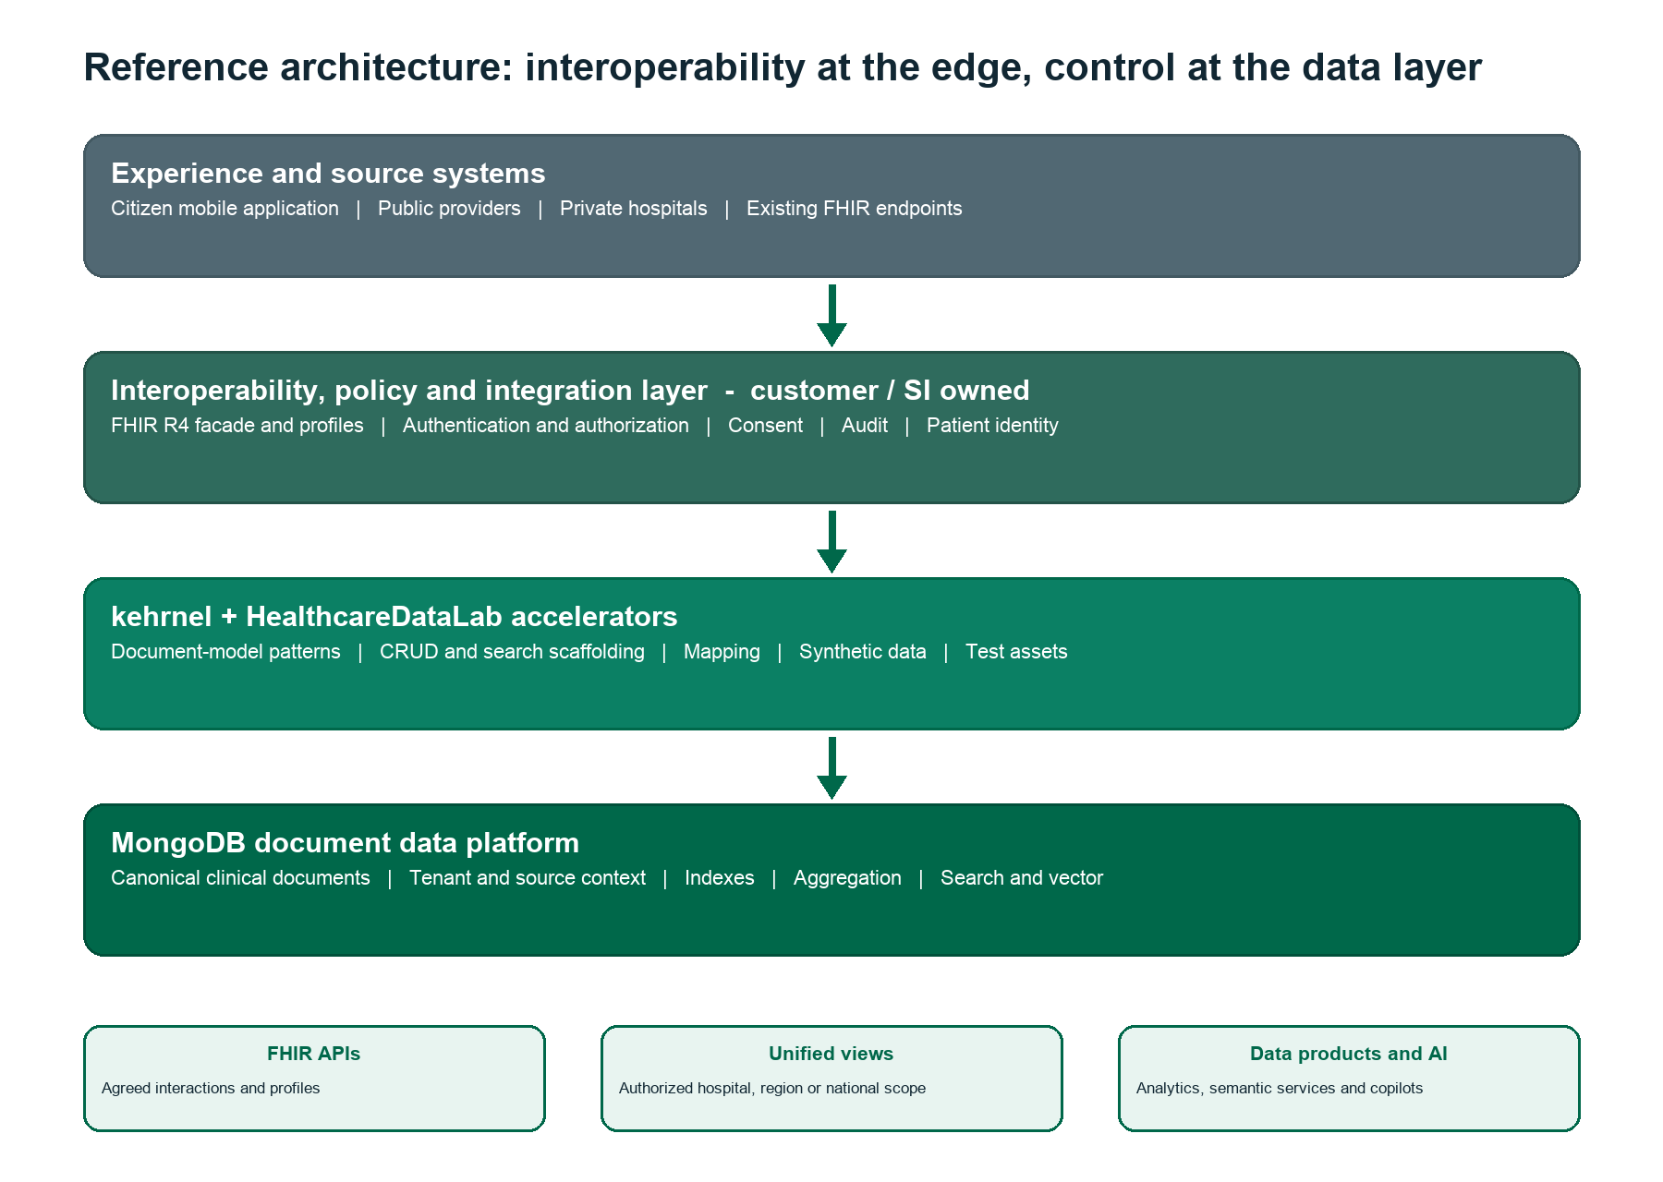
Figure 1. Responsibility boundaries are part of the architecture: standards-facing behavior and policy remain solution concerns; MongoDB provides the data foundation.

Core flow
- Ingest. Mobile applications, hospital systems or existing cloud FHIR services send resources or source data through controlled integration endpoints.
- Validate and map. The solution applies the agreed R4 profiles, validation rules, terminology mappings, identity rules and source provenance before persistence.
- Persist. FHIR-shaped documents are stored with immutable tenant and source context, versioned operational metadata, search projections and indexes. Internal fields are excluded from standards-facing serialization.
- Serve. FHIR APIs return the supported resource and search behavior, while controlled services can also use aggregation, search, graph and vector capabilities directly.
- Govern. Authorization, consent, purpose of use, auditing, retention, data residency, backup and recovery are applied across the complete solution.

Tenant-aware national view
For the El Salvador scenario, each resource should carry immutable source and access context such as hospital or tenant, managing organization, region and provenance. Hospital-facing services always include their authorized scope in queries. A separately privileged national service can query across scopes for approved public-health, care-coordination or operational purposes.
Design caution A national view requires more than placing records in one database. Patient and practitioner identity, duplicate resolution, terminology normalization, consent, legal purpose and cross-tenant authorization must be agreed before the view can be trusted.
Sharding and indexing follow the access pattern. A tenant-aware shard key can improve routing and isolation; other high-cardinality fields may be needed for balanced distribution. Related records can be localized by design where the workload justifies it, but no universal shard-key choice optimizes every hospital-level and national-level query. The production design must be proven with representative volumes and query patterns.

6. Responsibilities and commercial boundary
A successful engagement depends on a clear delivery model. The following split protects the customer, keeps partner roles explicit and prevents the accelerator from being confused with a packaged clinical product.
Party | Primary responsibility | Typical deliverables
MongoDB | Data platform and product support | MongoDB software or managed cloud service; database architecture guidance; security and performance practices; optional professional services.
kehrnel / HealthcareDataLab | Implementation acceleration | Document-model and runtime patterns; CRUD/search scaffolding; mappings; synthetic data; test assets; reference configurations; rapid experimentation.
Customer / systems integrator | Production solution ownership | Application and API implementation; R4 profiles; identity; security; consent; audit; integrations; SRE; validation; compliance; support and release management.
FHIR product or specialist partner | Packaged interoperability capability where selected | Broader FHIR server/CDR behavior, conformance tooling, terminology or certification evidence; integration with MongoDB or synchronization into the document platform.

Contract principle Every production capability must have one accountable owner. If a requirement is not provided by MongoDB or the accelerator, it must be explicitly assigned to the customer, SI or specialist product partner.

7. Customer and workload fit

Strong fit
- Healthcare software vendors, national or regional platforms and provider groups that want to own the clinical data model and delivery roadmap.
- Solutions with a bounded, well-understood FHIR R4 contract: selected resources, profiles, CRUD interactions and search parameters that can be implemented and tested deliberately.
- Multi-hospital platforms that need both tenant-level operations and authorized cross-tenant reporting or longitudinal views.
- Workloads that combine clinical documents, unstructured notes, search, aggregation, semantic enrichment or AI retrieval.
- Programs with an experienced internal engineering team or systems integrator capable of owning clinical-grade operations.

Conditional fit
- High-volume transactional workloads, where shard keys, indexes, consistency, latency, disaster recovery and cost must be tested against real access patterns.
- Advanced FHIR interactions such as transaction bundles, conditional operations, version history, subscriptions, bulk data or complex chains, which require additional implementation and conformance testing.
- National patient or provider views, which depend on identity resolution, consent and terminology governance beyond the storage model.
- AI-enabled clinical workflows, which require provenance, access-filtered retrieval, evaluation, human oversight and safeguards against writing unverified output into the clinical record.

Not the recommended approach
- The procurement requirement is a turnkey, broadly conformant or certified FHIR server with minimal custom engineering.
- The customer expects a complete terminology service, master patient index, consent engine, workflow engine or regulatory program to be included in the database or accelerator.
- There is no qualified party to own production security, interoperability testing, operations and support.
- The intended architecture treats a tenant field as the only security control or assumes consolidation automatically creates semantic interoperability.

8. Deployment patterns
Three patterns allow customers to select the right balance of control, standards completeness and delivery responsibility. They are not mutually exclusive across all workloads.
Pattern | Use when | Architecture | Trade-off
1. Owned model + custom FHIR facade | Control and model evolution are strategic; the FHIR contract is bounded. | MongoDB is the clinical data foundation. The SI builds the required R4 facade using the accelerators. | Maximum flexibility; highest customer/SI responsibility for conformance and operations.
2. Specialist FHIR platform | Packaged FHIR breadth, conformance tooling or vendor accountability is primary. | A product such as Firely, Smile CDR or equivalent supplies the FHIR layer and uses or integrates with MongoDB as supported. | Faster standards coverage; data-model freedom and architecture depend on the selected product.
3. Hybrid cloud architecture | Existing Google Cloud Healthcare API tenants must coexist with a new unified data capability. | Retain selected FHIR endpoints while synchronizing governed data to MongoDB, or place a new facade over MongoDB. Define one system of record per data class. | Supports phased migration; requires explicit synchronization, conflict, provenance and failure semantics.

Google Cloud deployment
MongoDB Atlas can be deployed in a compatible Google Cloud region and integrated with the customer’s existing cloud networking, identity, key management, observability and data pipelines. Google Cloud Healthcare API does not need to be removed on day one. It can remain an interoperability endpoint during migration or for workloads where its managed FHIR behavior remains the best fit.
The critical architectural decision is the system of record. Bidirectional synchronization without explicit ownership creates duplicate truth, version conflicts and incomplete deletes. For each resource class and workflow, the target design must identify the authoritative store, allowed writers, event path, replay behavior and reconciliation process.

9. Deployment and qualification path
- Scope the interoperability contract. Inventory the R4 implementation guides, profiles, resources, search parameters, operations, bundles, versioning and error semantics used by the mobile application and hospitals.
- Define governance and tenancy. Agree hospital and national access scopes, patient identity, consent, provenance, retention, residency, encryption and audit requirements before fixing the physical model.
- Prove the critical path. Use synthetic or de-identified data to demonstrate selected CRUD/search flows, cross-hospital views, failure behavior and migration from current tenant stores.
- Engineer for production. Complete threat modeling, performance tests, indexing and sharding, observability, backups, disaster recovery, data-quality controls, conformance tests and operational runbooks.
- Migrate in controlled waves. Onboard hospitals by cohort, reconcile counts and clinical meaning, validate access boundaries, and retain rollback or dual-read options until acceptance criteria are met.

10. Specific recommendation for the El Salvador opportunity
Begin with a bounded proof of value for the national-view problem, not with a promise to replace every existing FHIR capability. Select the resources and searches that drive the mobile application and the first cross-hospital use cases. Demonstrate that hospital-scoped access and an authorized national view can operate over the same governed data foundation.

Proof-of-value objectives
- Ingest a representative R4 subset from at least two differently configured hospital tenants, preserving source identifiers and provenance.
- Expose the exact create, read, update, delete and search behavior required by the current application for that subset.
- Demonstrate hospital-level isolation and one approved cross-hospital dashboard or longitudinal query.
- Show an enrichment use case—such as search or embeddings over clinical note text—while applying the same access filters and retaining traceability to the source resource.
- Measure latency, throughput, index size, data growth and operational recovery with representative data and query shapes.

Exit criteria before production
- R4 profile and search coverage is documented, automated and regression-tested against the customer’s actual contract.
- Tenant and national authorization paths have negative tests proving that forbidden cross-tenant access fails closed.
- Patient identity, consent, provenance and terminology responsibilities are assigned and evidenced.
- Backup, restore, disaster recovery, monitoring, incident response and upgrade runbooks are tested.
- A customer, SI or partner has accepted production ownership, support obligations and the compliance validation plan.
Recommended first decision Confirm whether the customer wants a bounded R4 application platform that it owns, a packaged FHIR product, or a hybrid. That choice determines the correct scope for MongoDB, the accelerators and specialist partners.

11. Accelerator maturity and claims
The kehrnel FHIR Clinical CDR capability should currently be positioned as a pre-production accelerator. The repository contains reference persistence, projection, indexing, search, import and synthetic-data capabilities with contract tests for selected flows. It is not a production-ready product that can be deployed without engineering and qualification.
The current reference package targets FHIR R5 and R6. The El Salvador solution uses R4; therefore R4 package support, profiles, search coverage and serialization behavior must be implemented or adapted and demonstrated during the proof of value. No customer commitment should assume complete R4 support until that evidence exists.
Safe customer language We provide a document-first clinical data foundation on MongoDB and accelerators for an agreed FHIR scope. We do not claim a turnkey or certified FHIR server. Production readiness is achieved through customer/SI engineering, testing, governance and operations.

12. Final position
MongoDB’s role is to give healthcare organizations durable control of their clinical data foundation. FHIR remains a first-class interoperability contract, but it does not have to define every internal representation or future data product. With a capable systems integrator and a deliberately bounded standards contract, the kehrnel and HealthcareDataLab accelerators can shorten the path from experiment to engineered solution.
This positioning creates room for customers who want ownership and speed, while remaining complementary to specialist FHIR vendors for customers who need a packaged server or broader conformance capability. The differentiator is not that MongoDB replaces FHIR. It is that the organization can own an open, evolvable, document-first data platform and use FHIR—and other models—as governed ways to exchange and consume data.

