SIZ October data

bbaasan

2022-10-24

## R Markdown

This is an R Markdown document for October data.

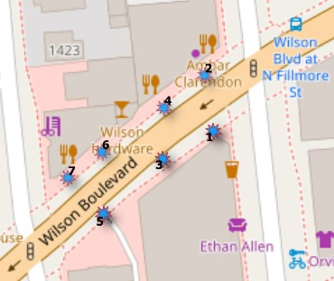 # Appearances Dataset

Let’s review whether there are empty or non-assigned geo points for any cells.

# A tibble: 1 x 2  
 yes_no n  
 <chr> <int>  
1 Yes 1052480

Data seems to contain no empty cells for geographical location for each row cell.

did n  
1 1e6e35f0 29761  
2 212cc010 7167

Let’s review the device id (sensors) and its recordings as data frame.

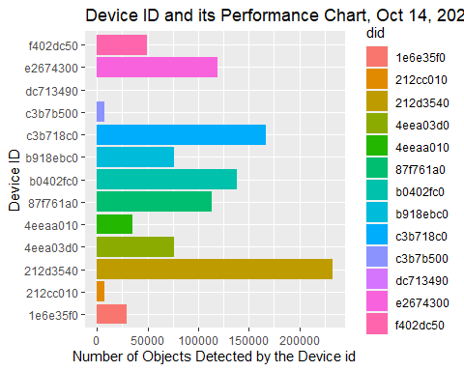

# A tibble: 2 x 4  
# Groups: timestamp, did [1]  
 timestamp did user_id n  
 <dttm> <chr> <chr> <int>  
1 2022-10-14 00:00:54 87f761a0 ce03b52e-4b74-11ed-b398-48b02d15cbd6 2  
2 2022-10-14 00:00:54 87f761a0 ce20ff94-4b74-11ed-b398-48b02d15cbd6 1

timestamp  
1 2022-10-14 00:00:00  
2 2022-10-14 02:00:00  
3 2022-10-14 04:00:00  
4 2022-10-14 06:00:00  
5 2022-10-14 08:00:00  
6 2022-10-14 10:00:00

Let’s review the how

# A tibble: 6 x 5  
 timestamp Y X did userid   
 <dttm> <chr> <chr> <chr> <chr>   
1 2022-10-14 23:59:59 38.88826052284246 -77.09378455732455 1e6e35f0 d7eca1da  
2 2022-10-14 23:59:59 38.888263195499135 -77.09378710901993 1e6e35f0 d7eccdc2  
3 2022-10-14 23:59:59 38.888367910857085 -77.09395429097694 c3b718c0 d0246a8c  
4 2022-10-14 23:59:59 38.888365552440376 -77.09363143165544 b918ebc0 68e8432a  
5 2022-10-14 23:59:59 38.88857198990392 -77.09366498036577 212d3540 bdd8bf86  
6 2022-10-14 23:59:59 38.888581554921046 -77.09365541650354 212d3540 c2e19a2a

# A tibble: 6 x 4  
# Groups: twohours, did [1]  
 twohours did userid n  
 <fct> <chr> <chr> <int>  
1 2022-10-14 00:00:00 1e6e35f0 0f4713e0 3  
2 2022-10-14 00:00:00 1e6e35f0 0f605f44 16  
3 2022-10-14 00:00:00 1e6e35f0 0fe3b862 16  
4 2022-10-14 00:00:00 1e6e35f0 1023cd76 16  
5 2022-10-14 00:00:00 1e6e35f0 1023e1a8 14  
6 2022-10-14 00:00:00 1e6e35f0 1023ef7c 17

## Steps took to analyze the geo points include:

### 1. Allocate geo points of the each user id

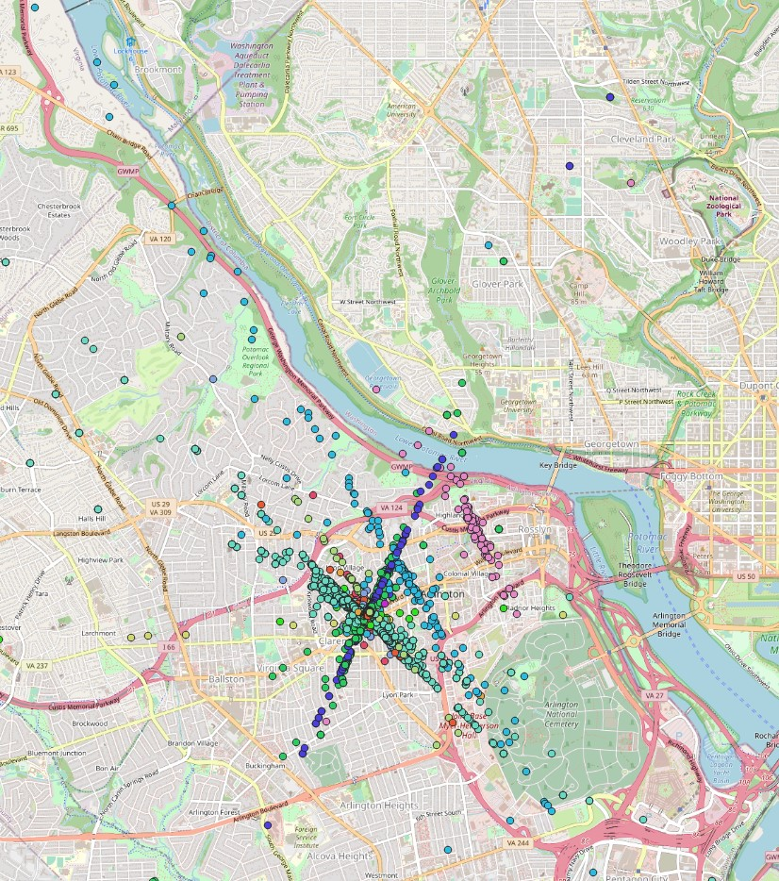

Geo Points

### 2. Draw a polygon that covers SIZ area.

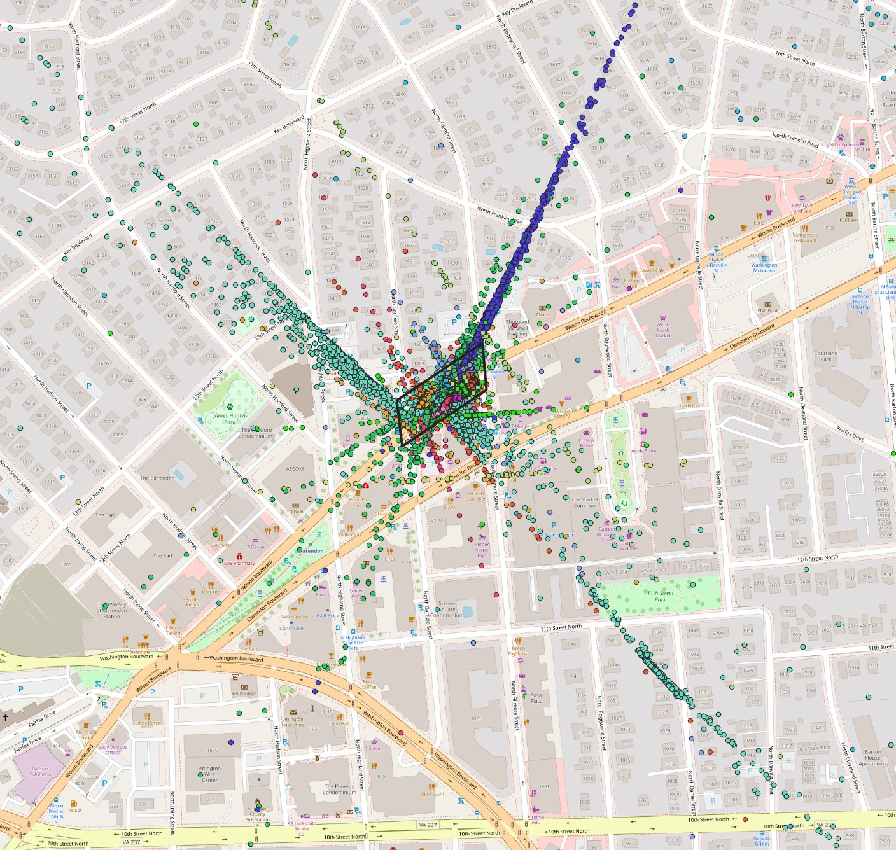

SIZ area

### 3. Clip the geo points within the polygon of the SIZ area

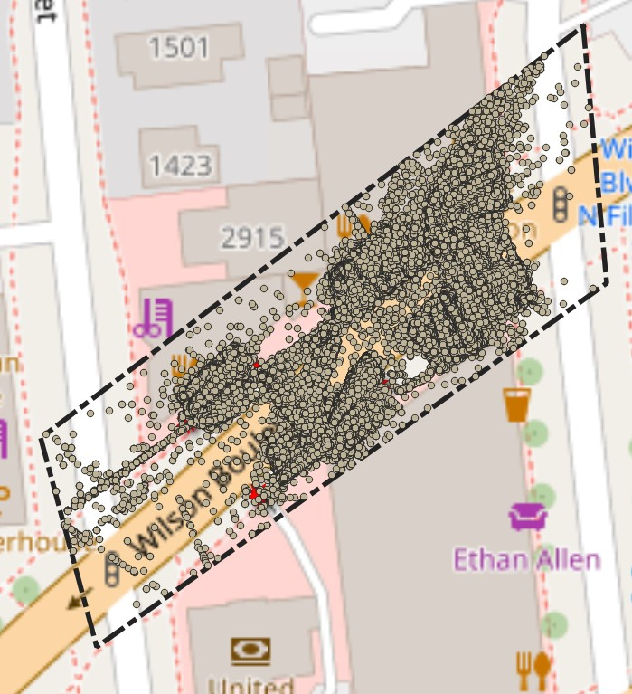

Clipped Geo Points within the SIZ area

### 4. Color the geo points based on device id

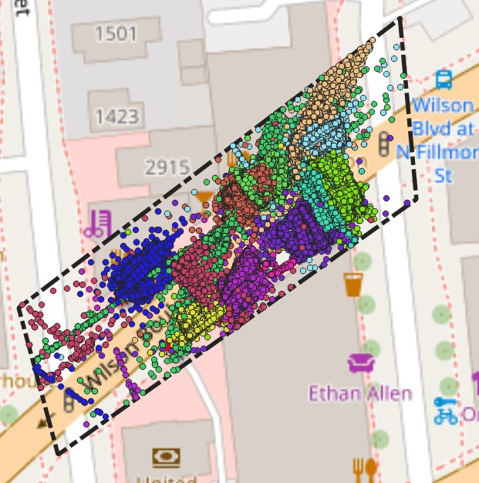 # Lines Crossed Dataset Review data set and its structure, column names.

tibble [4,415 x 9] (S3: tbl_df/tbl/data.frame)  
 $ ts : chr [1:4415] "2022-10-14 23:59:57.000 -0400" "2022-10-14 23:59:50.000 -0400" "2022-10-14 23:59:50.000 -0400" "2022-10-14 23:59:49.000 -0400" ...  
 $ id : chr [1:4415] "b7dd5fdf-62d3-4786-832d-9839d81d303c" "3fe12832-1403-4b46-8560-f7c7d6b80102" "1ce24c9c-e955-4146-9238-af4fef46b1d4" "6b7ab47f-d22e-42f0-83ce-a4ffb9d1f68e" ...  
 $ type : chr [1:4415] "IN" "IN" "IN" "IN" ...  
 $ device_id : chr [1:4415] "e2674300-ff8a-11eb-9c5e-1143c0a740b4" "c3b718c0-ff82-11eb-9c5e-1143c0a740b4" "e2674300-ff8a-11eb-9c5e-1143c0a740b4" "c3b718c0-ff82-11eb-9c5e-1143c0a740b4" ...  
 $ label : chr [1:4415] "Line Cross 3" "Line Cross 2" "Line Cross 3" "Line Cross 2" ...  
 $ count : num [1:4415] 1 1 1 1 1 1 1 1 1 2 ...  
 $ object_type: chr [1:4415] "PERSON" "PERSON" "PERSON" "PERSON" ...  
 $ timestamp : POSIXct[1:4415], format: "2022-10-14 23:59:57" "2022-10-14 23:59:50" ...  
 $ did : chr [1:4415] "e2674300" "c3b718c0" "e2674300" "c3b718c0" ...

# A tibble: 4 x 4  
# Groups: did [4]  
 did label total fixture  
 <chr> <chr> <dbl> <dbl>  
1 1e6e35f0 Line cross 1 534 5  
2 87f761a0 Line Cross 4 994 1  
3 c3b718c0 Line Cross 2 1738 7  
4 e2674300 Line Cross 3 1554 2

`summarise()` has grouped output by 'twohours'. You can override using the  
`.groups` argument.

# A tibble: 6 x 5  
# Groups: twohours [6]  
 twohours `1e6e35f0` `87f761a0` c3b718c0 e2674300  
 <fct> <dbl> <dbl> <dbl> <dbl>  
1 2022-10-14 00:00:00 3 13 12 11  
2 2022-10-14 02:00:00 NA NA NA 1  
3 2022-10-14 04:00:00 NA 1 1 2  
4 2022-10-14 06:00:00 5 15 13 21  
5 2022-10-14 08:00:00 26 33 41 83  
6 2022-10-14 10:00:00 32 62 66 72

[1] 12 15

timestamp.x 1e6e35f0.x 212cc010 212d3540 4eea03d0 4eeaa010 87f761a0.x  
1 2022-10-14 00:00:00 351 81 413 297 41 356  
2 2022-10-14 02:00:00 12 0 18 23 0 32  
3 2022-10-14 04:00:00 23 0 145 143 47 64  
4 2022-10-14 06:00:00 554 45 1107 993 421 1045  
5 2022-10-14 08:00:00 1442 1289 4288 2965 1724 3471  
6 2022-10-14 10:00:00 1701 1236 4394 3591 1814 5655  
 b0402fc0 b918ebc0 c3b718c0.x c3b7b500 e2674300.x f402dc50 dc713490 1e6e35f0.y  
1 521 417 477 82 398 222 0 3  
2 29 17 24 3 60 11 0 0  
3 100 18 254 44 177 6 16 0  
4 1415 673 1033 361 1392 700 97 5  
5 4379 4361 2865 728 3585 2902 0 26  
6 4621 4088 4059 834 4446 4191 0 32  
 87f761a0.y c3b718c0.y e2674300.y  
1 13 12 11  
2 0 0 1  
3 1 1 2  
4 15 13 21  
5 33 41 83  
6 62 66 72

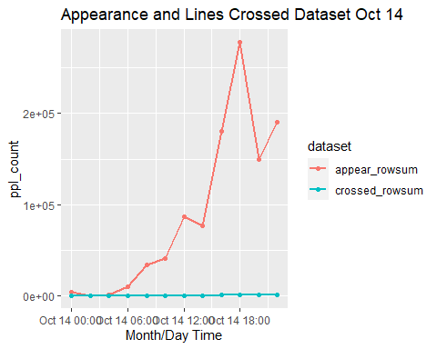

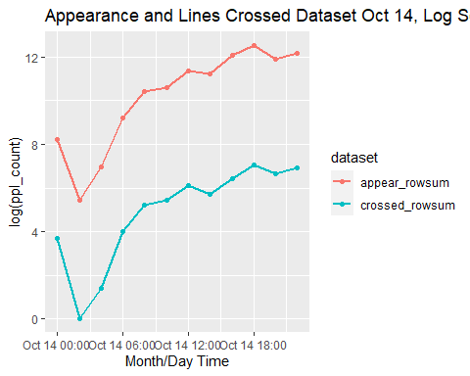

## save the file in csv format for Qgis upload

Appearance October 15 data seems to follow the same pattern of allocating geo points beyond the SIZ area. 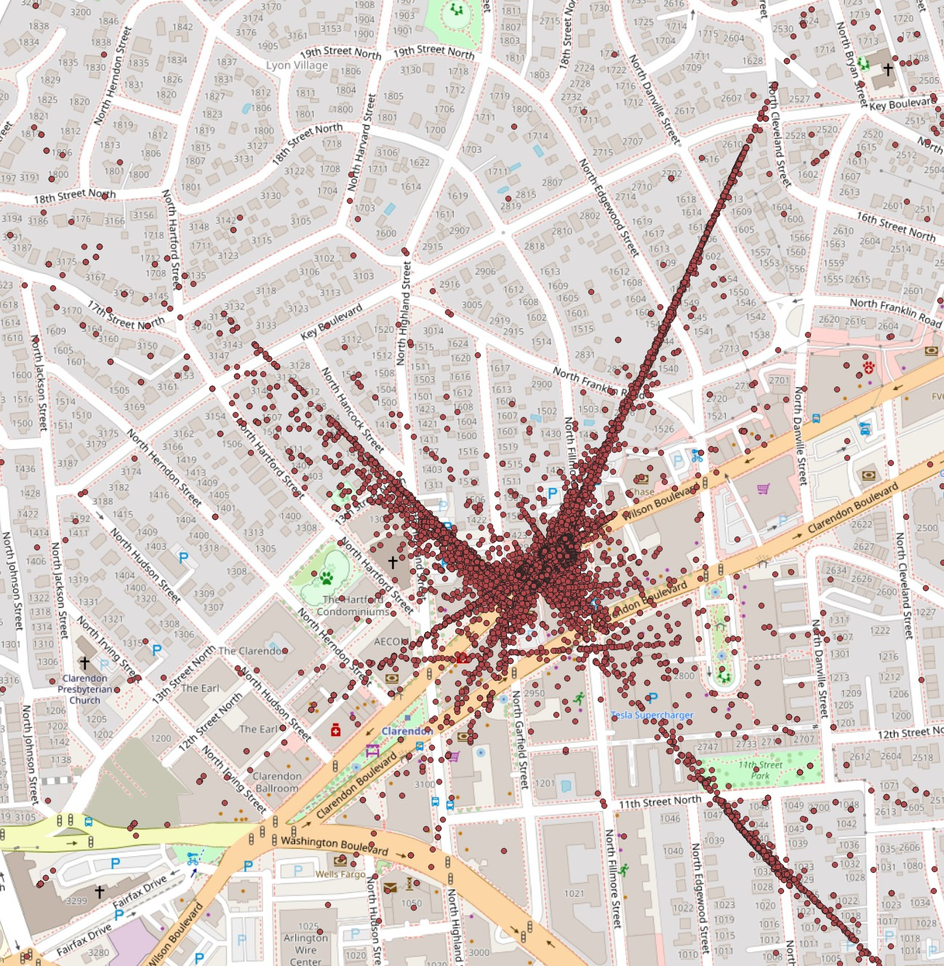

As well as Appearance October 16 data seems to follow the same pattern of allocating geo points beyond the SIZ area. 