Dear Bill Isbill,

It's Will from Ops. I am glad you reached out to me before before your budget hearing with the board because I found some discrepancies in your calculations. It looks like for some of your work, you inadvertantly used either the aggregate sales data or the data for Store A. I went ahead and processed all of store B’s numbers instead. The good news is that my revisions should set you up with an even better chance for an expanded budget in the next fiscal cycle.

I suppose the first thing we should go over is the new mean, median, and standard deviation numbers for your store. Based on my research, the revised sale figures for the time period spanning from June to September 2019 should be

Store B MEAN: $6088
Store B MEDIAN: $5800
Store B STD DEV: $904

At first glance it might look like these are worse numbers, but please rest assured that they are not. What really matters is your store’s performance relative to itself and to the other stores in the region. Lets take a look at the data when plotted side by side:
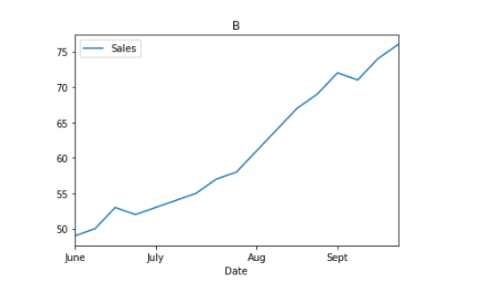
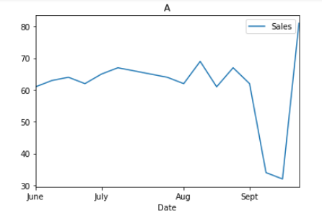
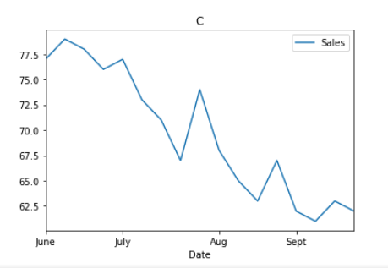

As you can see, while the other stores are experiencing downtrends or inconsistency, store B’s sales are consistently on the rise!
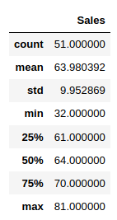
Here is some data to help you flesh out your store comparison.
To the right is the average by store, then overall average.
This show that B is performing with the other stores, a huge improvement from last budget cycle!
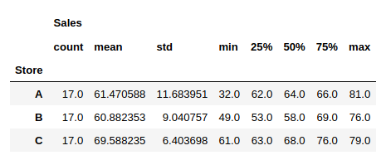

Next I want to talk about some figures you should probably leave out. Most important is your Empirical Rule. The Empirical Rule does not apply in your situation because the sales data is not a normal distribution (the traditional bell curve.) After charting the data I found our sales to look a bit more irregular:
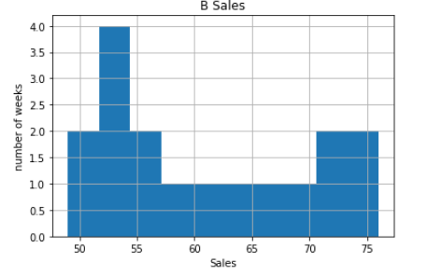

This histogram uses another way to show that while we have been experiencing a boom, the majority of our weekly sales reports are still under $6000. Using Chebychev’s Theorem we can determine that in fact 75% of our sales are within $4334.07 and $7842.40. These numbers do not mean as much for your purposes, so I would just leave that part out.

Based on this new information, I think we have a great shot at an increased budget. We are trending upward, and closing the gap between other stores. Store A’s rocky performance could be an anomaly, but with a bigger budget I’m sure we can infuse cash into our customer experience and boost our sales even more!

Please do not hesitate to ask if you have any questions.

I hope you are well,
William Pulkownik

