***Experiment No : 07***

***Experiment Name:*** *Implementation of Email Service.*

***Objective:***

­In this experiment, we are going to implement Email service using ‘CISCO Packet Tracer’.

Here, we use a sample network diagram it contains 2 switches, 1 Router, 2 mail servers and 2 PCs.

Server1: IP: 192.168.1.3

DNS name: ju.edu

Server2: IP: 192.168.2.3

DNS name: emcs.edu

User-1 in network 192.168.1.0 has email address [mkroy@ju.edu](mailto:mkroy@ju.edu) and user-2 in network 102.168.2.0 has email address [roy@emcs.edu](mailto:roy@emcs.edu) .

***Design Procedure:***

# Let us implement the network like below:

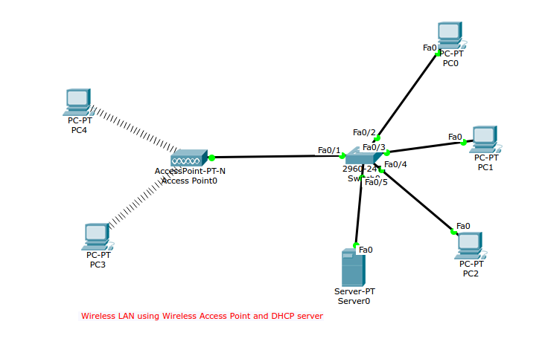

Configure host-1: IP 192.168.1.1:

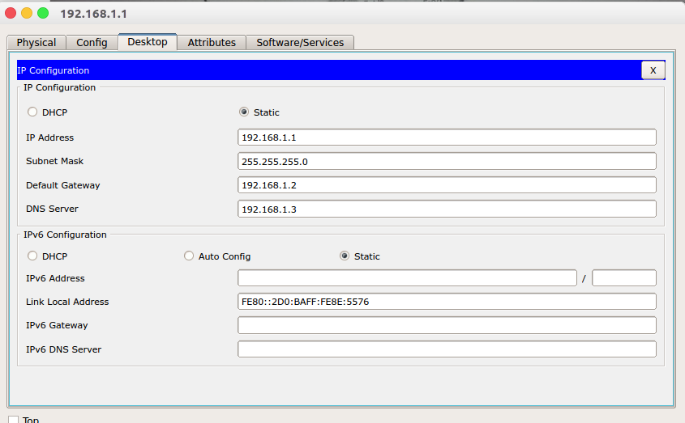

Configure host-2: IP: 192.168.2.1

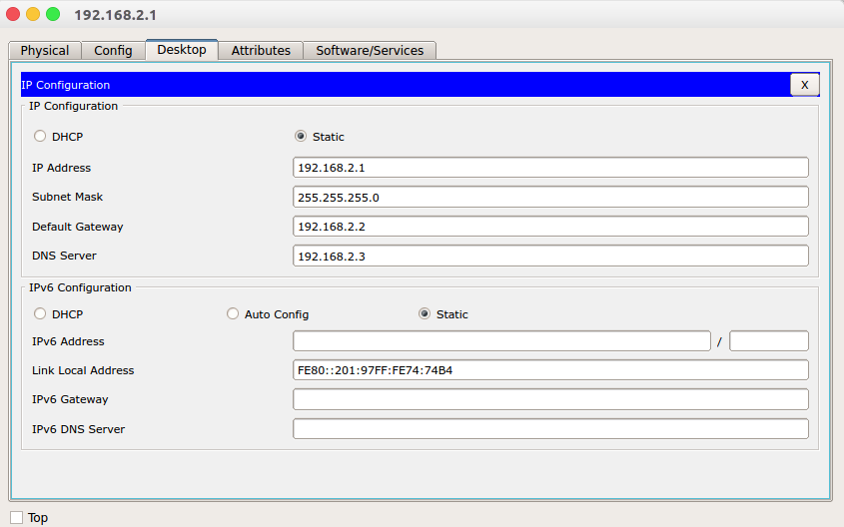

Configure both interface of router:

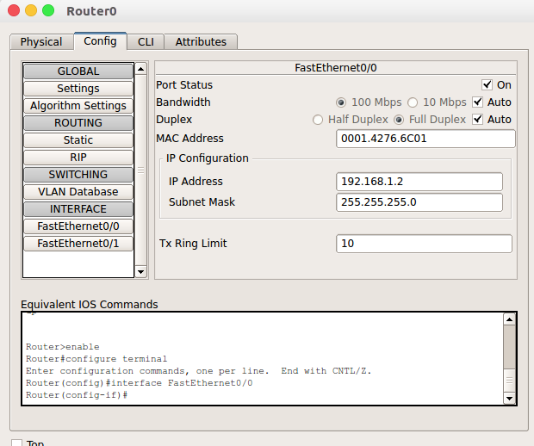

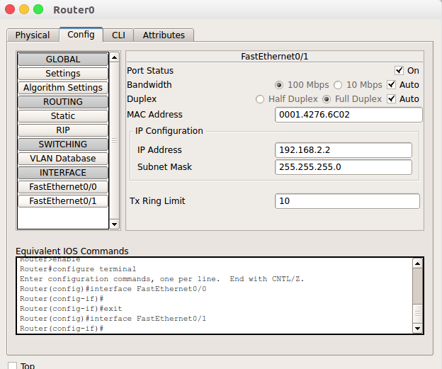

Configure 1st DNS/MAIL server:

IP configure:

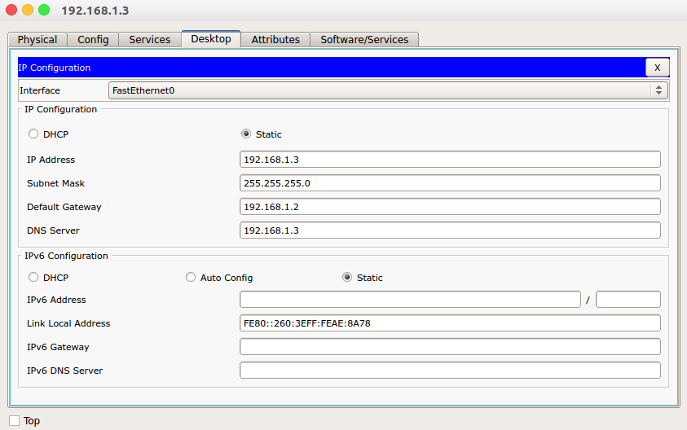

DNS configure:

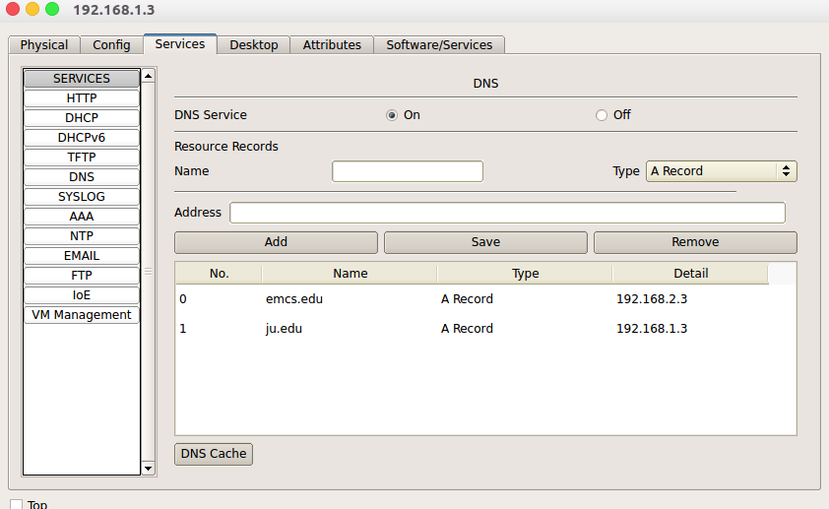

Email Configure:

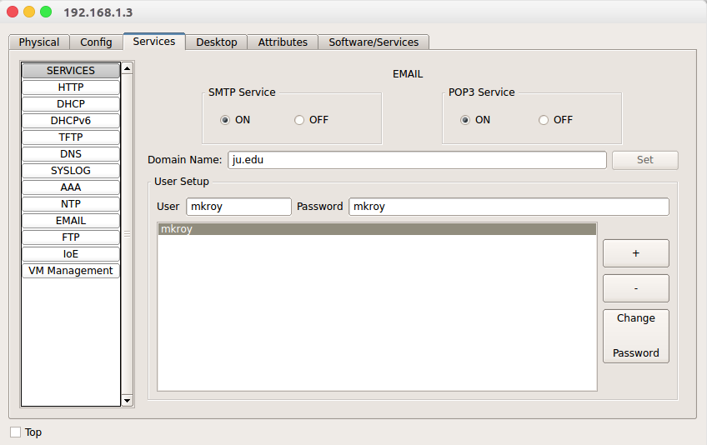

Configure 2nd DNS/MAIL server:

IP configure:

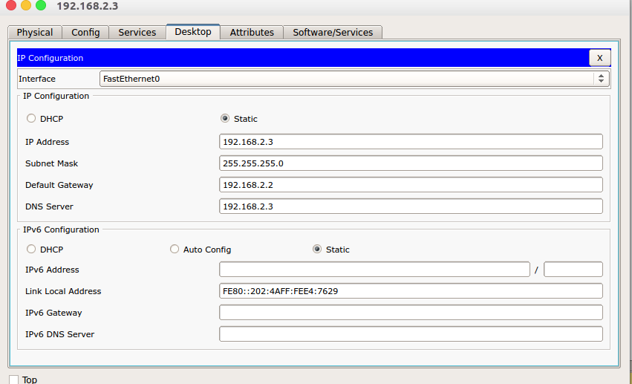

DNS configure:

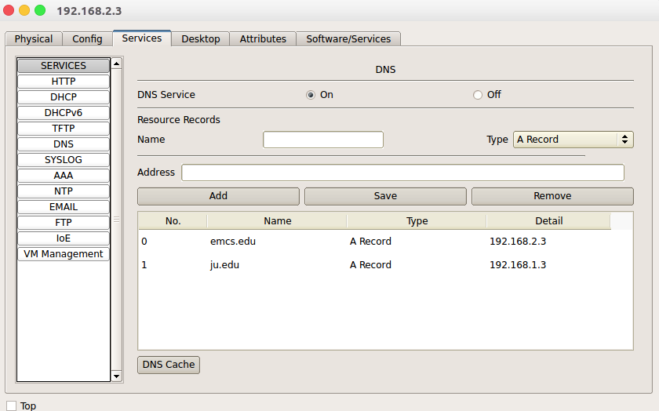

Email configure:

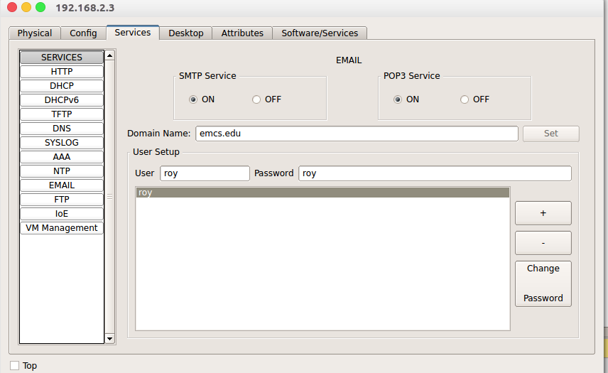

Configure the mail of the client-1:

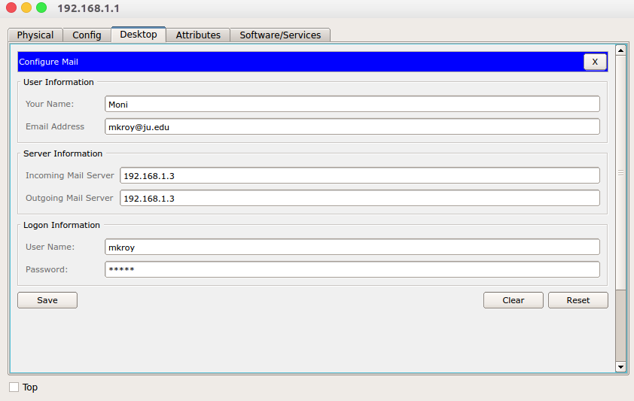

Configure the mail for client-2:

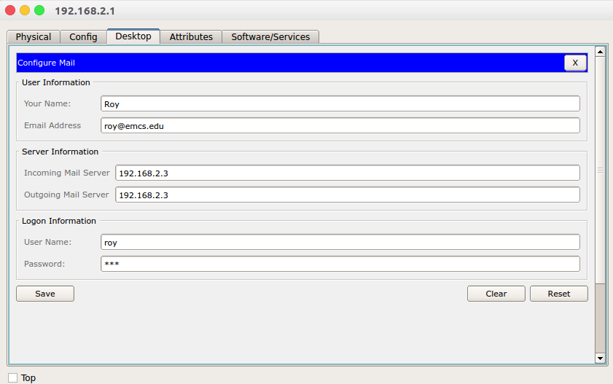

Send mail from client-1:

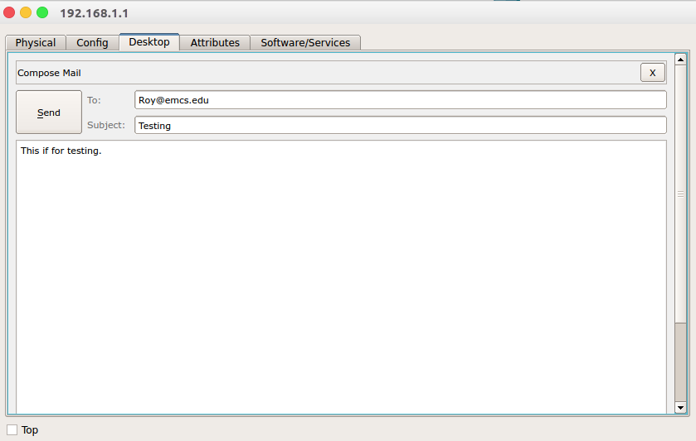

Verify the received mail from client-2:

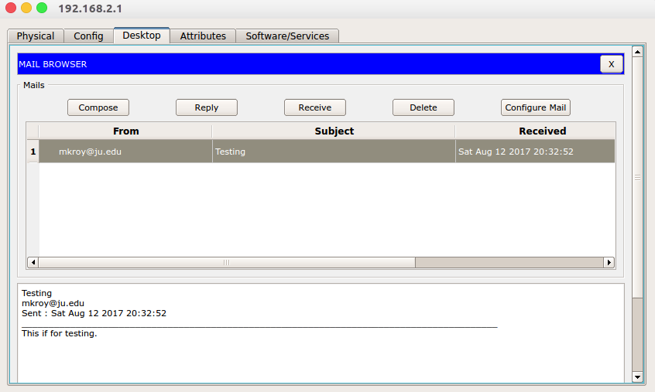

Reply mail from client-2:

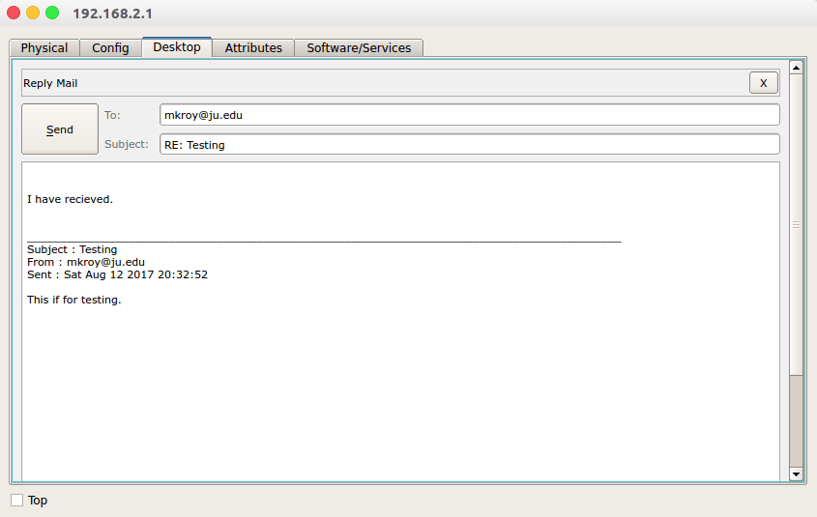

Verify the reply mail from client-1:

