***Experiment No: 02***

***Experiment Name:*** Packet through Routers.

***Objective:***

Since we’re going to transfer packet through Routers. we’ll design a simple network diagram using “ CISCO Packet Tracer”.

First we’ll test a simple packet transfer from one PC. The circuit contains one or more Hub(s) , Routers, some PCs. We’ll connect two end point PC-to-PC , PC-to-Hub/Switch, PC to Routers, Routers to Hub, etc.

***Design procedure:***

Here a simple network connection using Routers & hubs:

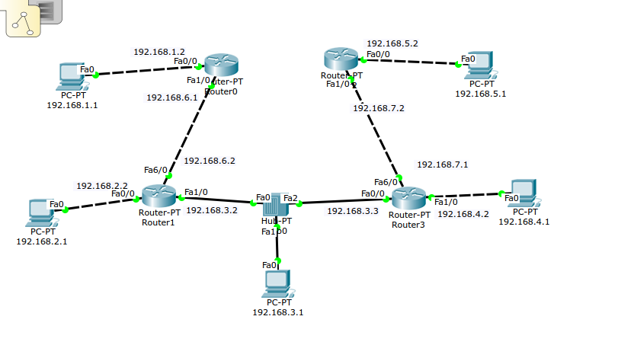

*Illustration 1: A network connection with routers & Hub*

This figure shows the connection among PC , routers and hub.

***Details procedure of configure router, PC & hub:***

***1. PC IP configure:***

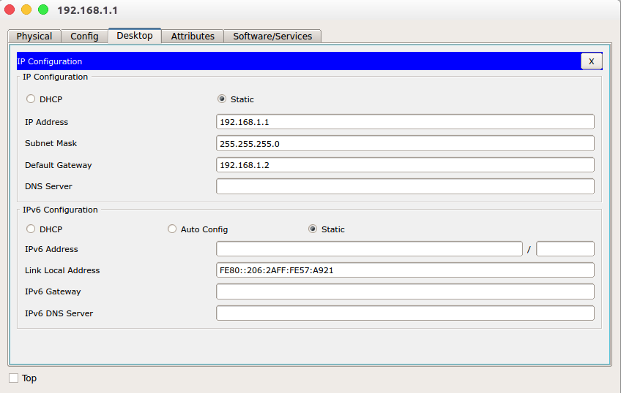 *Illustration 2: IP configure of PC*

***2. Router configure:***

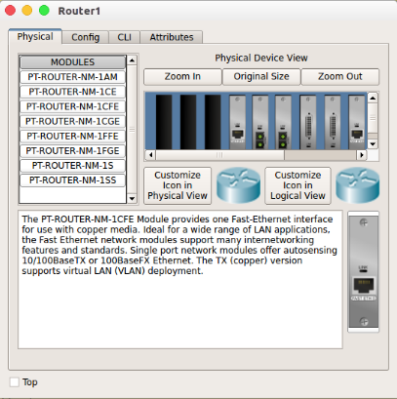

*Illustration 3: Add Interface card ICFE*

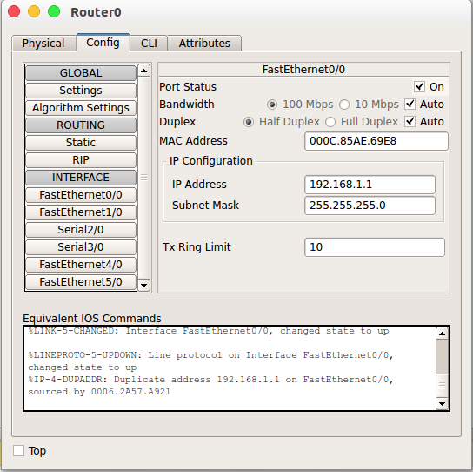

*Illustration 4: Fast Ethernet Configure*

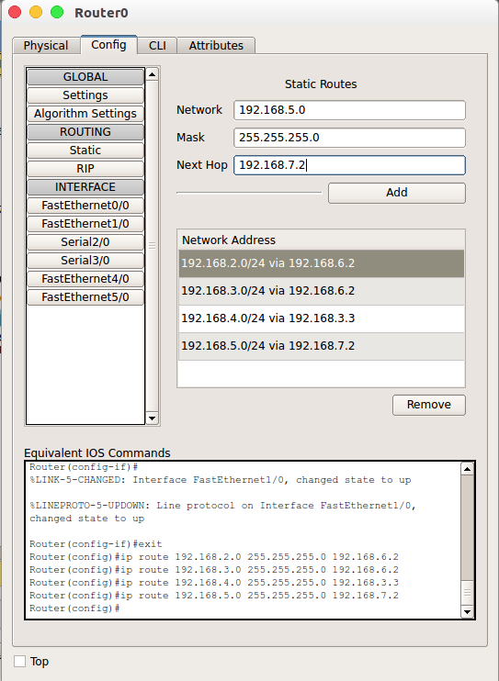

*Illustration 5: Routes configure*

**3. Packet transferring between two PC.**

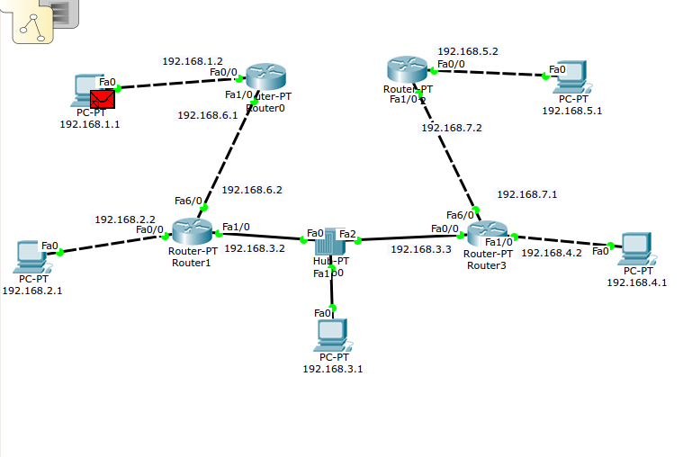

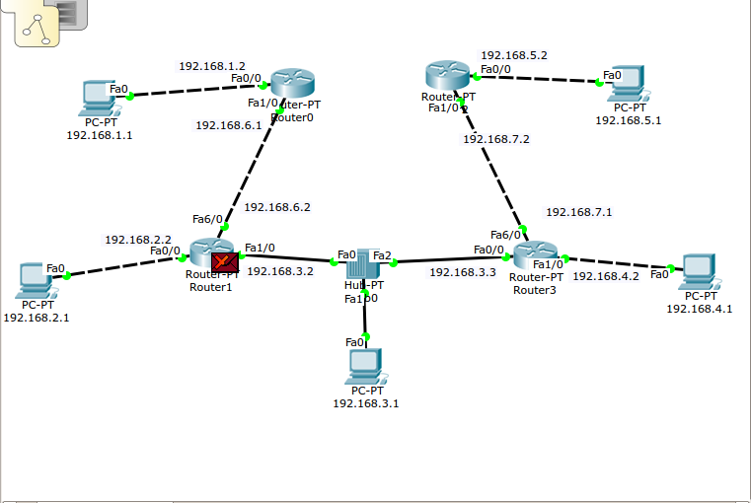

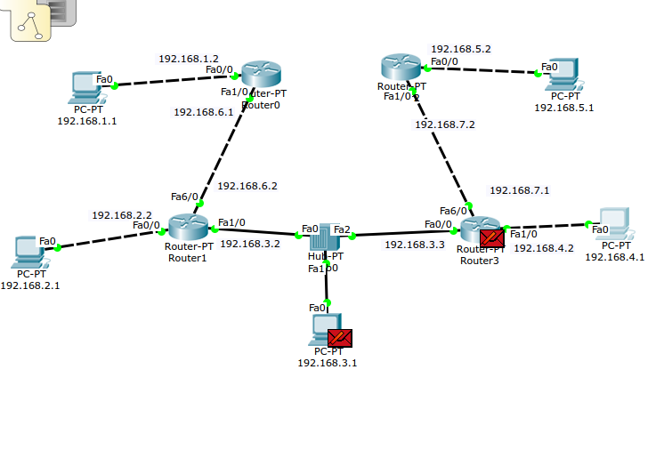

*Illustration 6: First time packet transferring*

**Successful packet transferring:**

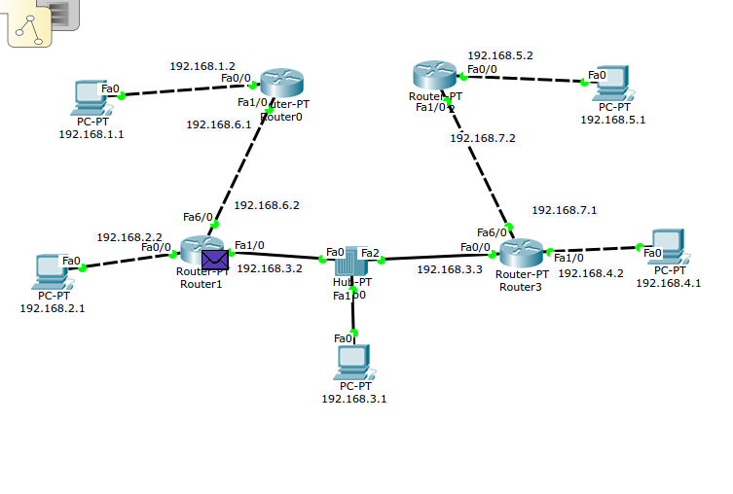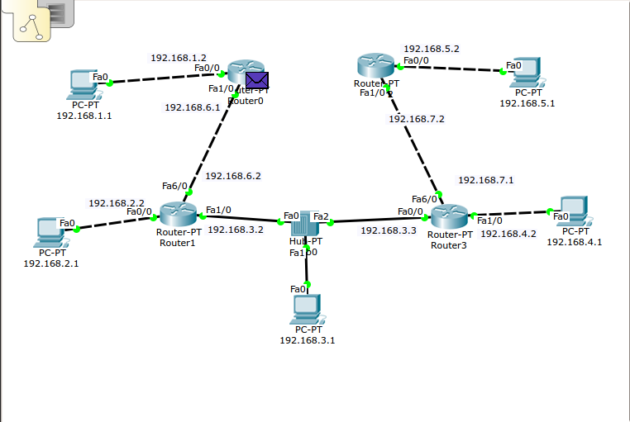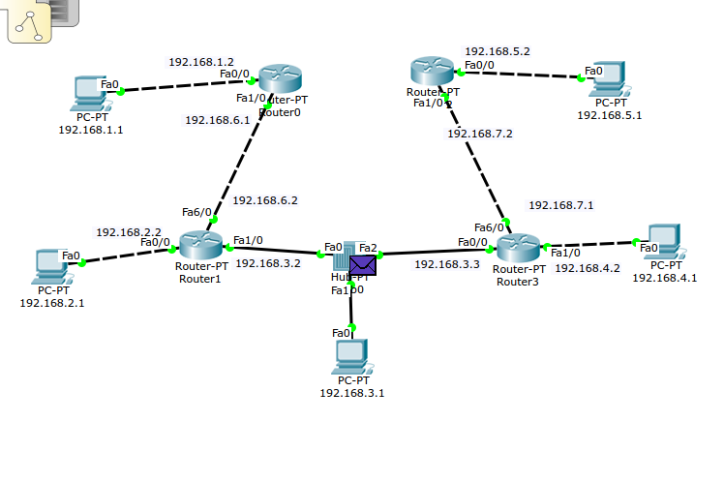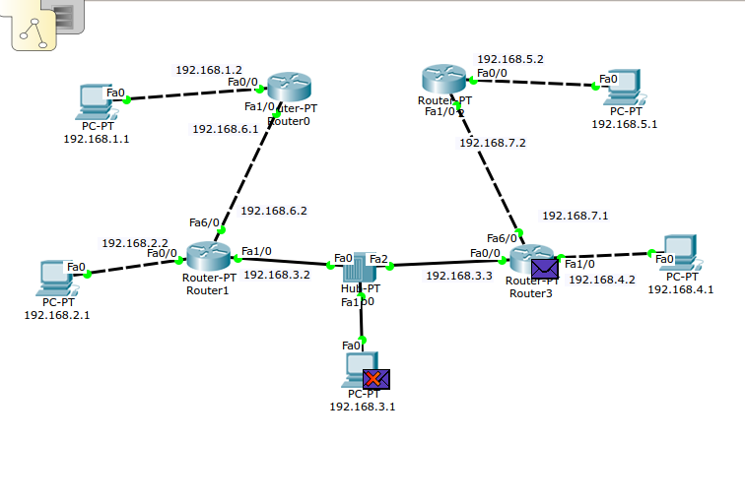

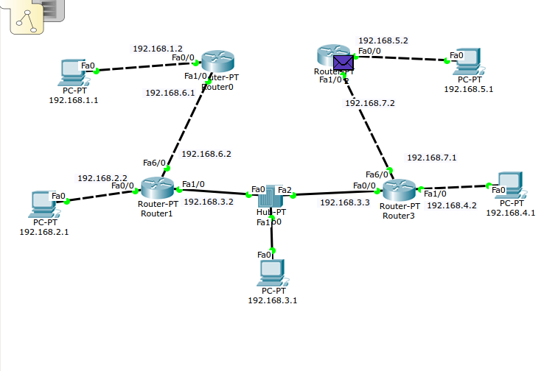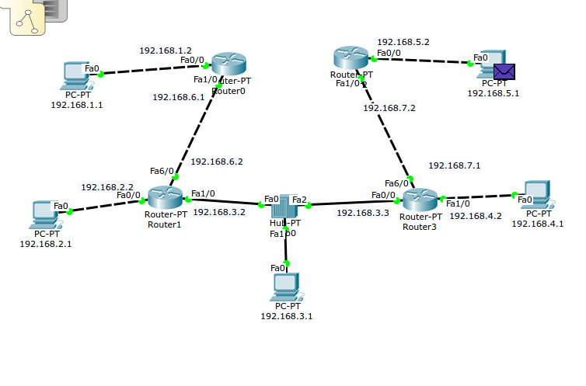

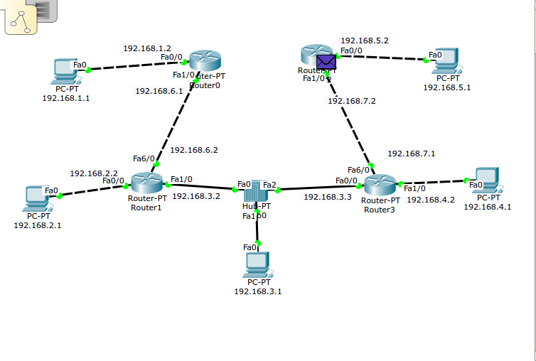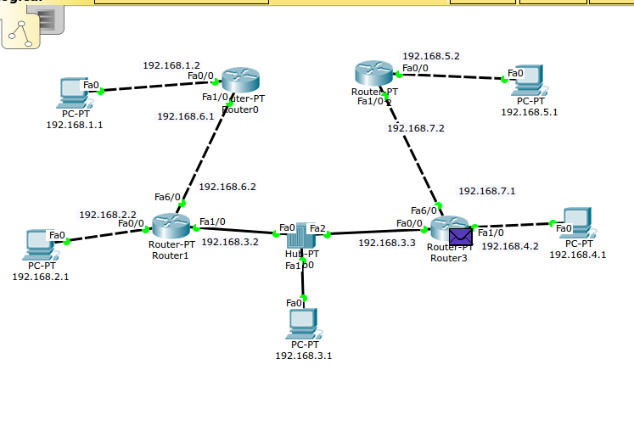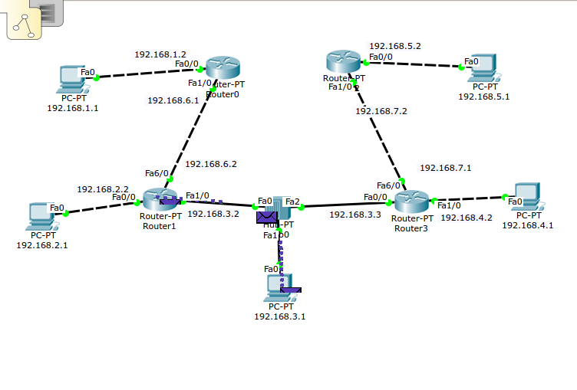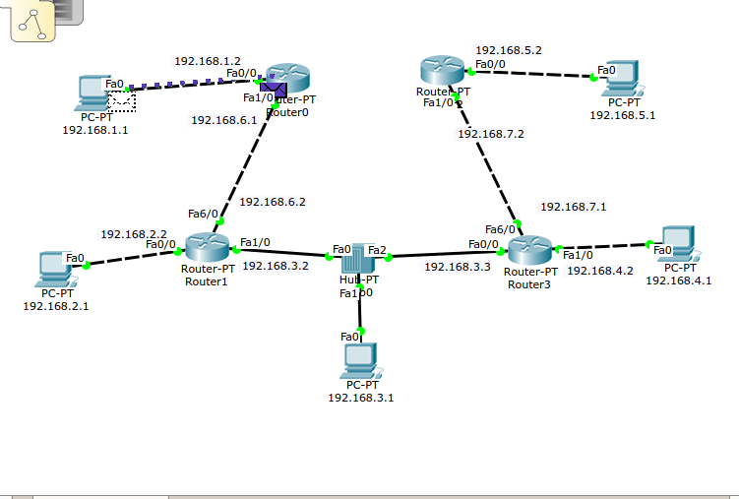

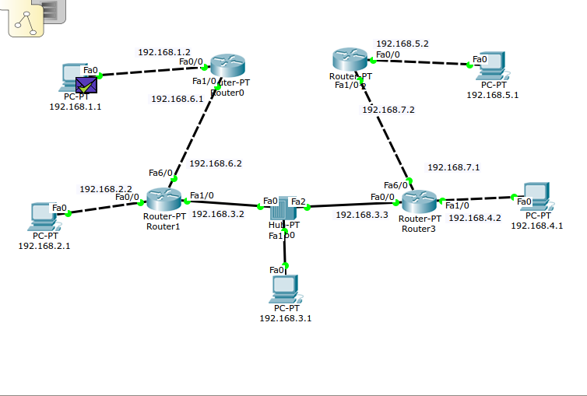

*Illustration 7: Transferring packet trough Routers.*