***Experiment No: 03***

***Experiment Name:*** Packet through Routers (Routers Configured with CLI)

***Objective:***

Since we’re going to transfer packet through Routers. we’ll design a simple network diagram using “CISCO Packet Tracer”.

In this experiment we’ll test a simple packet transfer from one PC to another. The circuit contains 3 Routers with delta connection & some PCs. We’ll configure the routers via command line interface and evaluate packet transfer (ICMP packet).

***Design procedure:***

* 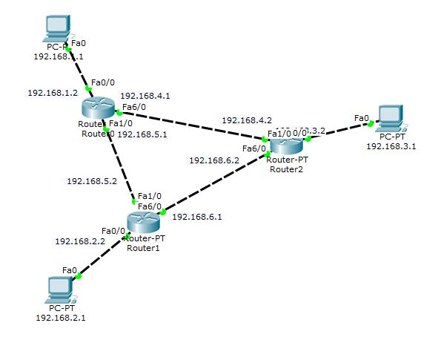Here a simple network connection using Routers connected via a delta connection:

The above figure shows the connection among PCs & routers.

* ***Details procedure of router, End Device configuration:***
  + ***End Device IP address configure:***
  + ***Device1***

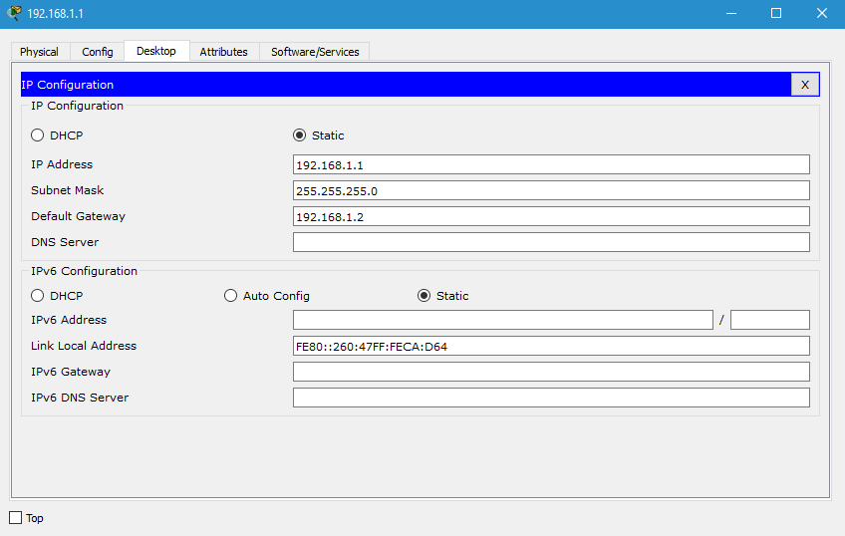

* + 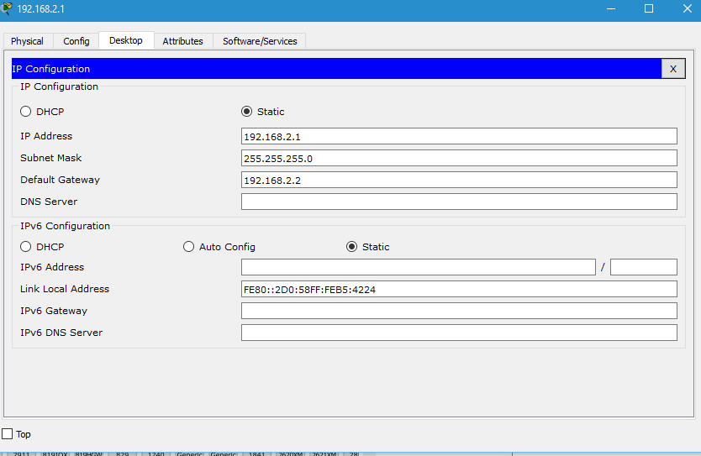***Device 2***
  + ***Device 3***

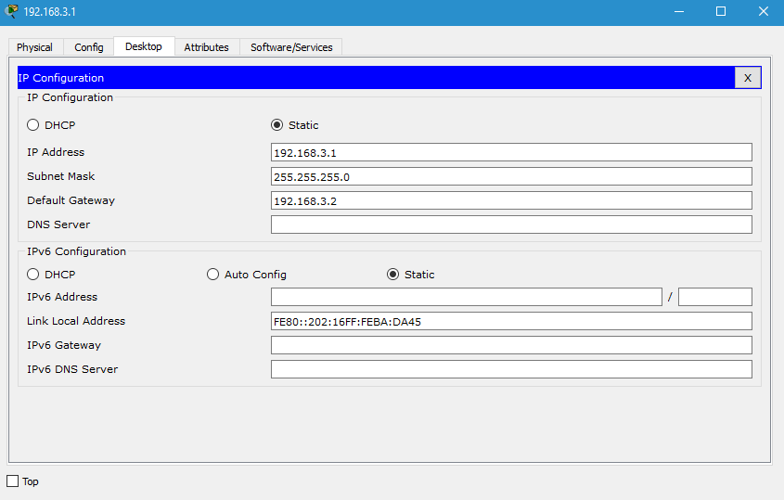

* ***Router configuration with CLI:*** *Each Router requires two step to be fully functional, first step we assign IP-addresses relative to each router. The second step we make the routing table ready. The router configuration for each router is as follows****:***
  + ***Router:0***

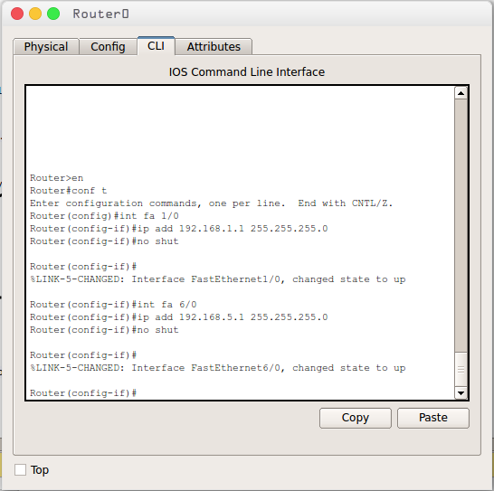

* + ***Router:1***

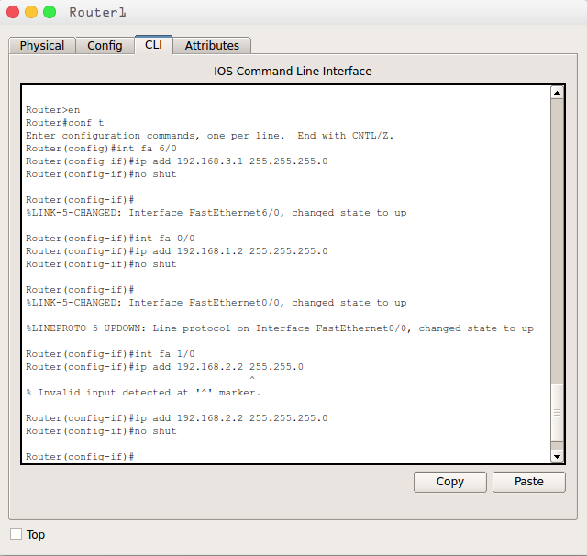

* + ***Router:2***

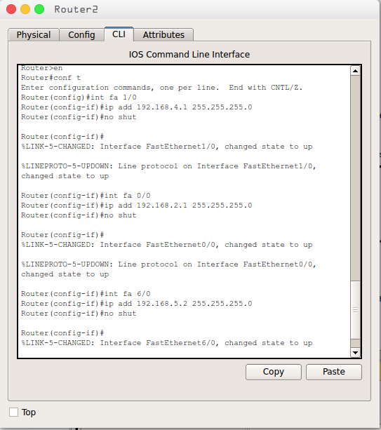

* **Routing Table:**
  + - **Router-0**

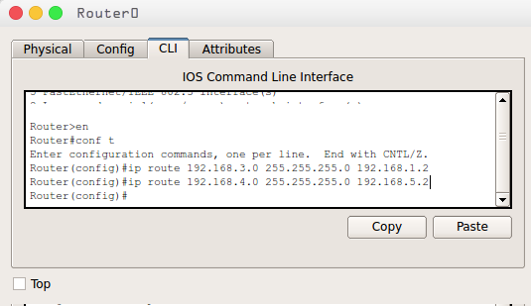

* + - **Router-2**

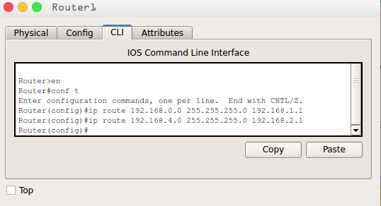

* **Router-3**

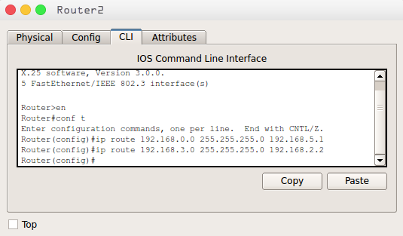

* Packet transferring between two Device.

