***Experiment No: 04***

***Experiment Name:*** Routing based on OSPF

***Objective:***

Since we’re going to transfer packet through Routers. we’ll design a simple network diagram using ‘CISCO Packet Tracer’.

In this experiment we’ll test a simple packet transfer from one PC to another. The circuit contains 3 Routers with delta connection with switch connected to each router & some PCs connected to each switches. We’ll configure the routers via command line interface and evaluate packet transfer (ICMP packet) for OSPF routing algorithm.

***Design procedure:***

* 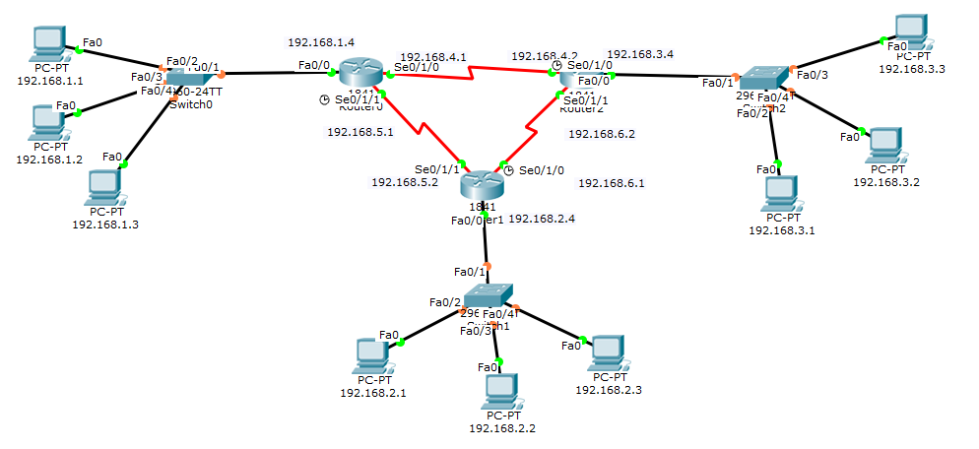Here a simple network connection using Routers connected via a delta connection:

The above figure shows the connection among PCs & routers.

* ***Details procedure of router, End Device configuration:***
  + ***End Device IP address configure:*** *These are sample configuration, not all end-device configuration has shown,*

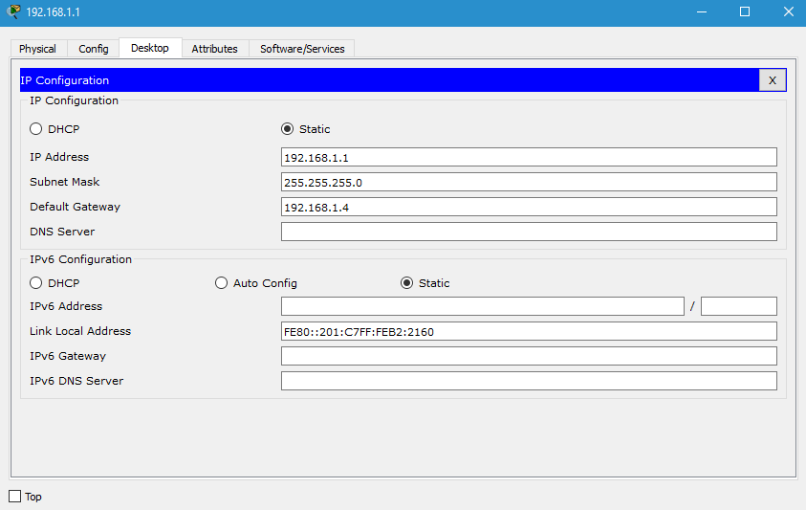

* ***Router configuration with CLI:*** *Each Router requires two step to be fully functional, first step we assign IP-addresses relative to each router. The second step we fix the OSPF area assigning. The router configuration for each router is as follows****:***
  + ***Router:0***

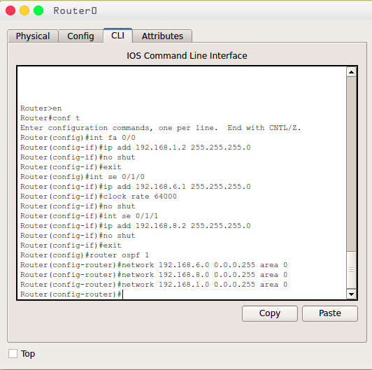

Illustration 5: Router-1 Configuration

* + ***Router:1***

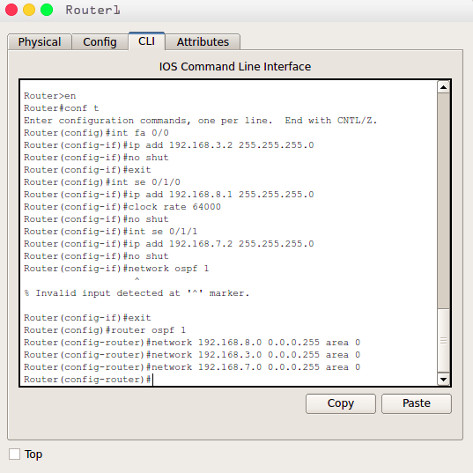

* + ***Router:2***

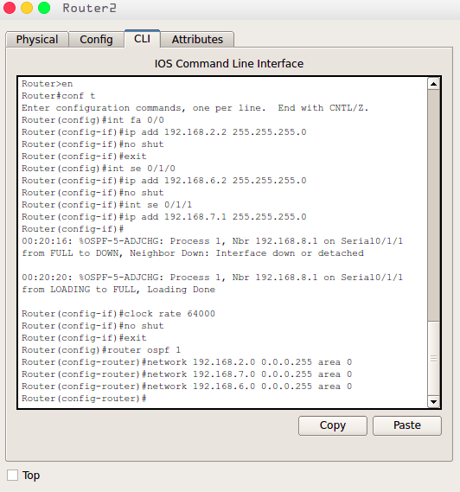

* 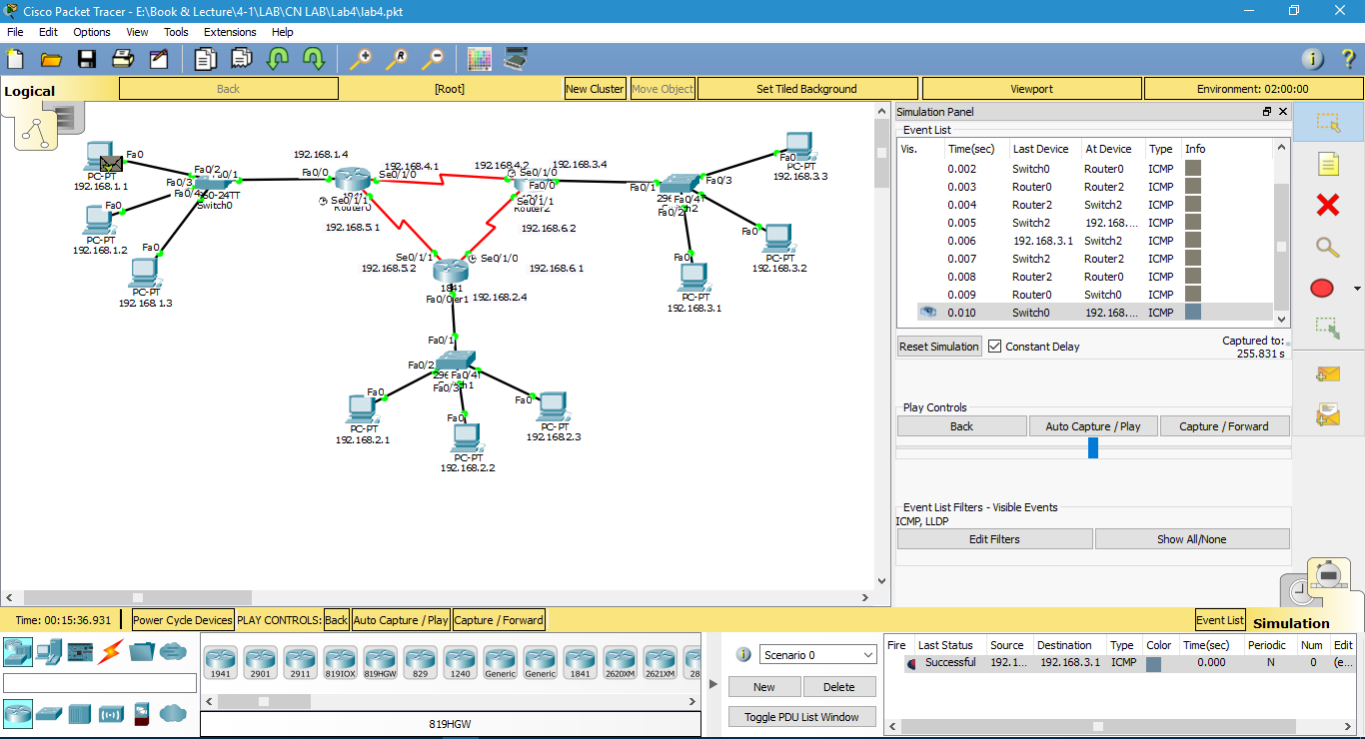**Packet transferring between two Device.**