***Experiment No :*** *05*

***Experiment Name :*** DNS server configuration

***Objective:***

In this experiment we’re going to simulate and evaluate the networking principle of DNS server. A DNS server is any computer registered to join the Domain Name System. A DNS server runs special-purpose networking software, features a public IP address, and contains a database of network names and addresses for other Internet hosts. We’ll be using two DNS servers for two virtual websites and test the working principle

***Design procedure:***

* Here a simple network connection using Routers, Switches and DNS servers:

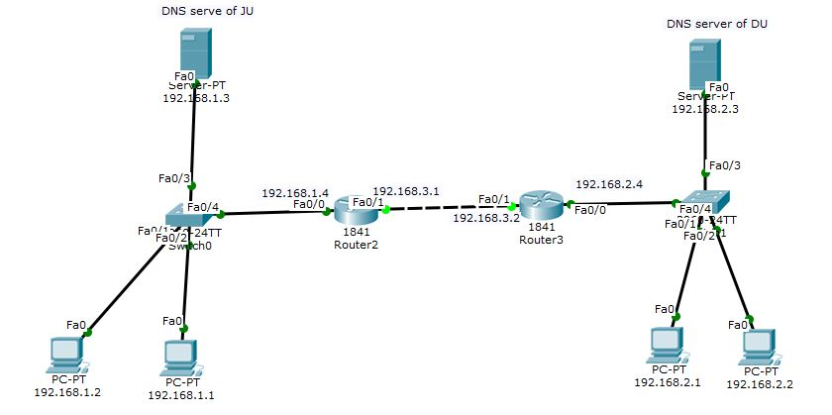  
 Illustration 1: DNS server connected to switch, connected via two routers.

The above figure shows the connection among PCs, switches, routers & DNS servers.

* ***Details procedure of router, End Device configuration:***
  + ***End Device IP address configure:*** *These are sample configuration, not all end-device configuration has shown,*
  + ***Device 1***

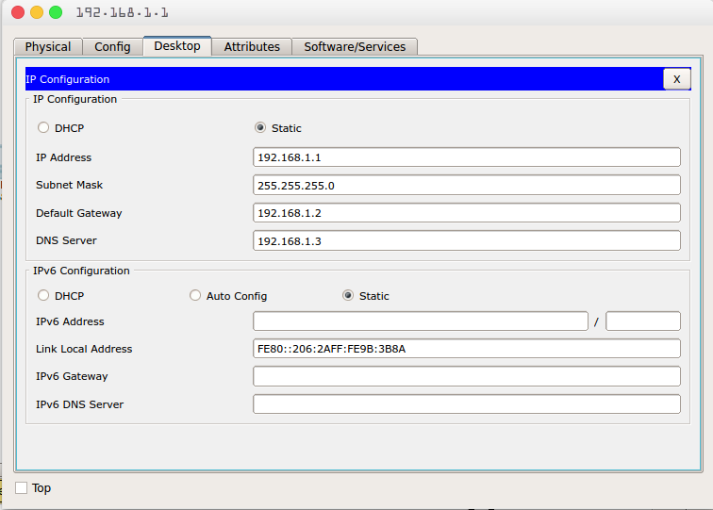

* + 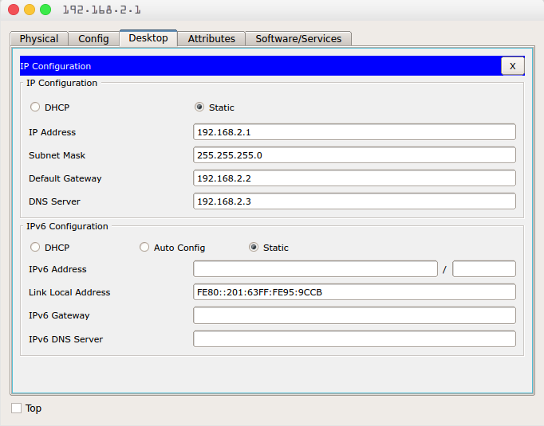***Device 2***
* ***2. Router configuration:*** *Each Router requires two step to be fully functional, first step we assign IP-addresses relative to each router. The second step we setup the routing table****:***
  + ***Router:0***

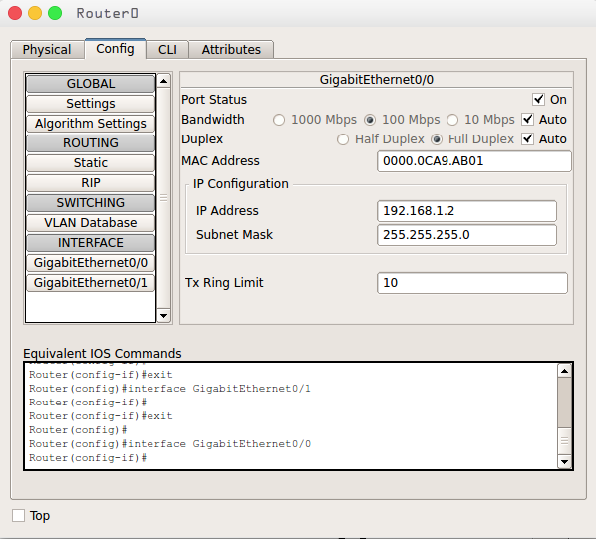

* ***Router:1***

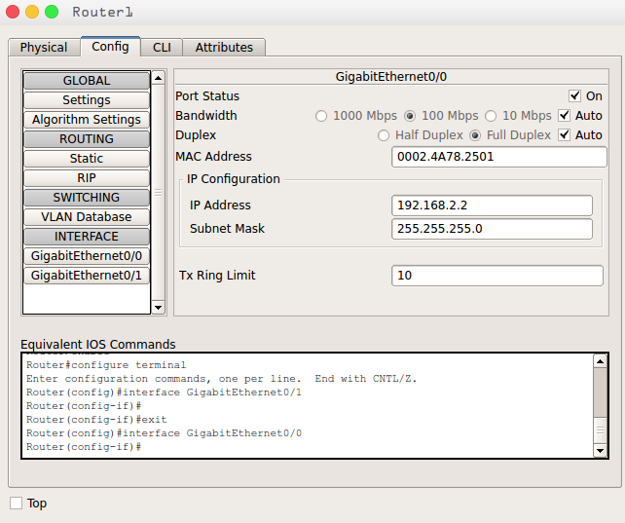

* ***DNS server configuration: We need to configure both of the DNS servers as follows***
  + ***DNS Server 1:***

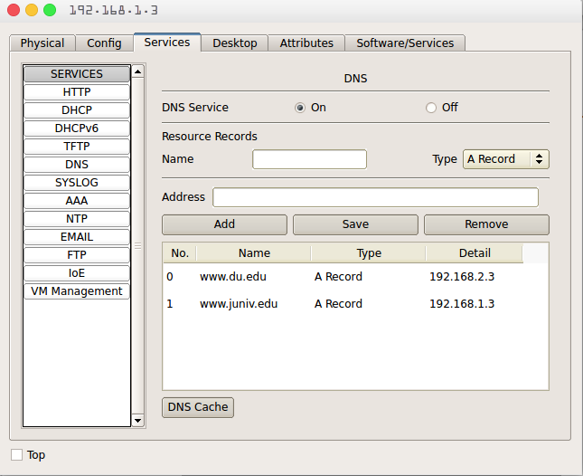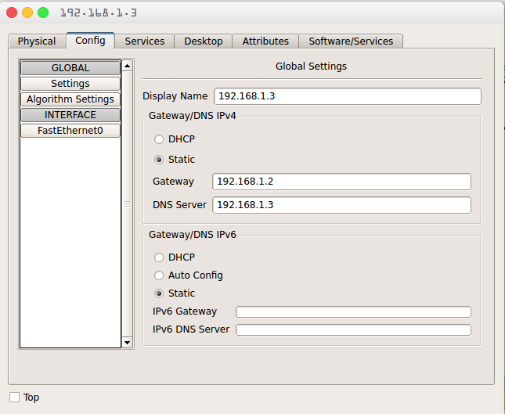

* + 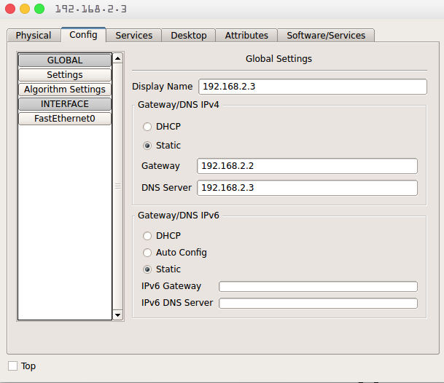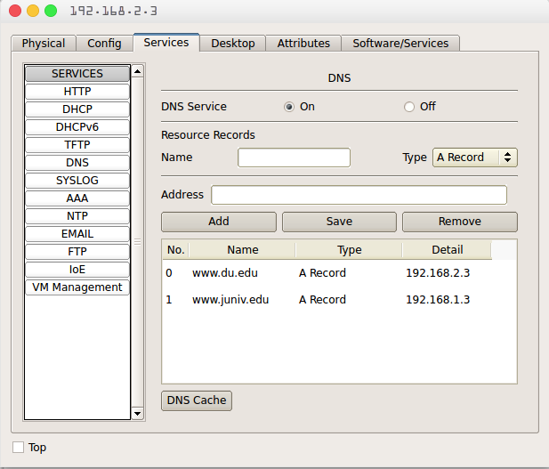***DNS Server 2:***

***Testing DNS Record:*** *Visiting one of the websites from any PC will make sure the DNS service*

