***Experiment No:*** *06*

***Experiment Name:*** *Implementation of Wireless LAN using Wireless Access Point and DHCP server.*

***Objective:***

­In this experiment, we are going to implement Wireless LAN using Wireless Access Point and DHCP server on ‘CISCO Packet Tracer’.

Here, we use a sample network diagram it contains 1 switch, 1 Wireless Access Point, 1 server and 5 PCs.

***Design Procedure:***

# E:\Book & Lecture\4-1\LAB\CN LAB\Lab6\pic\8.pngLet us implement the network like below:

* Server Configuration:

1. 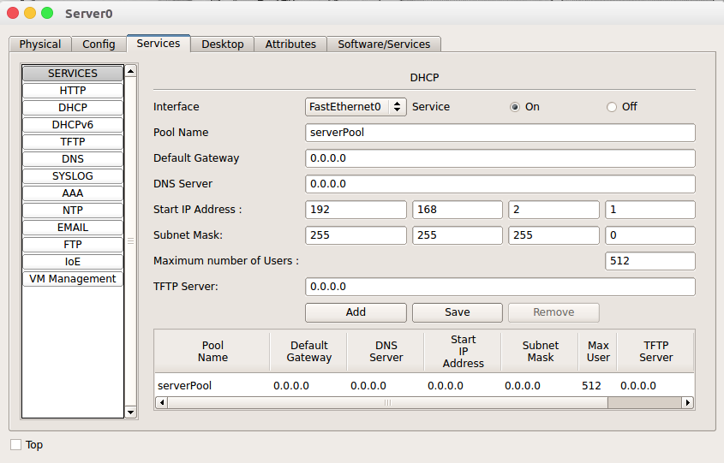DHCP configure:
2. 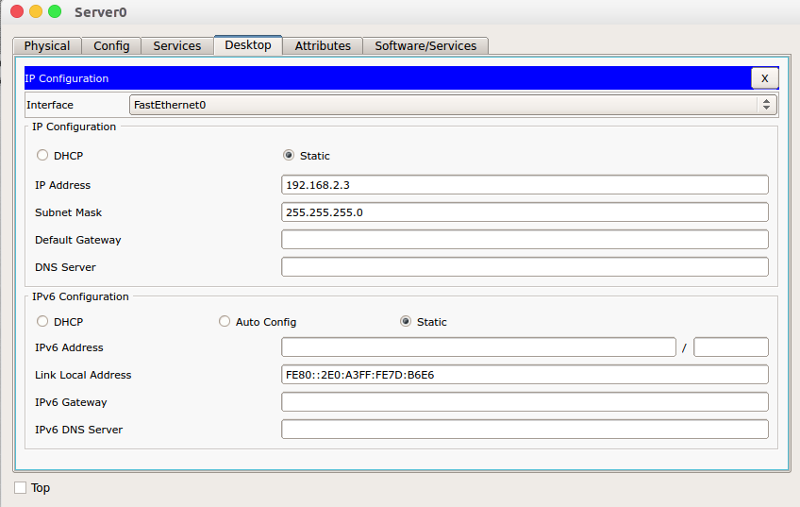IP configure:

* Install WLAN card for PC-3:
  + At first off the connection. Then add the ‘Linksys-WMP300N’ WLAN card for PC-3 and same for PC 4.

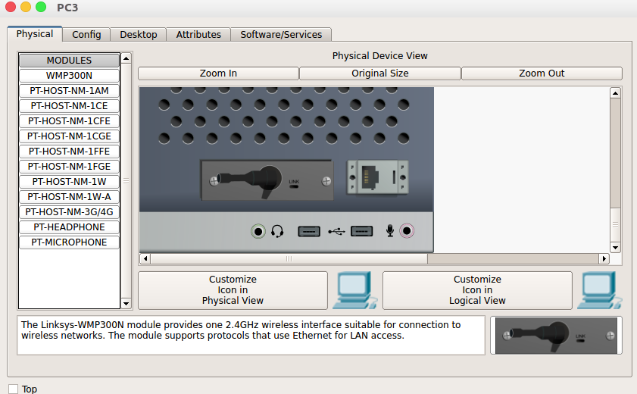

* 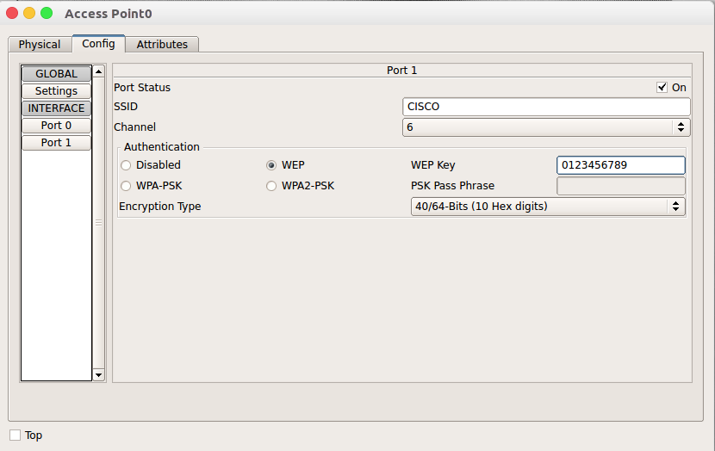Configure the access point like below:
* 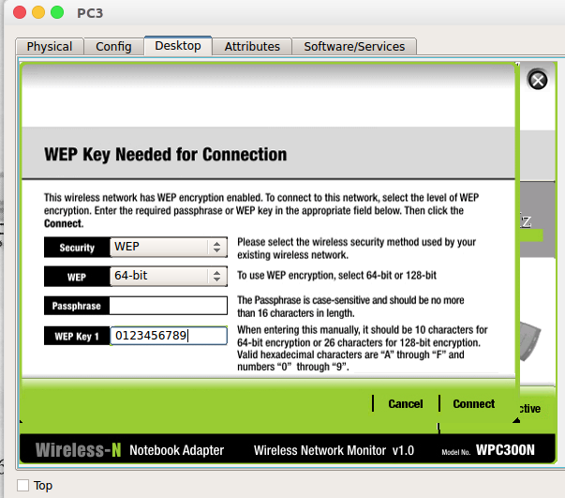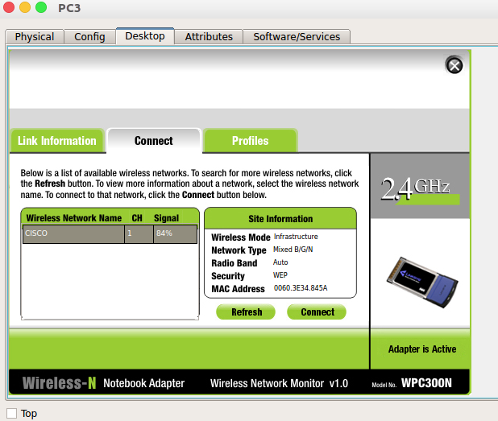Connect it as SSID: CISCO and WEP Key: 0123456789 on PC-3 and PC-4
* Make DHCP configuration on PC0, PC1 and PC2 in IP address configuration.

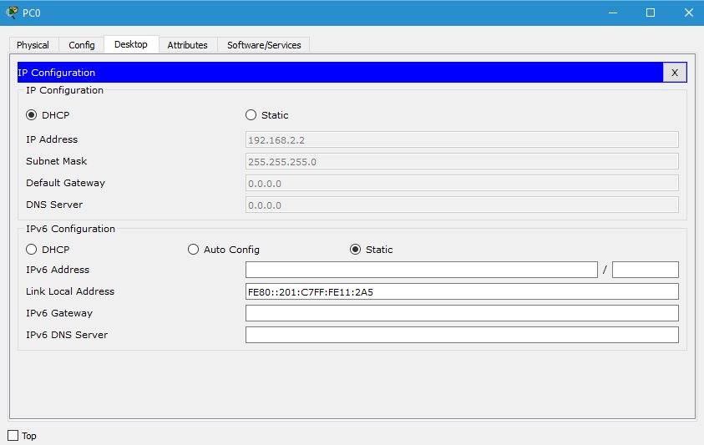

* The IP of DHCP server is 192.168.2.3. Try to connect to the sever from PC3 using URL as: 192.168.2.3.

