***Experiment No :*** *07*

***Experiment Name :*** *Implementation of Email Service.*

***Objective:***

­In this experiment, we are going to implement Email service using ‘CISCO Packet Tracer’.

Here, we use a sample network diagram it contains 2 switches, 1 Router, 2 mail servers and 2 PCs.

**Server1: IP:** 192.168.1.3

**DNS name:** ju.edu

**Server2:** **IP:** 192.168.2.3

**DNS name:** emcs.edu

User-1 in network 192.168.1.0 has email address [mkroy@ju.edu](mailto:mkroy@ju.edu) and user-2 in network 102.168.2.0 has email address [roy@emcs.edu](mailto:roy@emcs.edu) .

***Design Procedure:***

* Let us implement the network like below:

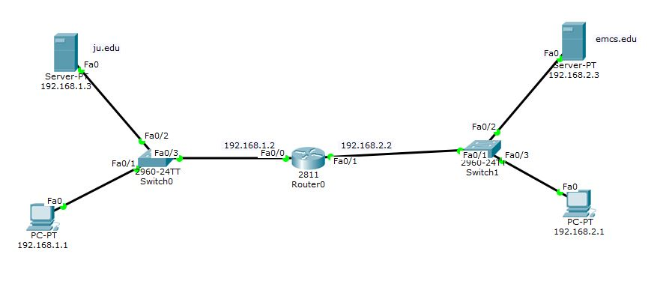

* Configure host-1: IP 192.168.1.1:

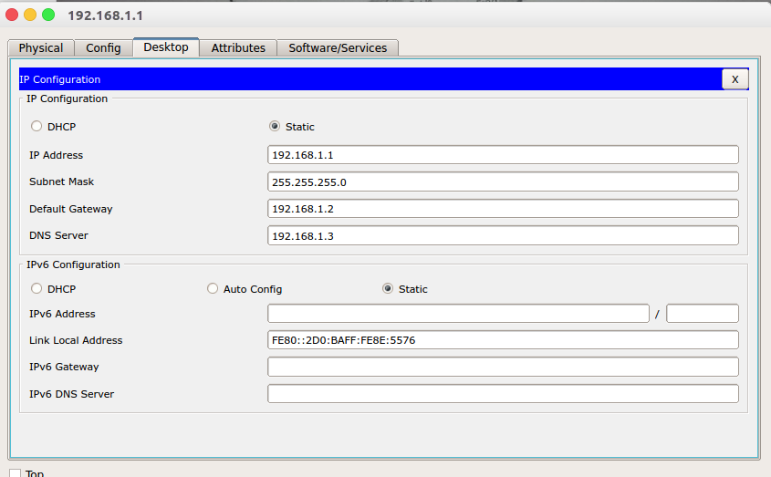

* Configure host-2: IP: 192.168.2.1

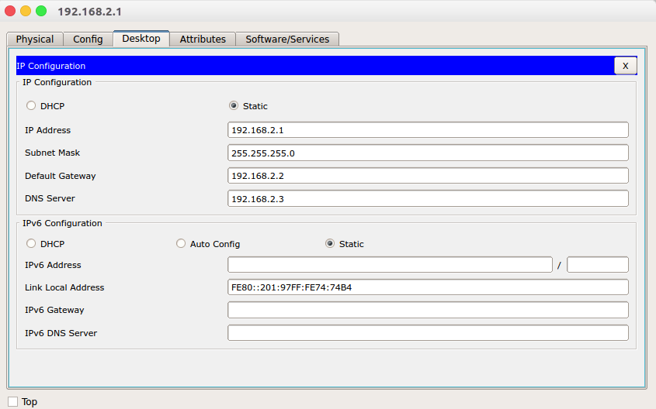

* Configure both interface of router:

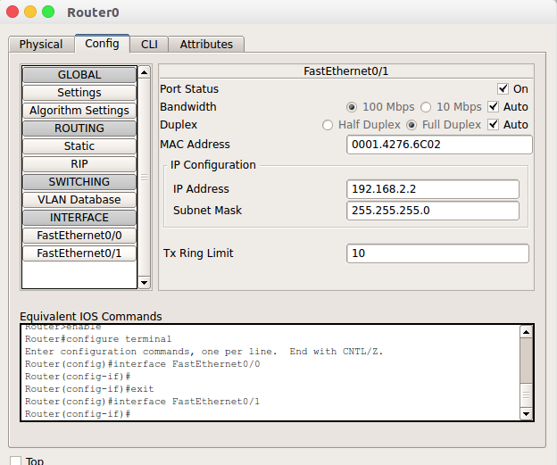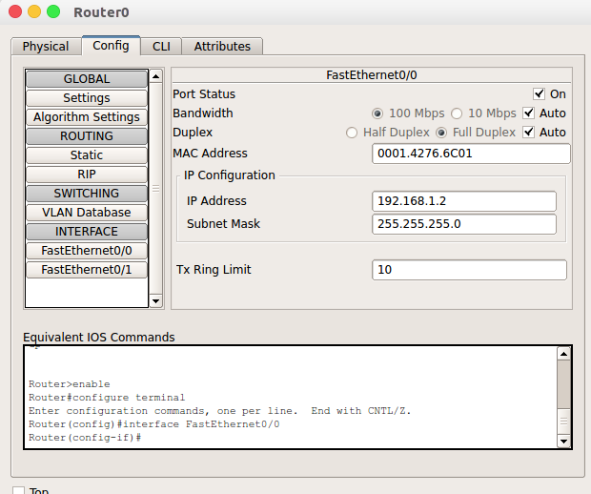

* Configure 1st DNS/MAIL server:
* IP configure: DNS Configure:

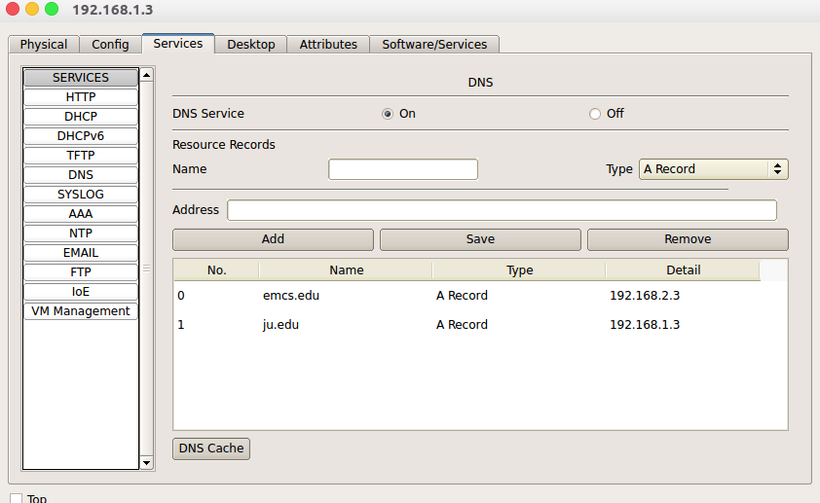

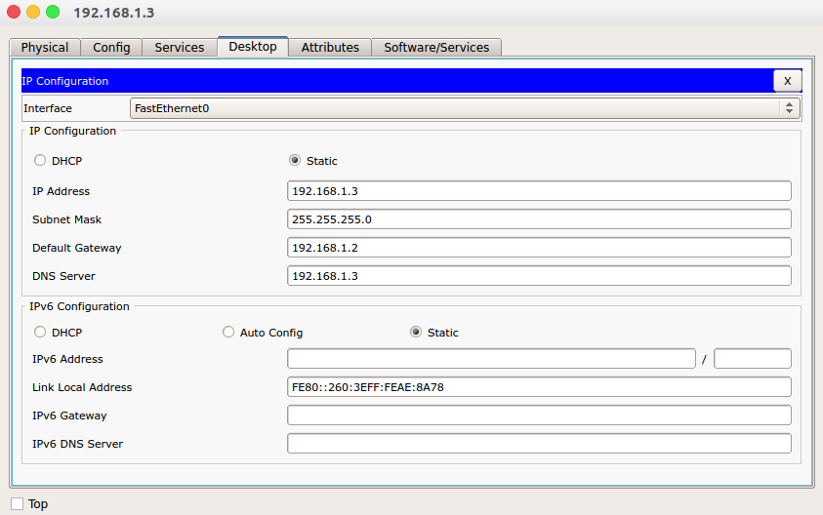

* 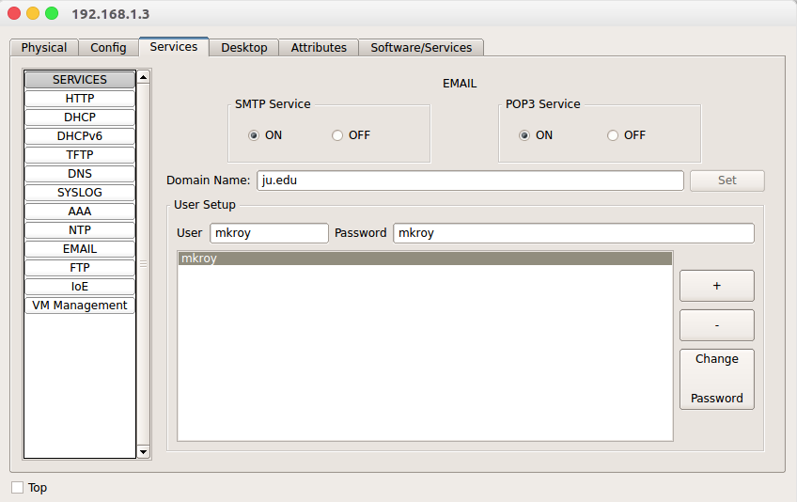Email Configure:
* Configure 2nd DNS/MAIL server:
* 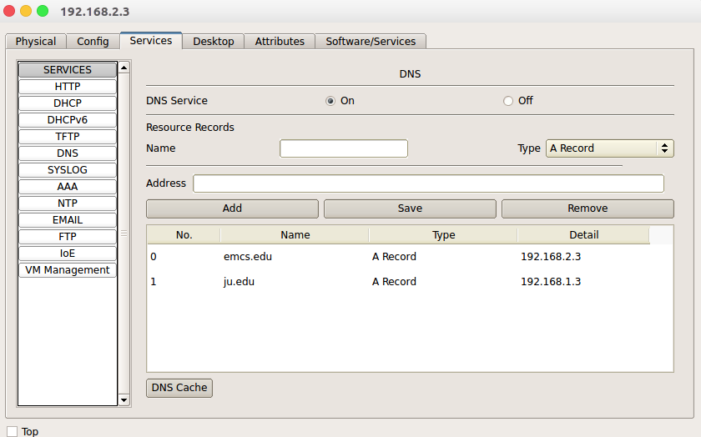IP configure: DNS configure:

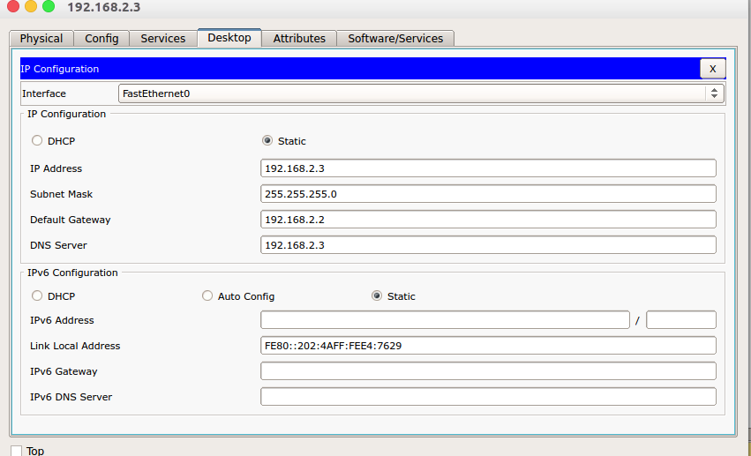

* 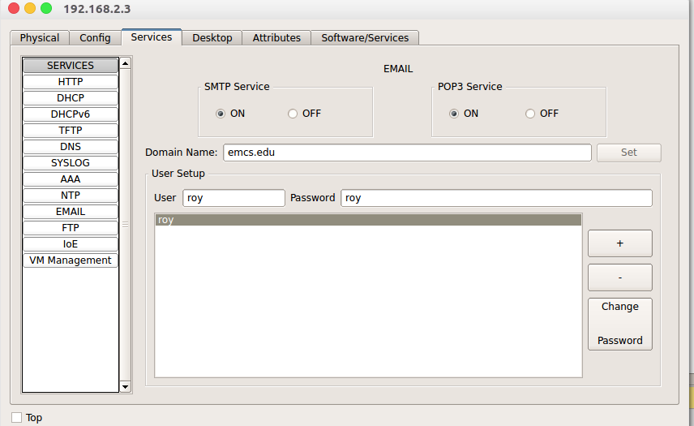Email configure:
* 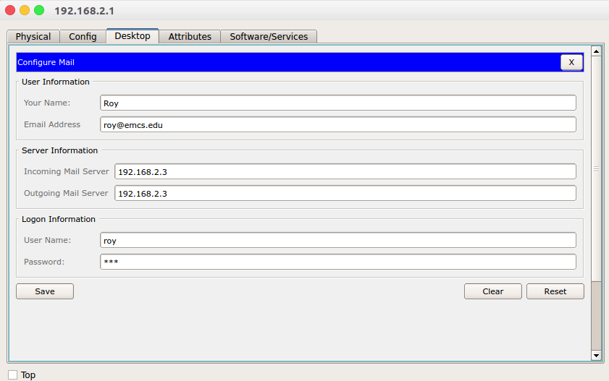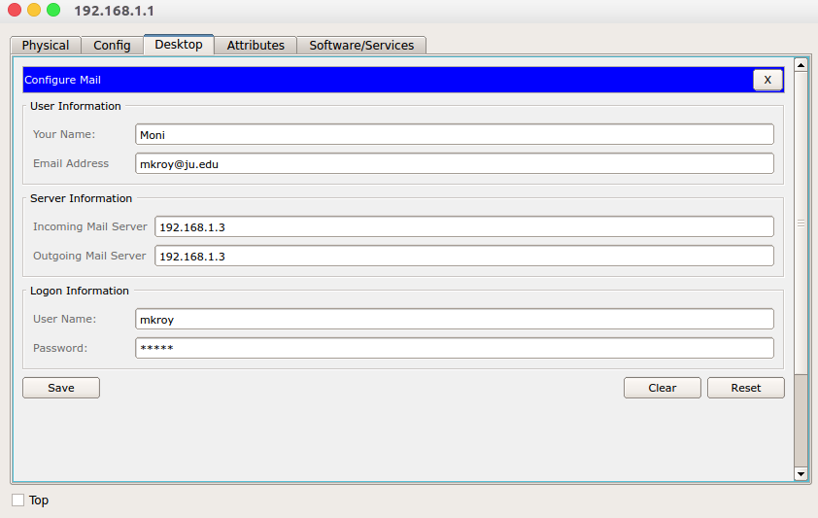Configure the mail of the client-1: Configure the mail for client-2:
* 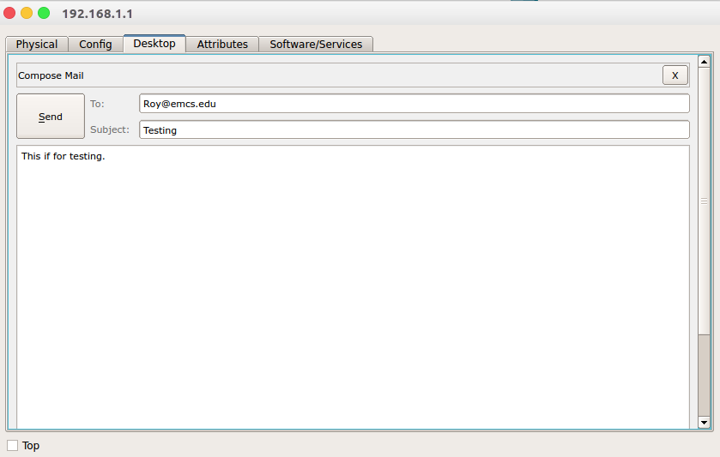Send mail from client-1: Verify the received mail from client-2:

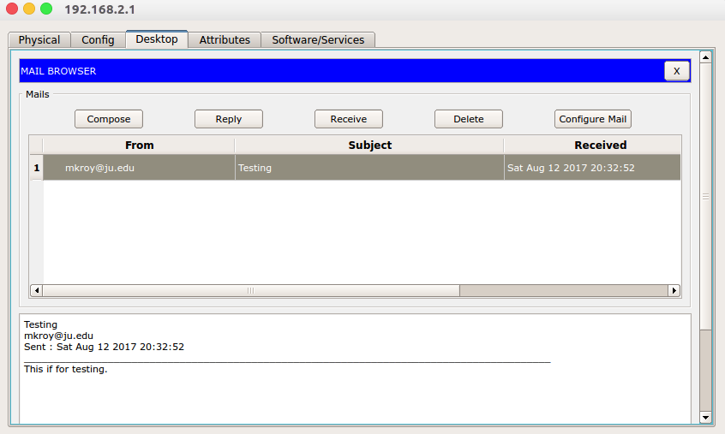

* Reply mail from client-2:

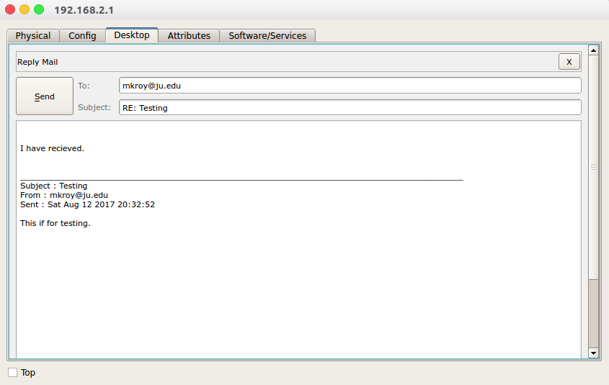

* Verify the reply mail from client-1:

