***Experiment No :*** *08*

***Experiment Name :*** *Configuration of VLAN.*

***Objectives:***

In this experiment, we are going to configure VLAN using ‘CISCO Packet Tracer’. Here, communication is possible only between PCs under the same VLAN.

Here, we use a sample network diagram it contains 3 switches and 7 PCs. We will configure switch using command line interface.

***Design Procedure:***

* Let us implement the network like below and configure the PCs with corresponding IP address. Here we do not need default gateway address for any PC.

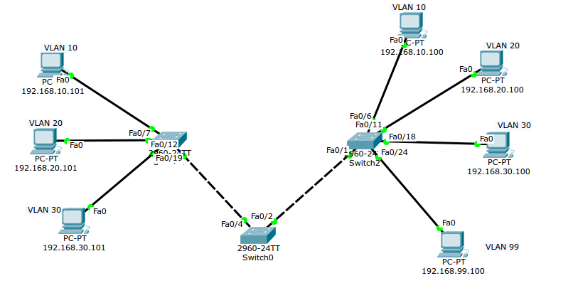

` *Illustration 1: Network circuit.*

* PCs IP address is configured like below, example for PC-1:

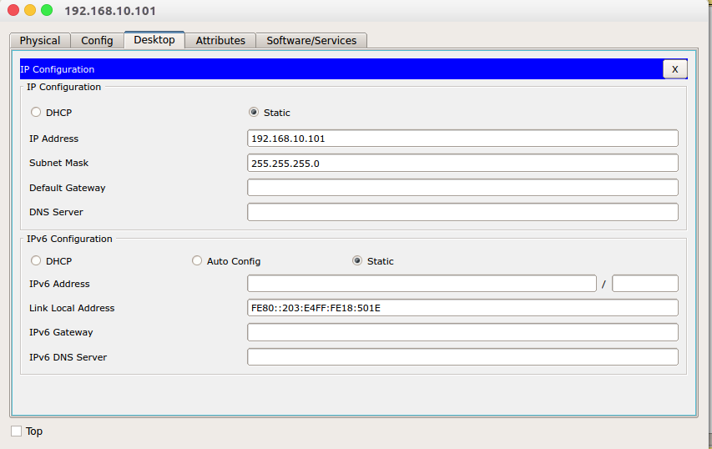

* Configure the switches on CLI, like below:

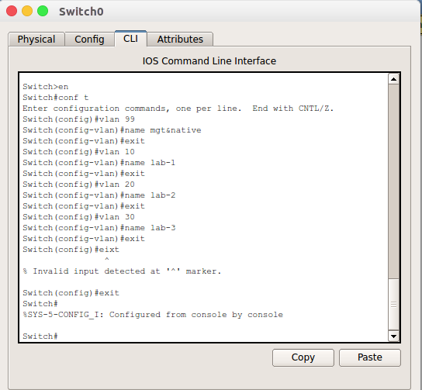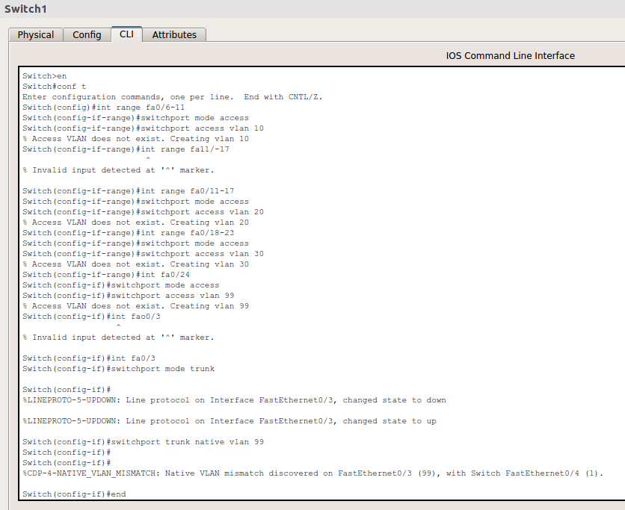

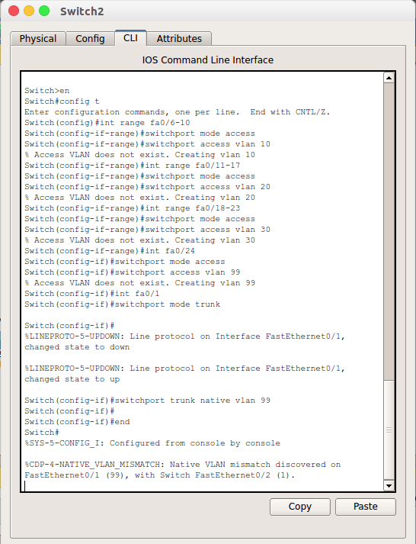

* Packet transferring between two PCs:

1. 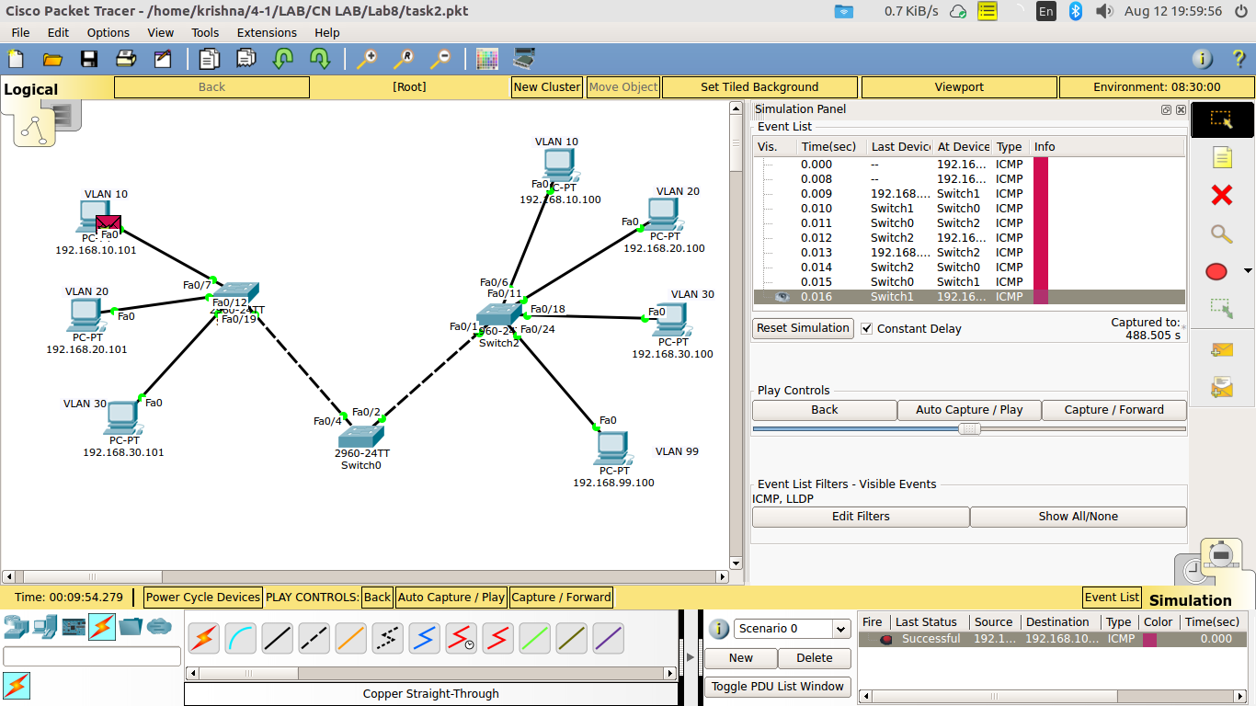Two PCs under same VLAN.
2. Two PCs under different VLAN:

