Experiment No: 03
Experiment Name: Packet through Routers (Routers Configured with CLI)

Objective:
Since we’re going to transfer packet through Routers. we’ll design a simple network diagram using “ CISCO Packet Tracer”.
In this experiment we’ll test a simple packet transfer from one PC to another. The circuit contains 3 Routers with delta connection & some PCs. We’ll configure the routers via command line interface and evaluate packet transfer (ICMP packet).

Design procedure:

Here a simple network connection using Routers connected via a delta connection:

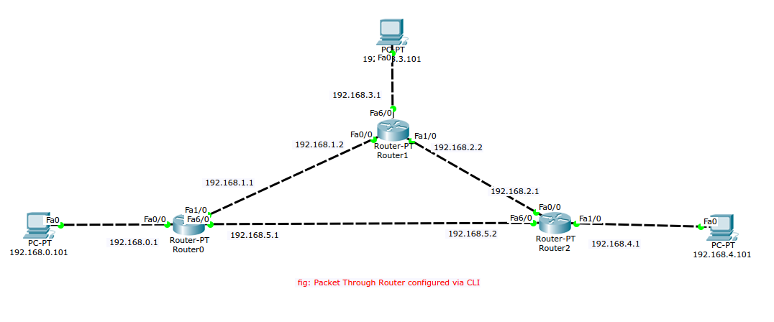Illustration 1: Delta Connected Routers and End Devices

The above figure shows the connection among PCs & routers.

Details procedure of router, End Device configuration:
1. End Device IP address configure:

- Device 1

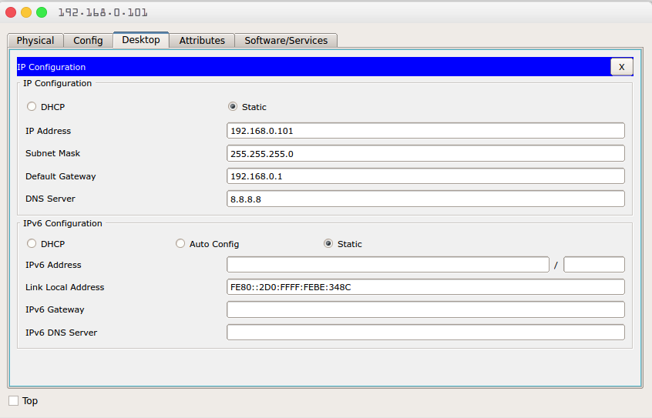Illustration 2: Device 1 IP configuration

- Device 2

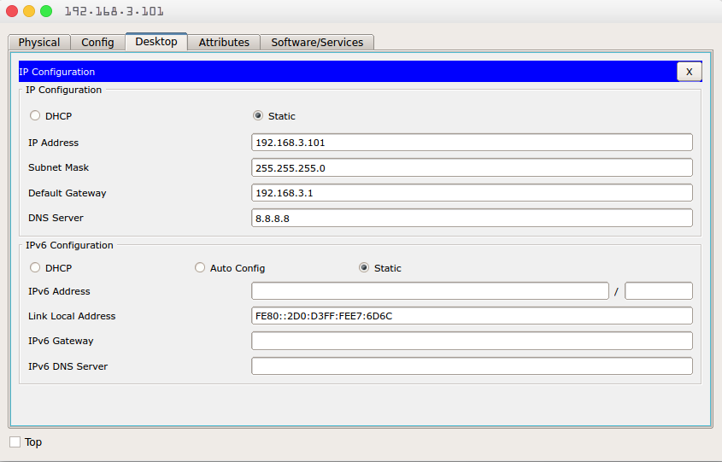Illustration 3: Device 2 IP configuration

- Device 3

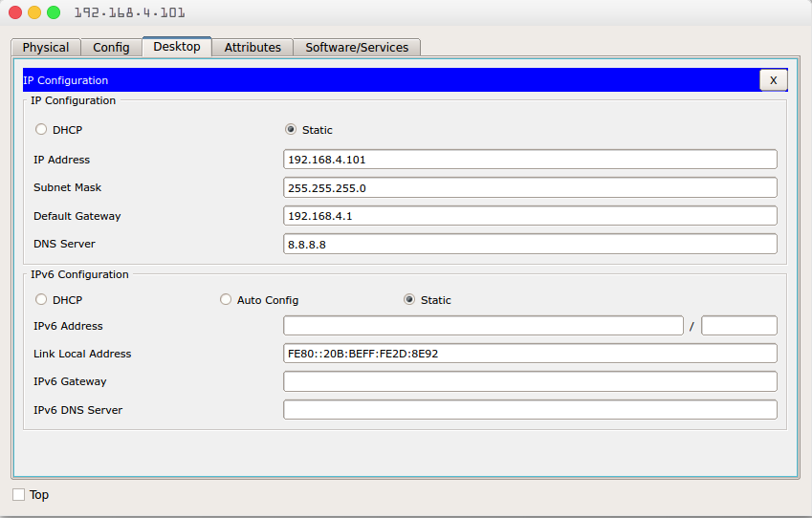Illustration 4: Device 3 IP configuration

2. Router configuration with CLI: Each Router requires two step to be fully functional, first step we assign IP-addresses relative to each router. The second step we make the routing table ready. The router configuration for each router is as follows:
- Router:1
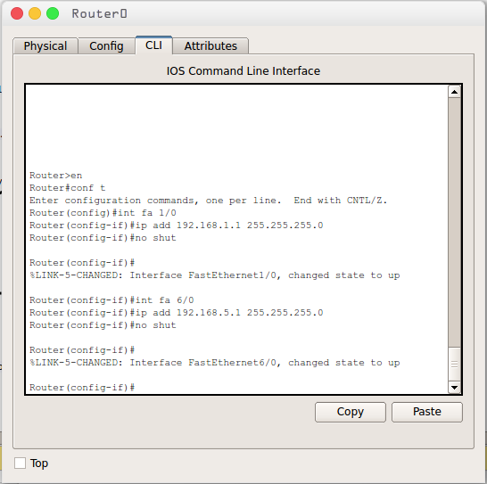Illustration 5: Router-1 Configuration

- Router:2
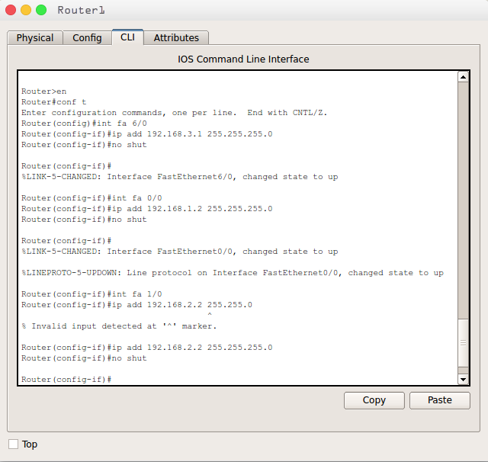Illustration 6: Router-2 Configuration

- Router:3
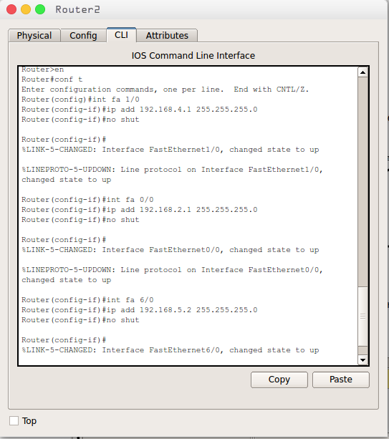Illustration 7: Router-3 Configuration

Routing Table:
- Router-1
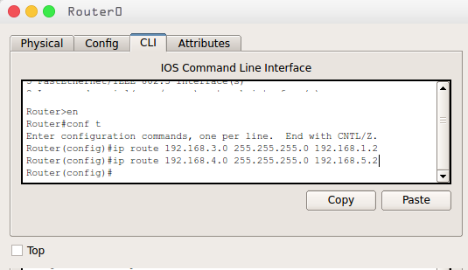Illustration 8: Router-1 Routing Table

- Router-2
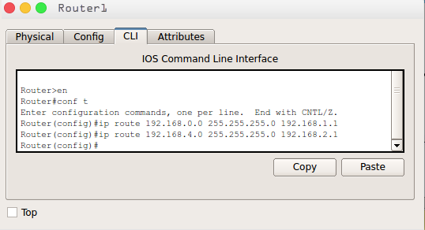Illustration 9: Router-2 Routing Table

- Router-3
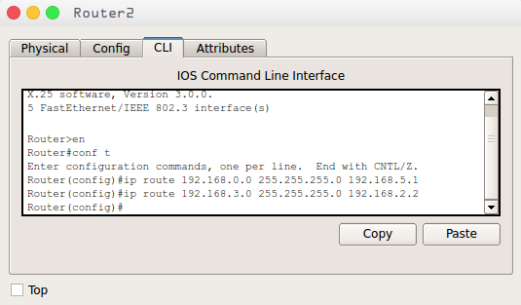Illustration 10: Router-3 Routing Table

3. Packet transferring between two Device.
