Experiment No: 05
Experiment Name: DNS server configuration

Objective:
In this experiment we’re going to simulate and evaluate the networking principle of DNS server.A DNS server is any computer registered to join the Domain Name System. A DNS server runs special-purpose networking software, features a public IP address, and contains a database of network names and addresses for other Internet hosts. We’ll be using two DNS servers for two virtual websites and test the working principle

Design procedure:

Here a simple network connection using Routers , Switches and DNS servers:

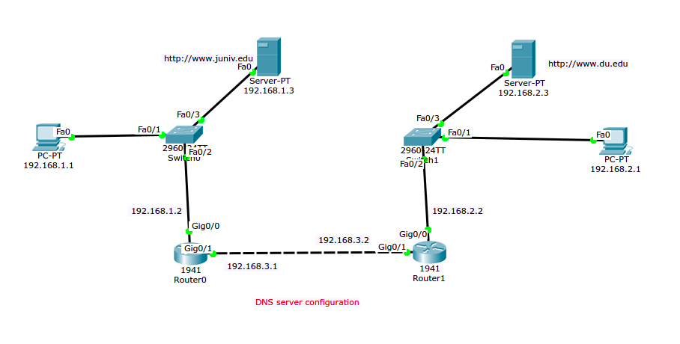Illustration 1: DNS server connected to switch, connected via two routers.

The above figure shows the connection among PCs , switches, routers & DNS servers.

Details procedure of router, End Device configuration:
1. End Device IP address configure: These are sample configuration, not all end-device configuration have shown,
- Device 1

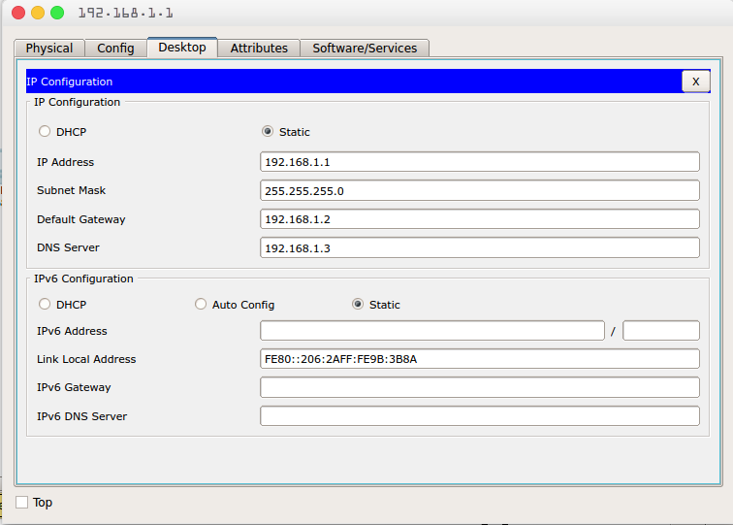Illustration 2: Device 1 IP configuration

- Device 2

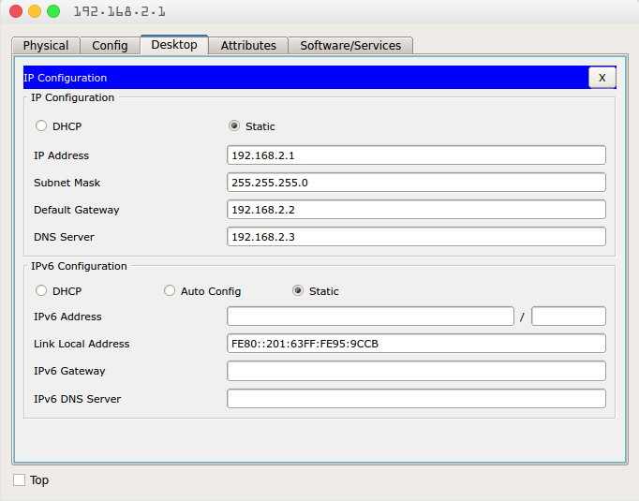Illustration 3: Device 2 IP configuration

2. Router configuration : Each Router requires two step to be fully functional, first step we assign IP-addresses relative to each router. The second step we setup the routing table:
- Router:1
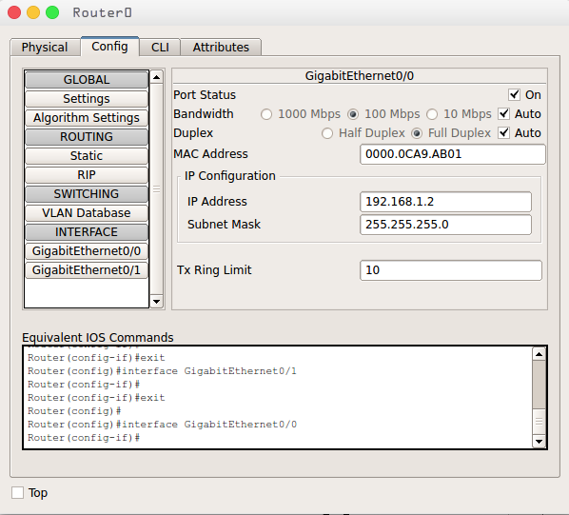Illustration 4: Router-1 Configuration

Router:2
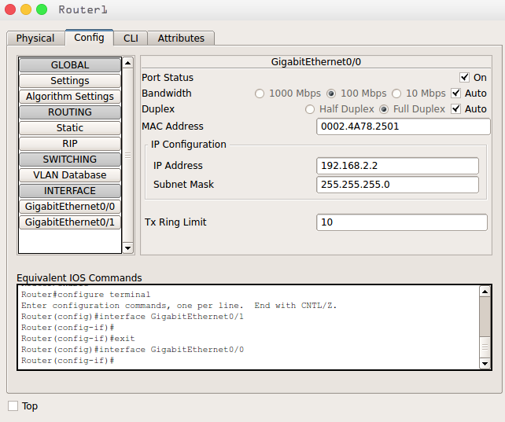Illustration 5: Router-2 Configuration

3. DNS server configuration : We need to configure both of the DNS servers as follows
- DNS Server 1:
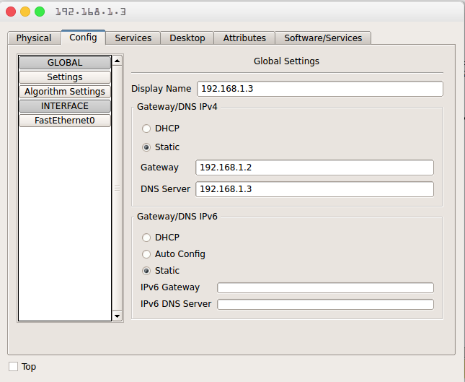Illustration 6: DNS server-1 IP configuration

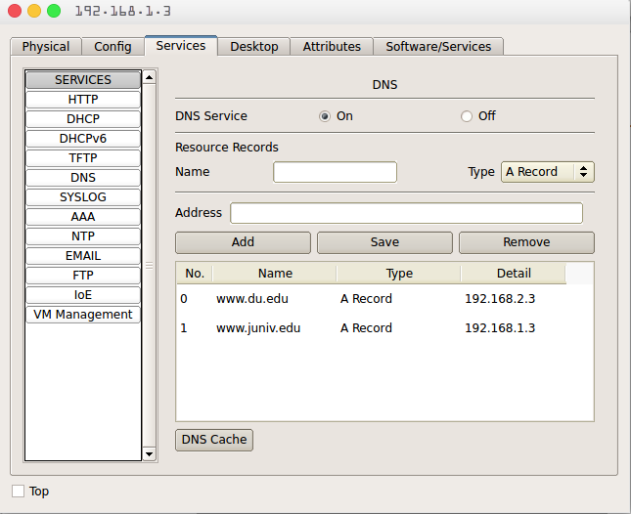Illustration 7: DNS-1 Resource Record Entry

- DNS Server 2:
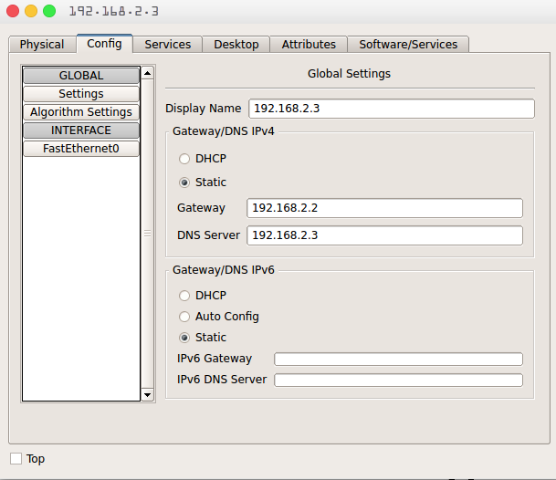Illustration 8: DNS server-2 IP configuration

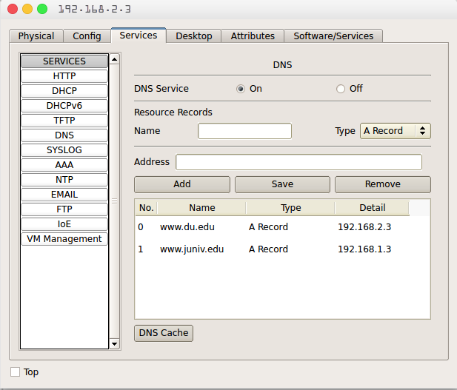Illustration 9: DNS-2 Resource Records Entry

Testing DNS Record: Visiting one of the websites from any PC will make sure the DNS service

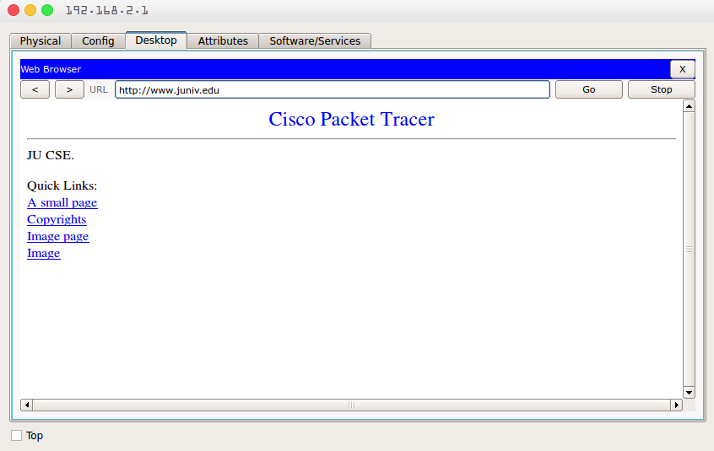Illustration 10: Browsing http://www.juniv.edu domain

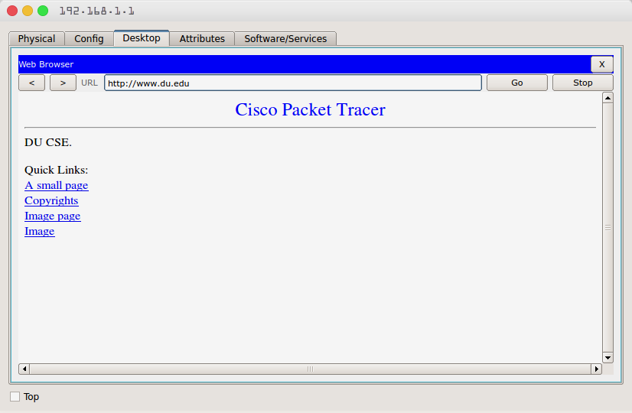Illustration 11: Browsing: http://www.du.edu domain

