Experiment No: 01
Experiment Name: Basic Concept of Switching

Objective:
Objective of this experiment is to get familiar with the basic concepts of computer network. In this experiment we’ll be using some basic computer networking devices such as End Devices (i.e PC), Switching Devices, Hubs, connecting cables etc. Using the Cisco Packet Tracer we’ll simulate the packet transferring from one PC to another and will check the efficiency of different working principles of different networking devices. We’ll use “ping” and “traceroute” to know how does it works and what type of output it gives.

Design Procedure:
Since we’re going to perform some very basic operations of networking we’ll design a simple network diagram using “ CISCO Packet Tracer”.
First we’ll test a simple packet transfer from one PC. The circuit contains one or more Hub(s) and some PCs. We’ll connect two end point PC-to-PC or PC-to-Hub/Switch using a copper wire, it is usually a twisted pair cable with connectors (RJ-45) attached to the end points of the cable.

Transferring some Packet from one PC to another connecting with Hub:
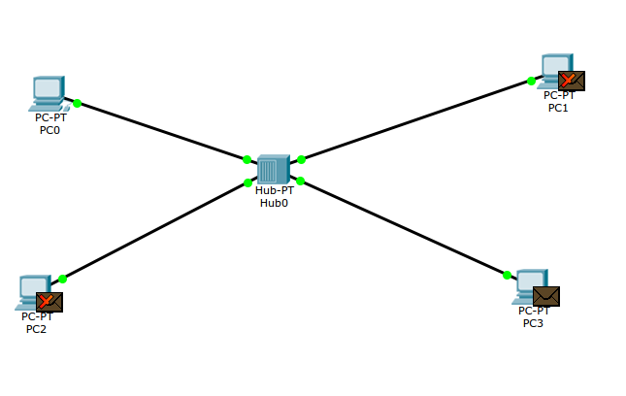Illustration 1: Several PC connected via a Hub in the center

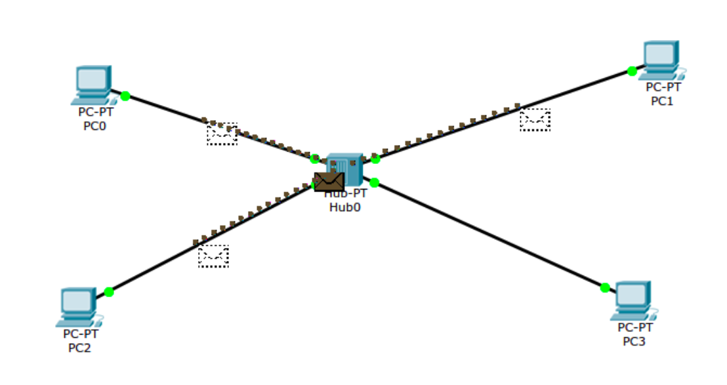Illustration 2: Packet transferring from Hub to all Other PCs
To test packet transfer from one PC to another via a Hub, we first connect the PCs to the hub as shown in figure above. The circuit is implemented using Packet Tracer software from CISCO. After connecting the PCs we assign IP addresses to all connected PCs. After assigning the IP address, we put some packet (ICMP) on one PC and set the destination PC. When in simulation mode in Packet Tracer software, we can easily see how a packet is transferred from on PC to another via a network Hub. After completing the packet transfer, we then replace the hub with a switch. Using a switch rather than a hub causes easy transfer of packet from one PC to another.

Configuring a Switch:
A switch is needed to be configured before using in a network circuit. In this experiment we’ll try configuring a switch from a PC via Packet Tracer software. We first connect a PC to a switch’s console using a RS-232 connector. The connection diagram is given below.
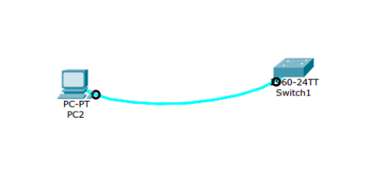Illustration 3: Connecting a Switch to a PC

We’ll be using the commands as bellow to initially configure a switch.
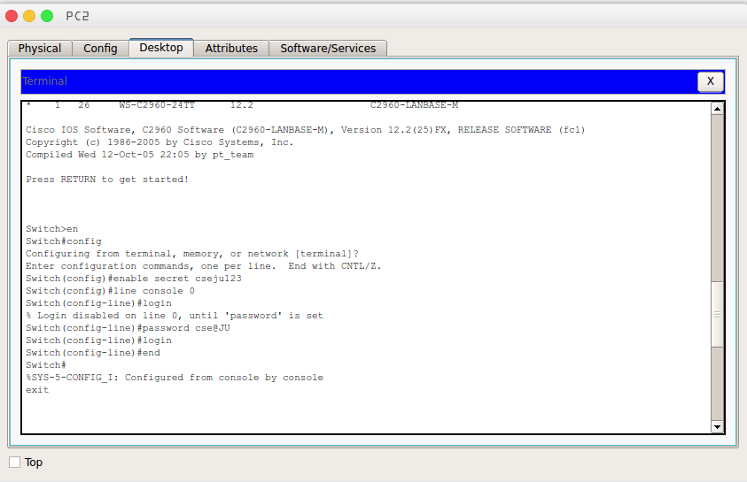
Illustration 4: Configuring a Switch from a PC
Ping & Traceroute:
Ping is a method to check if a host is alive or not. It sends some packets to a host defined by an IP address. It measures the round-trip time for messages sent from the originating host to a destination computer that are echoed back to the source.
Basic command is : ping ‘hostname’ (host can be a IP adress or web address)
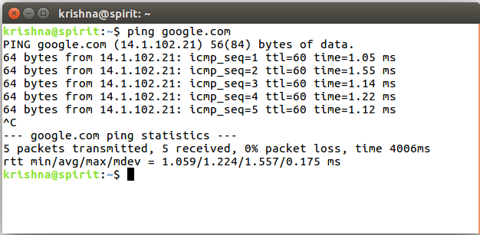
the output results shows the statistics of 4 ICMP packets that was transferred within host and a client PC.

tracert (traceroute in unix like systems) is a computer network diagnostic tool for displaying the route (path) and measuring transit delays of packets across an Internet Protocol (IP) network.
Basic command: tracert ‘hostname’ (in windows system)
: traceroute ‘hostname’ (in unix like systems)

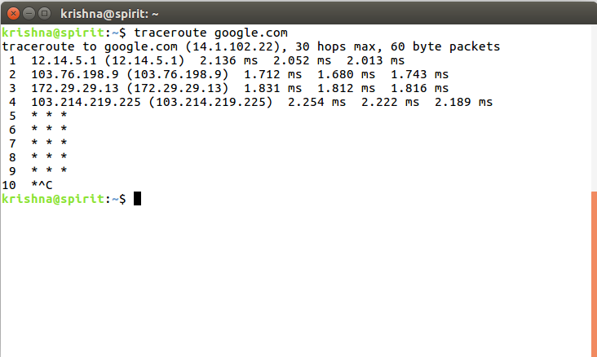

Discussion:
In this experiment we’ve tested some packet transfer virtually and tested some packet transfer measurement tools such as PING and Traceroute. we’ve found that network latency is increased in real life because of surround noise and long distance of network cable.

