Experiment No: 04
Experiment Name: Routing based on OSPF

Objective:
Since we’re going to transfer packet through Routers. we’ll design a simple network diagram using “ CISCO Packet Tracer”.
In this experiment we’ll test a simple packet transfer from one PC to another. The circuit contains 3 Routers with delta connection with switch connected to each router & some PCs connected to each switche. We’ll configure the routers via command line interface and evaluate packet transfer (ICMP packet) for OSPF routing algorithm.

Design procedure:

Here a simple network connection using Routers connected via a delta connection:

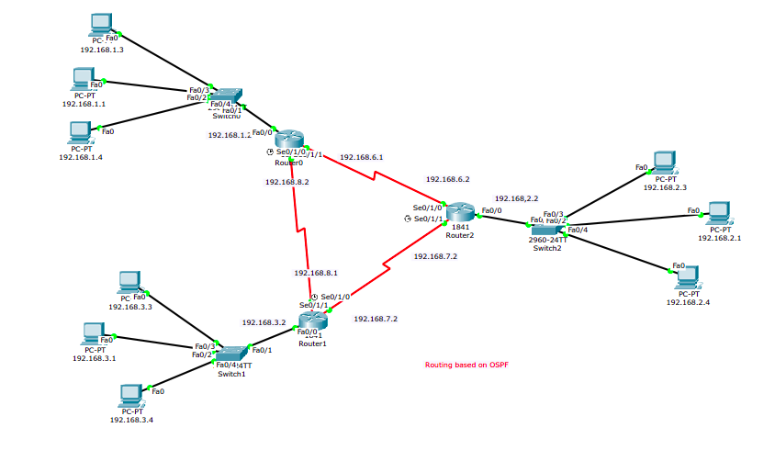Illustration 1: Delta Connected Routers with switch connect to each

The above figure shows the connection among PCs & routers.

Details procedure of router, End Device configuration:
1. End Device IP address configure: These are sample configuration, not all end-device configuration have shown,
- Device 1

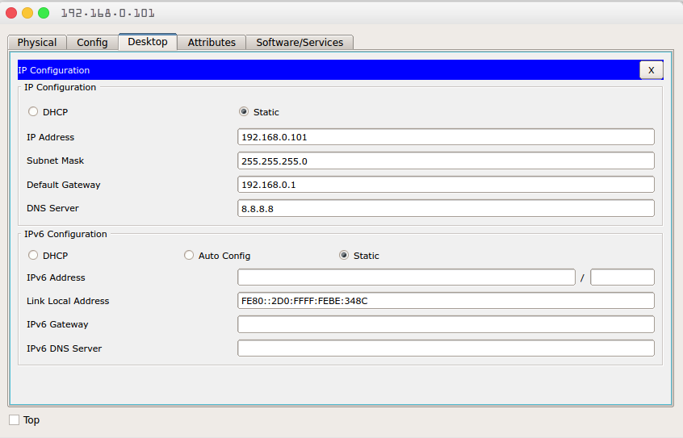Illustration 2: Device 1 IP configuration

- Device 2

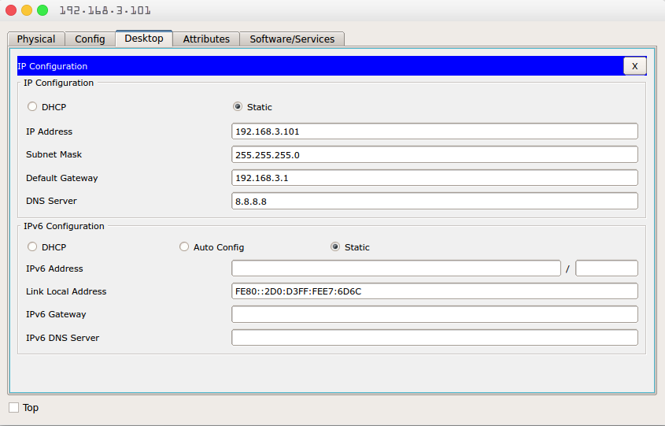Illustration 3: Device 2 IP configuration

- Device 3

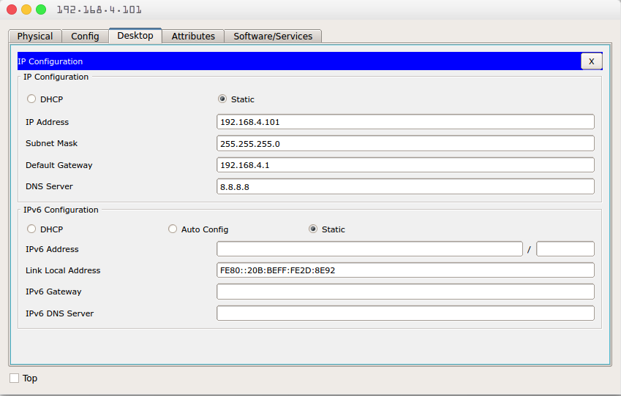Illustration 4: Device 3 IP configuration

2. Router configuration with CLI: Each Router requires two step to be fully functional, first step we assign IP-addresses relative to each router. The second step we fix the OSPF area assigning. The router configuration for each router is as follows:
- Router:1
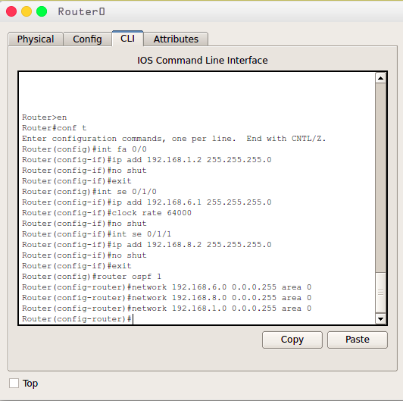Illustration 5: Router-1 Configuration

- Router:2
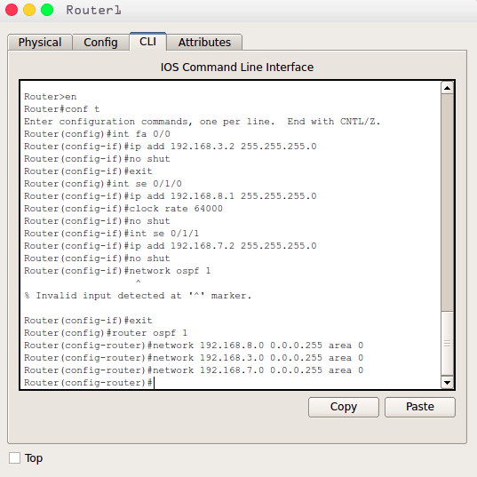Illustration 6: Router-2 Configuration

- Router:3
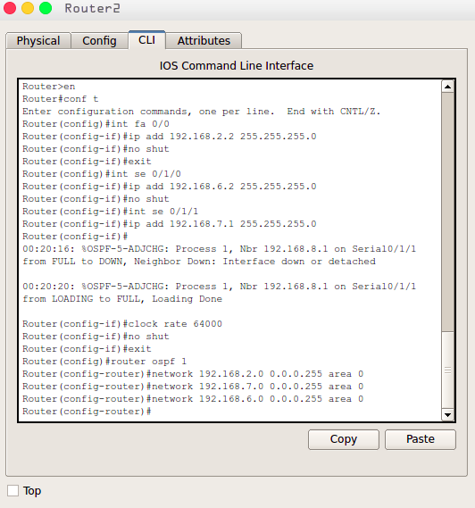Illustration 7: Router-3 Configuration

3. Packet transferring between two Device.
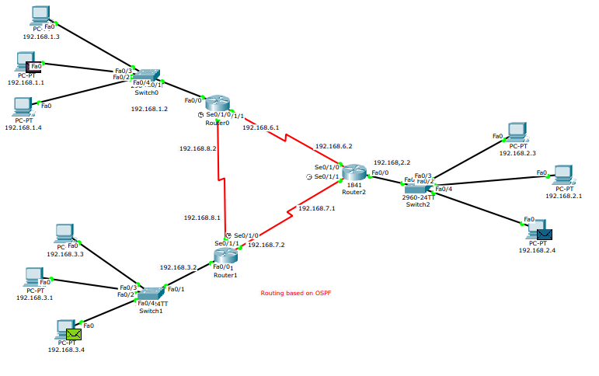Illustration 8: Initiating packet transfer

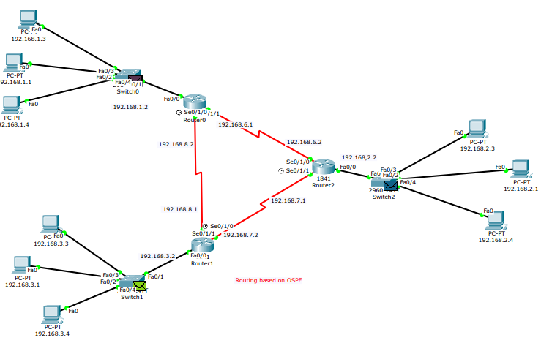Illustration 9: Packet Transferred to Switch

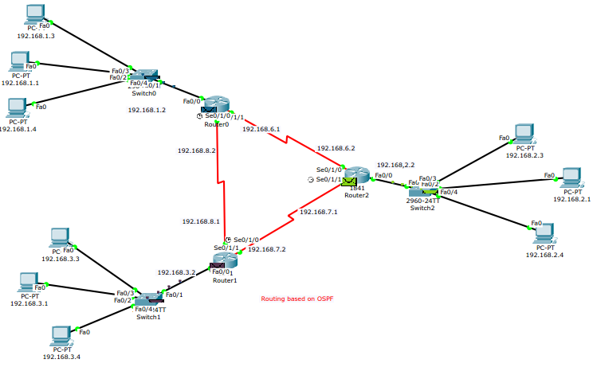Illustration 10: Packet Transferred to relevant routers

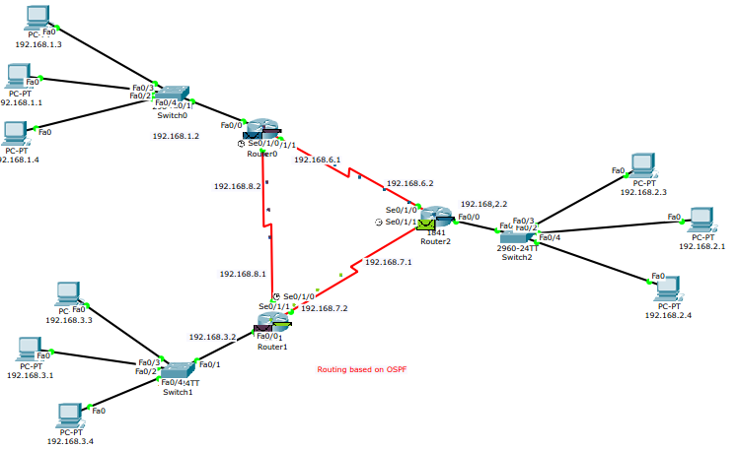Illustration 11: Packets transferred to destination network's routers

