Experiment No : 08
Experiment Name : Configuration of VLAN.

Objective :
In this experiment, we are going to configure VLAN using ‘CISCO Packet Tracer’. Here, communication is possible only between PCs under the same VLAN.
Here, we use a sample network diagram it contains 3 switches and 7 PCs. We will configure switch using command line interface.

Design Procedure:
1. Let us implement the network like below and configure the PCs with corresponding IP address. Here we do not need default gateway address for any PC.

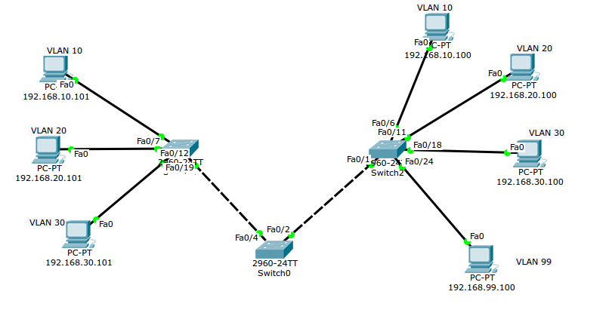
Illustration 1: Network circuit.

IP address is configured like below, here for PC-1:

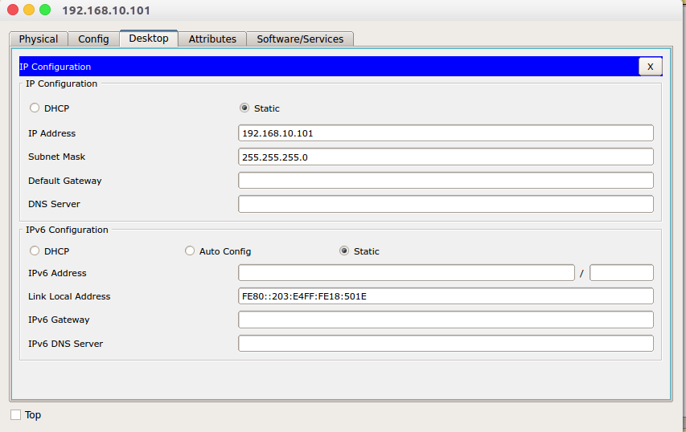

2. Configure the switch on CLI like below:
Switch-0:
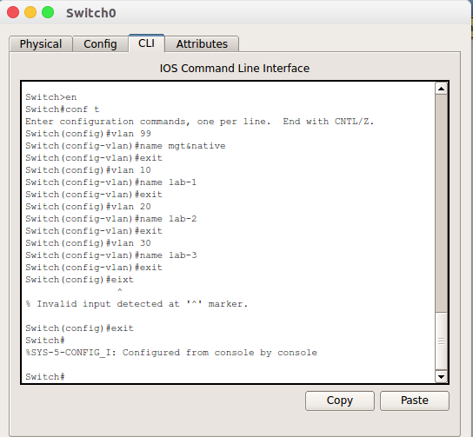
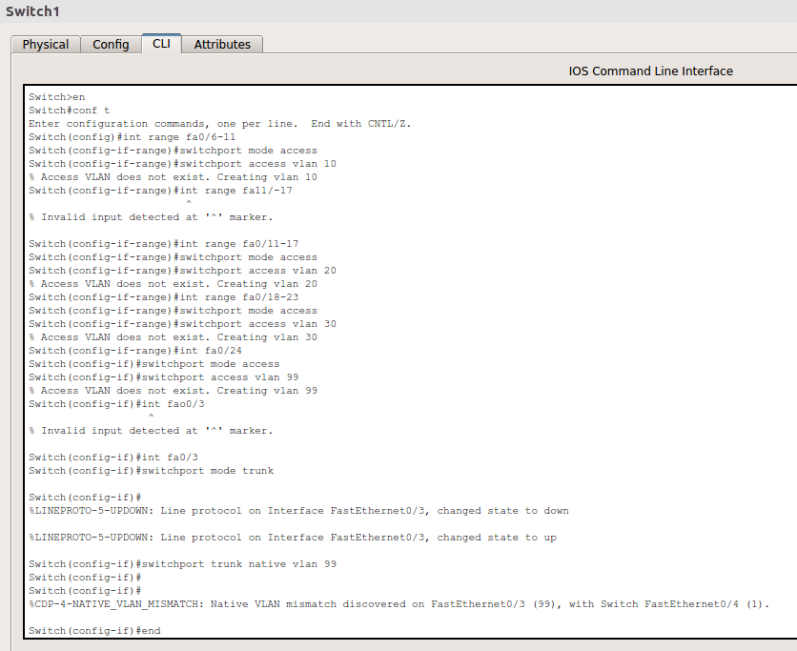

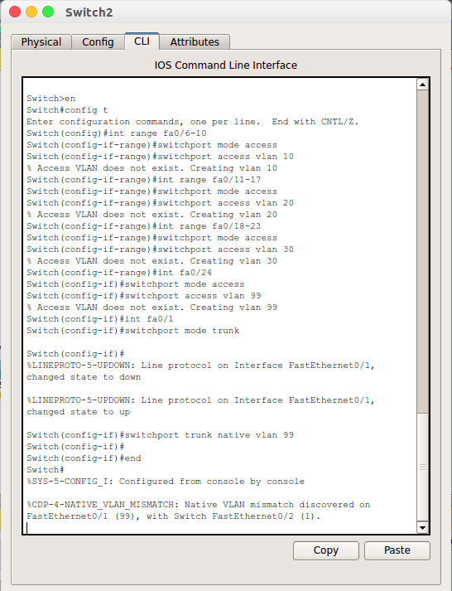

3. Packet transferring between two PCs:
Two PCs under same VLAN.
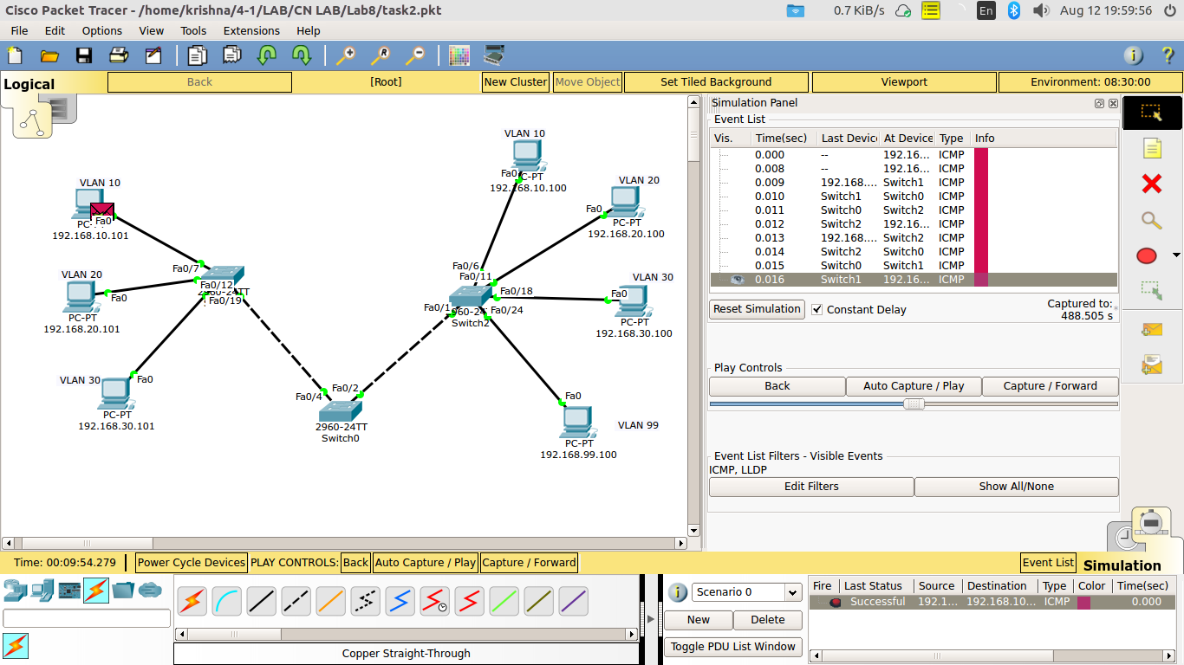
Two PCs under different VLAN:
