**Lab Experiment: 02**

**Experiment Name: Smart Quantization Technique of an Analogue Signal**

**Objective:** Introduction to basic delta modulation and demodulation.

**Working Principle:** Delta Modulation (DM) is a simplified PCM. In some type of signals, the neighboring samples are closely correlated with each other. Therefore, once a sample value is known this enables the determination of the following sample values most probably. Thus, instead of sending the real value of each sample at each time, differences (variances) between adjacent samples are sent in DM. In DM, two-level quantizer and one-bit coding is used. Transmitted code pulses do not carry the data related to the message signal itself; instead they carry data regarding the differentials of the message function. The output of a delta modulator is a bit stream of samples at a relatively high rate, the value of each bit being determined according to whether the input message sample amplitude has increased or decreased relative to the previous sample.

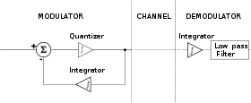

**Experiments and Results:**

predictor=[0 1];

% y(k)=x(k-1) i.e previous sample is predicted sample

%predictor =[0,a1,a2,a3....am]

%y(k) =a1x(k-1)+a2x(k-2)...+amx(k-m)

partition=[-1:0.1:0.9];

codebook=[-1:0.1:1];

t=0:pi/100:2*pi;

x=sin(pi*t); %original Signal

%quantize x using dpcm

encodedx=dpcmenco(x,codebook,partition,predictor);

%try to recover x from the modulated signal

decodedx=dpcmdeco(encodedx,codebook,predictor);

plot(t,x,'r',t,decodedx,'k--')

legend('original’, ‘recovered')

grid on

distor=sum((x-decodedx).^2)/length(x) %mean square error

xlabel('time')

ylabel('original and recovered signal');

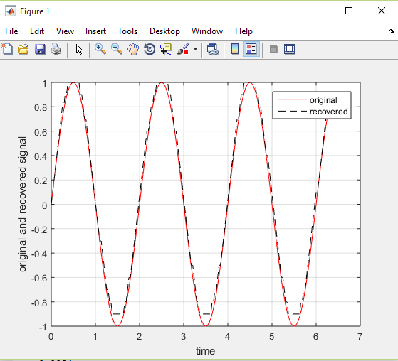

**Console output:**

distor = 0.0034

**Discussion:**

The system is in the form of a feedback loop. It is a continuous-time to discrete-time converter. In fact, it is a form of analog to digital converter. After the sampler is clocked, the resulting signal is the delta modulated signal. The output from the sampler is a bipolar signal, in block diagram being either ± ∆ volts. If the output of ‘summer’ (or comparator) is positive than the sample value of DM signal is +∆, otherwise it is -∆. It is fed back, in a feedback loop, via an integrator, to a summer. The integrator output is a saw tooth like waveform