

GOVERNMENT OF KARNATAKA
DEPARTMENT OF COLLEGIATE AND TECHNICAL EDUCATION GOVERNMENT POLYTECHNIC, ARAKERE
FIRST INTERNSHIP REVIEW REPORT

A report submitted in partial fulfillment of the requirements for the Award of

DIPLOMA
in
ELECTRICAL ENGINEERING & ELECTRICAL VEHICLE TECHNOLOGY
by

THANUSHREE C N
157EV23026

Under the Supervision of

DARSHAN

(Duration:18th Dec,2025 to 18th APRIL,2026)

Internship carried out at

KAYNES TECHNOLOGY INDIA LIT
HEBBAL INDUSTRIAL AREA,MYSURU,KARNATAKA-570016

Under the guidance of
Mrs.Deepthi
Lecturer
ELECTRICAL ENGINEERING & ELECTRICAL VEHICLE TECHNOLOGY
GPT ARAKERE

Contents
- About Organization
- Company Branches
- Vision Of The Company
- Mission Of The Company 5.Organization Structure
- Business Verticals
- Main Team Members Of Company
- Global Accreditation To Company
- Services Offered By Company
- Company Process
- Company Process Flow Chart
- Roles And Responsibilities OfPersonnal In Organization 13.Products
14.Market Performance

CHAPTER 1

About Organization
KAYNES TECHNOLOGY established in the year 1988 in Mysuru. Ramesh Kannan launched KaynesTechnology in 1988. Where he innvatiovelyused technology instead of manual labour. From baby steps in a rented space in Mysuruin 1988, Ramesh Kannan’s venture has grown into a Rs 300 crore company leading the domestic market in electronics manufacturing
The company classifiesits operations under 4 business verticals:
    - OEM turnkey solutions- box build (Original Equipmentd Manufacturer)
    - OEM turnkey solotions-printed circuit board assemblies
    - ODM (Original Design Manufacturer)
    - Product engineering and IOT solutions
Kaynes Technology is a leading end-to-end and IOT solutions enabled integrated electronics manufacturer in india. They have capabilities across the entire sprecteum of ESDM services (Electronics System Design And Manufactueing.) This company has over 3 decades od experience in providing Conceptual Design, process Engineering, Integrated Manufacturing And Life Cycle Support for major players in the automotive, Industrial, Aerospaceand Defence, Outer-space, Nuclear, Medical, Railways, Internet of Thigs(“IOT”), Information Technology(“IT”) and othr segments.

Company Branches
The main headquarters of kaynes technologies is located in mysore district Karnataka also there is 9 manufacturing facility all across india.
    - Mysuru 2 units - Domestic and Export
    - Chamarajanagara - PCBA and Wire Harness
    - Banglore, Peenva- PCBA
    - Chennai – Domestic and Export
    - Delhi – Domestic
    - Mumbai
    - Cochin
    - Hydhrabadh

Vision Of The Company
Vision: The vision of Kaynes Technology is typically focused on providing innovative solutions in the field of electronics and technology. Their primary goal is to be a global leader in the design, development, and manufacturing of high-quality, advanced electronic systems and products.

Innovation Driven
It isan approach orstrategy that prioritizes innovation as a key driver of growth, competitiveness, and success. This approach emphasizes the importance of generating and implementing new ideas, products, services, and processes to stay ahead of the competition and address emerging challenges and opportunities.
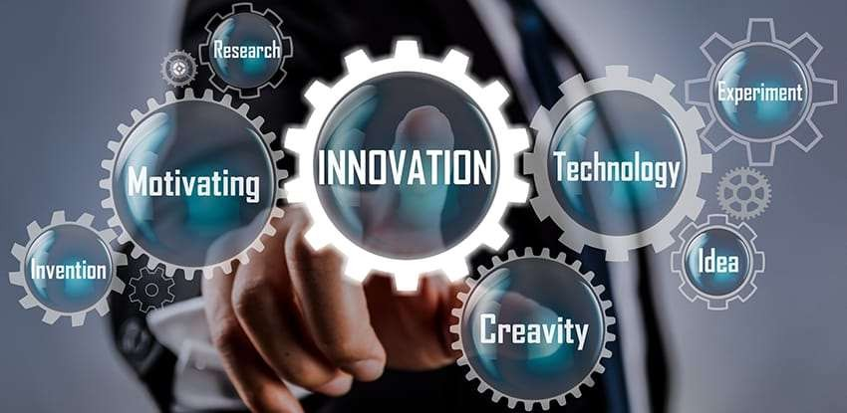

Technology Driven
This approach emphasizes the use of technology to create new products, services,and businessmodels,Embracing the latesttechnologies, such as artificial intelligence,blockchain, and the Internet of Things (IoT).


Customer Centric
This approach emphasizes understanding and meeting customer requirements, building strong relationships, and delivering value to customers and Prioritizing customer needs and preferences.
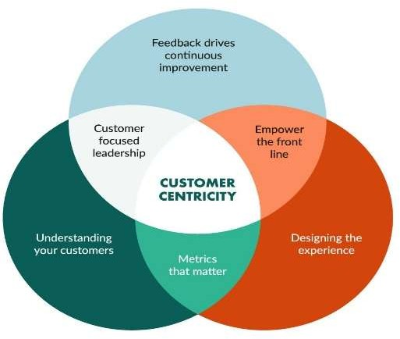

People Centric
This bapproach recognizes that peoplen are the most valuable asset of anyorganization and seeks to create a positive, supportive, and inclusive work environment that fosters engagement, motivation, and growth.


Relationship Centric
This approach recognizes thatrelationships are a key driverof business success andseeks to foster trust, loyalty, and long-term connections.

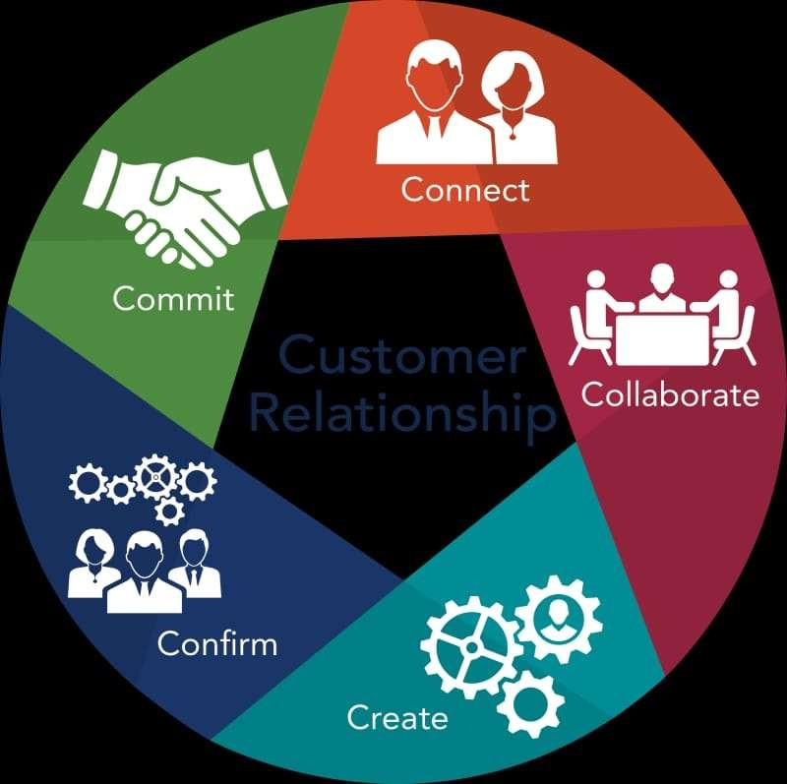

Environment Centric
This approach recognizes the interconnectedness of business and the environment and seeksto minimize harm while maximizing benefits to both and Adopting green technologies and practices, such as renewable energy, recycling, and waste reduction.
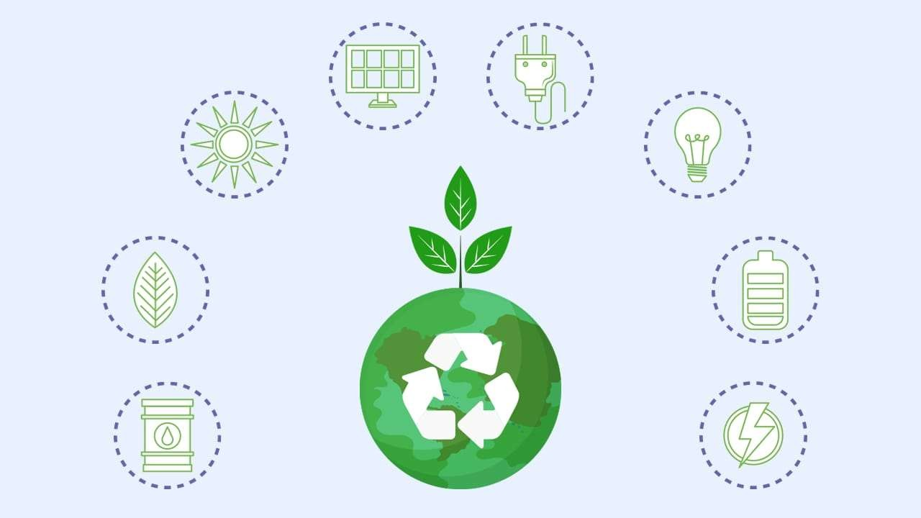

Quality Centric
This approach emphasizes a relentlessfocus on deliveringhigh-quality outcomes exceeding customer expectations, and continuously improving processes.
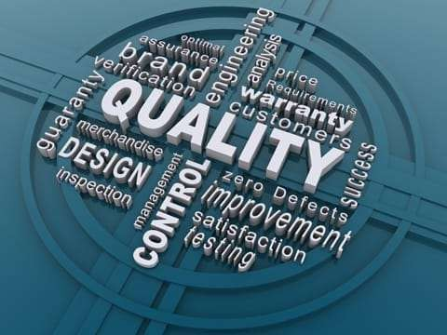

Process Centric
This approach emphasizes the importance of well-designed and continuously improved processes in driving business success and Establishing standardized processes to ensure consistency and repeatability.
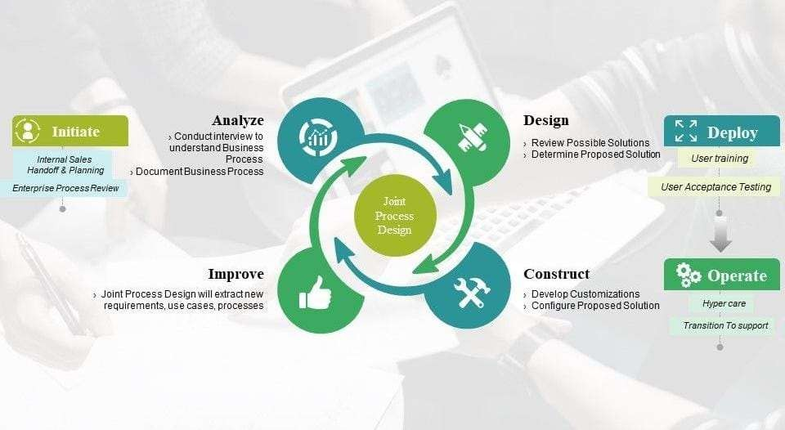

Profit Centric
This approach focuses on optimizing financial performance,increasing revenue, and reducing costs to achieve higher profit margins and Emphasizing metrics such as revenue growth, profit margins, and return on investment (ROI).


Mission of the company
Mission:Kaynes Technology (KT) is committed to provide best in class electronics manufacturing services, to customers globally in the areas of mobility, industrial, healthcare, defence and communication through highly skilled and innovative people by adapting contemparory technologies and processes, thus creating a healthy environment and performance culture to delight all intrested parties.

Organization structure
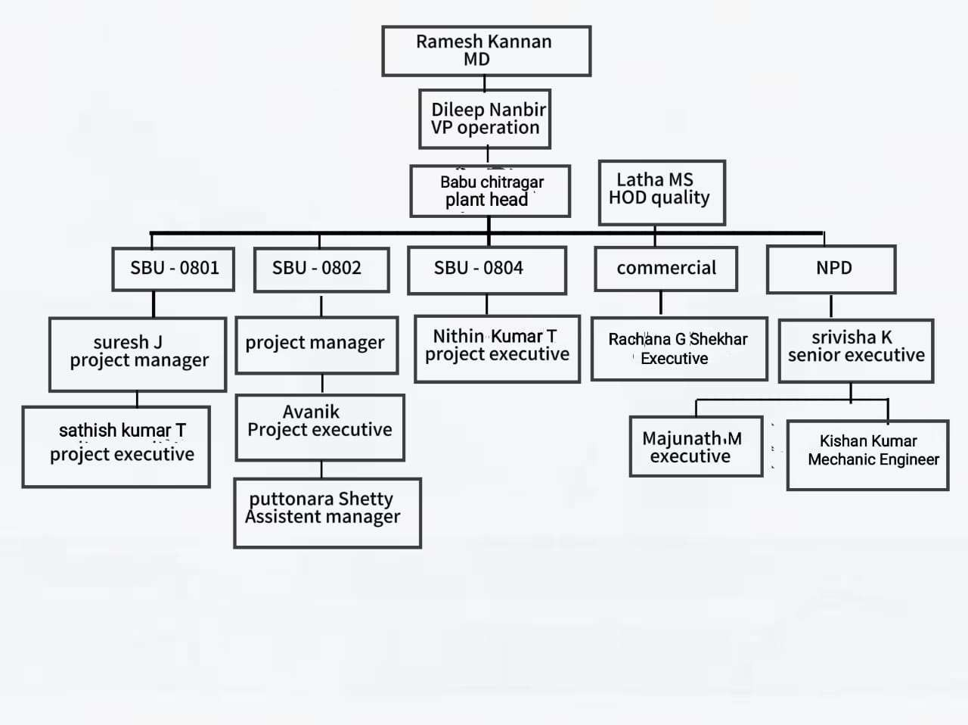

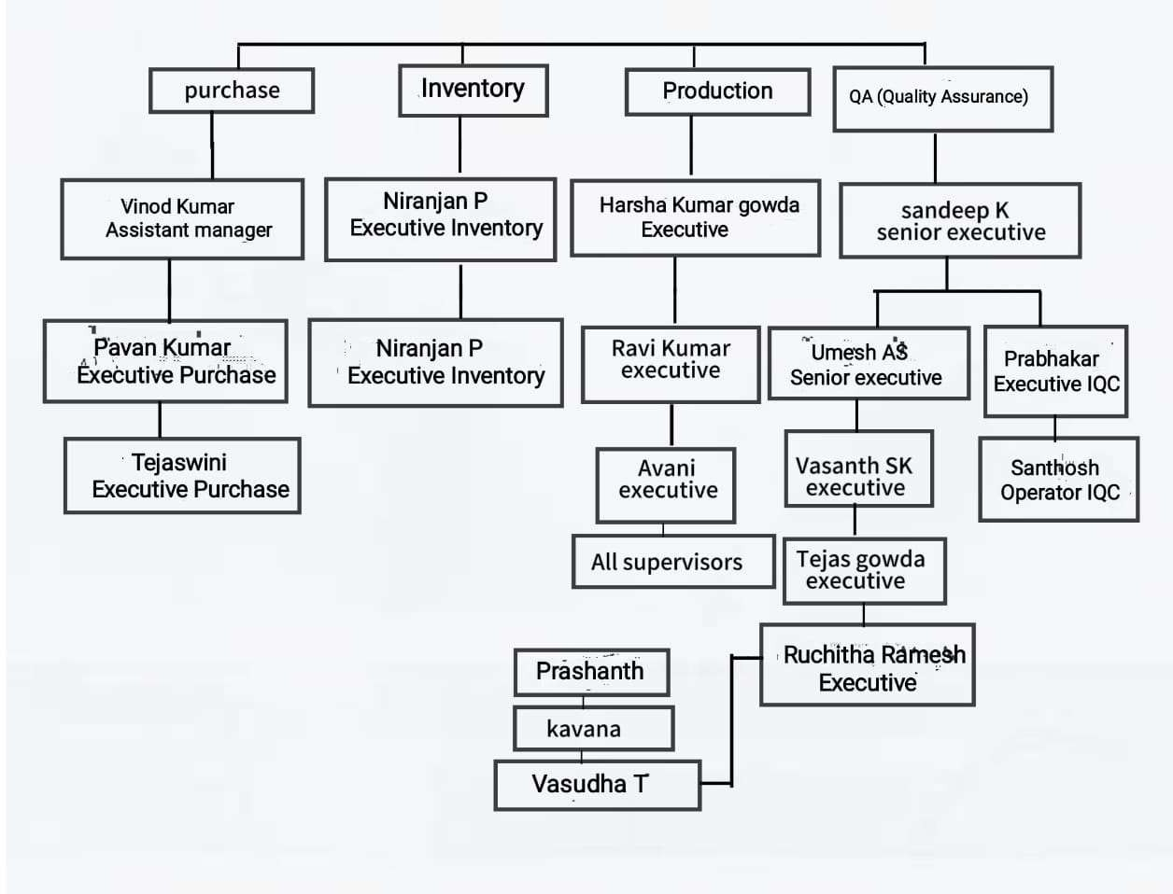

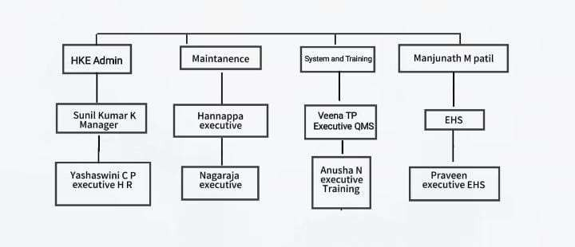

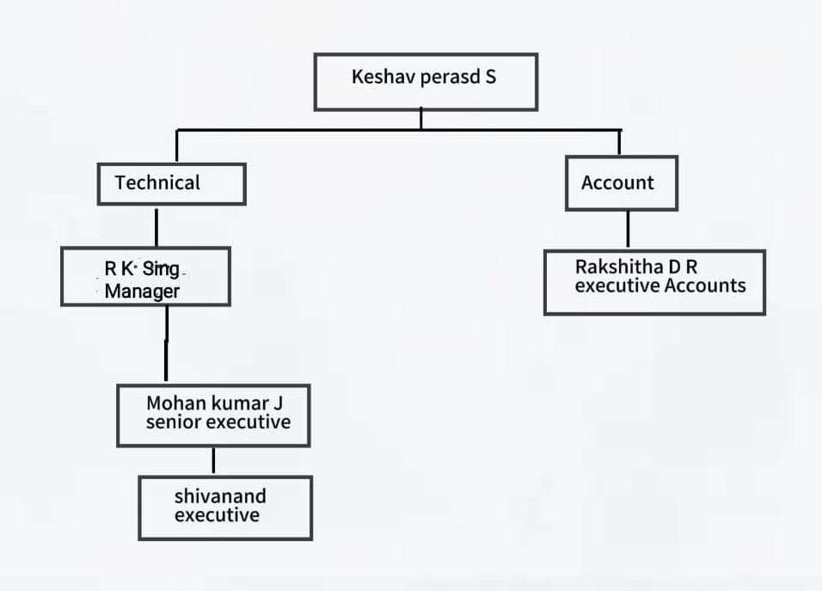

  - Business verticals
Kaynes technology is providing the ESDM services across verticals mentioned below.
    - Defence
    - Avionics
    - IT peripherals
    - Telecommunication
    - Industrial controls
    - Medical electronics
    - Railway signaling
    - Navigation system
    - Automotive
    - Power and energy

Main Team Members Of Company
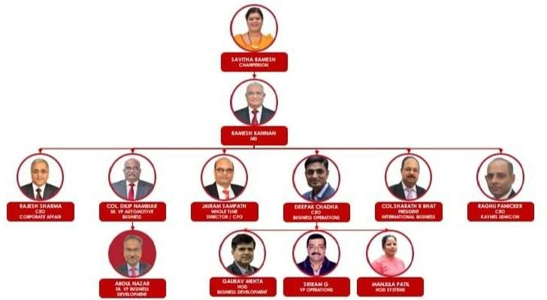

  - Global Accreditation To Company
The company has 10 global certification for different verticals of electronics
    - ISO 9001:2015 [quality management system]
    - ISO 14001:2015 [environment management system]
    - ISO 45001:2018 [occupational health and safety]
    - IATF 16949:2016 QMF [aerospace standards]
    - ISO 22163:2016 [international railway industry standards]
    - As 9100rev [aerospace standards]
    - ISO 13485:2016 [medical standards]
    - NADCAP ac 7120 REVE [defence]
    - SA 8000:2014 [accountability]
    - ANSI ESD s20.20.2014 [electronics discharge]

Services Offered By Company
    - Prototyping
    - Design validation and verification
    - Allied parts developments
    - Procure assemble test and delivery
    - Sourcing support
    - Job work paw
    - Testing
    - Full module assembly
    - Product testing
    - Logistic service
    - PCB design layout and design support

Company Process SMT
    - Backing :- Pcb baking process.
    - Screen printing :- It will creating a layer of visible information like components identification, reference.
    - Screen printing inspection :-It will inspect the printing.

    - Pick &place:- To place the components using machine.
    - Reflow :- The SMT components will get soldered, in various temperature.
    - AOI :- Direction will be checked

THROUGH HOLE
    - Forming :- The process of converting original shape to required shape.
    - Stuffing :- Components placement, using CADA document design.
    - LQC :- They will verify all the value ,placement of the components, they will cgech as per the checklist
    - Wave soldering :-Through hole components will soldered.

CLEARENCE
    - Touch up(hand soldering) :- In wave soldering we have miss soldered part, so here it get soldered by manually.
    - FCI :- It is the process of checking the SMT & through-hole components.
    - FSI :- Final checking of solder part.
    - Rework :- In both FCI&FSI is any mistake happens it will go for rework.
    - Spot cleaning :- By using Iso profile alchol(IPA) the board will get cleaned.
    - Deep analyzing :-Unwanted potion will cutoff.
    - OQC:- Quality checking of the overall components.

FUNCTIONAL TESTING
In circuit testing(ICT)

ASSEMBLY
Pad printing:-Printing logs as per requirement Integration :-Process of fixing PCB to various base. Labeling :- Pasting the labels.
OQC :- Quality checking,To test marks /scratch on the components. Box building :- building box to dispatch.
Dispatch.

Company process flow chart
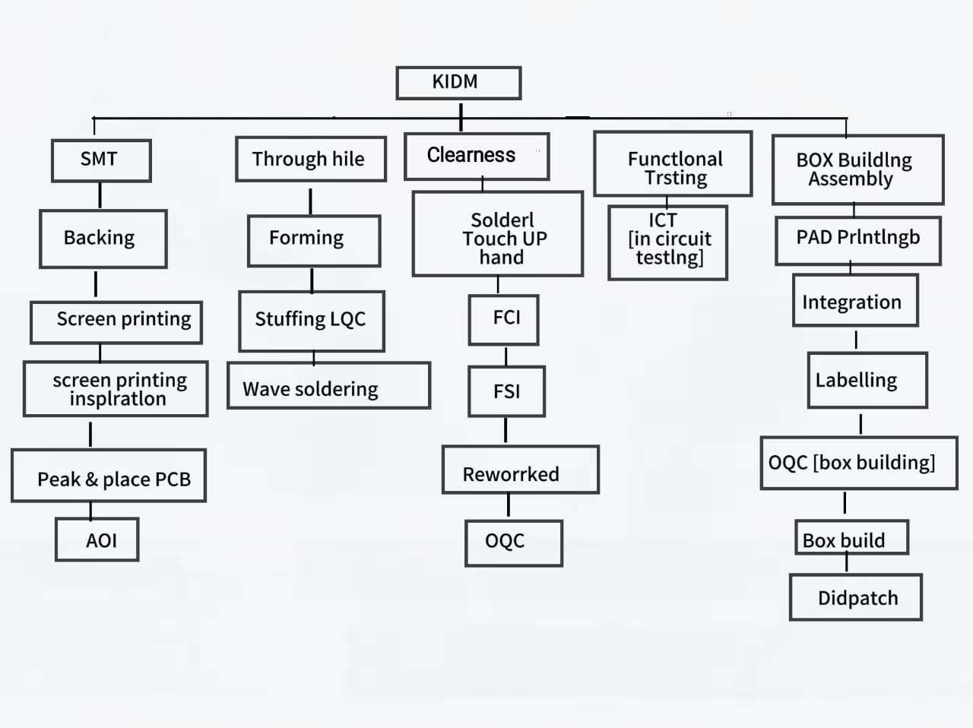
  - Roles And Responsibilities Of Personnal In Organization
In the company we are working as on-the-job training.The work or task which is assignedby the company supervisor, that will be completed by trainees, basically the work is related to electronics manufacturing the company such as PCB testing wave soldering depanelizing conformalcoatingofPCBA,our responsibilities is toattending at companyon time maintaining discipline doing 5s before starting training or work.
Here are some potential roles and responsibilities within kaynes technology:
- Senior management roles
- Manufacturing and operations roles
- Design and engineering roles
- Business development and sales roles

- Support function roles

Products
The company’s products find use in various industry verticals like automotive, industrial, aerospace, defence, outer-space and nuclear, medical, railways, IOT/IT and consumer. Kaynes technology serves 230 customers across the world, which includes names like Agape Diagnostic Ltd, Canyon Aero, Frauscher Sensor Technology, Hitachi Rail STS, India Japan Lighting, Siements Rail Automation and Tonbo Imaging.
The Popular Produts are
    - Smart energy meter
    - Industrial UPS
    - Cable assembly
    - Eaton
    - Nakamura
    - Iscramic

14. Market Performance
India’s ESDM industry is likely to grow at a healthy CAGR (Compound Annual Growth Rate) of 30% from |265,400 crore in FY (Financial Year) 21 to| 9,96,300 crore by FY26. The strong growthis expected to be driven by robust demand for electronic products across all industries (Automative, Industrial and IT) where Kaynes is present. Kaynes is backed by a robust supplier network. Its suppliers are spread across North America, Europe, Singapore as well asIndiaandthis company long standing relationships with its marquee customers.
Consolidated revenuesgrew at a CAGR (Compound Annual Growth Rate) of ~ 38% over FY20-22 The Automotive, Industrial and Railways verticals contribute ~70% to the company’s overall revenue kayneshas an order book of ~|2200 crore as of june 30,2022, which serviceable in ~1.5 years.Total 75% of this order book comprises orders from Automotive, Industrial and Railways verticals.

