Task 1

How to install Wireshark

What is Wireshark?

Wireshark is one of the best network protocols for analyzing freely available packages. This program is the most famous network protocol analyzer, and its purpose is to see what is happening around your network. Wireshark provides all the details you need to know about the packets in movement in your network.

How to Install Wireshark on Ubuntu 20.04 LTS ?

Step 1: Update APT
First, as always, update and upgrade your APT through the following command.
---> sudo apt update
–-> sudo apt upgrade

Step 2: Download and Install Wireshark
Now that Wireshark’s latest version has been added to the APT, you can download and install it with the following command.
---> sudo apt install wireshark

Step 3: Enable Root Privileges
When Wireshark installs on your system, you will be prompted by the following window. As Wireshark requires superuser/root privileges to operate, this option asks to enable or disable permissions for all every user on the system. Press the “Yes” button to allow other users, or press the “No” button to restrict other users from using Wireshark.
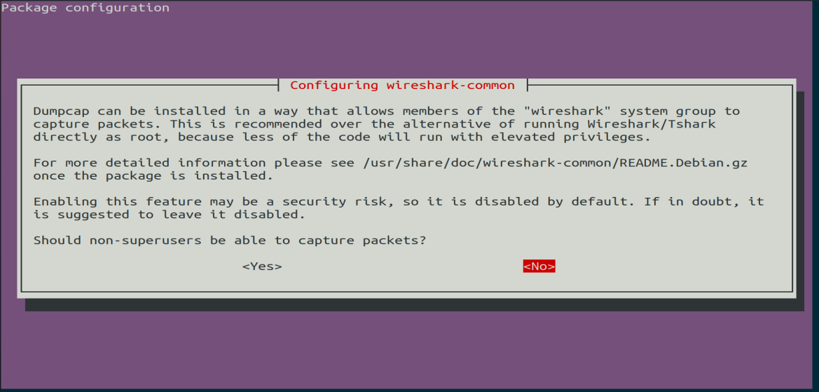

Step 4: Launch Wireshark
In the terminal window, type the following command to start the Wireshark application.
---> wireshark
You can also open Wireshark through the Graphical User Interface (GUI) by opening the activities on the Ubuntu desktop, and in the search bar, type “Wireshark,” and click on the application result.

Conclusion :
This article provided a simple, easy tutorial for installing Wireshark. Wireshark is the best tool for network analysis and packet investigation, and is an open-source and freely available network analyzing tool.

