g Mocking

- What is g mocking?
Mocks are used for testing the behavior of API (s) interfaces which will be used in component under test .Writing unit tests looks simple in blogs, books, and tutorials. However, it can be quite difficult when attempted in the real world where real code has dependencies that make unit testing difficult. The solution is to isolate unit tests using mocks, stubs, and fakes. Using mocks is crucial for any developer who attempts to unit test his code. g Mock is used for creating fake objects in order to remove external dependencies for effective testing.

In this article , a brief description is explained about g mocking .

G mocking

- To perform g mocking first we have to install g-mock package the following command perform this functionality
sudo apt-get install libgmock-dev
- Then import libraries of google testing and g mock testing
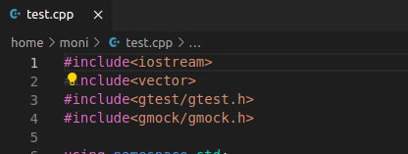

- Then we create a constructor named as DataBaseConnect
in which some functions login, logout and fetchRecord are declared .This DataBaseConnect is an interface .

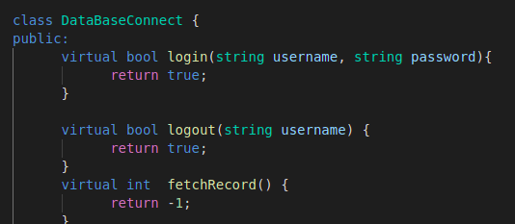

- Then we create a MockDB class which is publically inherit from DataBaseConnect . So inside this MockDB class write all the Mock_Methods inside the public section and use mock macro’s that are depending upon the number of parameters that are there in the function of method that we are trying to mock .
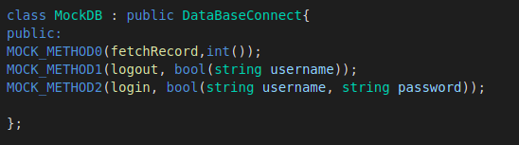

- Then we create a MyDatabase class in which we create instance of the DataBaseConnect that connects the MyDatabase class and DataBaseConnect class and sets two conditions as show below in pic.
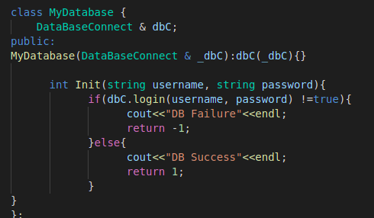

- Then we write the Tests in which we can generate macro’s Expect_call and On_call .
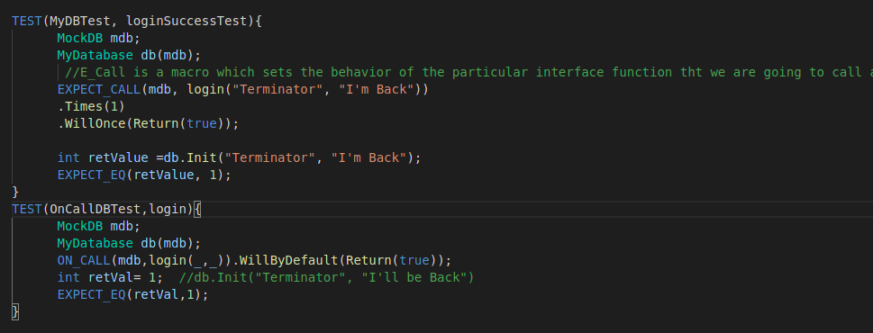

- The difference between the Expect_Call and the On_Call is that in expect call the called function will be executed and in on call it is not necessary to be executed if it is executed it will executed the default value ( .WillByDefault(Return(true)) .
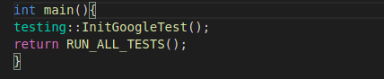
- Then we write the main function .

- Then executed the whole program
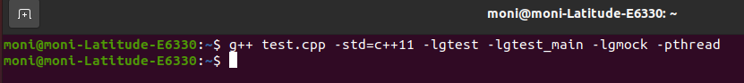
- The tests will passed as shown in below pic .

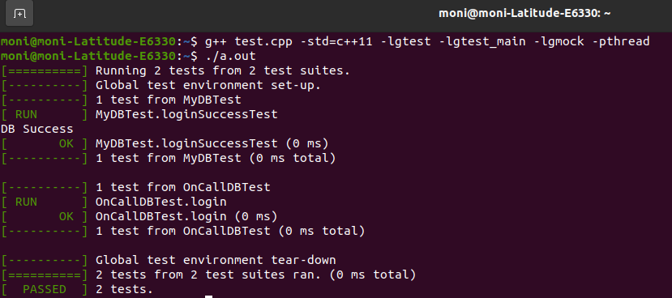

- Hopefully this article explained all concepts to you .

