|  |
| --- |
| Al-Fidaa Foundation Skills Development Centre |
| Enriching Lives Through Skills |
| Testimonials By Students |

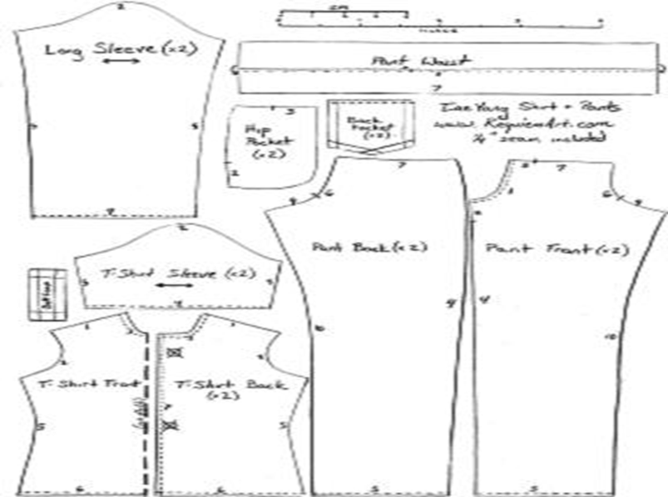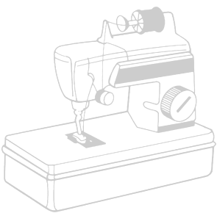

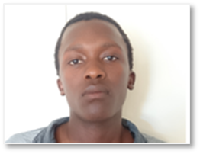 Name: Sandile Progress Nxumolo  
 Id No. 9310115325080  
 Highest Grade: Grade 12  
 Suburb: Kwazakhele  
 Class: September to December 2015

**Background**  
Sandile heard about the training offered at Al-Fidaa Foundation Skills Centre and enrolled. Having previously only sewed by hand, he has learnt to operate a sewing machine and sew a garment. Sandile feels that the experience of training at the Skills Centre has allowed him to believe in his abilities and be more confident overall. **Sandile’s Words**“I always had a dream that I will be a fashion designer but I could not apply to any institution because I did not meet the requirements. Some friend of mine told me about AL-FIDAA I showed interest and I wanted to apply by the grace of God I was accepted.”

“My experience at the foundation was great I learned a lot. The first week was difficult because it was my first time using a machine and learning how to sew. As days past by I started to get used to the environment, it was also challenging because I was the only male.”

“I was always challenged by the teachers of AL –FIDAA to attain greater height they believed in me and help med me discover my own new style as a designer.”

“The most important thing that I have learned at AL-FIDAA was in other to be great you need to involve yourself with people who believe in you.”

“My life at AL –FIDAA is exciting and at the same time scary. With all the experience I have gained at AL-FIDAA **I decided to start my own business clothing company with friends of mine. We will be designing clothes, enter fashion week competition and also inspire the youths who will be future designers .The clothing company will be named BUNDUAFRICA** LOOKOUT.”

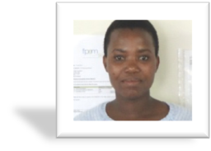 Name: Yoliswa Gwavu  
 Id No. 8510010463081  
 Highest Grade: Grade 12  
 Suburb: New Brighton  
 Class: September to October 2014

**Background**  
A single mother of 1, Yoliswa grew up in a child headed household and attempts to improve the quality of her life through further education. She is confident that her CV, with her sewing, computer and business skills will increase her employability

**Yoliswa’s Words**  
“I will always be forever grateful for the skills and the knowledge that I have acquired and accumulated from the AL-FIDAA FOUNDATION. I came into the foundation wanting to learn sewing; little did I know that I would leave with a whole lot more than that.”  
  
“My heart kept pounding every morning with excitement when I prepare to attend the classes because they always showered us with new things that I was learning for the first the first time and this surprises me greatly. I was ecstatic when they announced that we would also be computer literate, business economics and accounting skills would be given. The weeks went by so quickly because the experience was just overwhelming.”

“Before coming to AL-FIDAA FOUNDATION, I worked as a security officer, **but now I am working as a secretary and office administrator in one of the small business thanks to the computer skills that I gained.”**

“Everything that I learned came in handy and I am not willing to let any of the skills that I have gained go to waste because I invested so much time and sacrifice my precious sleep as I worked as a security officer by night and I was a student at AL-FID AA FOUNDATION by day. I did not mind though because I had the time, and I wanted to invest in myself most importantly for my life in the future.”

**“I am now putting the business skills into good use as I am busy drawing up my business plan.** And the accounting skills will definitely come in handy when the business is up and running.”

“May the foundation continue doing what they do to better the lives of those less fortunate and those who do not have the means to reach their dreams .Believe me when I say it does not go unnoticed, if I could I would do it again.”

“I appreciate the life –changing opportunity from AL-FIDA FOUNDATION SKILLS DEVELOPMENT CENTER. It has been a journey well received and has actually been a stepping stone, for me. This was the begging of a learning curve- from here there is no stopping.”

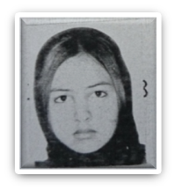   
 Name: Alleweya Hendricks  
 Id no. 8205080104083  
 Highest Grade: Grade 12  
 Suburb: Malabar  
 Class: June to August 2014

**Background**  
Alleweya was unemployed and needed to add to her skills set. Alleweya managed to secure employment at Mondelez while studying at Al-Fidaa.

**Alleweya’s Words**“In 2012, I unfortunately become unemployed by Absa and later onwards in the beginning of June 2014, was introduced to AL-FIDAA‘s sewing skills course introduced to me by Shaidat Aroyewun.

“I was very impressed with AL-FIDAA on the entire course overview. The staff was very friendly and helpful and an added bonus to the sewing course lectured by a qualified dressmaker and clothing designer Sindiswa Zokufa, was a basic computer Microsoft word up skills course by Shaidat Aroyewun an MBA holder.

The group attending the course was an amazing fun team of different age groups and dynamics being motivated and encouraged by Al –FIDAA FOUNDATION with assistance to be collected from home to ensure the entire course period is completed with a delicious Wednesday meal offered to all who attended the course.

**I never thought it possible that I would eventually be able to sew something by an industrial sewing machine looking professional**. it was one dream goal achieved. And to add to the achieved list of accomplishment. **I never thought that I would learn so much more in a short span of time what initially meant to a brush up of Microsoft word by Shaidat. I was immediately able to implement my new trained Microsoft word skills in my new job role at Mondelez a few weeks later. After being employed there for only two weeks, I was allowed to restructure the accounts payable recons process using sister Shaidats excel teaching**.

I would like to say a special thank you to all AL-FIDAA for the lifelong knowledge and skills given freely with no cost. And I pray for more to inspire to support your organization the way I have been inspired.

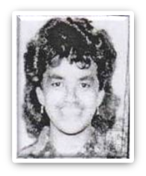 Name: Tayyiba Da Silva  
 Id no. 7310010009088  
 Highest Grade: Grade 12  
 Suburb: Central  
 Class: June to August 2014

**Background**  
Tayyiba was unemployed and used the opportunity at Al-Fidaa Foundation to add to her skills set as she has been struggling to secure employment for some time.

**Tayyiba’s Words**Al-Fidaa is a wonderful organisation I’d like to thank. The first thing I want to mention is the warm hospitality and beautiful character of the people working there. **During my most difficult time they supported me, not only in kind but also emotionally. I had someone to talk to at Al-Fidaa and that made me feel encouraged and dignified as a person in need of a shoulder to cry on.**

I’ve received computer literacy and sewing lessons. However, I maintain that the love and support shown by Al-Fidaa is the best hospitality one could ask for in such an organisation.

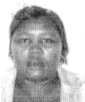 Name: Veliswa Clowe Ngqokwe  
 Id no. 790804114084  
 Highest Grade: Grade 11  
 Suburb: Kwazakhele  
 Class: May to July 2015

**Background**  
Veliswa’s dream has been to become her own boss, running a successful home enterprise. She enrolled in Fire and Safety training at the local community centre and was contractually employed as a cleaner. Being a busy single mother of 2, she continues to strive to improve her situation and is optimistic about her new learnt skills at the Al-Fidaa Foundation.

**Veliswa’s Journey**Veliswa displayed great interest in sewing during her time at the skills centre. She was determined to produce great looking items while doing her practical’s. After completing the course, Veliswa continued coming to the centre from time to time to harness her skills into doing more intricate work**. In 2016 Veliswa started manufacturing items at home for sale to community members**. In 2017 Zozinette baby carrier manufacturing company approached Al-Fidaa Foundation looking to employ a trainee staff member. Veliswa was nominated for the interview which she excelled at.

**Today Veliswa is part of the Zozinette Company Staff**, and enjoys her daily work.

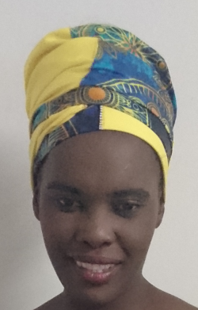 Name: Neliswa Bani  
 Id no. 83022200269084  
 Highest Grade: Grade   
 Suburb: Motherwell  
 Class: January to March 2017

**Background**  
Neliswa has been unemployed for a long time. Desperate for success, she desired to gain sewing skills to become financially self-sustainable.

**Neliswa’s Journey**  
Neliswa quickly gained the basic skills of sewing. With the basics she crafted her way into manufacturing and designing. Soon after completing her course, Neliswa started her very own business. Neliswa made use of the facility at the Al-Fidaa foundation skills centre to complete work for her clients. Today Neliswa has built a name for herself in her community.

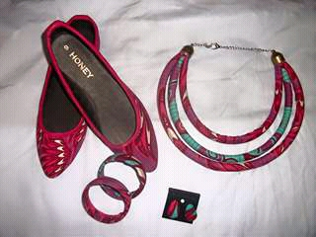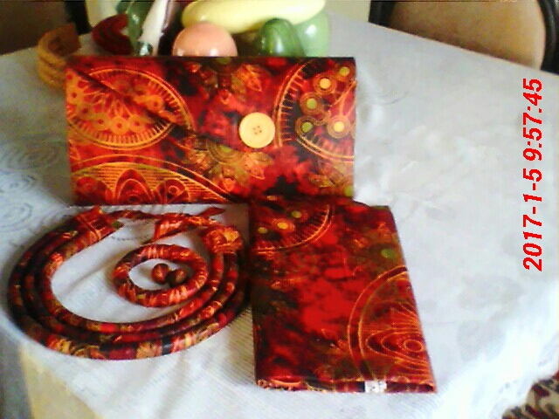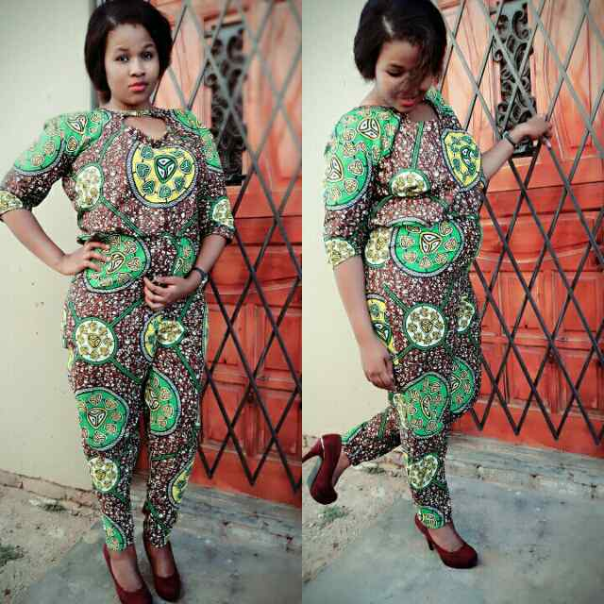

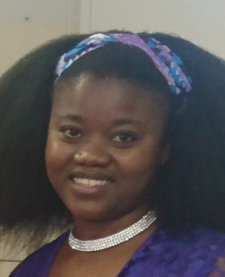 Name: Ntombenkosi Masa  
 Id no. 8807061228086  
 Highest Grade: Grade   
 Suburb: Motherwell  
 Class: April to July 2017

**Background**Married with two kids. I was attending night school at ABET in Motherwell hoping to find work when I finish, unfortunately I could not find anything. I was a stay at home mom with nothing to do. Not knowing where to start. My friend told me about Al-Fidaa. I did not have any skills, it was my first time learning a new skill. It was a great experience for me. I have learnt a lot at Al-Fidaa. I have been equipped with a lot of education. It is the best thing that has happened to me.

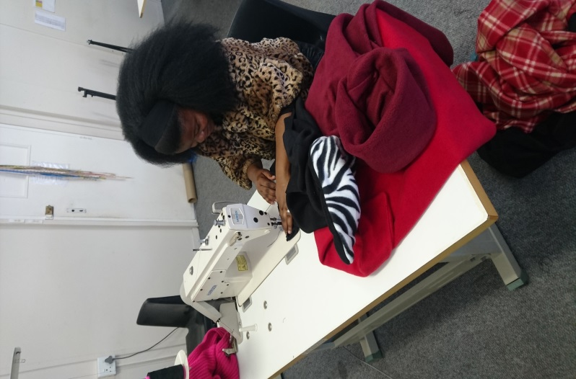**Ntombekosi Success**Ntombekosi immediately put her newly founded skills to action after completing her course. She started manufacturing Fleece Capes for clients. She makes use of social media advertising to get her product out in the market.

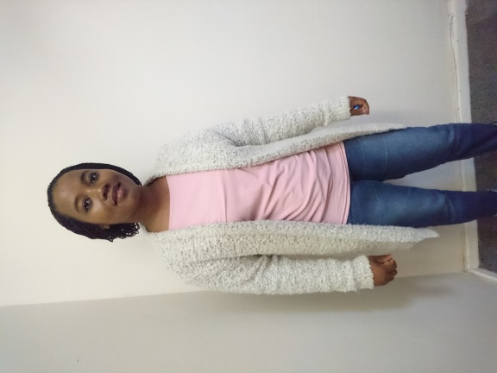 Name: Thembela Lisa Mblatshwa  
 Id.No: 8611170308083  
 Highest Grade: 11  
 Suburb: Kwadwesi  
 Class: May to July 2015

**Background**  
I am a shy person who loves other people and I love working with my hands. Team work is very important to me and I learned how to sew clothing at Al-Fidaa Foundation and I thank them for the skill they gave me.

**Thembela’s Journey**  
I started making clothes for people then it was African doeks. Al-Fidaa Foundation facilitated a work exposure for me at Zozinette where I learnt to manufacture baby carriers. I now also plan to start manufacturing baby carriers for the local market as Zozinette has moved to Johannesburg.

Name: Debbie Du Plessis  
 Id.No: 7306090161088  
 Highest Grade: 12  
 Suburb: Schauderville  
 Class: February to May 2018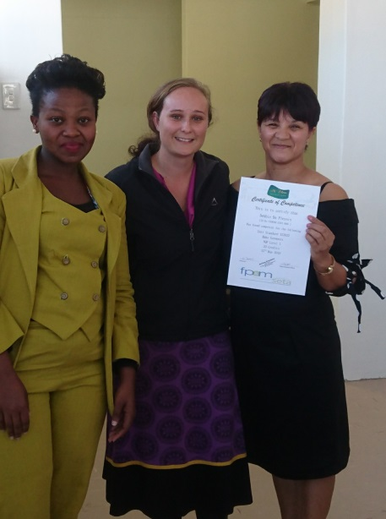

**Background**  
Debbie was unemployed for over a year. She knocked on many doors to find employment but always met with reject. Debbie had no prior sewing experience but always wanted to learn the skill.

**Debbie’s Story**  
Debbie enrolled in the School of Sewing and was dedicated and committed with her studies. She practiced daily on her new skills learnt in the classroom. When Debbie completed in May 2018 she started the journey of job hunting again. She was called in for an interview by a tracksuit manufacturing company who had a position of a qualified sewing machinist available. Debbie aced the interview and was given the job.

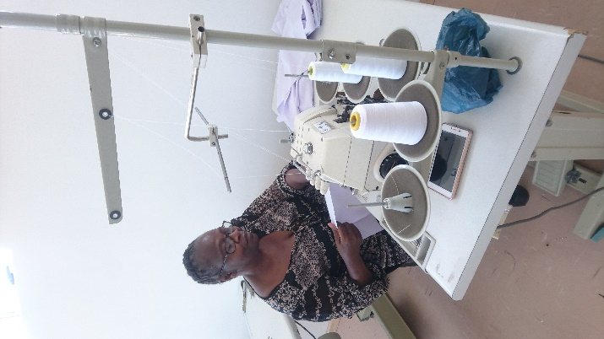 Name: Ntombekhaya Dimbaza  
 Id.No: 6101200480085  
 Highest Grade: Grade 12  
 Suburb: New Brighton  
 Class: June to August 2018

**Background**  
Ntombhekaya was hovering around a number of part time jobs, looking for stability in her life she enrolled to learn the skill of sewing.

**Ntombhekaya Story**Ntombhekaya always wanted to learn to sew. Her dream came true after completing the 12 week course. After her completion she managed to get an order for 30 aprons from a community organization. She manufactured sample doeks (traditional African ladies headwear) which was seen by a client in KingWilliamstown which placed an order for 12. She is currently busy with an order of 10 uniforms for a womens group in East London.

Name: Siphokazi Kemele  
 Id.No: 9202220264082  
 Highest Grade: Grade   
 Suburb:   
 Class: February to May 2018

**Background**  
Siphokazi Kemele tried on many attempts to enter the job market. As an unemployed youth she felt despondent of ever finding employment. Siphokazi applied for the sewing course to gain the skill to become self employed.

**Siphokazi’s Story**My name is Siphokazi Kemele, a former student from Al-Fidaa I applied for the dressmaker course in 2017 after a few months of waiting I was called-in for the classes to start in February 2018, where I learnt to make an apron, bag then a dress, the course was 3months long under the leadership of Nomakhaya Toise a very patient and insightful young woman, when I finished my course I was later introduced to a Metro wind representative from Sofisa and Phillips to pitch for funding to start my business.

After pitching and submitting my forms I then got feedback in a period of 4weeks,where my business HOUSE OF TSHIWO was awarded with R85,830 (eighty five thousand eight hundred and thirty rands) of funds which enabled me to purchase 2 Gemsy industrial machines, an industrial over locker ,clothing rack ,office equipment, a financial management course and a monthly allowance of fabric and threads.

My business has now been running for 4months at 10% profit. The Al-fidaa foundation has armed me with the skills and opportunity to change my situation and inspire my peers, I have not only been given the tools to materialise my dreams but I’ll also be helping 2 families put food on the table and play a part in growing and sustaining the economy.