Project Report

## TITLE : Sustainable Smart City Assistant Using IBM Granite LLM

MY TEAM FORMATION IN SMARTINTERNZ

Team ID:LTVIP2025TMID32279

Team Leader: Kuppam Nithin

Team Member: Guddam Divyasri

Team Member: K Lahari

Team Member: H Monica

1. INTRODUCTION

* 1. Project Overview

The Sustainable Smart City Assistant is an AI-powered tool designed to enhance urban living by providing citizens with real-time information and services. Leveraging IBM Granite LLM, this project aims to create a user-friendly interface for accessing city services, reporting issues, and receiving personalized recommendations.

* 1. Purpose

The purpose of this project is to improve the quality of life in urban areas by making city services more accessible and efficient. The Sustainable Smart City Assistant will help reduce waste, improve public safety, and enhance overall citizen engagement.

1. IDEATION PHASE

* 1. Problem Statement

Current city services are often fragmented and difficult to access, leading to inefficiencies and citizen dissatisfaction.

* 1. Empathy Map Canvas

* Citizens: Need easy access to city services and information.

* City Officials: Require efficient tools for managing and responding to citizen requests.

2.3 Brainstorming

* Integration with existing city infrastructure.

* User-friendly interface for citizens.

* Real-time reporting and feedback mechanisms.

1. REQUIREMENT ANALYSIS

3.1 Customer Journey Map

* Citizens interact with the assistant via a mobile app or web portal.

* City officials receive and respond to requests through a dedicated dashboard.

3.2 Solution Requirement

* Integration with IBM Granite LLM for natural language processing.

* Secure data storage and management.

3.3 Data Flow Diagram

* Citizens send requests through the app/portal.

* Requests are processed by the AI and forwarded to relevant city departments. - Responses are sent back to citizens.
* 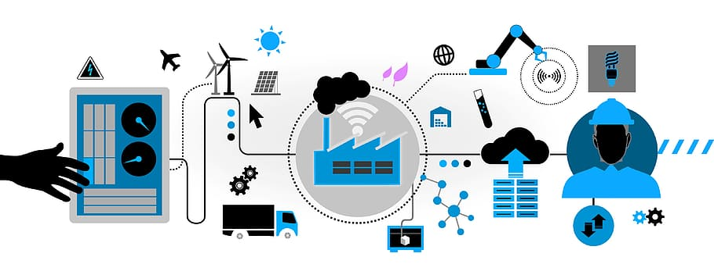

1. PROJECT DESIGN

* 1. Problem Solution Fit

The Sustainable Smart City Assistant addresses the need for a unified and accessible platform for city services.

* 1. Proposed Solution

* Develop a mobile app and web portal for citizens.

* Implement a dashboard for city officials.

4.3 Solution Architecture

* Frontend: Mobile app and web portal.

* Backend: IBM Granite LLM, data storage, and city infrastructure integration.

1. PROJECT PLANNING & SCHEDULING

5.1 Project Planning

* Phase 1: Research and requirement gathering.

* Phase 2: Development.

* Phase 3: Testing and deployment.

1. FUNCTIONAL AND PERFORMANCE TESTING

6.1 Performance Testing

- Conduct load testing to ensure the system can handle a large number of users.

1. RESULTS

7.1 Output Screenshots

* Screenshots of the mobile app and web portal.

* Dashboard for city officials.

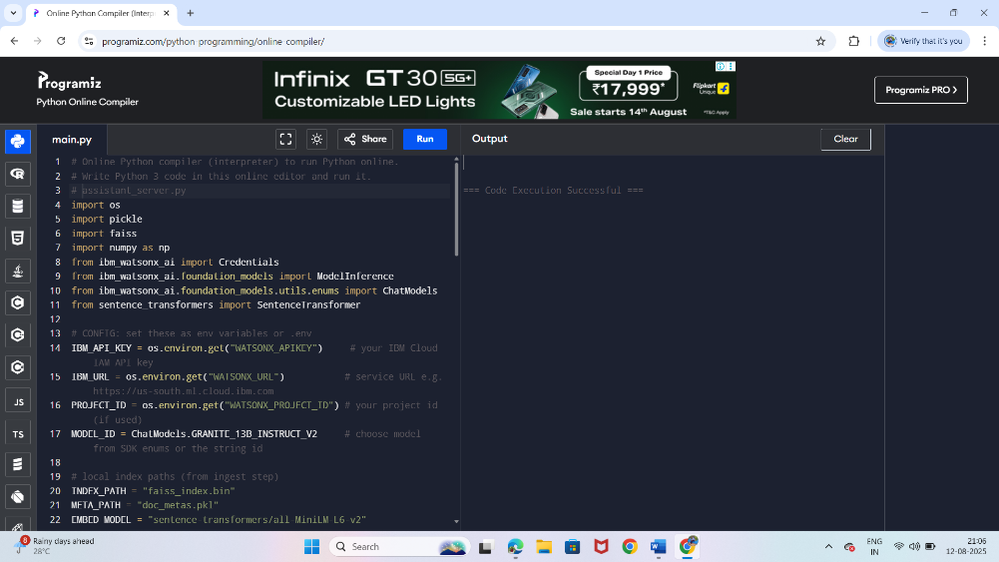

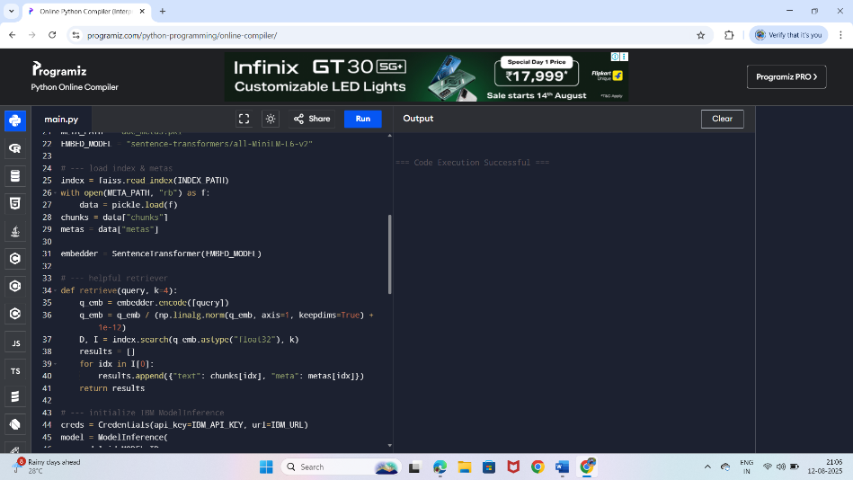

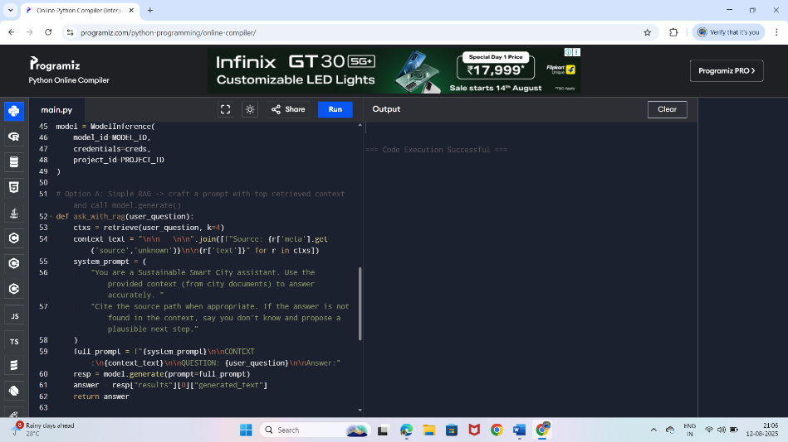

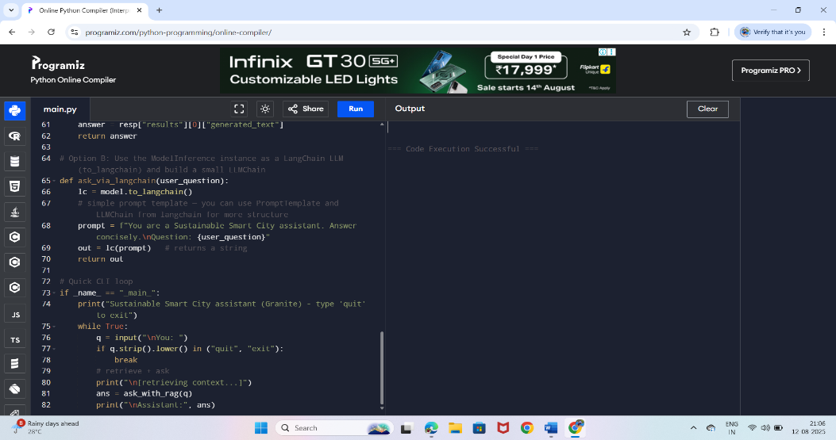

8. ADVANTAGES & DISADVANTAGES

Advantages:

* Improved citizen engagement.

* Enhanced efficiency of city services.

Disadvantages:

* Dependence on technology infrastructure.

* Potential privacy concerns.

1. CONCLUSION

The Sustainable Smart City Assistant has the potential to significantly improve urban living by making city services more accessible and efficient. With careful planning and execution, this project can serve as a model for other cities.

1. FUTURE SCOPE

* Integration with more city services.

* Expansion to other cities.

11. APPENDIX

* Source Code: Available on GitHub.