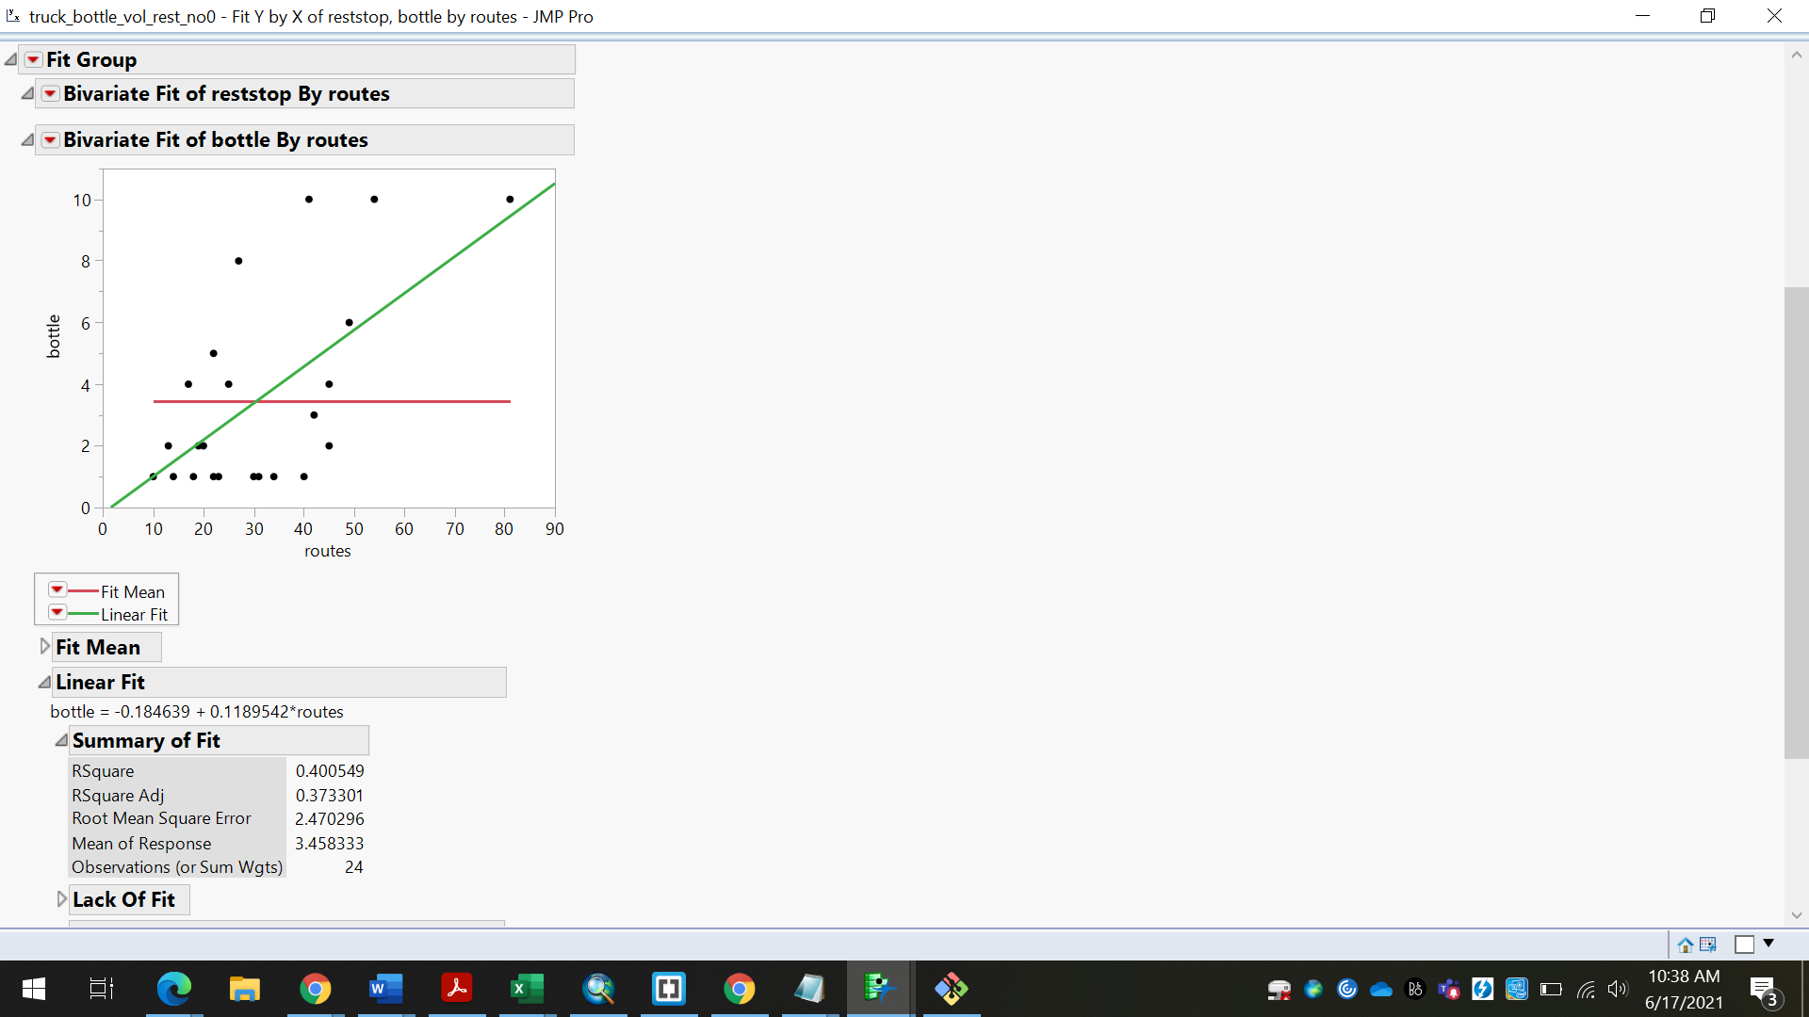

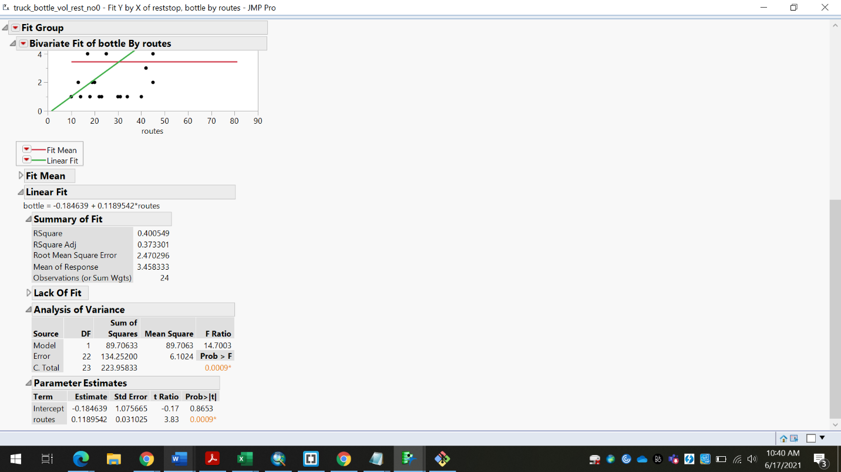

Here we can see that there is also a significant R square here which shows that there is a 40% increase in bottlenecks on truck routes. There is also a significant t-value which is at 0.0009% which shows that this analysis holds significance and can be investigated further for more research. We can also note that there is a root means square error of 2.4 showing that there is some information missing from this estimate. This analysis could mean that there is a relationship between more routes and also more bottlenecks. It would be interesting to note how many trucks use these routes during peak times and how these routes affect their delivery times.

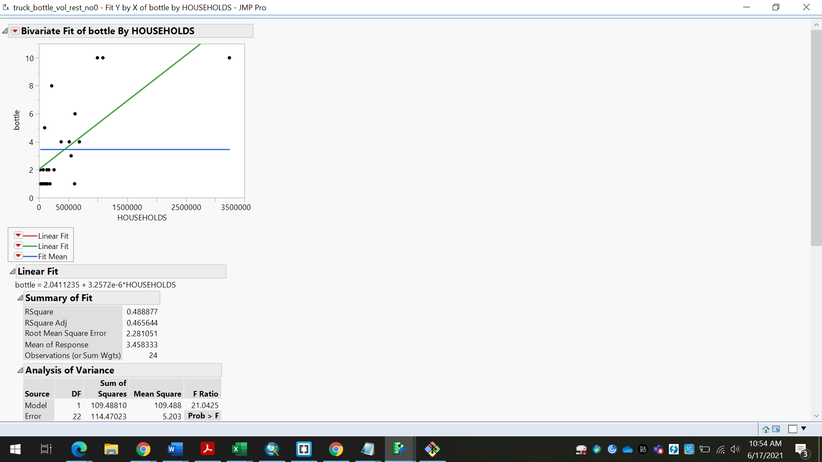

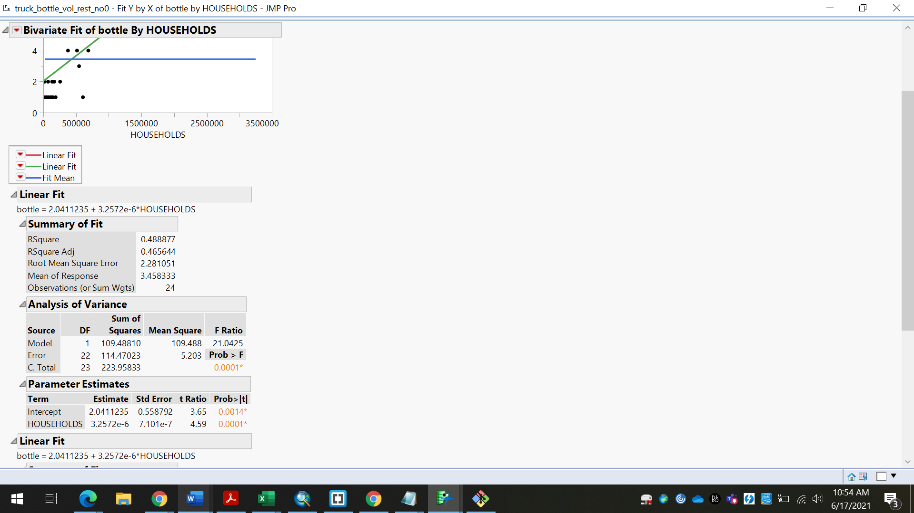

Here we can see that there is also a significant R square here which shows that there is a 48% increase in bottlenecks near households. There is also a significant t-value which is at 0.0001% which shows that this analysis holds significance and can be investigated further for more research. We can also note that there is a root means square error of 2.28 showing that there is some information missing from this estimate. This could be because there was a small dataset that was used. This analysis could mean that there is a relationship between more bottlenecks and households in the area. The more households that are located along the root, the more bottlenecks there will be. This could be because there are more commuters in the area.