MATH 546 - Summer 2026
Time Series Modeling and Forecasting of Georgia Docks Chicken Prices
By Monica Yesildirek
Disclosures
I have read and understood the assignment policies. I did not work with any classmates.
Notebooklm was used to summarize and produce study materials, particularly to combine like concepts spread throughout the readings, recordings, and slides. Claude code was used to aid in taking the original 1200 lines of R code I wrote down to the 238 lines submitted.

Introduction
The chicken dataset in the astsa package contains 180 monthly observations of whole-bird spot prices at Georgia docks from August 2001 through July 2016, measured in U.S. cents per pound. The series was first evaluated for trend, seasonality, changing variance, unusual observations, and stationarity to determine whether transformation or differencing was required.
The analysis then used the ACF and PACF of the stationary series to identify candidate ARIMA or SARIMA models. Candidates were compared using coefficient estimates, AIC, AICc, parsimony, and residual diagnostics, and the selected model was used to produce a 24-month forecast with prediction intervals.

Preliminary Analysis

Original series and transformation decision
The monthly chicken price series was first examined for trend, seasonality, changing variance, and unusual observations. As shown in Figure 1, prices increased from approximately 65 cents per pound in 2001 to more than 110 cents per pound by 2016, indicating a clear upward trend and changing mean. Short-term fluctuations occur throughout the series, but no consistent seasonal pattern, isolated outlier, or increase in variability is visually apparent.
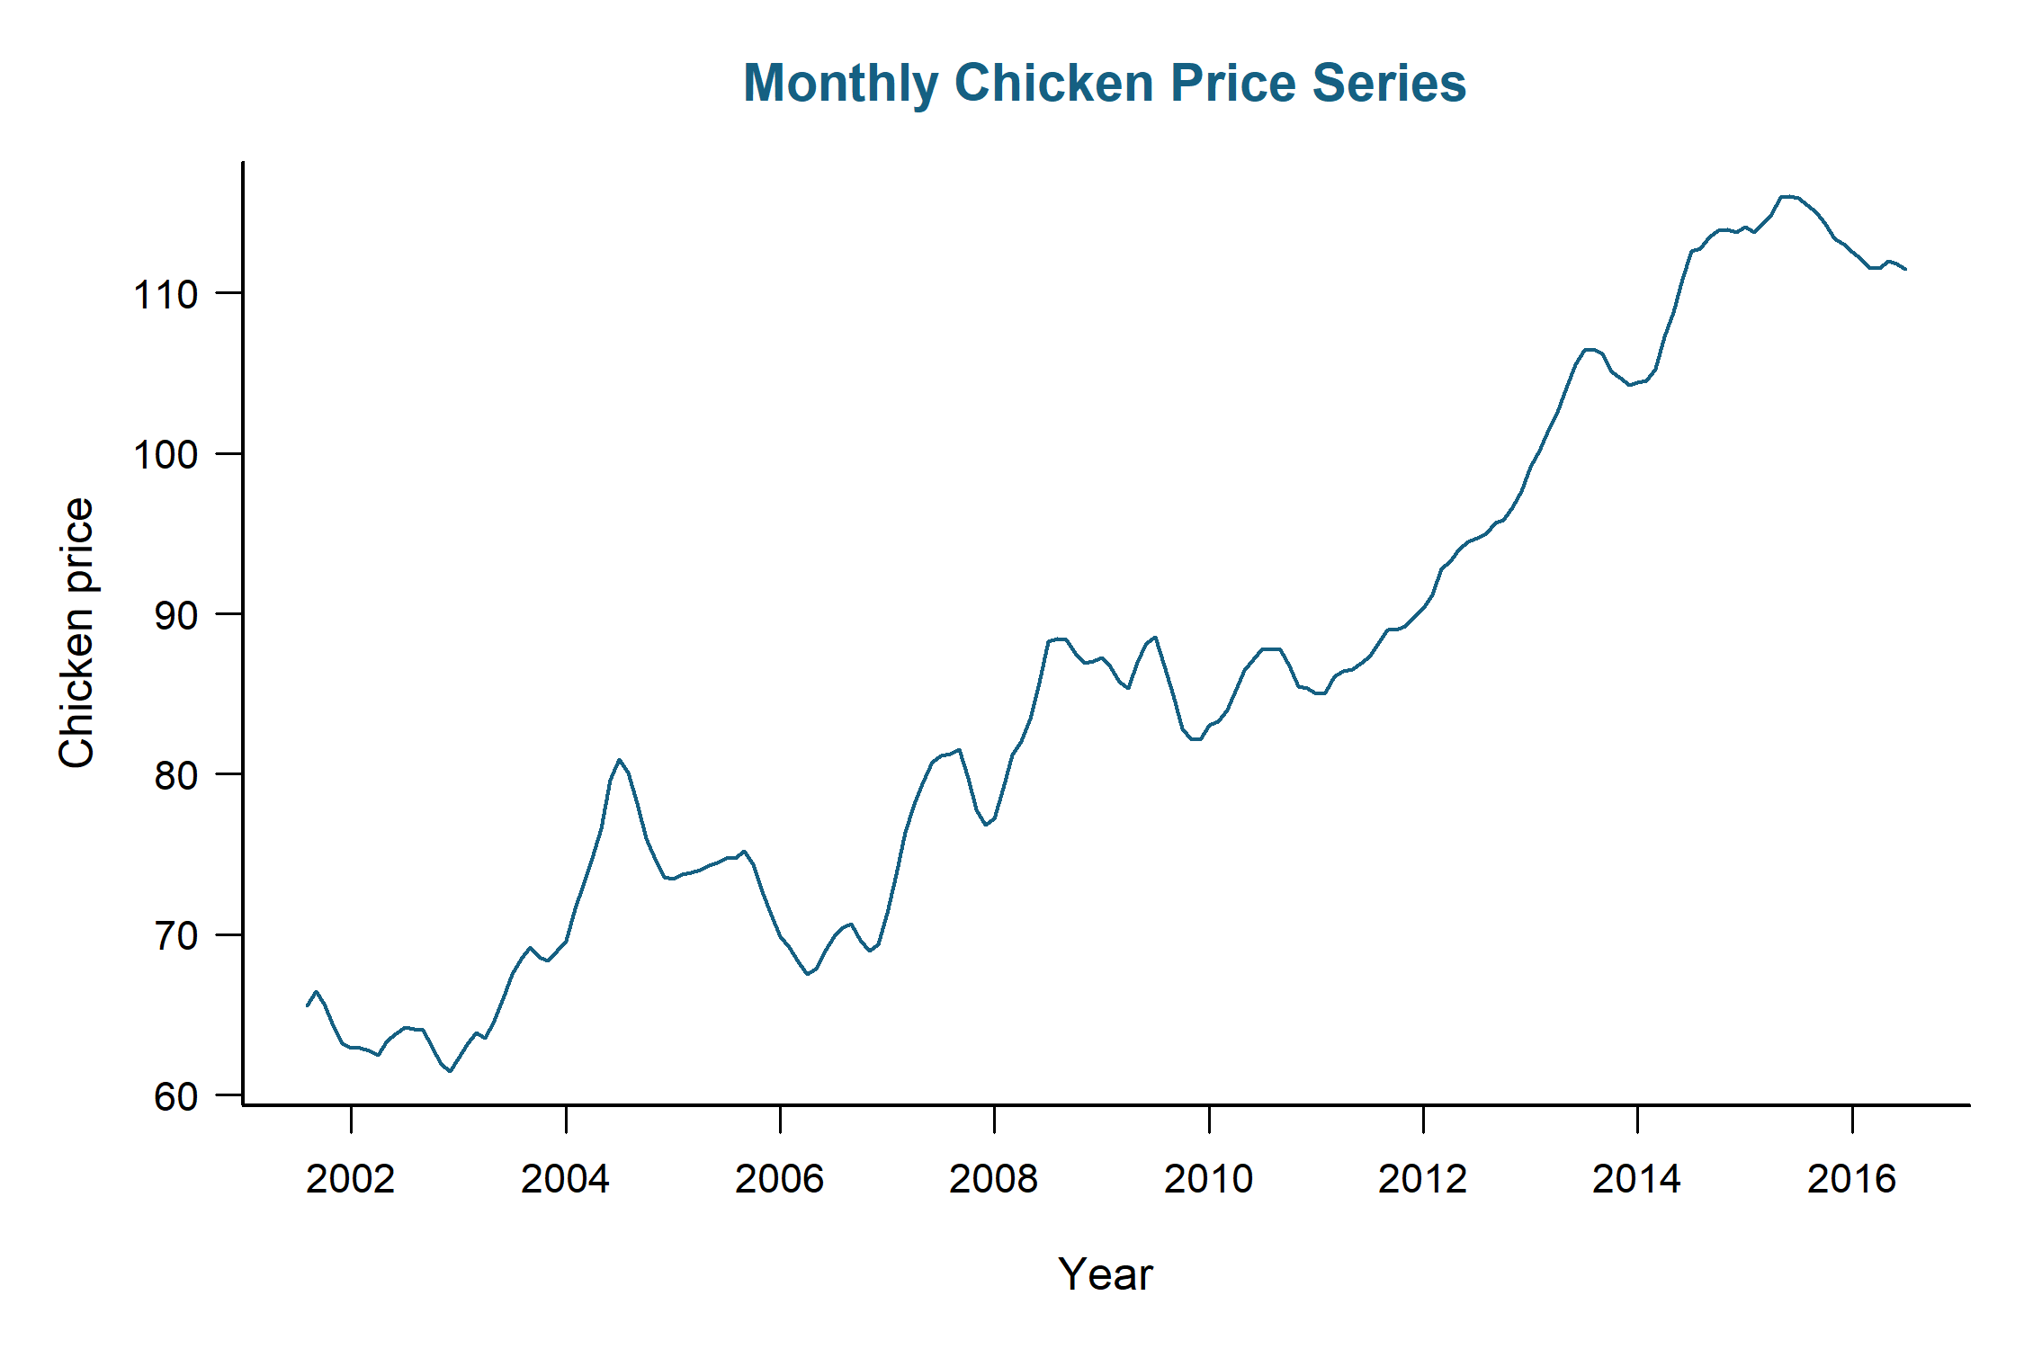
Figure 1. Monthly chicken price series on the original scale.
Because variability remains relatively stable as the price level increases, a log transformation is not required. The series is therefore retained on the original scale, allowing results and forecasts to remain directly interpretable in cents per pound. The persistent upward trend, however, indicates that differencing should be evaluated before model identification.

Differencing and stationarity
The sample ACF of the original series was examined to assess whether the changing mean persisted over time. Figure 2 shows strong positive autocorrelation that declines gradually from nearly 1.0 at short lags to about 0.20 after four years, with most correlations remaining above the confidence bound. This slow decay is consistent with nonstationarity and indicates that differencing is required.
The ACF does not show distinct peaks at 12-month intervals, so seasonal differencing is not clearly indicated from the original series alone. A lag-12 difference was therefore evaluated next to determine whether it removes the changing mean and produces a stationary series.
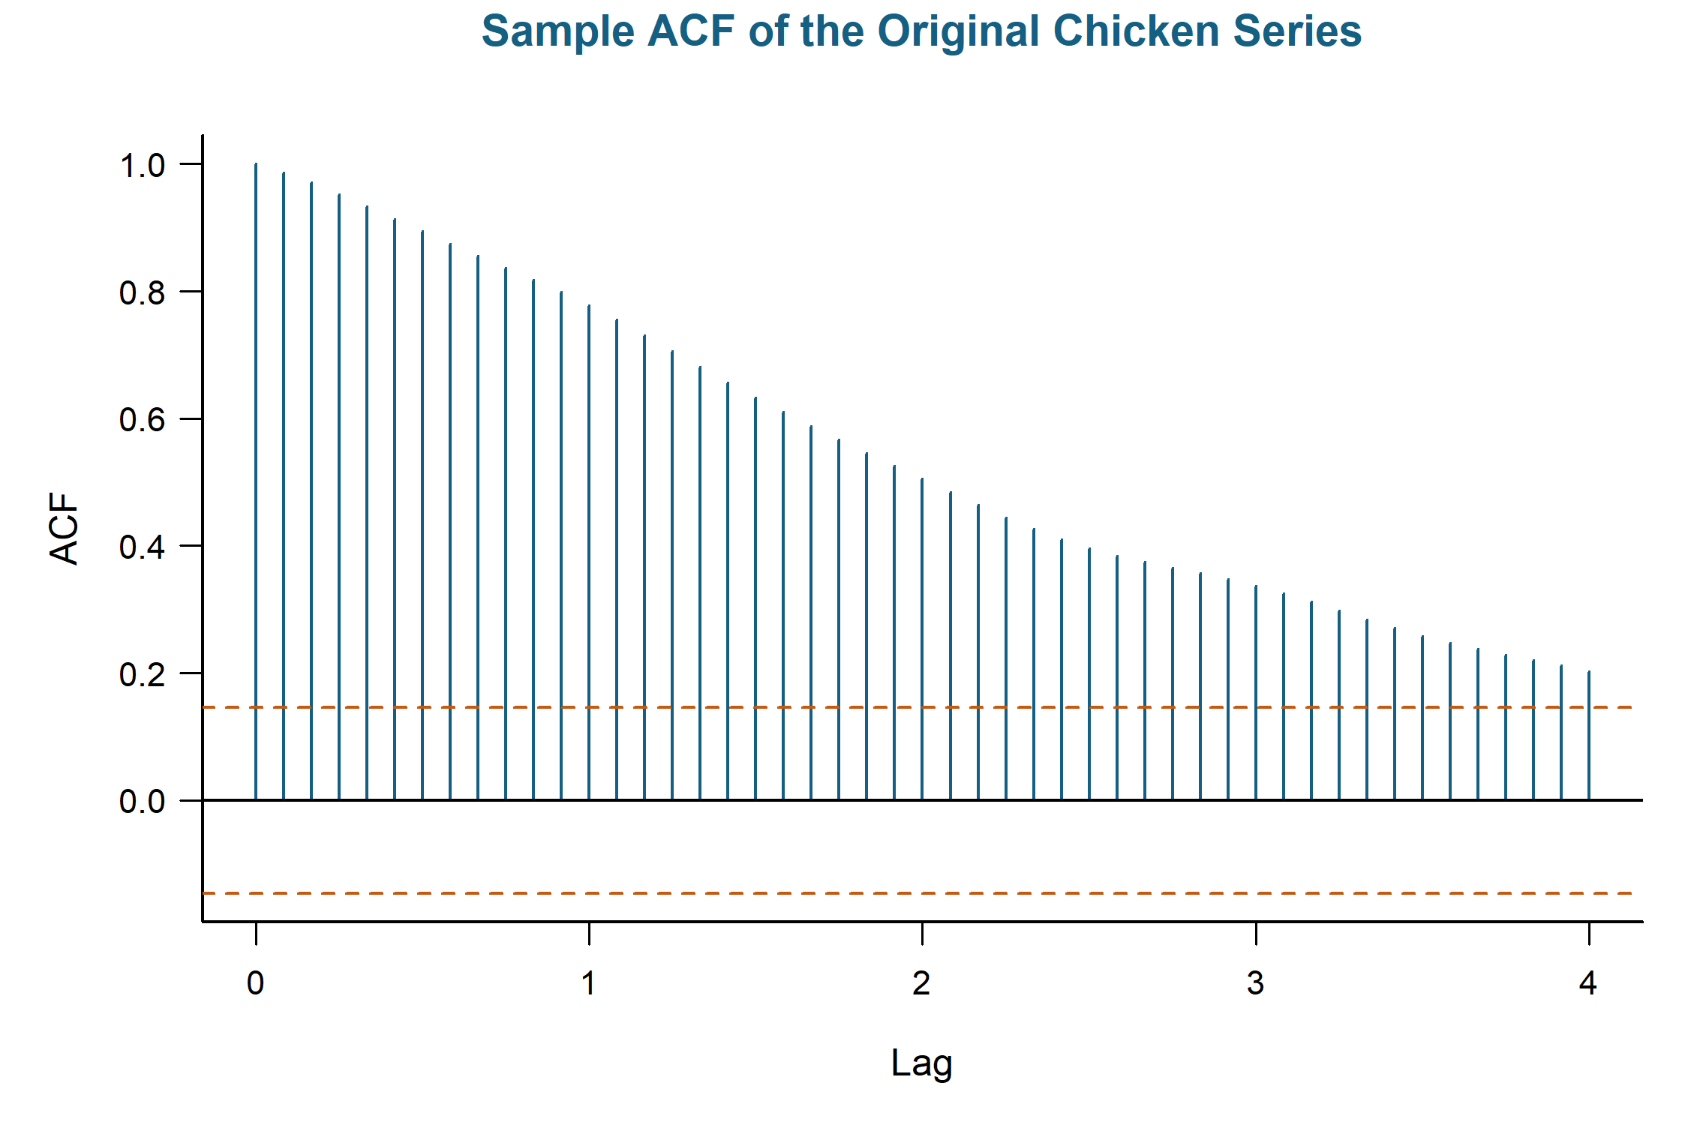
Figure 2. Sample autocorrelation function of the original monthly chicken price series.
The slow decay in the original-series ACF indicated nonstationarity and the need for differencing. A lag-12 seasonal difference was applied so that each monthly price was compared with the same month of the preceding year. As shown in Figure 3, the differenced series fluctuates around a more stable level and no longer shows the persistent upward trend or increasing variance seen in the original series.
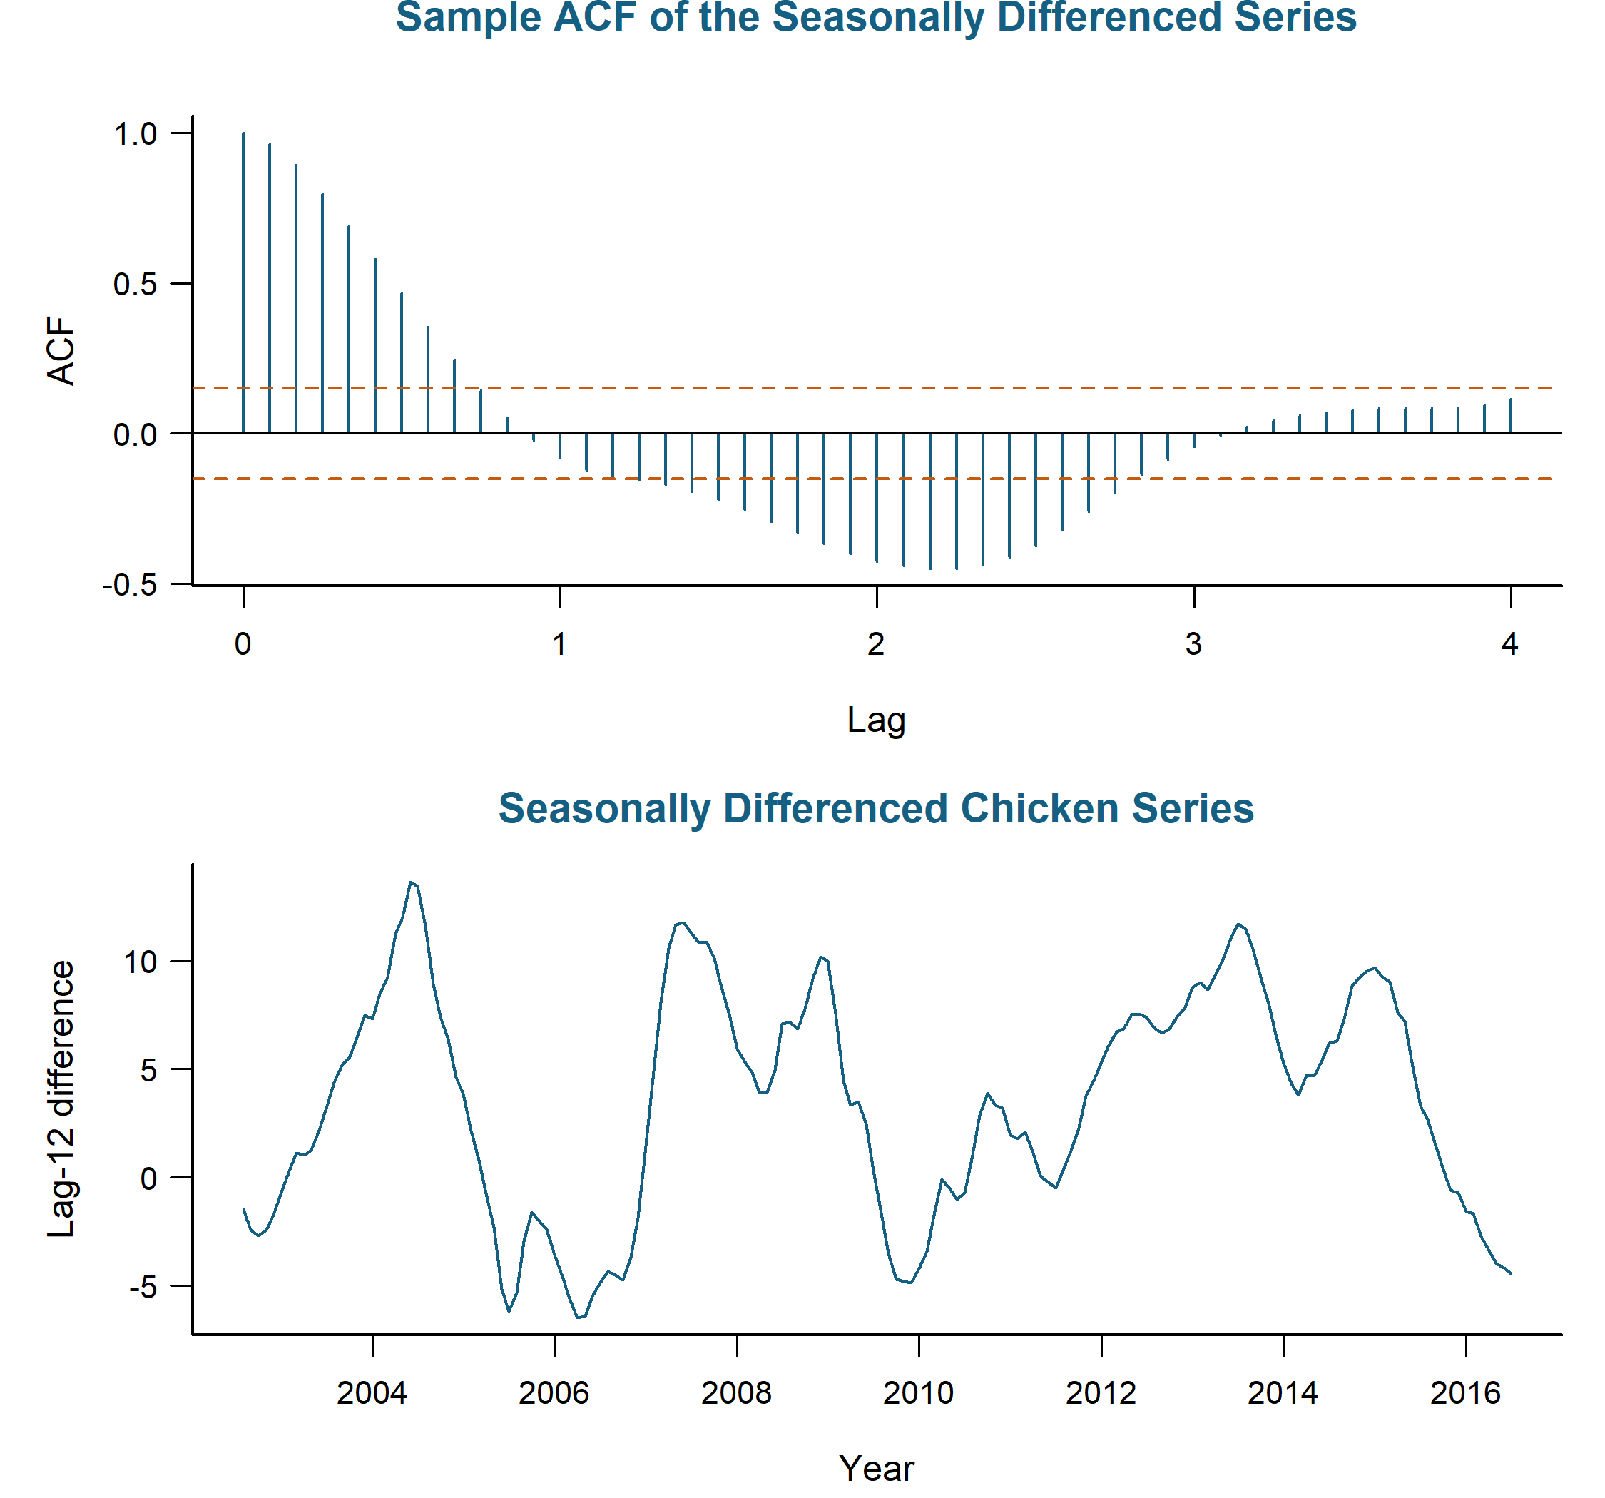
Figure 3. Sample autocorrelation function and seasonally differenced monthly chicken price series. The upper panel shows the sample ACF after applying a lag-12 difference, and the lower panel shows the resulting differenced series over time.
The ACF of the seasonally differenced series crosses zero and gradually returns toward zero, indicating remaining serial dependence but not a clear need for additional ordinary differencing. An augmented Dickey-Fuller test using five lags and a constant rejected the null hypothesis of a unit root (p<.01), supporting stationarity after seasonal differencing. The series used for model identification is therefore
Yₜ = (1 − B¹²) Xₜ = Xₜ − Xₜ₋₁₂. (1)
Thus, no ordinary difference was used (d=0), while one seasonal difference was applied (D=1) with a 12-month seasonal period.

Model Identification
Model identification used the ACF and PACF of the stationary lag-12 differenced series. As shown in Figure 4, the ACF exhibits a gradual oscillating decay, while the PACF has its largest spikes at the first two monthly lags followed by smaller correlations. These patterns support a low-order autoregressive or mixed ARMA structure, while the seasonal order is less apparent from the plots alone.
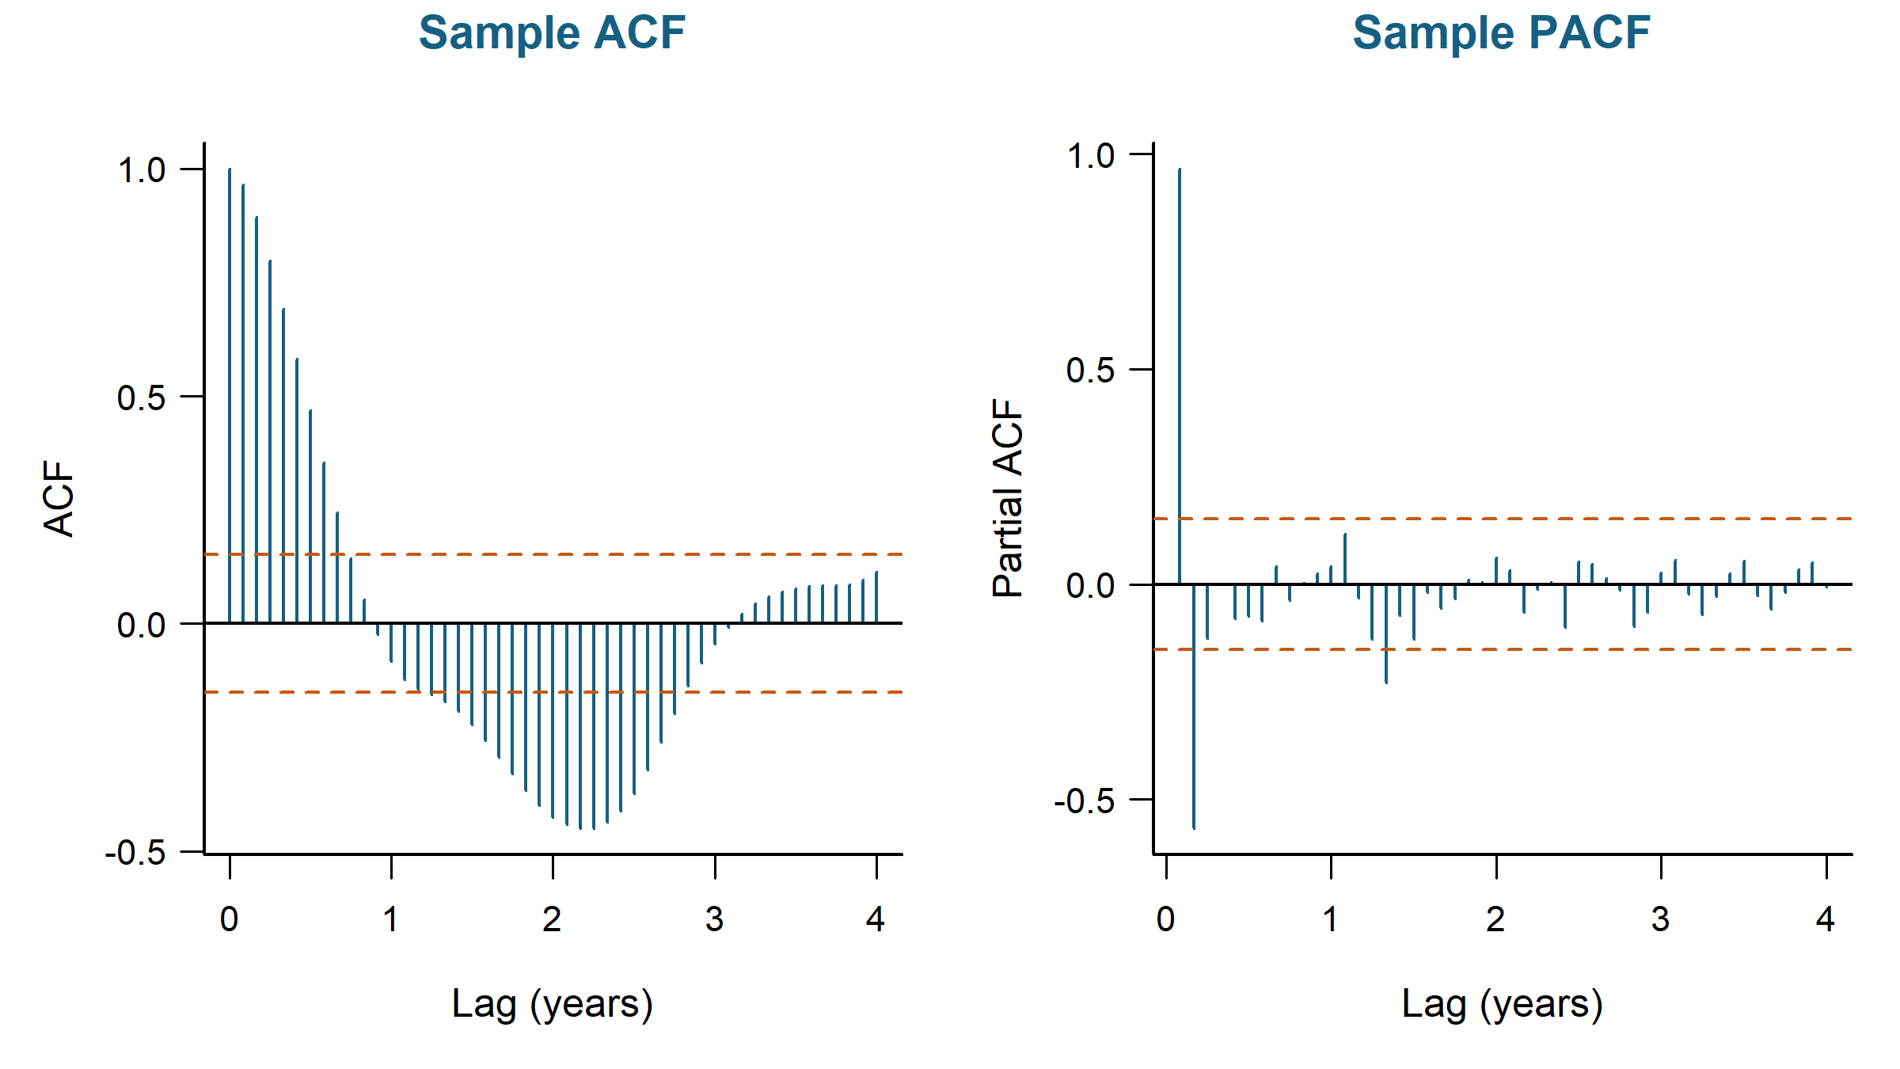
Figure 4. Sample ACF and PACF of the seasonally differenced chicken price series. Lags are displayed in years, with one year corresponding to 12 monthly lags.
An auto.arima() search was therefore applied to the seasonally differenced series. The lowest AICc was obtained by an ARIMA(3,0,0)×(0,0,1)₁₂​ model with a nonzero mean (AICc = 318.74), corresponding to a SARIMA(3,0,0)×(0,1,1)₁₂​ model for the original series. A closely competing ARIMA(2,0,1)×(0,0,1)₁₂​ model had an AICc of 318.98, while the simpler ARIMA(2,0,0)×(0,0,1)_{12​} model had an AICc of 321.65. These three models were retained for subsequent fitting and comparison.
The corresponding models for the original series are SARIMA(3,0,0)×(0,1,1)12​, SARIMA(2,0,1)×(0,1,1)12​, and SARIMA(2,0,0)×(0,1,1)12​. Each model includes one seasonal difference (D=1) and no ordinary difference (d=0). Therefore, sarima() represents the nonzero mean through a linear time regressor. The fitted models can be written in the general form
φ(B)Φ(B¹²) (1 − B)ᵈ (1 − B¹²)ᴰ Xₜ = θ(B)Θ(B¹²)Wₜ. (2)

Candidate Fitting and Comparison
The three data-driven candidates identified from the ACF, PACF, and automated search were fitted to the original chicken price series using sarima(). Each model included one seasonal difference at lag 12 and a linear time regressor, while the nonseasonal ARMA orders varied across candidates. The leading SARIMA(3,0,0)×(0,1,1)_{12​} model was compared with the closely competing SARIMA(2,0,1)×(0,1,1)_{12​} model and the simpler SARIMA(2,0,0)×(0,1,1)_{12​} alternative. A documented SARIMA(2,1,0)×(1,0,0)₁₂​ model was also fitted as an external benchmark for the differencing choice. Automated AICc values were used to identify candidate orders, while the final comparison used residual variance and the scaled AIC, AICc, and BIC values returned by sarima() for models fitted to the same original series.

Leading candidate
The leading candidate was the SARIMA(3,0,0) × (0,1,1)12 model. It includes three nonseasonal autoregressive terms, one seasonal moving-average term, and a linear time regressor. The coefficient estimates used to construct Equation 3 are summarized in Table 1. The fitted model is
(1 − 1.8401B + 1.0371B² − 0.1767B³) (1 − B¹²) (Xₜ − 0.2833t) = (1 − 0.8806B¹²) Wₜ. (3)
All five estimated coefficients were statistically significant at the .05 level. The first two autoregressive terms, seasonal moving-average term, and drift coefficient were highly significant (p < .001), while the third autoregressive term was smaller but remained significant (φ̂3 = 0.1767, p = .025). The positive drift coefficient indicates an underlying increase of approximately 0.2833 cents per pound per month. The model produced an estimated residual variance of 0.317870, an AIC of 1.8941, and an AICc of 1.8963, the lowest values among the three data-driven candidates.

Competing candidate
The primary competing model was SARIMA(2,0,1) × (0,1,1)₁₂. It replaces the third autoregressive term in the leading candidate with a first-order nonseasonal moving-average term while retaining the seasonal moving-average term and linear time regressor. Its coefficient estimates are also summarized in Table 1. The fitted model is
(1 − 1.6137B + 0.6400B²) (1 − B¹²) (Xₜ − 0.2844t) = (1 + 0.2176B) (1 − 0.8796B¹²) Wₜ. (4)
All five estimated coefficients were statistically significant at the .05 level. The nonseasonal moving-average term was significant (θ̂₁ = 0.2176, p = .021), while the seasonal moving-average and drift estimates were nearly identical to those of the leading candidate. The competing model had an estimated residual variance of 0.318216, an AIC of 1.8956, and an AICc of 1.8978. Because the differences in fit were small and both models contained five fitted coefficients, coefficient significance and parsimony alone did not clearly distinguish the two leading candidates.

Candidate-model comparison
The SARIMA(3,0,0)×(0,1,1)₁₂​ model produced the lowest residual variance (0.317870), AIC (1.8941), and AICc (1.8963) among the three data-driven candidates. The SARIMA(2,0,1)×(0,1,1)₁₂​ model performed nearly identically, with the same five fitted coefficients and an AICc only 0.0015 higher. The simpler SARIMA(2,0,0)×(0,1,1)₁₂​ model used four coefficients and had a marginally lower BIC (2.0053 versus 2.0057), but larger residual variance, AIC, and AICc. Because all three models were fitted using sarima(), their scaled information criteria are directly comparable. Overall, the information criteria slightly favored the SARIMA(3,0,0)×(0,1,1)₁₂​ model, with residual diagnostics used to determine whether this advantage was supported by model adequacy.
Parameter | Leading Estimate (SE) | Leading p | Competing Estimate (SE) | Competing p
AR(1) | 1.8401 (0.0763) | < .001 | 1.6137 (0.0761) | < .001
AR(2) | -1.0371 (0.1422) | < .001 | -0.6400 (0.0762) | < .001
AR(3) | 0.1767 (0.0781) | 0.025 | -- | --
MA(1) | -- | -- | 0.2176 (0.0936) | 0.021
Seasonal MA(1) | -0.8806 (0.0802) | < .001 | -0.8796 (0.0799) | < .001
Drift | 0.2833 (0.0371) | < .001 | 0.2844 (0.0356) | < .001
Table 1. Coefficient estimates of models fitted to the monthly chicken price series.
Model | Params | Sig.squared | Log.Likelihood | AIC | AICc | BIC | Delta.AICc
SARIMA(3,0,0)  x(0,1,1)[12] | 5 | 0.31787 | -153.10739 | 1.894 | 1.896 | 2.006 | 0.000
SARIMA(2,0,1)  x(0,1,1)[12] | 5 | 0.31822 | -153.22941 | 1.896 | 1.898 | 2.007 | 0.001
SARIMA(2,0,0)  x(0,1,1)[12] | 4 | 0.33120 | -155.63632 | 1.912 | 1.914 | 2.005 | 0.017
Table 2. Comparison of candidate SARIMA models fitted to the monthly chicken price series.

Model Diagnostics
Residual diagnostics were examined to determine whether the two leading candidates adequately accounted for the dependence in the chicken price series. For each model, the standardized residual time plot, residual ACF, normal Q-Q plot, and Ljung-Box p-values were evaluated for remaining serial correlation, changing variance, unusual observations, and departures from normality before the final model was selected.

Leading candidate
The residuals from the SARIMA(3,0,0) × (0,1,1)₁₂ model were first examined to determine whether the leading candidate behaved approximately as white noise.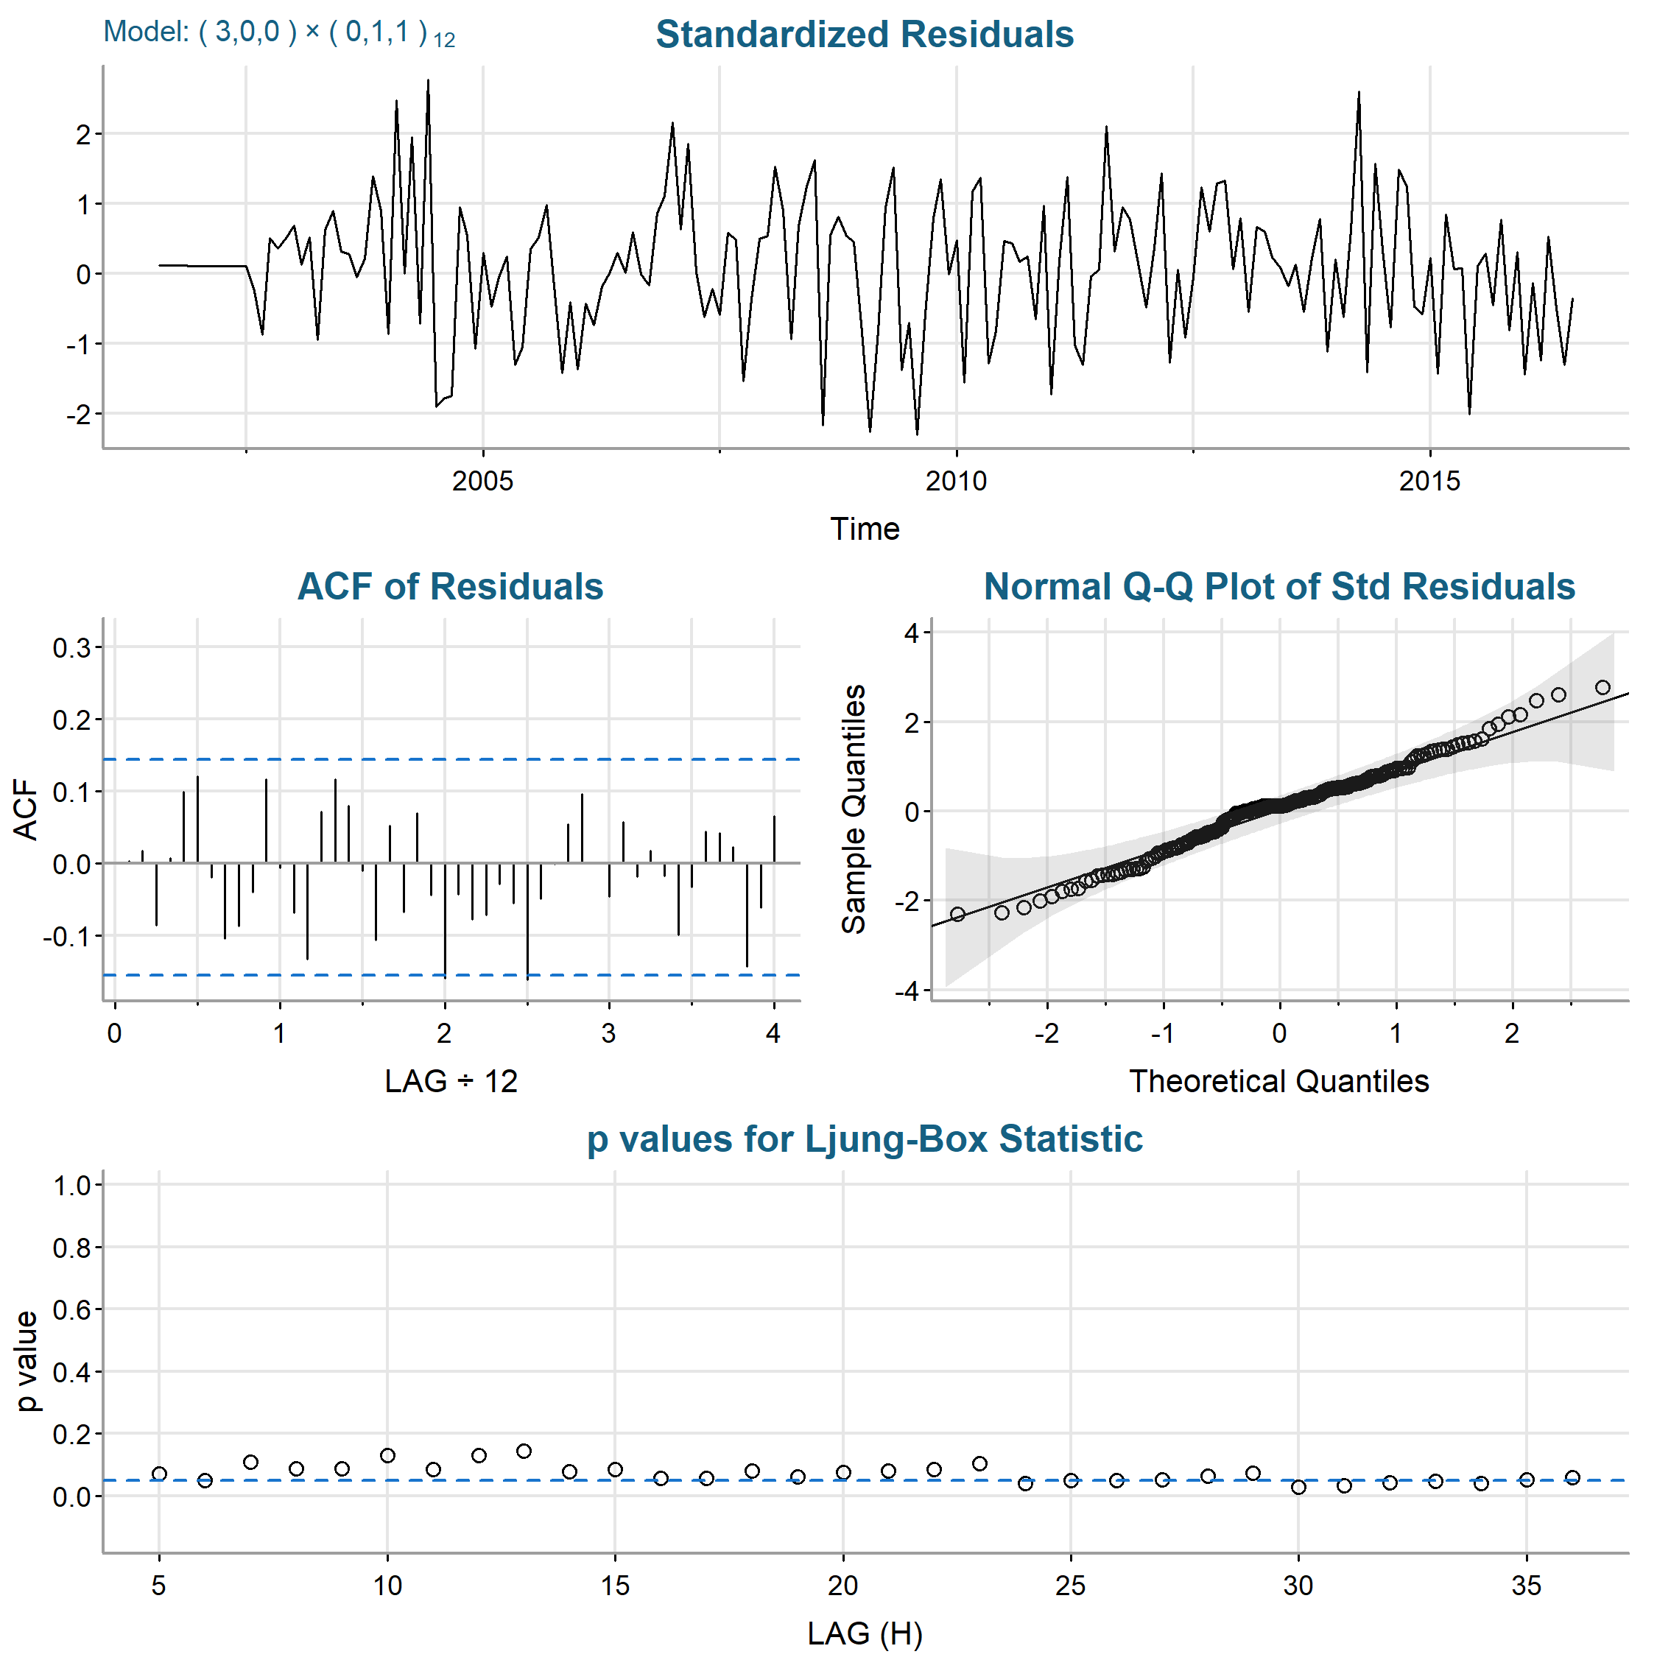
Figure 5. Residual diagnostics for the SARIMA(3,0,0) × (0,1,1)₁₂ candidate. The panel includes the standardized residual series, residual ACF, normal Q-Q plot, and Ljung-Box p-values.
As shown in Figure 5, the standardized residuals fluctuate around zero without a persistent trend or progressive change in variance, although several isolated observations approach approximately ±2.5 standard deviations. Most residual autocorrelations are small, but isolated negative spikes near approximately 24 and 30 months reach or slightly exceed the confidence bounds. Several Ljung-Box p-values at higher lags also fall below .05, indicating that modest long-lag dependence remains. The normal Q-Q plot is approximately linear through the center with mild departures in both tails. The leading candidate therefore captures the dominant dependence in the series, although its residuals are not perfectly white noise.

Competing candidate
The same diagnostic checks were applied to the SARIMA(2,0,1) × (0,1,1)₁₂ model so that the two candidates could be evaluated using the same criteria.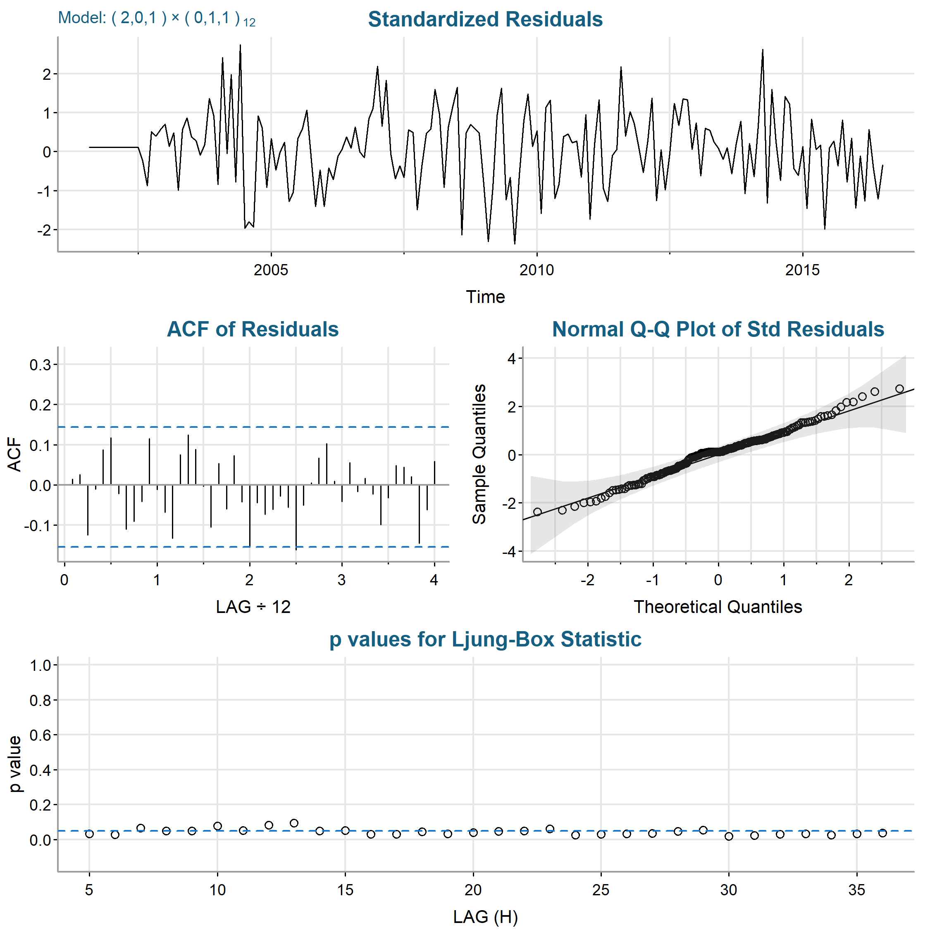
Figure 6. Residual diagnostics for the SARIMA(2,0,1) × (0,1,1)₁₂ candidate. The panel includes the standardized residual series, residual ACF, normal Q-Q plot, and Ljung-Box p-values.
Figure 6 shows a residual pattern very similar to that of the leading candidate. The standardized residuals remain centered near zero with generally stable variance, and the Q-Q plot is close to linear through the middle of the distribution with mild tail departures. The residual ACF again contains isolated negative spikes near approximately 24 and 30 months, and several Ljung-Box p-values are at or below .05. The competing model therefore leaves a similar amount of long-lag dependence and does not provide a diagnostic improvement over the leading candidate.

Diagnostic comparison
The two leading candidates have nearly indistinguishable diagnostic behavior, and neither removes every indication of long-lag dependence. The SARIMA(3,0,0) × (0,1,1)₁₂ candidate nevertheless provides the stronger overall combination of fit and parsimony because it has the smaller residual variance, AIC, and AICc while using the same number of fitted coefficients as the SARIMA(2,0,1) × (0,1,1)₁₂ competitor. Most residual autocorrelations remain within the confidence bounds and departures from normality are mild; however, the diagnostics do not clearly distinguish the two leading candidates. The isolated residual correlations and low Ljung-Box p-values are acknowledged as a limitation rather than evidence that the model captures every feature of the series.

Final Selection and Forecasting

Final model selection
The SARIMA(3,0,0) × (0,1,1)₁₂ model was selected for forecasting based on the combined evidence from coefficient estimates, information criteria, parsimony, and residual diagnostics. It produced the smallest residual variance (0.317870), AIC (1.8941), and AICc (1.8963) among the three data-driven candidates, and all five estimated coefficients were statistically significant at the .05 level. Its BIC (2.0057) was essentially tied with that of the simpler model (2.0053), but the selected model provided better fit by the other criteria without using more parameters than its closest competitor. The third autoregressive coefficient also remained significant (φ̂₃ = 0.1767, p = .025), supporting its retention rather than reducing the nonseasonal autoregressive order.
In practical terms, the selected model indicates that monthly chicken prices are not independent observations. Current prices retain information from recent months, while the seasonal structure accounts for recurring annual dependence in the monthly price process. The fitted linear time coefficient of 0.2833 represents an underlying increase of approximately 0.2833 cents per pound per month after the modeled temporal dependence is taken into account. For a stakeholder, the model therefore represents chicken prices as a combination of persistent short-term price behavior, annual dependence, and a gradual long-term increase rather than as isolated monthly changes.
The SARIMA(2,0,1) × (0,1,1)₁₂ model was not selected because it had slightly larger residual variance, AIC, and AICc, did not improve the residual diagnostics, and used the same number of fitted coefficients. The simpler SARIMA(2,0,0) × (0,1,1)₁₂ model reduced the parameter count by one but sacrificed fit. These differences are small, so the selected model should not be interpreted as overwhelmingly superior; rather, it provides the strongest overall representation of the observed price behavior among the models evaluated. The final numerical fitted model is given in Equation 3.

Twenty-four-month forecast
A 24-month forecast was generated from the selected SARIMA(3,0,0) × (0,1,1)₁₂ model with 80% and 95% prediction intervals using forecast(). As shown in Figure 7, the point forecast initially declines from approximately 111 cents per pound to about 109 cents per pound before increasing with moderate recurring fluctuations. By the end of the forecast period, the expected price reaches approximately 119 cents per pound. The complete monthly point forecasts and corresponding prediction intervals are provided in Appendix B. 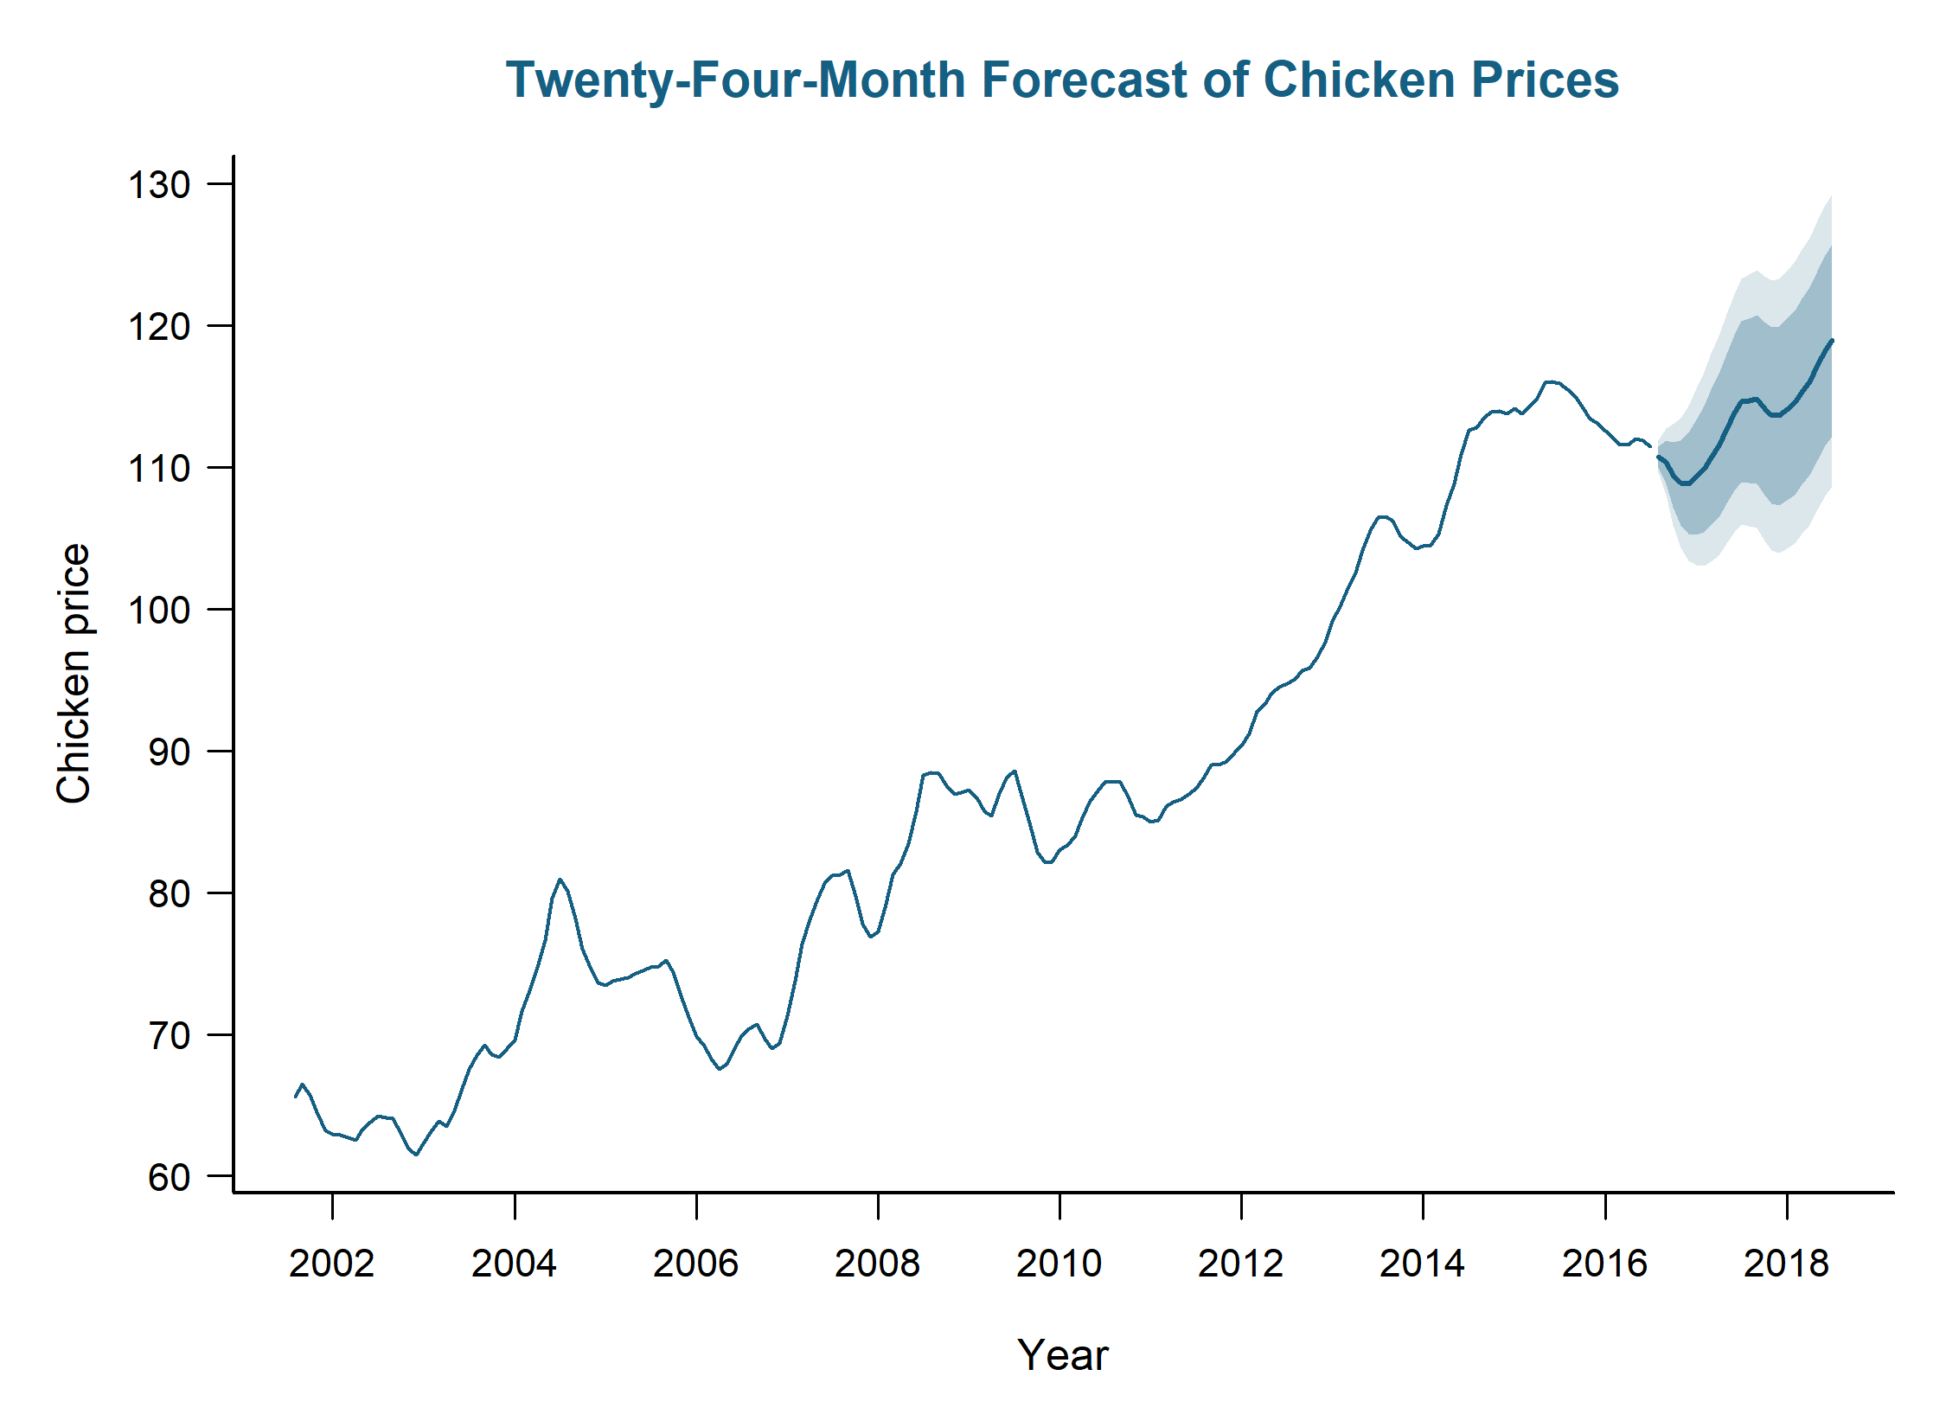
Figure 7. Twenty-four-month forecast from the selected model with 80% and 95% prediction intervals.
For a stakeholder, the forecast suggests that chicken prices are expected to remain near their recent historically high levels rather than return to the lower price levels observed earlier in the series. The projected path includes short-term increases and declines, so the model should not be interpreted as predicting a steady month-to-month rise. Instead, it indicates an overall upward direction across the two-year horizon while preserving the recurring temporal behavior found in the historical data. This distinction is important for planning: the point forecast provides a reasonable expected price path for budgeting or procurement, but individual monthly prices may deviate from that path.
The 80% and 95% prediction intervals widen as the forecast horizon increases, quantifying the growing uncertainty in prices farther into the future. Near-term forecasts therefore provide a narrower range of plausible prices, whereas longer-horizon values should be treated as planning ranges rather than precise predictions. The 95% interval is wider than the 80% interval because it is designed to contain a broader range of plausible future outcomes. For decision-making, the intervals are particularly useful because they show the range of prices that should be considered when evaluating cost exposure or planning under uncertainty, rather than relying only on the point forecast.
Forecasts are reported on the original scale of U.S. cents per pound. The series was not logarithmically or otherwise variance-transformed before model fitting, so no back-transformation or transformation-bias adjustment was required. Although the selected model captures the dominant temporal structure, isolated long-lag residual dependence remains. The forecasts should therefore be interpreted as statistically supported estimates based on historical price behavior, not as guarantees or as predictions that incorporate future market shocks or other external drivers.
Overall, the SARIMA(3,0,0) × (0,1,1)₁₂ model provides the strongest combination of fit, significant coefficients, and parsimony among the models evaluated, while exhibiting residual behavior comparable to its closest competitor. Quantitatively, it minimizes residual variance, AIC, and AICc among the data-driven candidates; qualitatively, it represents chicken prices as persistent over time, influenced by annual dependence, and subject to a gradual upward trajectory. The 24-month forecast consequently supports planning for generally elevated and increasing prices while emphasizing progressively greater uncertainty farther into the future.

Appendix A: R Script for figures and tables
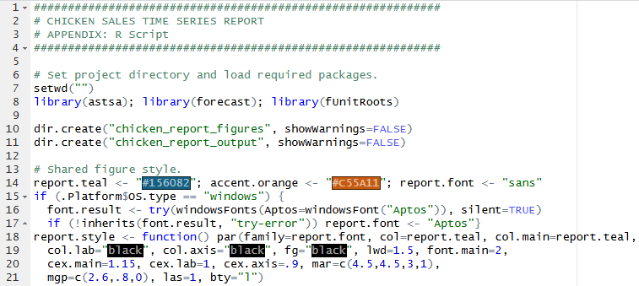
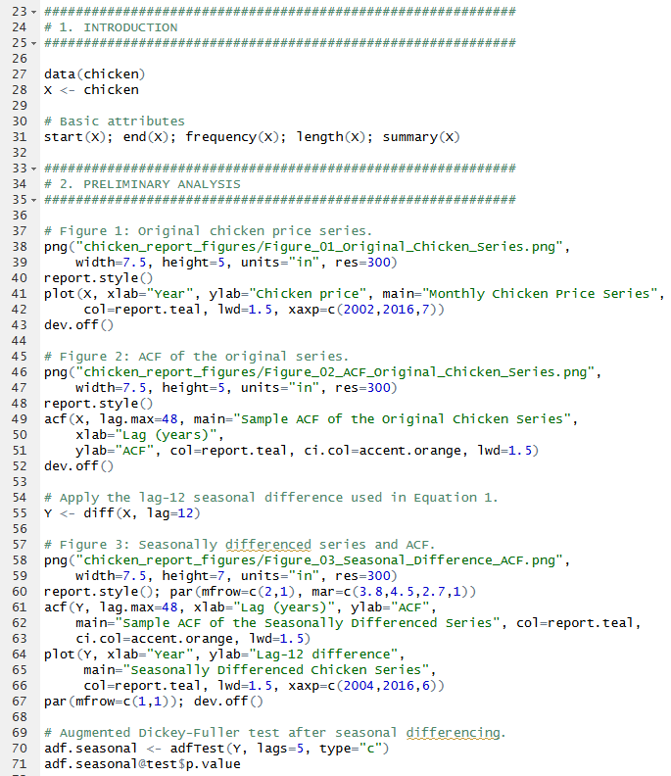
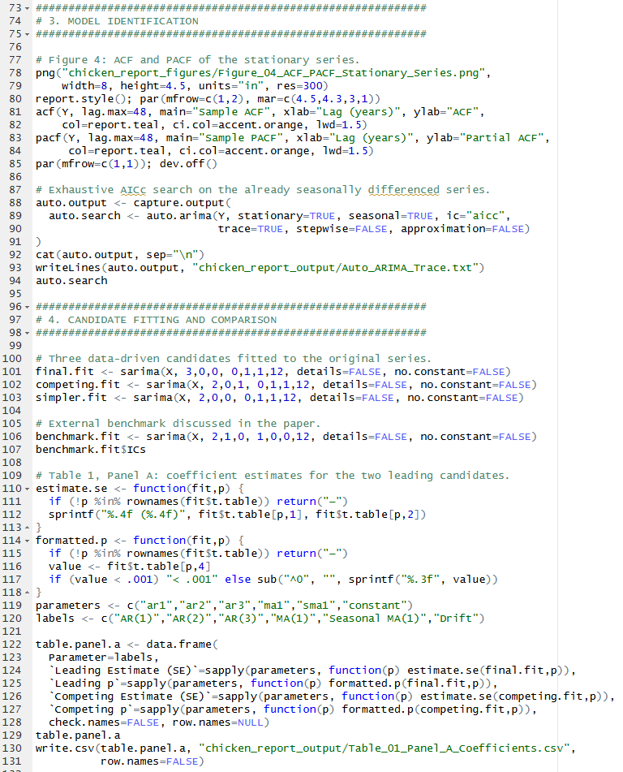
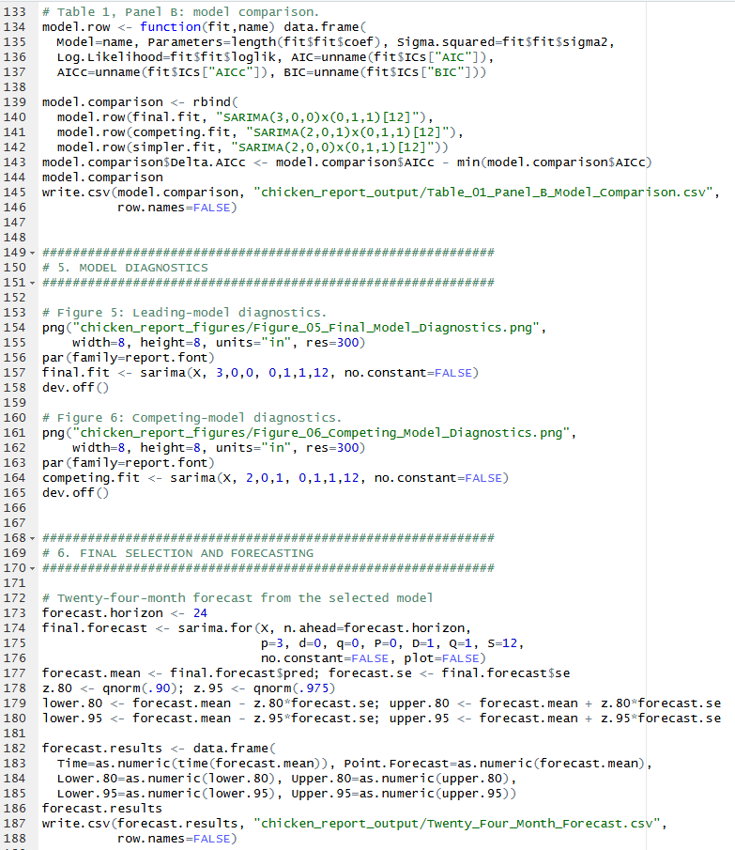
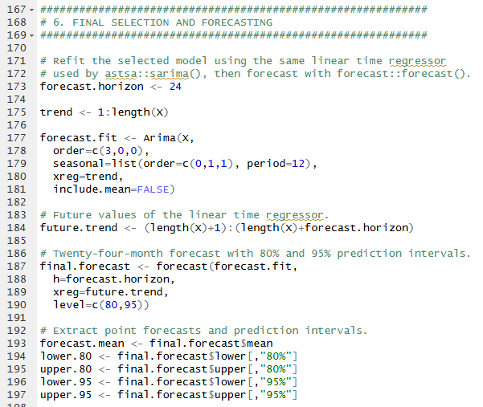
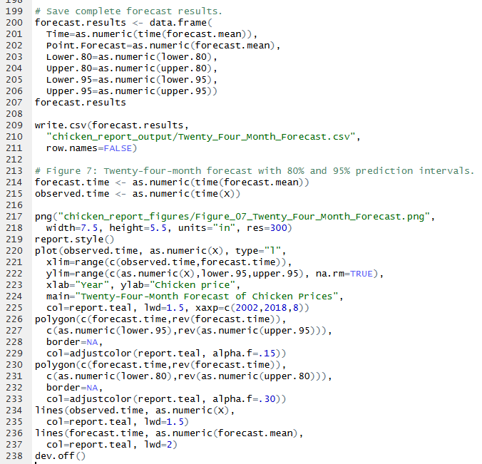

Appendix B: Model Outputs

Model Outputs

SARIMA(3,0,0) x (0,1,1)₁₂
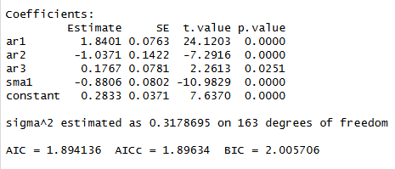

SARIMA(2,0,1) x (0,1,1)₁₂
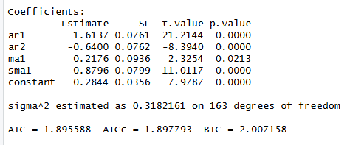

SARIMA(2,0,0) x (0,1,1)₁₂
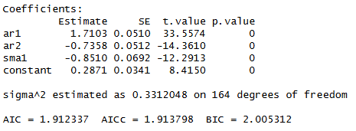

Twenty-four-month forecast
Time | Point.Forecast | Lower.80 | Upper.80 | Lower.95 | Upper.95
2016.583 | 110.723 | 109.987 | 111.459 | 109.597 | 111.849
2016.667 | 110.352 | 108.811 | 111.893 | 107.995 | 112.709
2016.75 | 109.453 | 107.137 | 111.768 | 105.912 | 112.994
2016.833 | 108.872 | 105.873 | 111.870 | 104.285 | 113.458
2016.917 | 108.835 | 105.257 | 112.414 | 103.362 | 114.308
2017 | 109.283 | 105.220 | 113.345 | 103.069 | 115.496
2017.083 | 109.842 | 105.378 | 114.305 | 103.015 | 116.668
2017.167 | 110.672 | 105.876 | 115.467 | 103.338 | 118.006
2017.25 | 111.481 | 106.411 | 116.552 | 103.727 | 119.236
2017.333 | 112.683 | 107.384 | 117.982 | 104.578 | 120.787
2017.417 | 113.791 | 108.301 | 119.281 | 105.395 | 122.188
2017.5 | 114.602 | 108.952 | 120.251 | 105.961 | 123.242
2017.583 | 114.674 | 108.869 | 120.478 | 105.797 | 123.551
2017.667 | 114.777 | 108.825 | 120.730 | 105.674 | 123.881
2017.75 | 114.122 | 108.034 | 120.211 | 104.811 | 123.434
2017.833 | 113.642 | 107.431 | 119.853 | 104.144 | 123.140
2017.917 | 113.621 | 107.304 | 119.939 | 103.959 | 123.283
2018 | 114.036 | 107.626 | 120.446 | 104.232 | 123.840
2018.083 | 114.537 | 108.047 | 121.027 | 104.611 | 124.463
2018.167 | 115.296 | 108.738 | 121.854 | 105.266 | 125.326
2018.25 | 116.031 | 109.414 | 122.647 | 105.912 | 126.150
2018.333 | 117.156 | 110.490 | 123.822 | 106.961 | 127.351
2018.417 | 118.191 | 111.482 | 124.899 | 107.931 | 128.450
2018.5 | 118.931 | 112.187 | 125.675 | 108.616 | 129.246

