EX–02: Cross-Platform Prompting – Evaluating Diverse Techniques in AI-Powered Text Summarization

AIM
To evaluate and compare the effectiveness of prompting techniques (zero-shot, few-shot, chain-of-thought, and role-based) across different AI platforms (ChatGPT, Gemini, Claude, Copilot) for the task of text summarization.

Scenario
You are part of a content curation team for an educational platform that delivers quick summaries of technical concepts to undergraduate students.
Your task is to summarize a 500-word technical article on “The Basics of Cloud Computing” using multiple AI platforms and prompting strategies.
The goal is to identify which prompting technique + AI platform combination produces the best summary based on:
- Accuracy
- Coherence
- Simplicity
- Speed
- User Experience

Algorithm
- Select a ~500-word technical article titled “The Basics of Cloud Computing.”
- Apply four prompting techniques:
  - Zero-shot
  - Few-shot
  - Chain-of-Thought
  - Role-based
- Use four AI platforms:
  - ChatGPT
  - Gemini
  - Claude
  - Copilot
- Record the generated summaries and response time.
- Evaluate outputs using predefined criteria.
- Compare results and identify the best-performing combination.

Input Article
The Basics of Cloud Computing
Cloud computing is a modern technology that enables users to access computing resources such as servers, storage, databases, networking, and software over the internet. Instead of owning and maintaining physical hardware, organizations can rent these resources from cloud service providers on a pay-as-you-go basis. This approach reduces costs, increases flexibility, and improves scalability.
Cloud computing services are broadly categorized into three models: Infrastructure as a Service (IaaS), Platform as a Service (PaaS), and Software as a Service (SaaS). IaaS provides virtualized hardware resources, PaaS offers platforms for application development, and SaaS delivers ready-to-use software applications through web browsers.
Deployment models include public cloud, private cloud, hybrid cloud, and community cloud. Cloud computing is widely used in industries such as education, healthcare, finance, and e-commerce due to its reliability, scalability, and cost efficiency. Despite its advantages, concerns related to data security, privacy, and vendor dependency remain important considerations.

Prompting Strategies Definition
- Zero-shot: Directly ask the model to summarize without examples.
- Few-shot: Provide 2–3 sample summaries before asking for the summary.
- Chain-of-Thought: Ask the model to identify key points before summarizing.
- Role-based: Ask the model to act in a specific role (e.g., “cloud computing instructor for undergraduates”).

Platform Selection
- ChatGPT (OpenAI)
- Gemini (Google)
- Claude (Anthropic)
- Copilot (Microsoft)

Execution
For each platform:
- Apply all prompting strategies using the same input article.
- Record the generated summary.
- Note the time taken for response.

Evaluation Criteria
- Accuracy: Captures main ideas correctly
- Coherence: Logical and well-structured
- Simplicity: Easy for undergraduates to understand
- Speed: Response time
- User Experience: Ease of use and clarity of output

Scoring & Analysis
Scores are assigned on a scale of 1 to 5 for each criterion
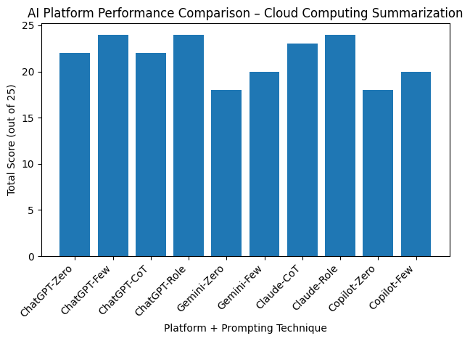
Result:
Platform | Prompt Type | Accuracy | Coherence | Simplicity | Speed | UX | Total (/25)
ChatGPT | Zero-shot | 4 | 4 | 4 | 5 | 5 | 22
ChatGPT | Few-shot | 5 | 5 | 5 | 4 | 5 | 24
ChatGPT | Chain-of-Thought | 5 | 5 | 4 | 3 | 5 | 22
ChatGPT | Role-based | 5 | 5 | 5 | 4 | 5 | 24
Gemini | Zero-shot | 3 | 3 | 3 | 5 | 4 | 18
Gemini | Few-shot | 4 | 4 | 4 | 4 | 4 | 20
Claude | Chain-of-Thought | 5 | 5 | 5 | 4 | 4 | 23
Claude | Role-based | 5 | 5 | 5 | 4 | 5 | 24
Copilot | Zero-shot | 3 | 3 | 3 | 5 | 4 | 18
Copilot | Few-shot | 4 | 4 | 4 | 4 | 4 | 20

Best Performing Combination
Claude + Role-based Prompting and ChatGPT + Few-shot Prompting achieved the highest score (24/25), demonstrating excellent clarity, accuracy, and suitability for undergraduate learners.

