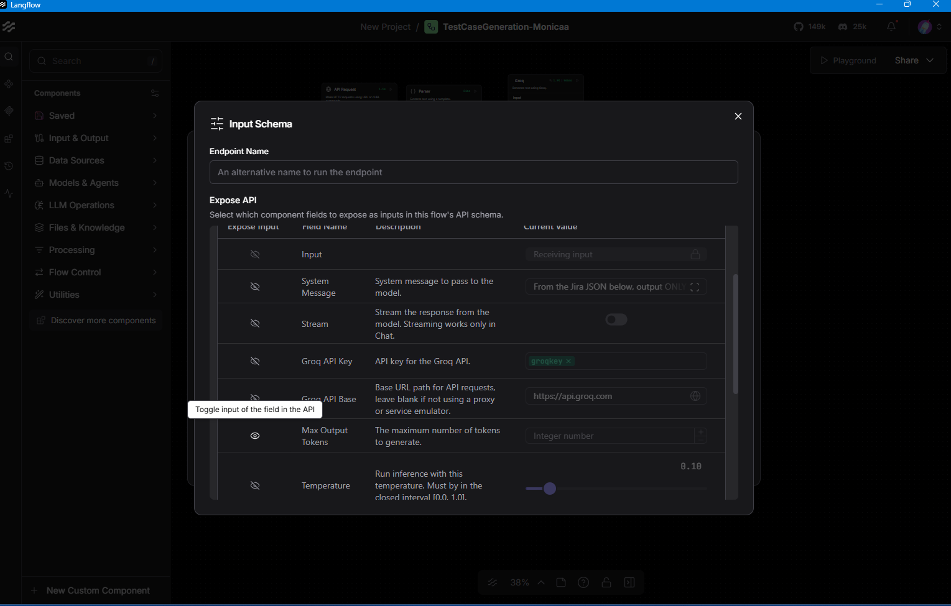

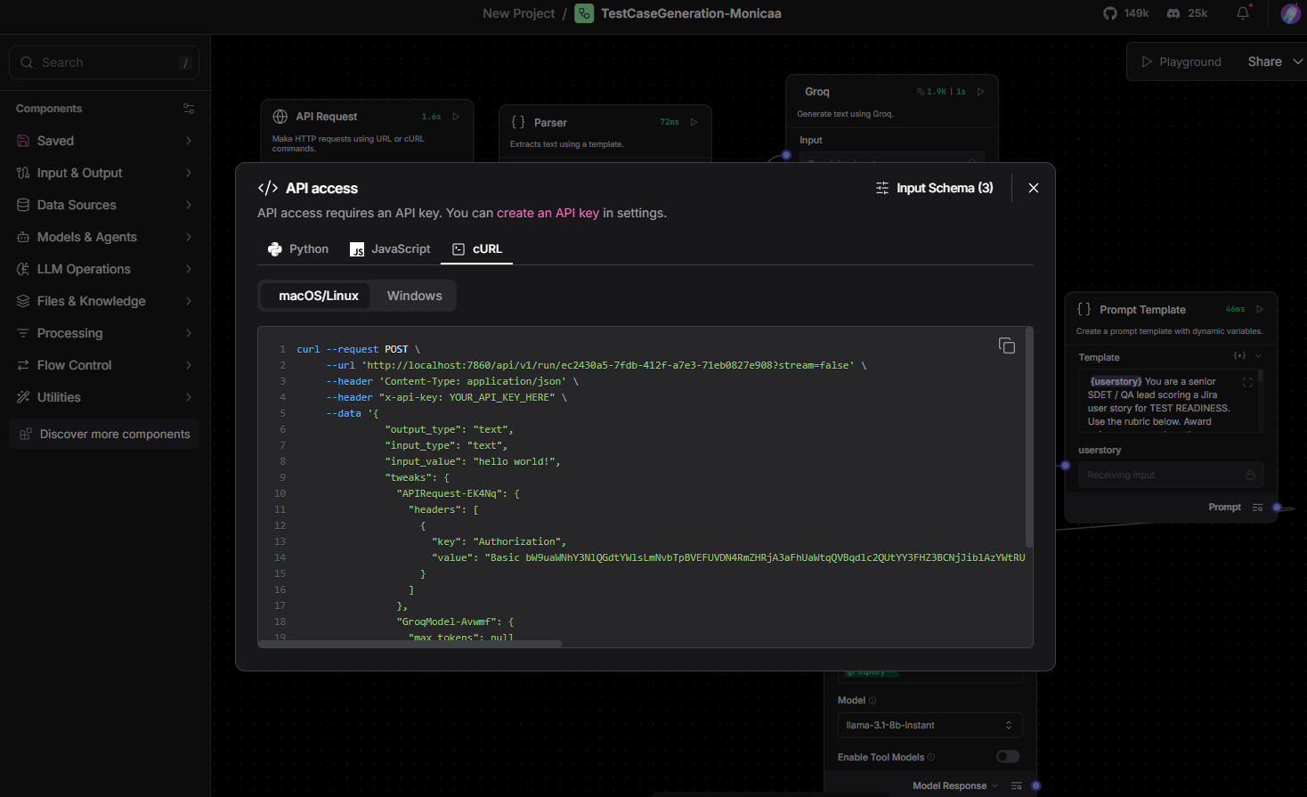
Allowed change of API- Body fields, Groq – maxtoken, groq – temperature, prompt template – input
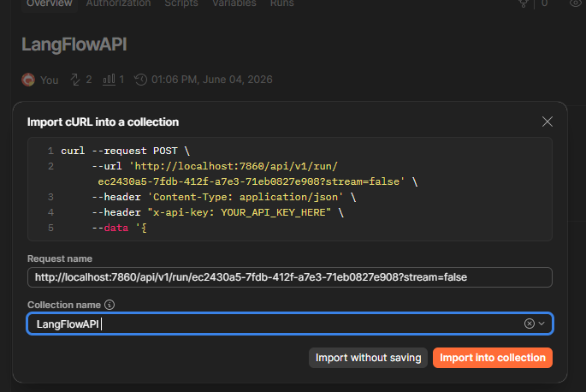

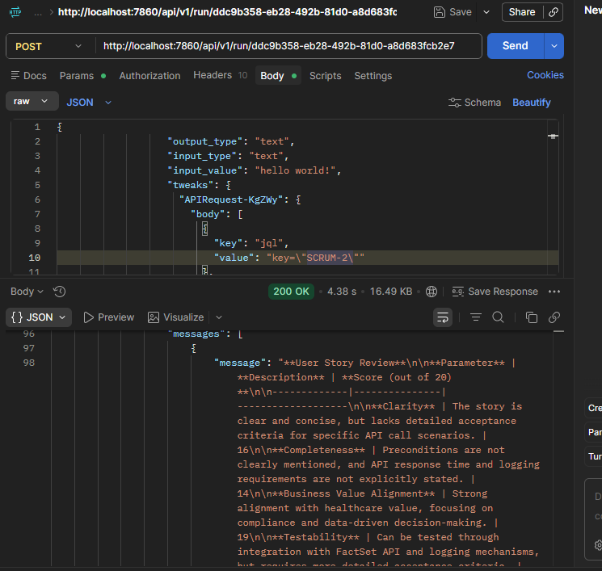
Output:
"outputs": {
"text": {
"message": "**User Story Review Summary**\n\n**Parameter** | **Description** | **Score (out of 20)**\n-------------|---------------|-------------------\n**Clarity** | The story is clear and concise, but lacks detailed acceptance criteria for API response time and logging. | 16\n**Completeness** | Preconditions are not clearly mentioned, and some acceptance criteria are missing. | 14\n**Business Value Alignment** | Strong alignment with healthcare value, focusing on compliance and data accuracy. | 19\n**Testability** | Can be tested through share price graph functionality, but some acceptance criteria are missing. | 17\n**Technical Feasibility** | Feasible with FactSet Market Data API integration, but requires secure authentication and logging. | 18\n\n**Overall Score:** 84 / 100\n\n**Improvement Areas:**\n\n1. **Add explicit acceptance criteria for API response time and logging**: Specify the expected response time and logging requirements for FactSet API calls.\n2. **Specify preconditions for page loading and security/ticker validation**: Clearly define the preconditions for page loading and security/ticker validation to ensure successful data retrieval.\n3. **Include system actor details for authentication and logging**: Specify the system actors responsible for authentication and logging to ensure secure and compliant data exchange.\n4. **Add missing acceptance criteria for share price graph functionality**: Include acceptance criteria for share price graph rendering, data accuracy, and user interaction.\n\n**Recommendations:**\n\n1. Review the FactSet Market Data API documentation to ensure accurate understanding of API requirements and limitations.\n2. Collaborate with the development team to design a secure authentication mechanism using approved credentials/tokens.\n3. Develop a logging mechanism to track FactSet API calls and ensure compliance with banking regulations.\n4. Conduct thorough testing to validate share price graph functionality, data accuracy, and user interaction.\n\n**Actionable Feedback:**\n\nTo improve the user story, focus on adding explicit acceptance criteria, specifying preconditions, and including system actor details. This will ensure a clear understanding of the requirements and facilitate effective testing and development.",
"type": "text"
}
},
"logs": {
"text": []
},
"messages": [
{
"message": "**User Story Review Summary**\n\n**Parameter** | **Description** | **Score (out of 20)**\n\n-------------|---------------|-------------------\n\n**Clarity** | The story is clear and concise, but lacks detailed acceptance criteria for API response time and logging. | 16\n\n**Completeness** | Preconditions are not clearly mentioned, and some acceptance criteria are missing. | 14\n\n**Business Value Alignment** | Strong alignment with healthcare value, focusing on compliance and data accuracy. | 19\n\n**Testability** | Can be tested through share price graph functionality, but some acceptance criteria are missing. | 17\n\n**Technical Feasibility** | Feasible with FactSet Market Data API integration, but requires secure authentication and logging. | 18\n\n**Overall Score:** 84 / 100\n\n**Improvement Areas:**\n\n1. **Add explicit acceptance criteria for API response time and logging**: Specify the expected response time and logging requirements for FactSet API calls.\n\n2. **Specify preconditions for page loading and security/ticker validation**: Clearly define the preconditions for page loading and security/ticker validation to ensure successful data retrieval.\n\n3. **Include system actor details for authentication and logging**: Specify the system actors responsible for authentication and logging to ensure secure and compliant data exchange.\n\n4. **Add missing acceptance criteria for share price graph functionality**: Include acceptance criteria for share price graph rendering, data accuracy, and user interaction.\n\n**Recommendations:**\n\n1. Review the FactSet Market Data API documentation to ensure accurate understanding of API requirements and limitations.\n\n2. Collaborate with the development team to design a secure authentication mechanism using approved credentials/tokens.\n\n3. Develop a logging mechanism to track FactSet API calls and ensure compliance with banking regulations.\n\n4. Conduct thorough testing to validate share price graph functionality, data accuracy, and user interaction.\n\n**Actionable Feedback:**\n\nTo improve the user story, focus on adding explicit acceptance criteria, specifying preconditions, and including system actor details. This will ensure a clear understanding of the requirements and facilitate effective testing and development.",
"sender": "Machine",
"sender_name": "AI",
"session_id": "",
"stream_url": null,
"component_id": "TextOutput-hIrtZ",
"files": [],
"type": "text"
}
Beautified:
Here's a more polished and professional version of the content:
User Story Review Summary
Parameter | Assessment | Score (/20)
Clarity | The user story is generally clear and concise; however, it lacks detailed acceptance criteria related to API response times and logging requirements. | 16
Completeness | Key preconditions are not explicitly defined, and several acceptance criteria are missing. | 14
Business Value Alignment | Strongly aligned with business objectives, emphasizing compliance, data accuracy, and reliable market data integration. | 19
Testability | The functionality can be validated through share price graph testing, but incomplete acceptance criteria limit full test coverage. | 17
Technical Feasibility | Implementation is technically feasible using the FactSet Market Data API, though secure authentication and audit logging must be addressed. | 18
Overall Score
84 / 100

Key Improvement Areas
1. Define API Performance & Logging Requirements
- Specify expected API response times (e.g., ≤ 2 seconds under normal load).
- Clearly outline logging requirements, including:
  - API request/response tracking
  - Error logging
  - Audit trail requirements for compliance purposes
2. Clarify Preconditions
Document the necessary prerequisites for successful execution, such as:
- Application/page is fully loaded.
- Valid security identifier (ticker/symbol) is available.
- User has appropriate permissions and access rights.
- FactSet API service is accessible and authenticated.
3. Specify System Actors & Responsibilities
Clearly identify the system components involved in:
- Authentication and authorization
- API communication
- Data processing
- Logging and monitoring
This improves traceability, accountability, and implementation clarity.
4. Strengthen Share Price Graph Acceptance Criteria
Include measurable acceptance criteria covering:
- Accurate data retrieval from FactSet
- Correct graph rendering across supported devices/browsers
- Refresh and update behavior
- User interactions (hover, zoom, tooltip display, date-range selection)
- Error handling when data is unavailable

Recommendations
1. Review FactSet API Requirements
Conduct a detailed review of the FactSet Market Data API documentation to:
- Understand authentication requirements
- Identify rate limits and performance constraints
- Confirm supported data formats and endpoints
2. Implement Secure Authentication
Work with the development and security teams to:
- Use approved authentication mechanisms (OAuth, API tokens, etc.)
- Protect credentials securely
- Ensure compliance with organizational security standards
3. Establish a Robust Logging Framework
Implement comprehensive logging that captures:
- API requests and responses
- Error events and exceptions
- Performance metrics
- Compliance-related audit information
4. Perform Comprehensive Testing
Validate:
- Data accuracy and consistency
- Graph rendering and responsiveness
- User interactions and usability
- Error scenarios and recovery mechanisms
- API performance under expected load conditions

Actionable Feedback
To enhance the quality of this user story, focus on:
✅ Adding explicit and measurable acceptance criteria
✅ Defining all required preconditions
✅ Identifying system actors and their responsibilities
✅ Expanding validation criteria for the share price graph functionality
These improvements will increase clarity, strengthen testability, reduce implementation ambiguity, and improve overall delivery quality.

Changed the JIRA ID to SCRUM-7 -
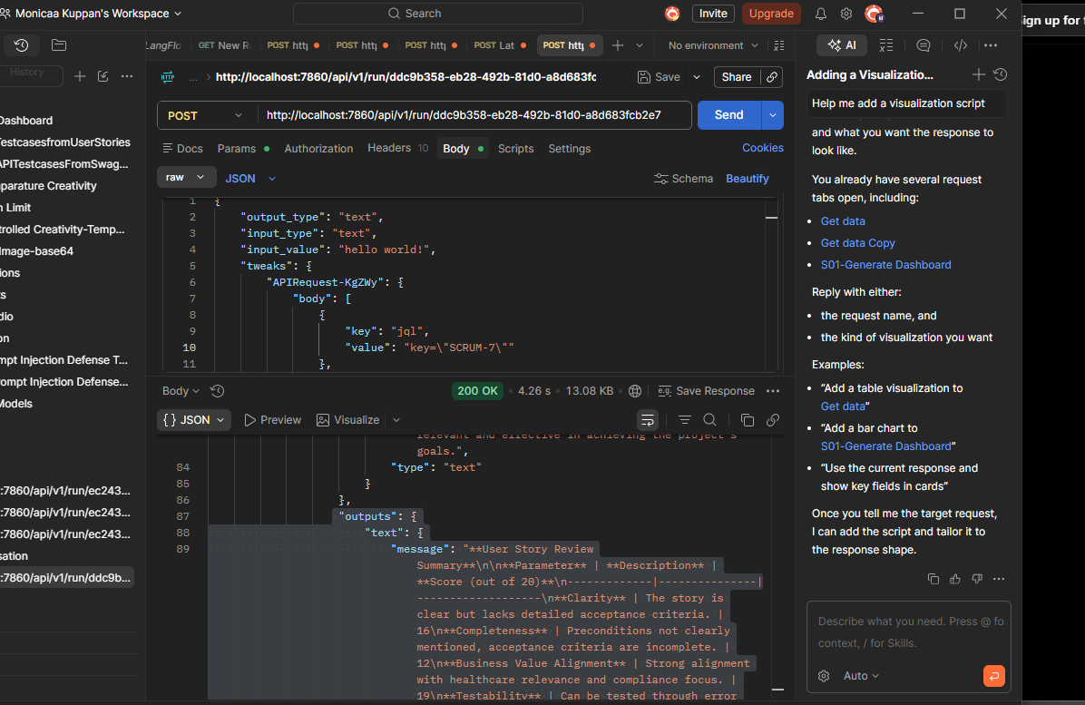
Beautified output:
User Story Review Summary
Evaluation Scorecard
Parameter | Assessment | Score (/20)
Clarity | The user story is easy to understand but lacks detailed acceptance criteria for edge-case scenarios. | 16
Completeness | Several preconditions are not explicitly defined, and certain acceptance criteria require further elaboration. | 14
Business Value Alignment | Strong alignment with healthcare objectives, compliance requirements, and secure user access; however, patient safety considerations could be articulated more explicitly. | 18
Testability | The login workflow can be validated through automated and manual testing, though additional acceptance criteria are needed to ensure complete test coverage. | 16
Technical Feasibility | The solution is technically feasible within standard healthcare application environments but may require enhanced security controls to mitigate authentication risks. | 17

Overall Assessment
Overall Score: 81 / 100
The user story provides a solid foundation for implementing a secure login workflow. It demonstrates strong business relevance and technical feasibility but would benefit from more comprehensive acceptance criteria, clearly defined preconditions, and enhanced security considerations.

Key Areas for Improvement
1. Define Acceptance Criteria for Edge Cases
Expand the acceptance criteria to cover common authentication failure scenarios, including:
Invalid Email Formats
- Missing "@" symbol
- Missing domain name
- Invalid characters
- Incorrect email structure
Mandatory Field Validation
- Blank email field
- Blank password field
- Both fields left empty
Multiple Failed Login Attempts
- Consecutive failed login attempts (e.g., 5 attempts)
- Temporary account lockout behavior
- User notification and recovery process
Example Acceptance Criterion
Given a user enters an invalid email format
When the login request is submitted
Then the system should display a validation message prompting the user to enter a valid email address.

2. Define Password Strength Requirements
Clearly specify password security standards, including:
- Minimum password length
- Uppercase and lowercase character requirements
- Numeric character requirements
- Special character requirements
- Password expiration or rotation policies (if applicable)
Example
Passwords must contain:
- Minimum 8 characters
- At least one uppercase letter
- At least one lowercase letter
- At least one numeric value
- At least one special character

3. Identify System Actors and Responsibilities
Document the key participants involved in the authentication process:
Actor | Responsibility
User | Enters login credentials and initiates authentication.
Authentication Service | Validates credentials and manages login sessions.
Application System | Displays appropriate success or error responses.
Administrator | Manages user accounts, lockouts, and access permissions.
Clearly identifying system actors improves requirement traceability and implementation clarity.

4. Improve Error Message Definition
The generic message "Invalid email or password" may create ambiguity during troubleshooting.
Consider defining error-handling behavior for:
- Invalid email format
- Non-existent user account
- Incorrect password
- Locked account
- Expired password
Recommended Approach
Where security policies permit, provide contextual guidance while avoiding disclosure of sensitive account information.
Examples:
- "Please enter a valid email address."
- "Your account has been temporarily locked due to multiple unsuccessful login attempts."
- "Password has expired. Please reset your password."

5. Strengthen Security Controls
To improve protection against unauthorized access and brute-force attacks, consider implementing:
Authentication Security Measures
- Rate limiting
- Account lockout policies
- CAPTCHA after repeated failures
- IP-based monitoring and blocking
- Multi-Factor Authentication (MFA)
- Audit logging for login attempts
- Session timeout controls
These controls are particularly important for healthcare applications handling sensitive user information.

Recommendations
Review and Refine Acceptance Criteria
Ensure all acceptance criteria are:
- Specific
- Measurable
- Testable
- Unambiguous
Add a Preconditions Section
Clearly define prerequisites such as:
- User account exists
- User account is active
- Authentication service is available
- Network connectivity is established
Emphasize Security Requirements
Include explicit security expectations within the user story to align with healthcare compliance and security standards.
Develop Comprehensive Test Scenarios
Create test cases covering:
- Positive login scenarios
- Negative login scenarios
- Validation checks
- Security controls
- Account lockout behavior
- Session management
Collaborate Across Teams
Engage Product Owners, Developers, QA Engineers, Security Teams, and Compliance Stakeholders to validate requirements before implementation.

Actionable Feedback
To strengthen this user story and improve delivery readiness:
✅ Add detailed acceptance criteria for edge cases
✅ Define password validation and strength requirements
✅ Document system actors and responsibilities
✅ Clarify error-handling and user messaging expectations
✅ Introduce security controls such as rate limiting and account lockout
✅ Clearly define all preconditions
By addressing these areas, the user story will become more complete, testable, secure, and implementation-ready, reducing ambiguity and improving overall solution quality.

