Day 2 : Testcase Generator using LangChain + Simple Rag
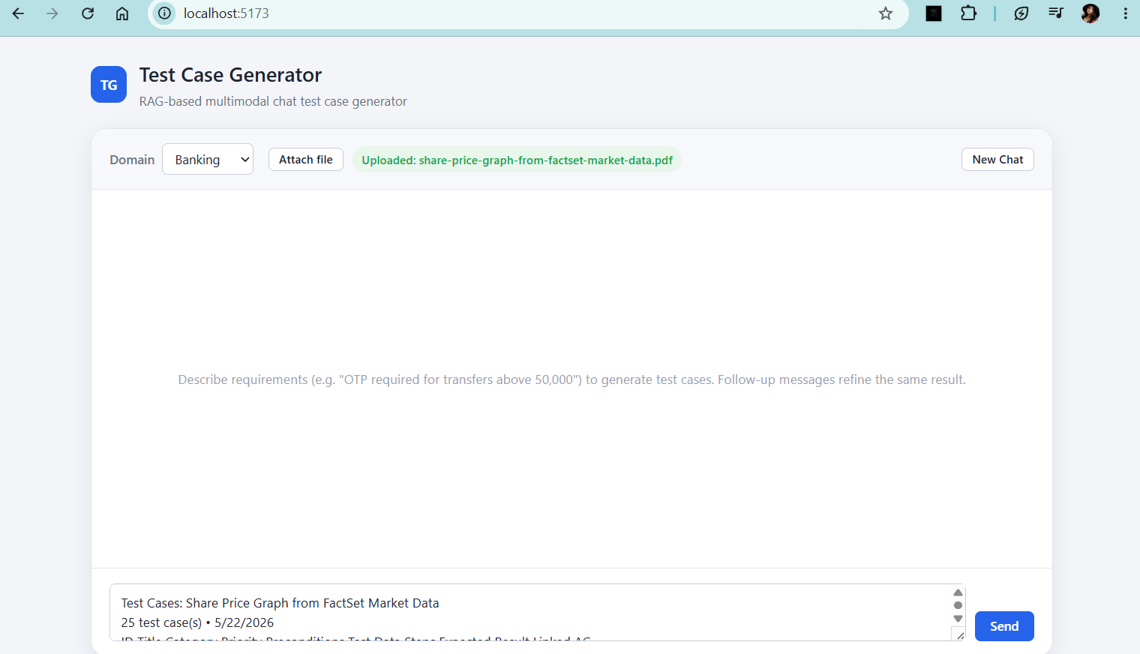
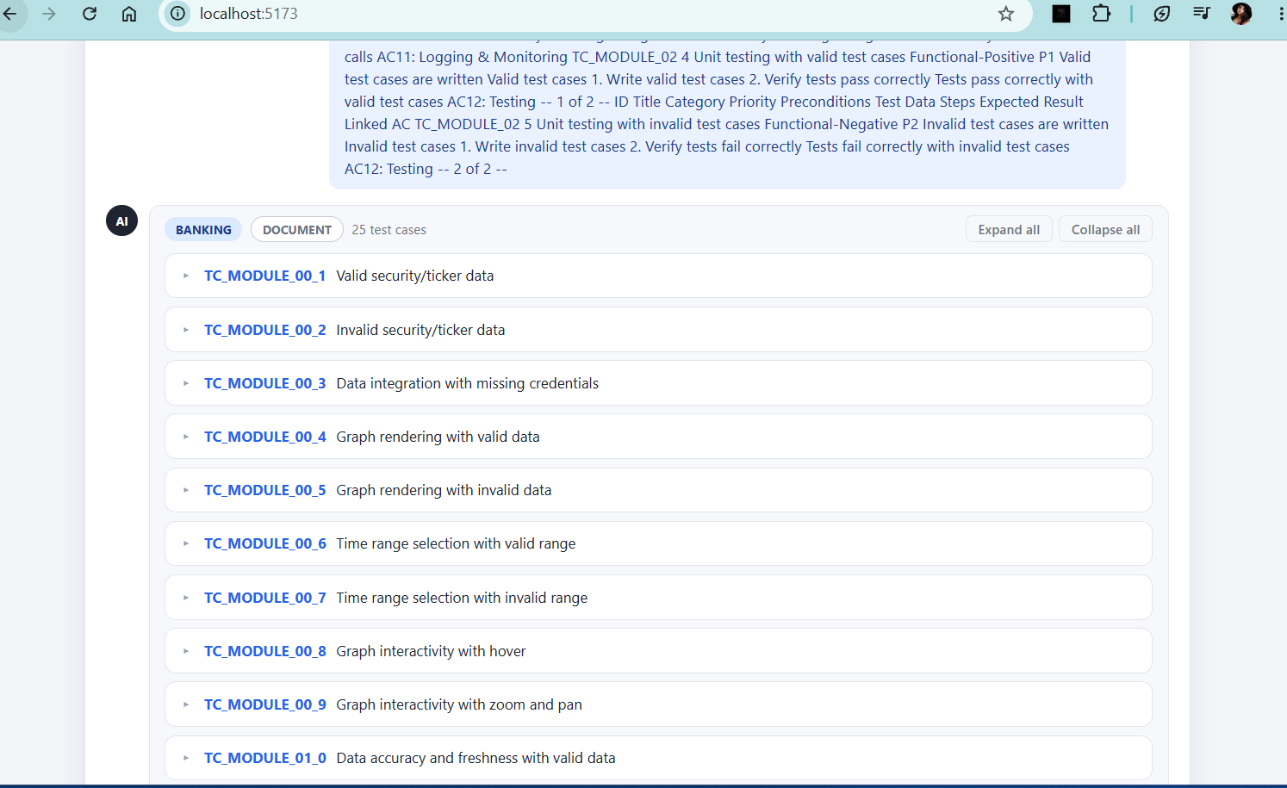

Postman collection of backend:

