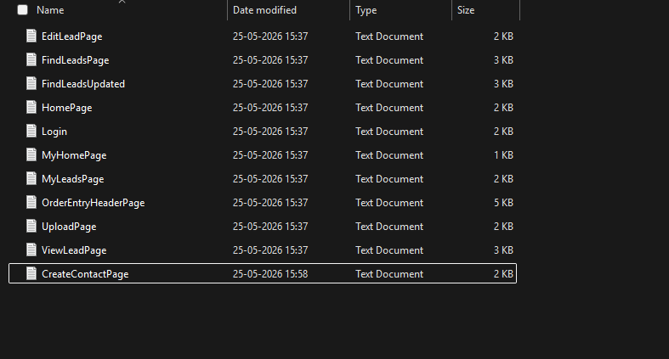

CreateContactPage Created under training
===HTML===

<input type="text" class="inputBox" name="firstName" size="30" maxlength="100" id="firstNameField" onchange="ensureToName()">
<input type="text" class="inputBox" name="lastName" size="30" maxlength="100" id="lastNameField" onchange="ensureToName()">
<input type="submit" class="smallSubmit" name="submitButton" value="Create Contact" id="ext-gen542">

===JAVA===

package com.leaftaps.pages;

import com.framework.selenium.api.design.Locators;
import com.framework.testng.api.base.ProjectSpecificMethods;

/**
* Page object representing the Create Contact.
* Provides methods to create contact.
* @author Auto-generated
*/
public class CreateContact extends ProjectSpecificMethods {
/**
* Enters the Firstname in Create Contact page.
* @return the current CreateContact page instance.
*/
public CreateContact enterFirstName(String firstName) {
clearAndType(locateElement(Locators.ID,"firstNameField"), firstName);
reportStep(updcomnyName +"Updated company name is entered successfully ", "pass");
return this;
}

/**
* Enters the Lastname in Create Contact page.
* @return the current CreateContact page instance.
*/
public CreateContact enterSecondName(String lastName) {
clearAndType(locateElement(Locators.ID,"lastNameField"), lastName);
reportStep(updcomnyName +"Updated company name is entered successfully ", "pass");
return this;
}
/**
* Clicks the Create Contact button to create the contact.
* @return the current CreateContact page instance
*/
public CreateContact clickCreateContactButton() {
click(locateElement(Locators.ID,"ext-gen542"));
reportStep(" Clicked on CreateContact Button", "pass");
return this;
}

After Conversion: Created JSONL file
