Greetings,

I’m interested in challenging, complex projects that support big data and greater information transparency. I’d prefer to work with teams that are mission-driven and are supporting a fair, healthy, just society.

My core competencies and past positions are as follows:
- Database architect - recently launched (April 1) the GistNetwork.org site, responsible for database requirements (in conjunction with client), database design, optimization, and modeling, and “big-picture” thinking about how client requests convert to actionable items from engineering team - PHP/mySQL
- Project lead - communicative, patient, timeline-oriented, manages teams of 2 - 5
- Full stack developer - PHP/mySQL since 2001, Drupal since 2008, Agile/scrum since 2012
- Product manager - functional specifications, wireframes, user pathways, analytics and reports
- Strategic integrator - understands and aligns needs of client, partners, internal team, technology resource people and products, and policy/content managers in order to support a successful outcome
- Advisor - technical advice to non-technical people for new projects, sold one project

My routine typically includes
- deep discussion re: client’s requests, as well as explaining/understanding client needs
- specifying functionality and architecture: clarifying what can be done and suggesting solutions
- production: implementation / wireframing / database architecture / MVP creation
D) communicating: presenting results, sharing analytics, supporting team and clients
E) managing: directing flow of scrums, specifying tickets, reviewing work, sign-off on incremental builds

Some career highlights:
  - January - April 2016: Database architect and engineering lead for redesign of GistNetwork.org, a US Department of State-funded entrepreneurship challenge for international participants ($310k Drupal)

  - 2015-2016: Delivered a Drupal 7 redesign for changemakers.com, which reaches 90,000 monthly users in the field of global social enterprise and has allocated Corporate Social Responsibility monies to innovators worldwide using the “competition” model (disbursed $60mm in funds, PHP/Drupal)

  - 2004-2014: Principal producer, delivered 240+ websites over 10+ years of working with public agencies, membership groups, and businesses to move their web properties online (PHP/mySQL)

  - 2012: As a founder, I built and sold a blog for success-oriented women (PHP/Drupal)

  - 2010: As a co-founder, I launched an e-commerce store for home & fashion accessories (PHP/Drupal)

  - 2000: Policy analyst as part of a project to evaluate all community-based organizations serving children, youth, families for the City and County of San Francisco ($750k budget, .NET)

  - 2001: I was part of the core team that launched the Odyssey Internet Treks by leading a pilot Mexico visit, traveling worldwide for 18 months, and creating educational content via online delivery (HTML)

  - I’ve written three trade books on building community through website engagement strategies.

  - I also blog, post articles, and speak on panels, videos, and podcasts.

I would be interested in connecting over your current programming needs.
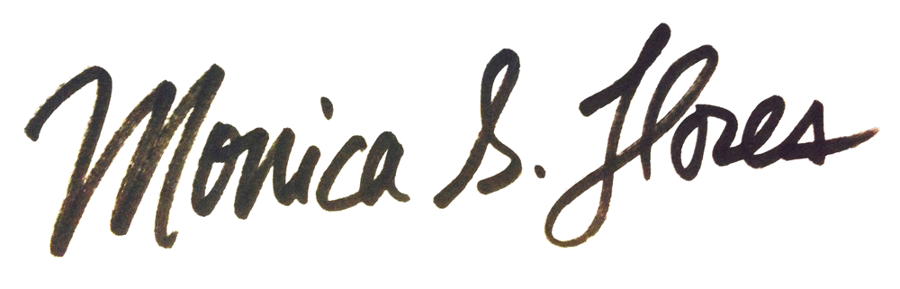
Sincerely,

OVERVIEW
+ Mission: to build community, foster connectedness, & use my tech skills to create a better world
+ Unique skill: translating business process needs into effective solutions, building solutions to solve pressing problems, communicating with teams to drive long-term initiatives
+ Turns ideas into reality: clarifies needs, develops plans, tests assumptions, implements production
+ Drives progress: understands goals, coordinates efforts, tracks schedules, explains documents

PRIMARY EXPERIENCE
Web Developer, Lead Architect, Managing Partner
10K Webdesign
Hawaii & California, July 2004 - present

Served as primary coder/producer on 240+ websites, project management, production, & development of web properties for clients like SOCCOM Princeton (research group), Castro Valley Sanitary District (government), West Contra Costa Integrated Waste Management Authority (public agency), Molokai Community Health Center (clinic) bit.ly/monicadearwebsites

- Client-facing manager: Identified process, developed standard operating procedures, created workflow
- Full stack developer: produced all database architecture, code, installation, build out, and themeing for websites for government, community-based orgs, membership groups, campaigns, clinics, education
- Built out proprietary PHP/mySQL content management system (2004-2008)
- Managed project milestones, kept team on track, ran scrums
- Worked with clients to determine business process and needs
- Scoped projects, listed deliverables, defined specifications, assessed user roles
- Project manager (designers, developers, themers, content editors, SEO managers)
- Organized DrupalCamp Hawaii 2011, Speaker at PodCamp/WordCamp Hawaii 2008
- Third-party integrations with: Facebook API (Login, Like Box), Twitter API, Constant Contact, Vertical Response, MailChimp, SalesForce, Wild Apricot, Google Maps API, Google Analytics, QuantCast, CiviCRM, PCI, Authorize.net, PayPal, SSL, AJAX, JQuery, PEAR, AddThis, CK Editor, TinyMCE, Vimeo, YouTube, vCard, Sitemaps, RSS, Google, Amazon Catalog Search

Product Team Lead, Web Developer
Ashoka Changemakers
Arlington, VA, Feb 2014 - present

Participated and led team that delivered a redesign and refactoring of a website in PHP/mySQL, cutting 80% of custom code and converting to standardized Drupal content types and views. Implemented scrum to roll out feature requests, where our team consisted of 3 engineers and supported an overall team of ~40 coordinators, managers, operations, & executive leaders; 90k monthly users

- Identified functional specifications, evaluated potential solutions, installed/wireframed/themed site
- Created custom views and content types and new features
- Developed reports, documentation, and training for multiple levels of users
- Led engineers, coders, & themers to support overall team (i.e. office hours, e-newsletter, trainings)
- Third-party integrations and workflow Tools: agile, Firebug, Analytics, Slack, Jira/Fisheye, Confluence, SequelPro, drush, Sublime, Git, TeamworkPM, Skype, Google Hangouts, PHP/mySQL, Google Drive, Google Docs, UXPin, LucidChart, Salesforce, Pantheon, Trello, Assembla, localization (supporting translation to 4 languages), Acquia
- Pilot projects: database architecture for conference application for Ashoka U (myashokau.org), searchable directory using Salesforce data, data architecture and functional specifications for informational “brochure” sites internal to Ashoka teams

Policy Analyst, JMPT Consulting Inc.
San Francisco, August 2001 - July 2004

- Project managed an 18-month outcomes-based evaluation, strategic planning, and technology project for San Francisco County Department of Children, Youth, & Their Families
- Supported 100+ community-based organizations, 35 subcontractors, 3 partners
- Conducted qualitative/quantitative evaluations based on focus groups & site visits
- Contributed to survey development and analyzed results, reported on project status, trained staff
- Researched, wrote, and presented reports to key stakeholders

Programmer/Analyst, UC Berkeley Center, Latin American Studies
Berkeley, January 2001 - June 2001
- Acted as primary web developer & site updater for nationally-recognized center
- Researched existing needs, created content management system for digital assets

Program Director, The Odyssey Internet Treks
San Francisco and internationally, August 1998 - August 2000
- Researched, photographed, and wrote two articles per week for 18 months (1500 words and 10 photos each) abroad, and returned to home office to write grants, interview, manage volunteers, and code
- Coordinated and conducted online events, features, & interviews
(including 3 Nobel Peace Prize Laureates, 2 former Presidents, 50+ grassroots groups)
- Arranged local and international transportation, visas, & site visits in 35+ countries
- Team Leader: directed 4-person team to provide content in Mexico City

OTHER EXPERIENCE
Mentor, Access to Software for All People, Berkeley (December 2000 - June 2001)
Mentored Berkeley High School students to create websites for local organizations

Multimedia Software Developer, Opus Technologies, San Diego (January 1996 - August 1998)
Designed, developed, edited, did QA, and wrote documentation for Braille projects
Created musical examples using MIDI files and created WinHelp clickable digital books: New International Manual of Braille Music Notation, How to Read Braille Music, and Primer of Braille Music

Environmental Educator, Slide Ranch, Marin County (August 1995 - December 1995)
Taught students on working ranch

Community Health Worker, Los Angeles Free Clinic now Saban Clinic (August 1994 - August 1995)
Triaged, provided medical intake, assisted doctors, and dispensed medications for community-based clinic focused on STDs, women's health, mental health, outreach, and counseling

COMMUNITY INVOLVEMENT
STEM Daisies, Increasing STEM women’s visibility through video (2014-present)
Girl Scouts Troop Leader, Daisies Arlington VA (2014-2015) and San Diego CA (2013-2014)
Vice President, PTSA, Mesa Verde Middle School (2012)
Emergency Room Volunteer, Cedars-Sinai Hospital, Saturday nights, triage department (1994-1995)
Pianist, Cornell University Religious Services (1990-1994)
B.S. Environmental Systems Technology, Dept. of Ag. & Bio. Engineering, Cornell University (1994)
Work Samples: https://github.com/monicadear/crispy-octo-parakeet

