EDUCATIONAL WEBSITE BUILT FOR ELEMENTARY SCHOOL KIDS FOR GRADES 1ST THROUGH 3RD.

BUILD UP YOUR MATH SKILLS USING THE FREE RESOURCE!

SOLVE MATH PRACTICE PROBLEMS 5 MINUTES EACH DAY!

Tech Stack: Bootstrap4, Html, CSS, JavaScript, jQuery

https://monicadeshmukh.github.io/sba.javascript_3-page-website/.

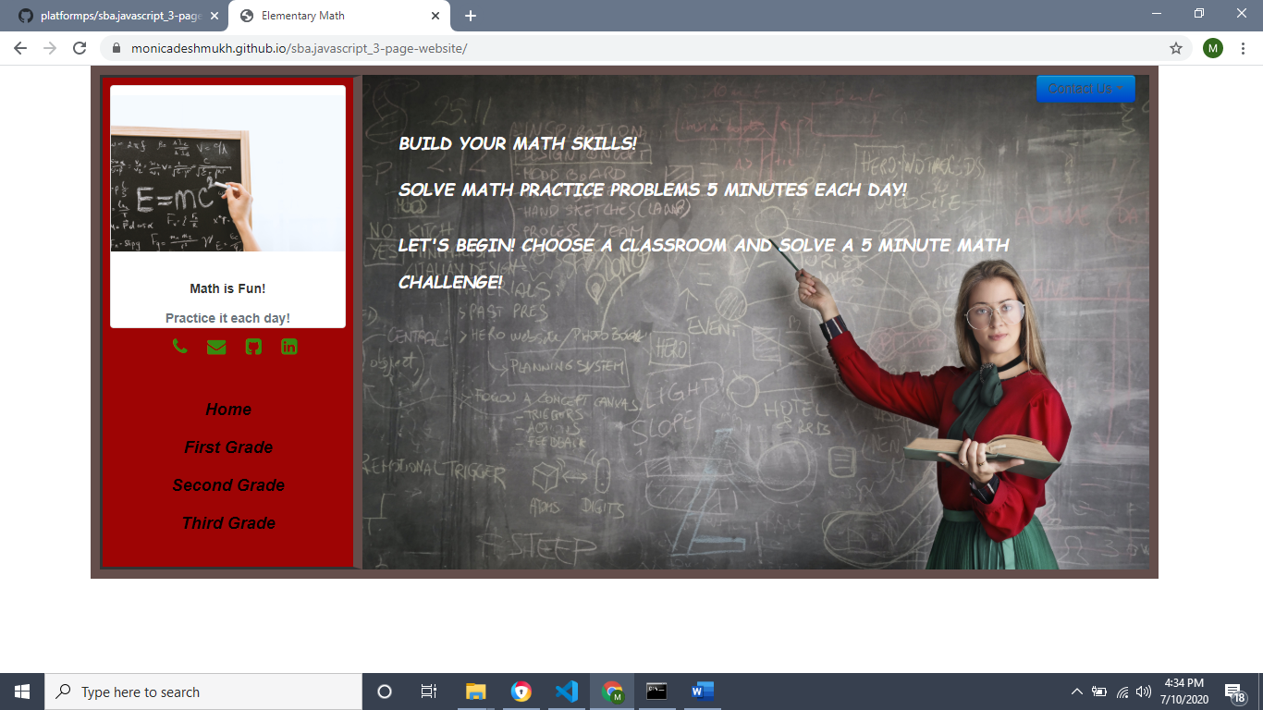

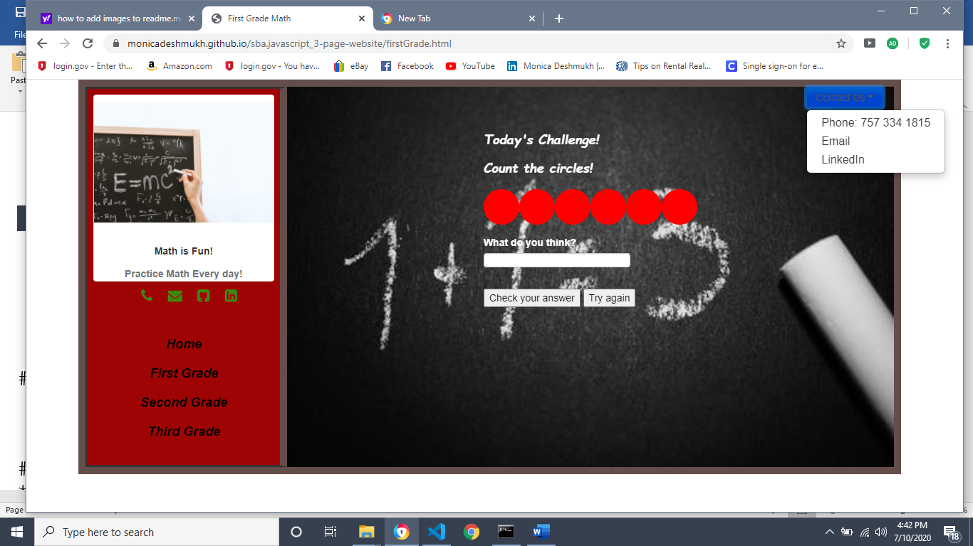

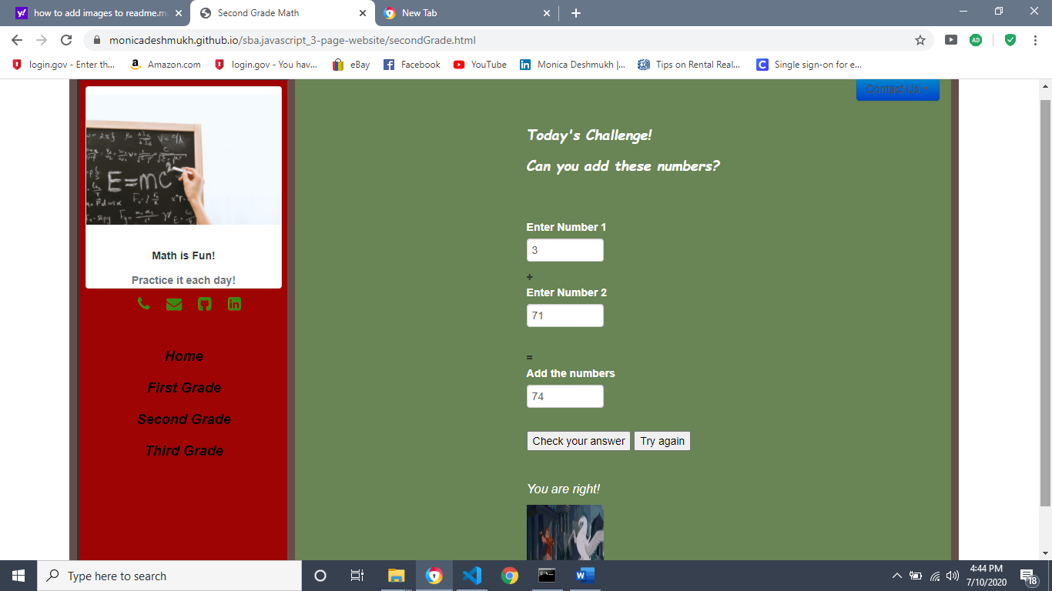

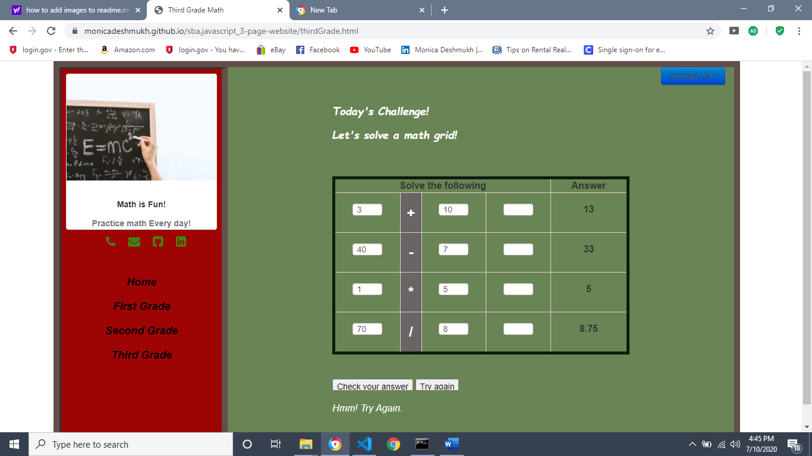

# AD - SBA - HTML/CSS/JavaScript

### Description

* In this Skill-based Assessment, you will be creating a small website and you get to pick what is the website about. The main purpose of this SBA is to test your skills in implementing a clean HTML structure that follows the methodologies of visual design, and styling your site so that it is user-friendly.

* You have the entire day for this SBA. Make sure to check in with your instructor for approval of your idea. Your work will be graded based on the below technical requirements. Also, creativity always works in your favor.

* Since this is your first time creating a 3 page website, keep it simple. Keeping it simple is very important. It ensures that you can complete this project within the given time and also gives you a better idea of what can you get done in the given time if you were to do it again with more requirements.

* Once you got your idea, think in the userâ€™s perspective when creating the website. Â You like your users to have a good experience when interacting with your site. This gives you a better chance of users trusting your site and coming back for more. For this SBA, donâ€™t worry too much about the content. There are many places you can get free content to display on your site. Concentrate more on the web site's structure and grid system.

* Some resources for free content:

* Photos:Â `https://www.pexels.com/search/template/`

* Text:Â `https://www.lipsum.com/`

* GIFs: `https://www.motionelements.com/stock-image-10116013-business-and-startup-4k`

* Useful API sites:

* https://rapidapi.com/ (Links to an external site.)

* https://any-api.com/ (Links to an external site.)

* https://github.com/toddmotto/public-apis#public-apis- (Links to an external site.)

* https://apilist.fun/

### Deliverable:

* A theme for your site that you feel comfortable with

* Complete all technical requirements for HTML, CSS, and Javascript

* Have markups of your pages

* Research for a public API that can provide you with content (Optional)

* Include a README file. The file should include technical specifications and description of your website.

* Host on GitHub, include the link to your GitHub account in the README file(optional)

* Submit the project in a ZIP file

## Technical requirements

* HTML

* Have at least 3 pages, keep the grid system consistent as much as possible

* Use at least 10 different HTML tags

* Use HTML tables

* Implement at least two uses for forms

* Dropped Down Menu

* Use web fonts

* Use different types of content in the form of text, images, videos, and GIFs

* Use regex validation

* CSS

* Inline, internal, and external styling

* Use five different CSS selectors

* Donâ€™t use too many fonts

* Use colors that complement each other

* Use Flexbox (Optional)

* Use SASS/SCSS (Optional)

* Use animations (Optional)

* Javascript

* External scripts

* Use variables, if statements, loops, at least one form of collections, functions/call back, and events

* Use AJAX (Optional)

* Use JSON or XML (Optional)

* Use JQuery (Optional)

## How to Download

#### Part 1 - Forking the Project

* To _fork_ the project, click the `Fork` button located at the top right of the project.

#### Part 2 - Navigating to _forked_ Repository

* Navigate to your github profile to find the _newly forked repository_.

* Copy the URL of the project to the clipboard.

#### Part 3 - Cloning _forked_ repository

* Clone the repository from **your account** into the `~/dev` directory.

* if you do not have a `~/dev` directory, make one by executing the following command:

* * `mkdir ~/dev`

* navigate to the `~/dev` directory by executing the following command:

* * `cd ~/dev`

* clone the project by executing the following command:

* * `git clone https://github.com/${MYUSERNAME}/${NAMEOFPROJECT}`

## How to Submit

#### Part 1 - _Pushing_ local changes to remote repository

* from a _terminal_ navigate to the root directory of the _cloned_ project.

* from the root directory of the project, execute the following commands:

* * add all changes

* * `git add .`

* * commit changes to be pushed

* * `git commit -m 'I have added changes'`

* * push changes to your repository

* * `git push -u origin master`

#### Part 2 - Submitting assignment

* from the browser, navigate to the _forked_ project from **your** github account.

* click the `Pull Requests` tab.

* select `New Pull Request`