No | Steps | Picture
1 | Open “File Explorer” on your computer | 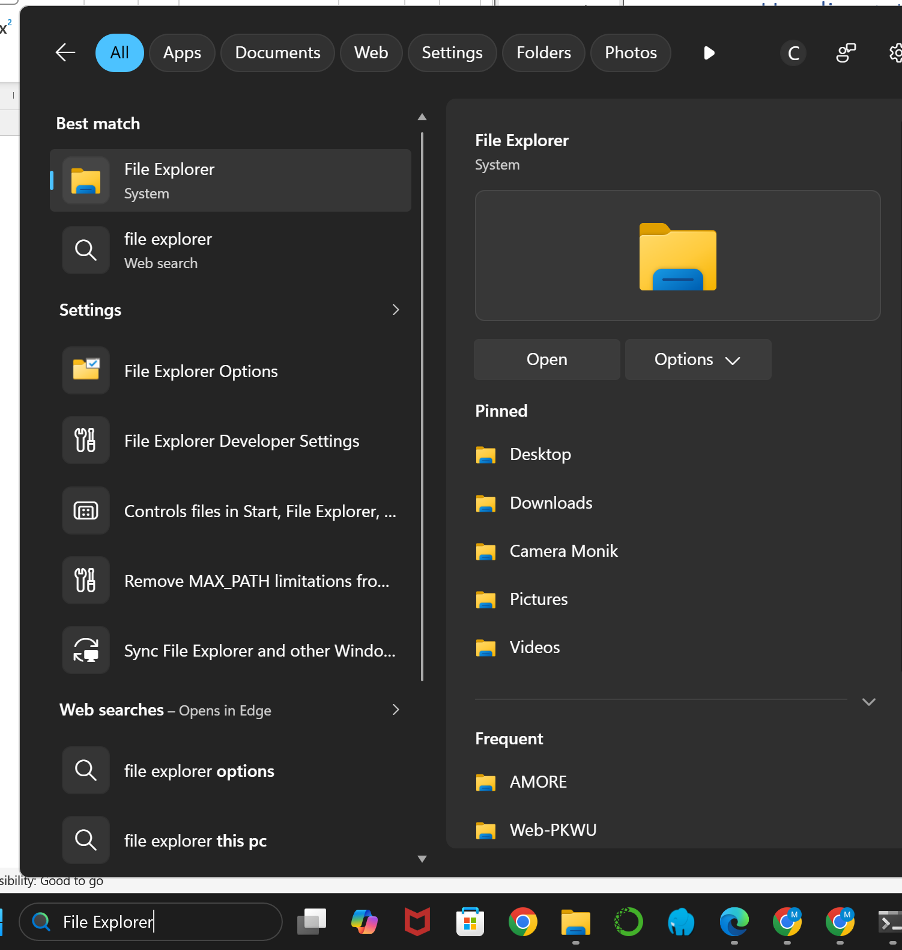
2 | Make a new folder | 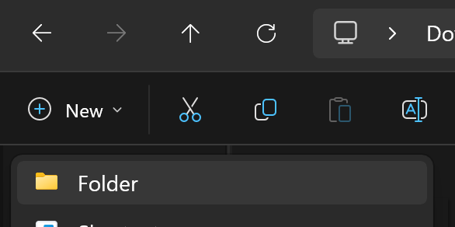
3 | Give the name of ther folder “PKWU-Web” | 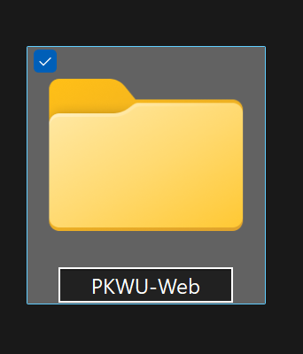
4 | Open the “PKWU-Web” folder that is still empty | 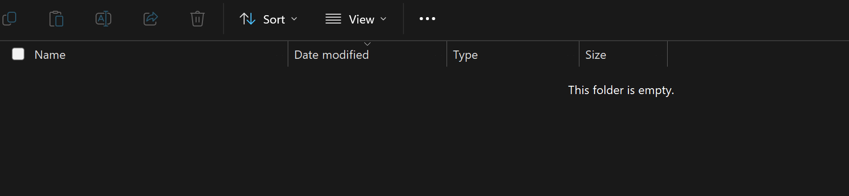
5 | Right click on your mouse at the empty folder and click “Open in Terminal” | 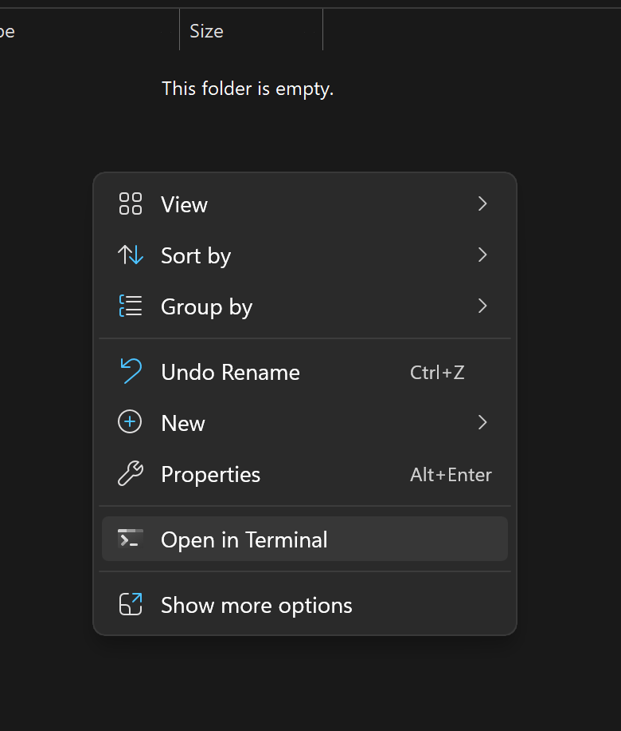
6 | You can see the pop up black CMD like this | 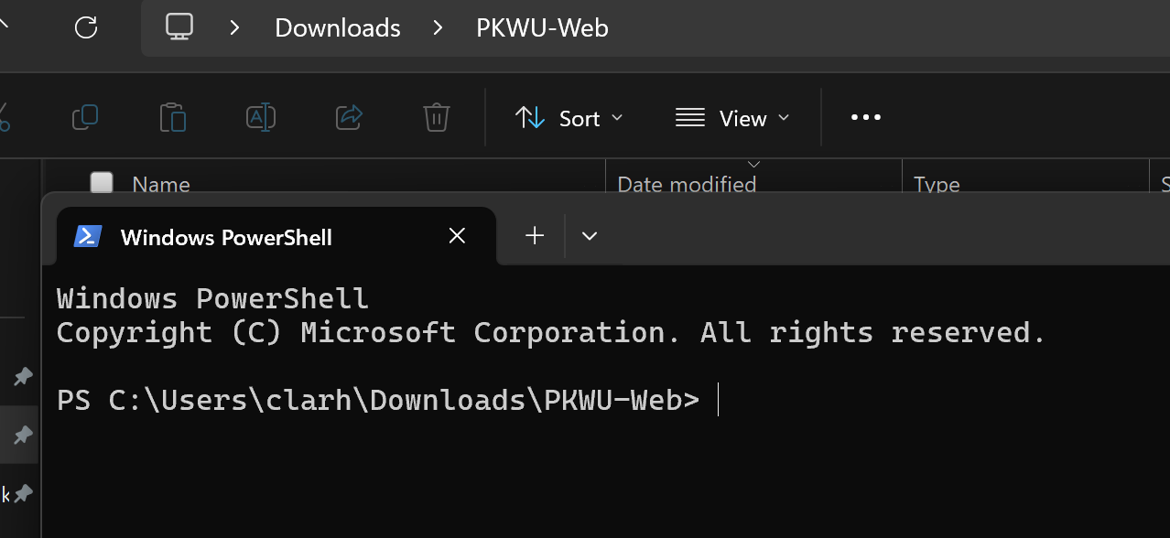
7 | Write code .  (code+space+dot) | 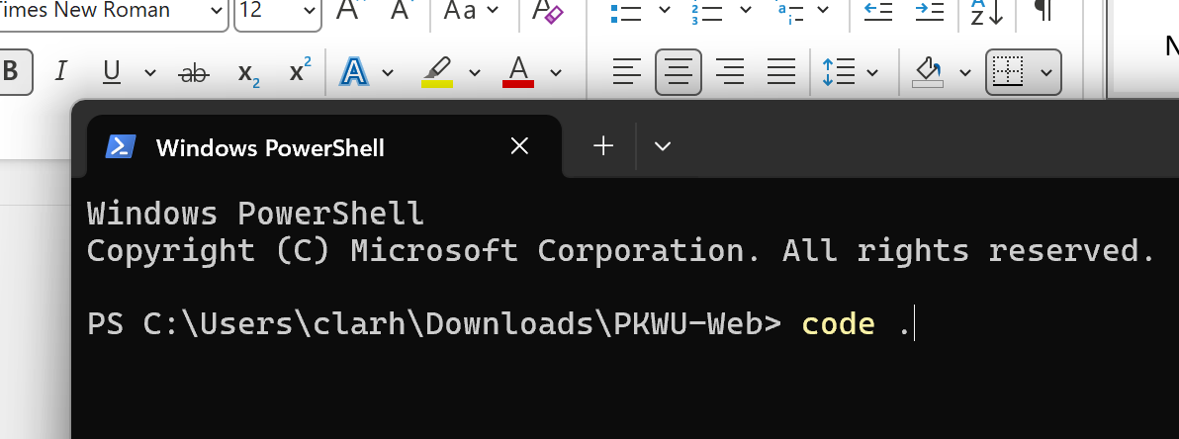
8 | Click “Enter” on your keyboard | 
9 | The Visual Studio Code application will open automatically | 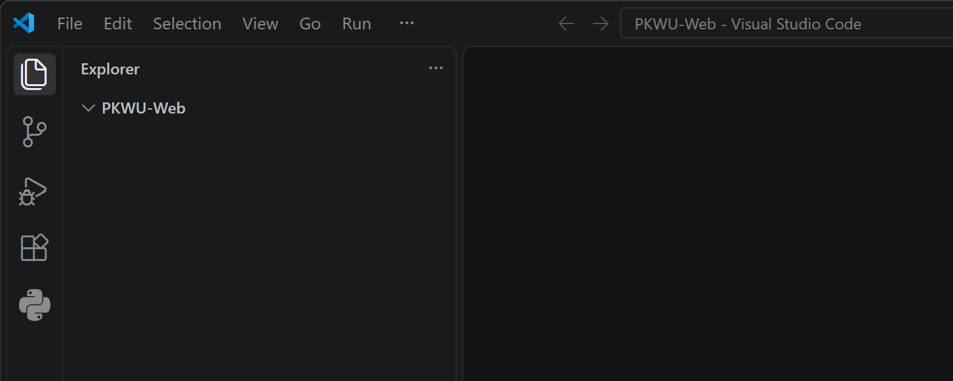
10 | Click “New File” | 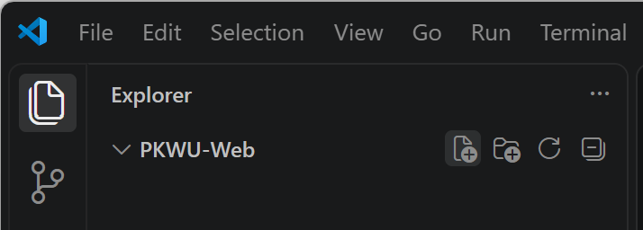
11 | Write the new file “index.html” | 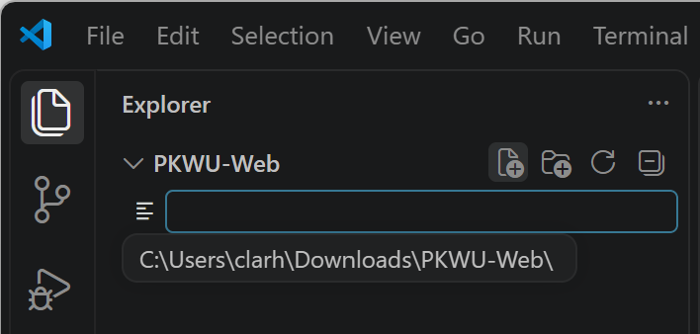  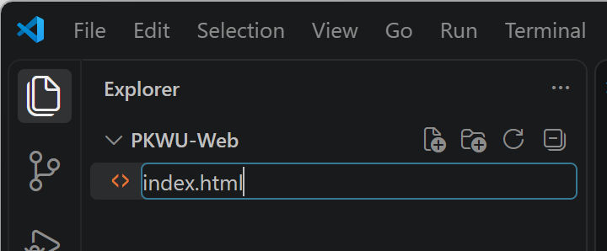
12 | Click again “New File” | 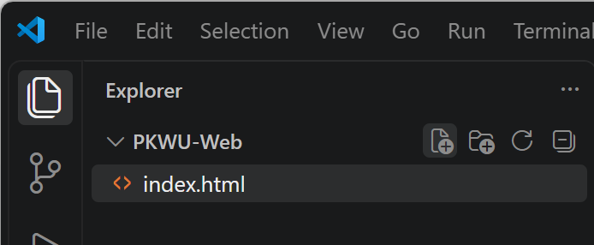
13 | Write the new file “style.css” | 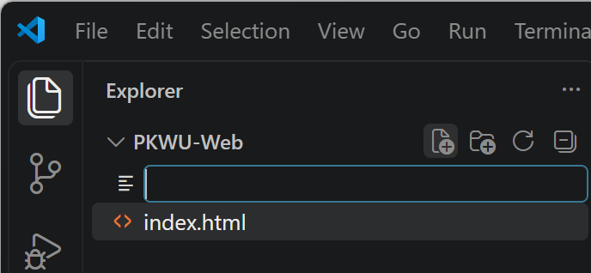  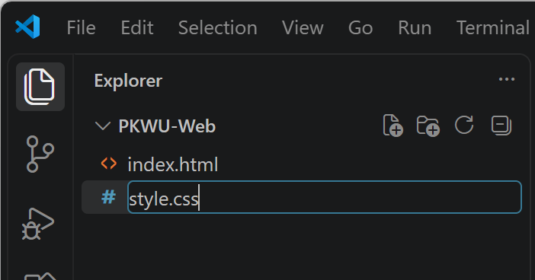
14 | Click the “index.html” file | 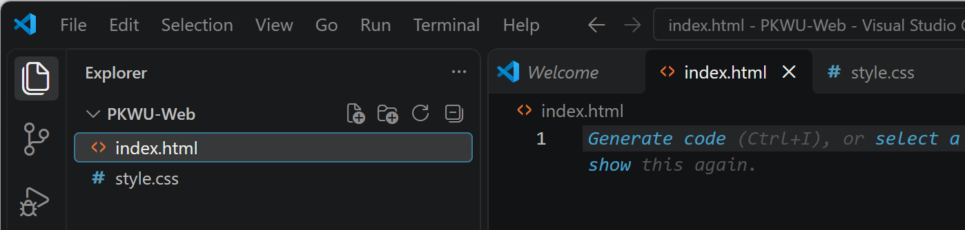
z | Type ! and then Enter | 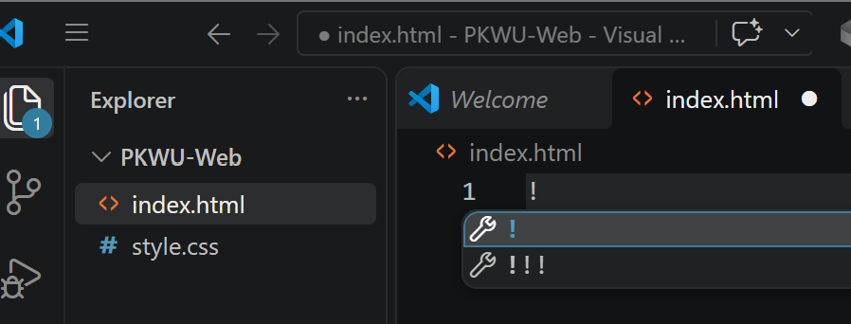
16 | until the basic HTML structure appears | 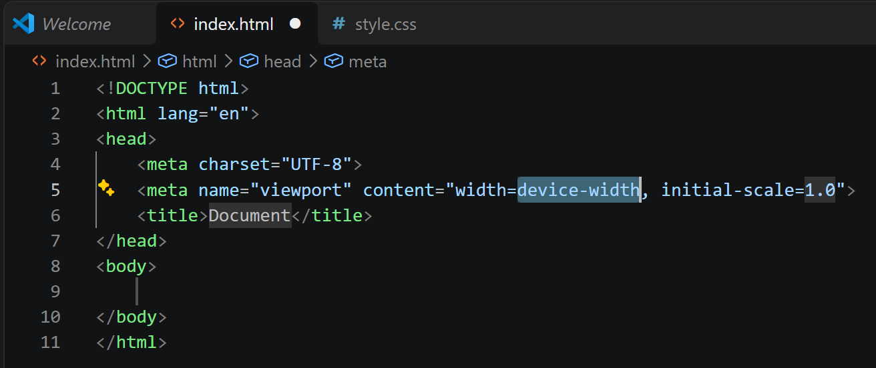
17 | Change the <title>Document</title> line to:  <title>Entrepreneurship Project - Group 1</title> | 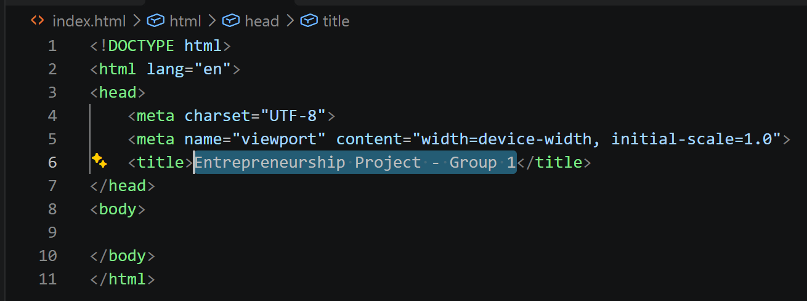
18 | Leave a blank line below the <title> line. | 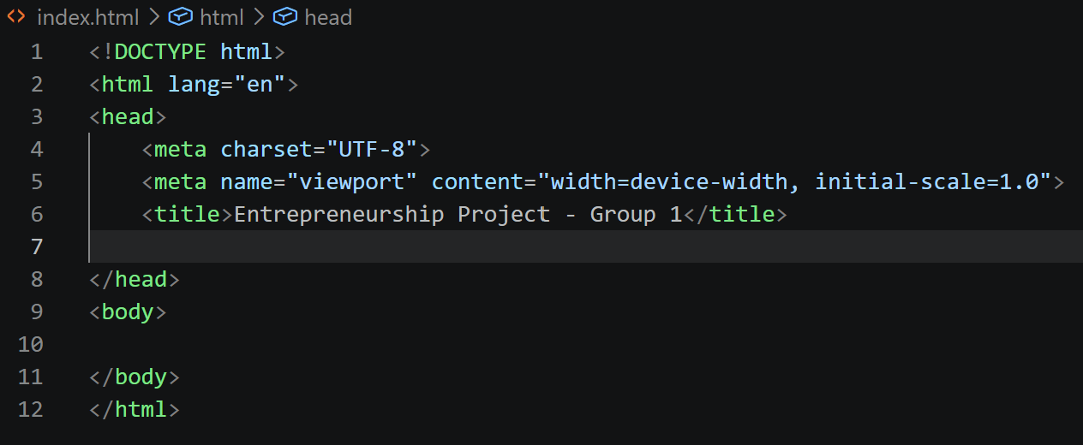
19 | Then, copy and paste this linking code (Favicon, CSS, Font, and Icon): | <link rel="icon" href="https://res.cloudinary.com/dzdnztjsi/image/upload/v1790296683/Sds-Amore-Prime-School-logo_z6vtpc.webp" type="image/webp">  <link rel="stylesheet" href="style.css">  <link href="https://fonts.googleapis.com/css2?family=Poppins:wght@300;400;600;700&display=swap" rel="stylesheet">  <link rel="stylesheet" href="https://cdnjs.cloudflare.com/ajax/libs/font-awesome/6.4.0/css/all.min.css">  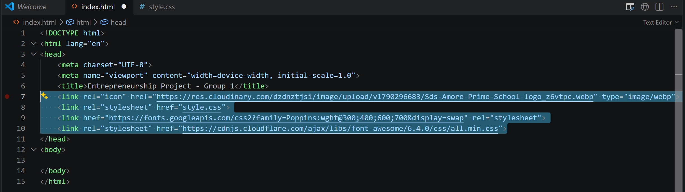
20 | Place the cursor on the empty line directly below <body>. | 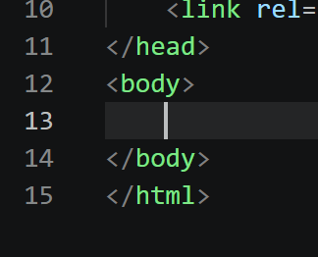
21 | Copy and paste the Emmet code below, delete the last letter (the letter 'e'), type the letter 'e' again, then press ENTER & Click: | 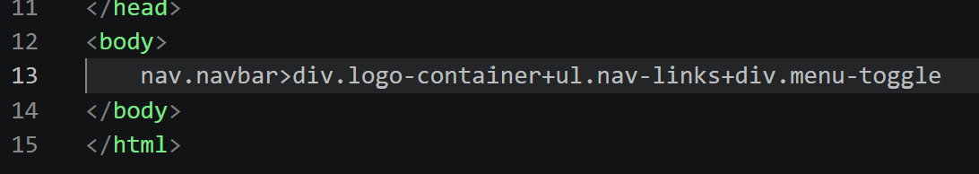  nav.navbar>div.logo-container+ul.nav-links+div.menu-toggle  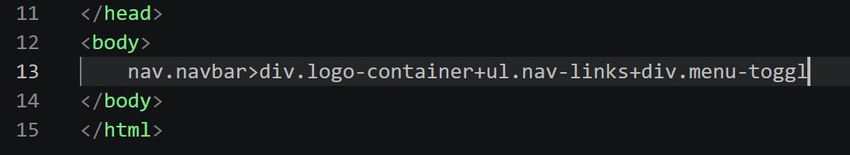  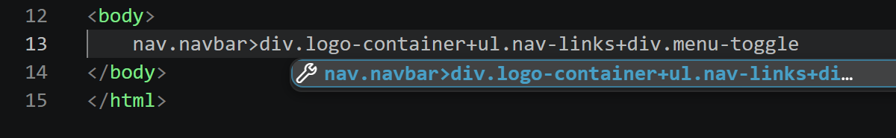  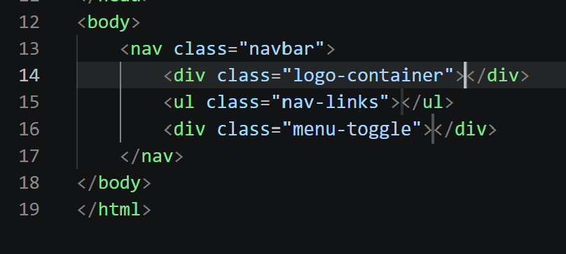
22 | Leave a blank line between the <div class="logo-container"> and the </div> | 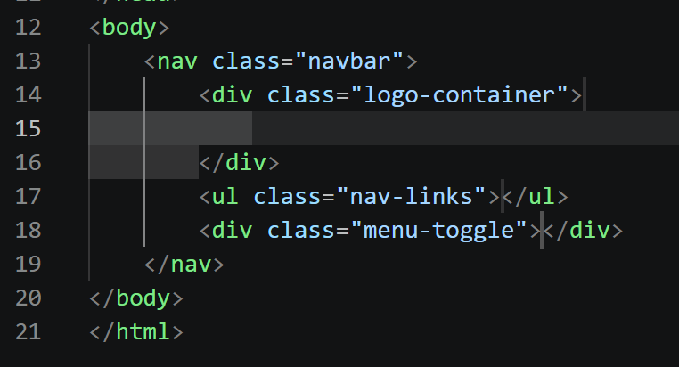
23 | Fill the area between <div class="logo-container"> and </div> with this code: | <img src="https://res.cloudinary.com/dzdnztjsi/image/upload/v1790296683/Sds-Amore-Prime-School-logo_z6vtpc.webp" alt="School Logo" class="school-logo">  <span class="logo-text">Amore Prime School - PKWU Project</span>  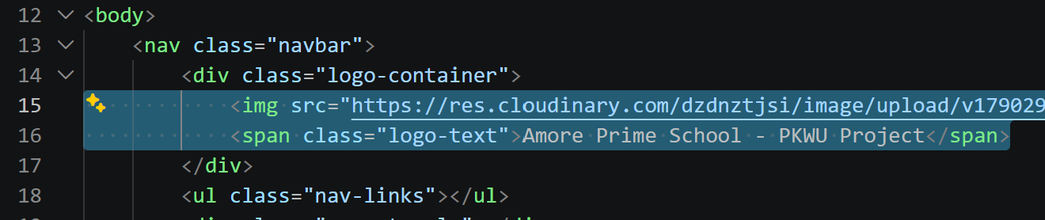
24 | Leave a blank line between the <ul class="nav-links"> and the </ul> | 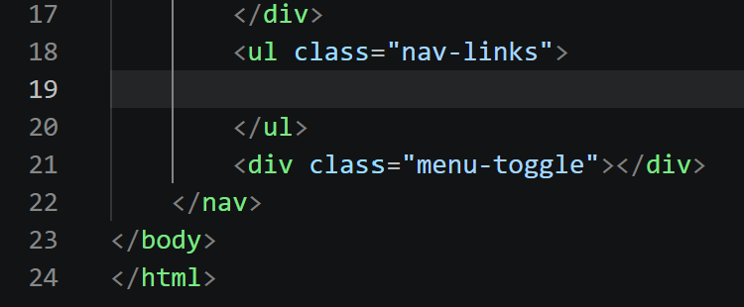
25 | Fill the section between <ul class="nav-links"> and </ul> with this menu: | <li><a href="#home">Home</a></li>  <li><a href="#about">About</a></li>  <li><a href="#products">Products</a></li>  <li><a href="#team">Team</a></li>  <li><a href="#contact">Contact</a></li>  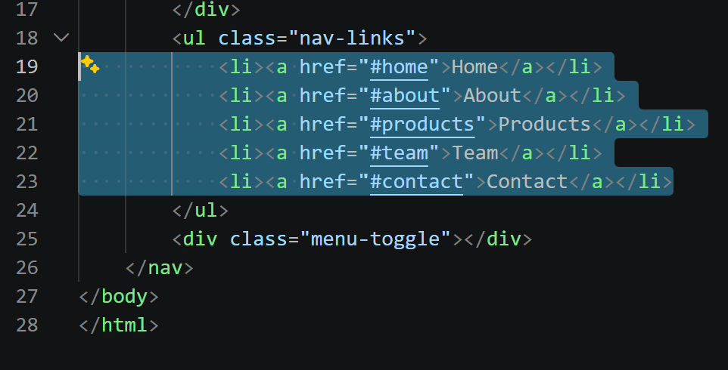
26 | Leave a blank line between the <div class="menu-toggle"> and the </div> | 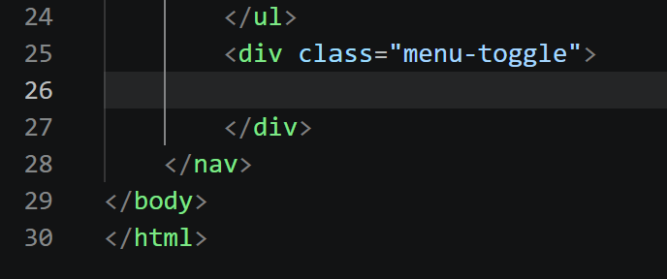
27 | Fill the middle section of <div class="menu-toggle"> with this hamburger icon: | <i class="fas fa-bars"></i>  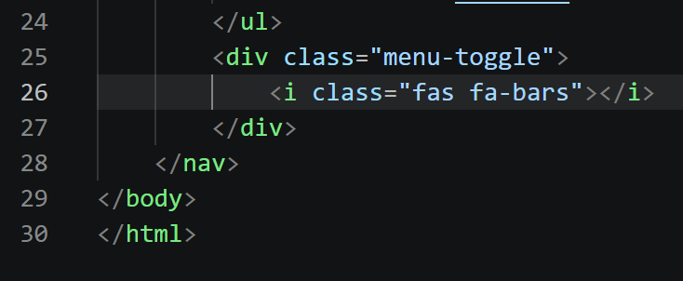
28 | Leave a blank line between the </nav> and the </body> | 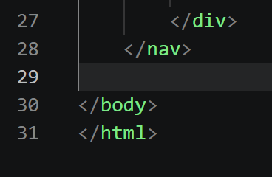
29 | Below the closing </nav> tag, use the Emmet trick (delete the end, re-type it, then press Enter) on this code: | section#home.hero>div.hero-content>h1{Nusantara Crafts}+p{Elevating local products with a touch of youthful creativity for our Entrepreneurship (PKWU) Project.}+a.btn-primary[href="#about"]{Discover More}  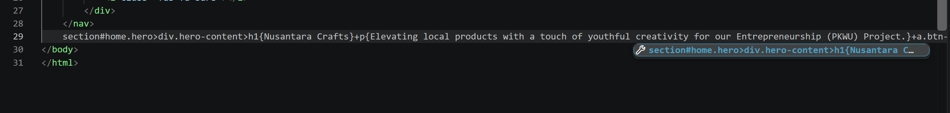  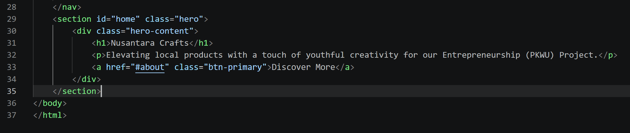
30 | Leave a blank line between the </section> and the </body> | 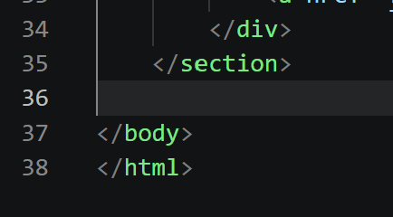
31 | Below the Hero's </section> tag, use the Emmet trick on this wrapper code: | section#about.section-container.bg-light>h2.section-title{About Our Project}+div.about-text+div.about-image  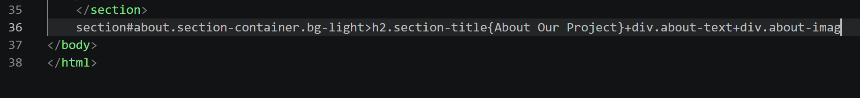  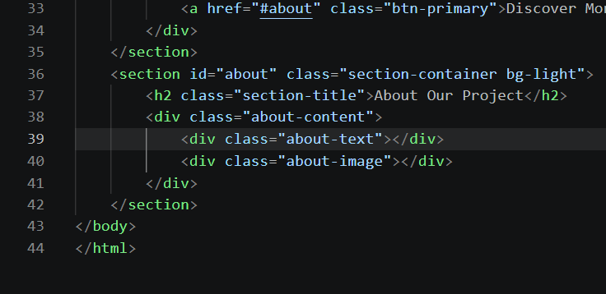
32 | Leave a blank line between the <div class=”about-text”> and the </div> | 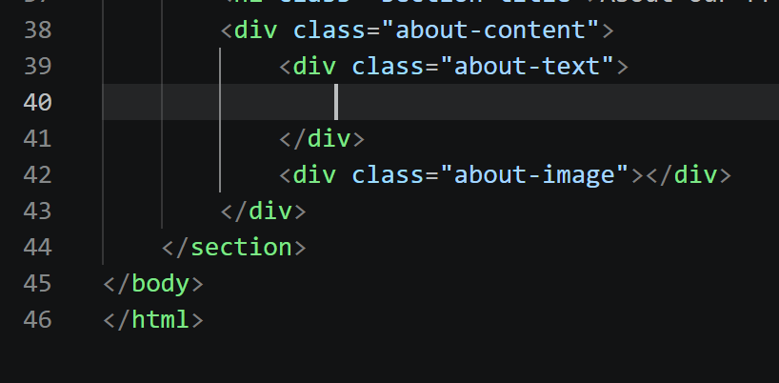
33 | Find the <div class="about-text"> tag, then place this code inside it: | <h3>Welcome to our Entrepreneurship Showcase!</h3>  <p>We are high school students learning the fundamentals of business, product design, and digital marketing. This website is built as part of our final project for the <strong>Entrepreneurship (PKWU)</strong> subject.</p>  <p>Our mission is to simulate a real-world e-commerce experience by creating, marketing, and selling our handcrafted products. By supporting us, you are contributing to our learning journey in becoming future young entrepreneurs!</p>  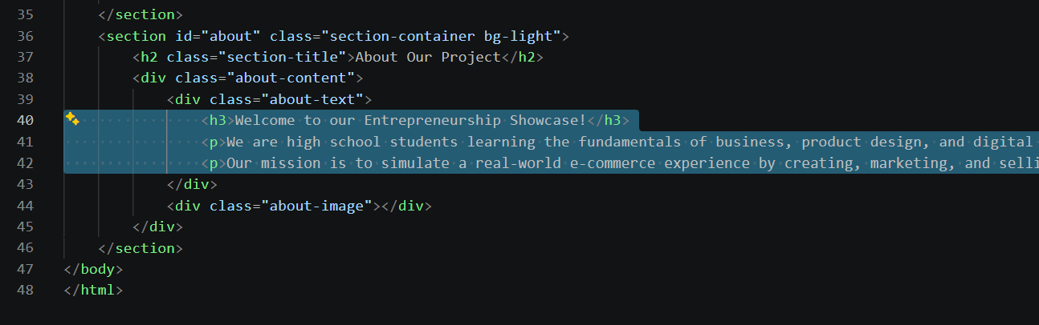
34 | Leave a blank line between the <div class=”about-image”> and the </div> | 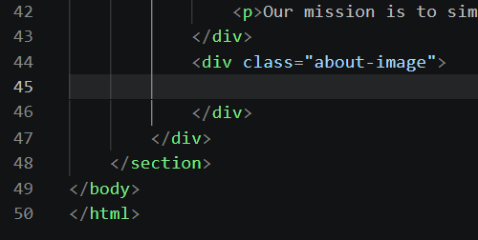
35 | Look for the <div class="about-image"> tag, then place this image code in it: | <img src="https://res.cloudinary.com/dzdnztjsi/image/upload/v1790270023/SISWA-SMA-hgfnhfn_k4b7by.jpg" alt="Students working on project">  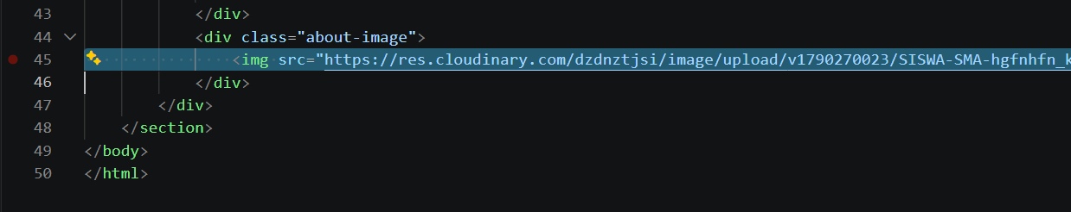
36 | You can add your own photos by logging in at here  https://console.cloudinary.com/app/c-dc0f5947f3b55331fbfe7cb9f3f027/assets/media_library/search?q=&view_mode=mosaic | 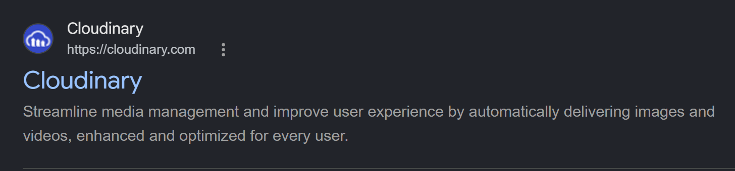
37 | You need to sign up first; you can use your own Google account. | 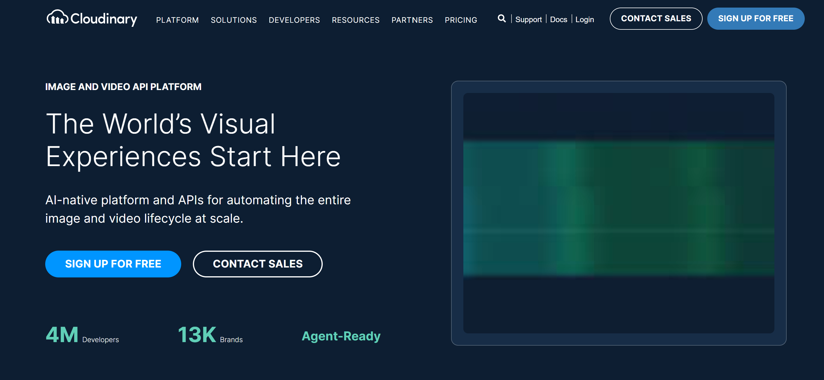
38 | You can login with your google account | 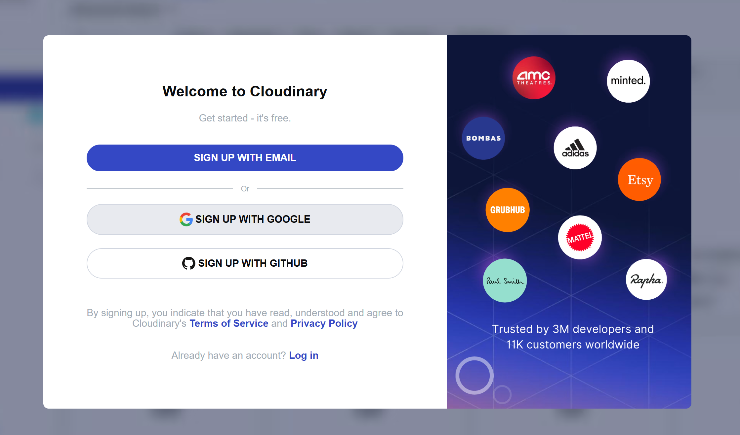
39 | After that, you will see this screen; simply select the upload option to upload your photos. | 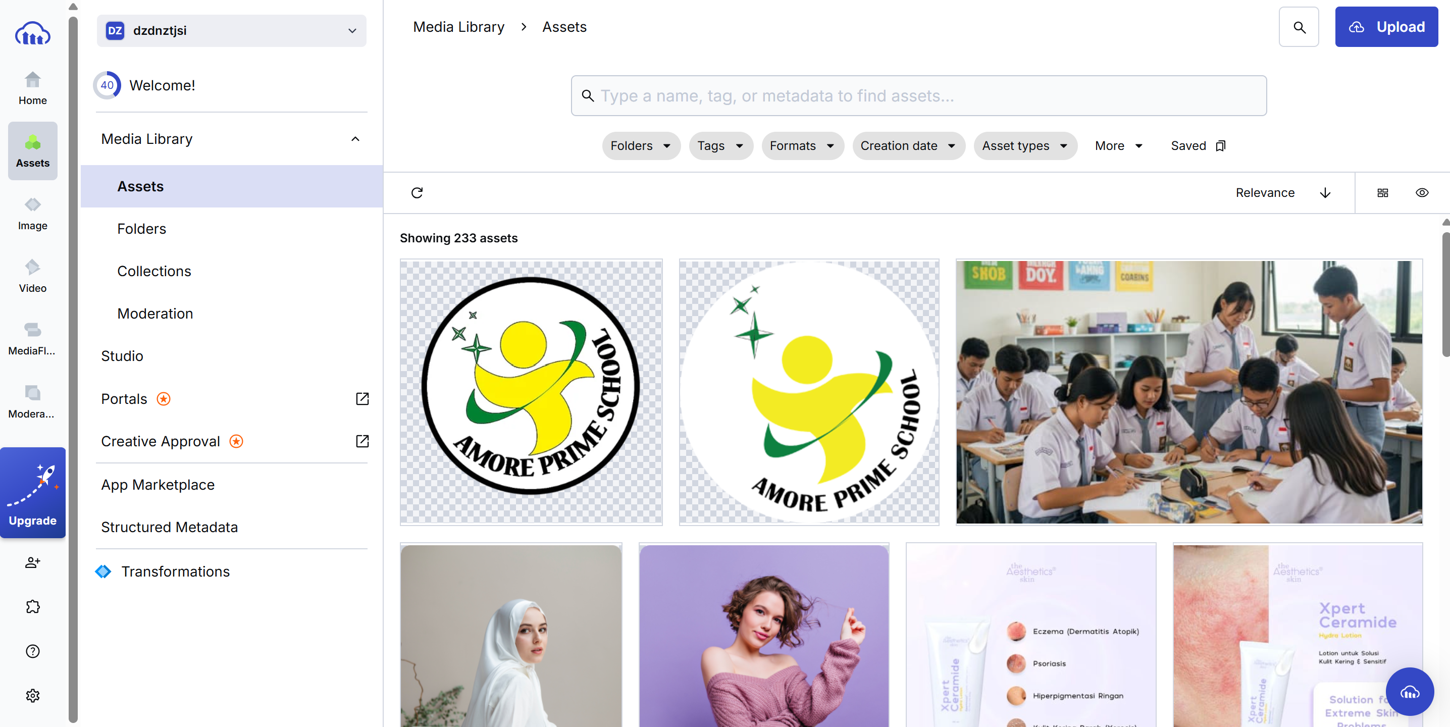
40 | The photo you upload will appear in this list, and you'll be able to copy the image link later.
41 | Then, when you click on the photo, there will be an option to copy the link to it. | 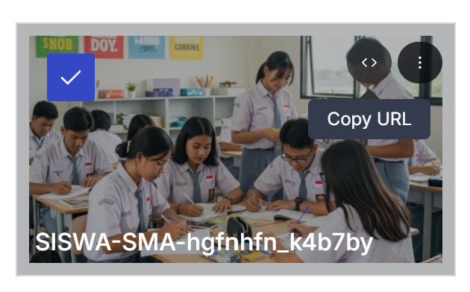
42 | You'll get a long link; if you open it in a web browser, the photo will be publicly visible because it has been uploaded to the cloud system. | 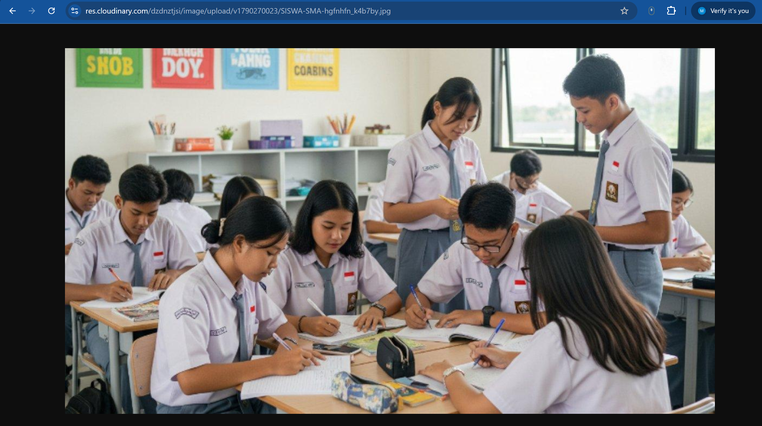
43 | You can use that link to replace the photo link I provided; feel free to use a photo of you and your classmates working on a group project, or a photo of the products you're selling.
44 | Leave a blank line between the </section> and the </div> | 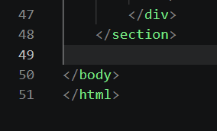
45 | Below the previous </section> closing tag, use the Emmet trick to create the main catalog box: | section#products.section-container>h2.section-title{Our Product Catalog}+div.product-grid  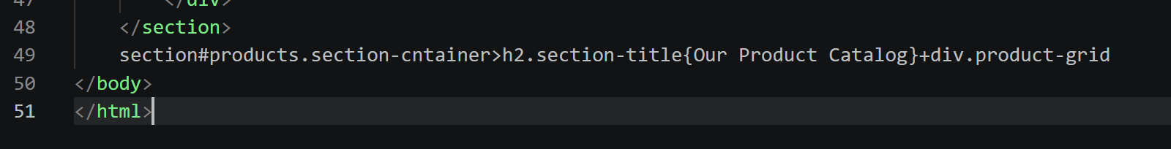  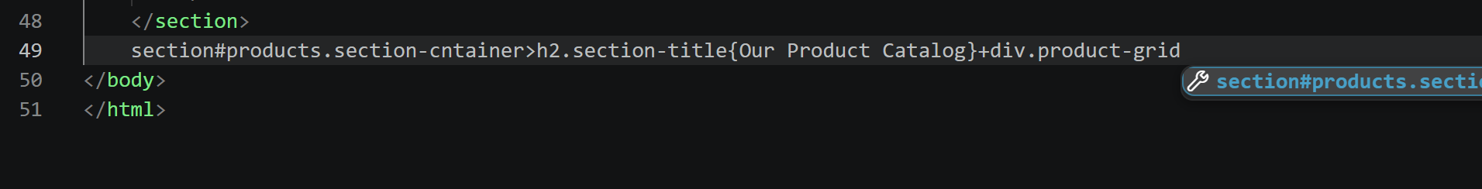  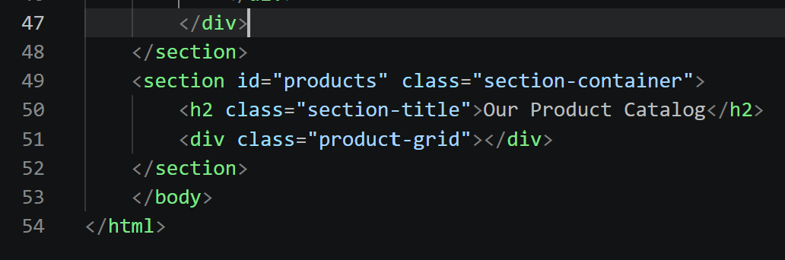
46 | Leave a blank line between the <div class=”product-grid”> and the </div> | 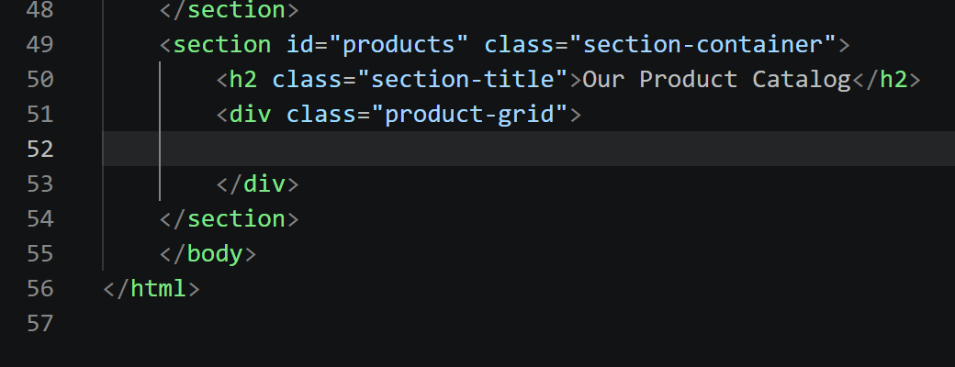
47 | Since the product content is quite extensive, place these 3 Product Cards directly inside the <div class="product-grid"> and </div> tags: | <div class="product-card">  <div class="product-image" onclick="openModal('https://res.cloudinary.com/dzdnztjsi/image/upload/v1763187296/samples/shoe.jpg')">  <img src="https://res.cloudinary.com/dzdnztjsi/image/upload/v1763187296/samples/shoe.jpg" alt="Paper Flowers">  <div class="overlay"><i class="fas fa-search-plus"></i> View Detail</div>  </div>  <div class="product-info">  <h3>Aesthetic Flowers Shoes</h3>  <p class="price">Rp 35.000</p>  <p class="desc">Beautiful handcrafted flowers made from recycled materials, perfect for room or desk decoration.</p>  <a href="https://wa.me/62895412022008?text=Hello,%20I%20want%20to%ask%20about%20the%20product" class="btn-whatsapp" target="_blank">  <i class="fab fa-whatsapp"></i> Order Now  </a>  </div>  </div>  <div class="product-card">  <div class="product-image" onclick="openModal('https://res.cloudinary.com/demo/image/upload/w_400,h_300,c_fill/shoes.jpg')">  <img src="https://res.cloudinary.com/demo/image/upload/w_400,h_300,c_fill/shoes.jpg" alt="Custom Painted Shoes">  <div class="overlay"><i class="fas fa-search-plus"></i> View Detail</div>  </div>  <div class="product-info">  <h3>Custom Painted Shoes</h3>  <p class="price">Rp 120.000</p>  <p class="desc">Canvas shoes with hand-painted designs. You can custom request the design based on your preference.</p>  <a href="https://wa.me/62895412022008?text=Hello,%20I%20want%20to%ask%20about%20the%20product" class="btn-whatsapp" target="_blank">  <i class="fab fa-whatsapp"></i> Order Now  </a>  </div>  </div>  <div class="product-card">  <div class="product-image" onclick="openModal('https://res.cloudinary.com/dzdnztjsi/image/upload/v1763187306/cld-sample-5.jpg')">  <img src="https://res.cloudinary.com/dzdnztjsi/image/upload/v1763187306/cld-sample-5.jpg" alt="Ethnic Bracelet">  <div class="overlay"><i class="fas fa-search-plus"></i> View Detail</div>  </div>  <div class="product-info">  <h3>Ethnic Handwoven Shoes</h3>  <p class="price">Rp 15.000</p>  <p class="desc">Handwoven string bracelets featuring beautiful local ethnic patterns. Great for daily wear.</p>  <a href="https://wa.me/62895412022008?text=Hello,%20I%20want%20to%ask%20about%20the%20product" class="btn-whatsapp" target="_blank">  <i class="fab fa-whatsapp"></i> Order Now  </a>  </div>  </div>  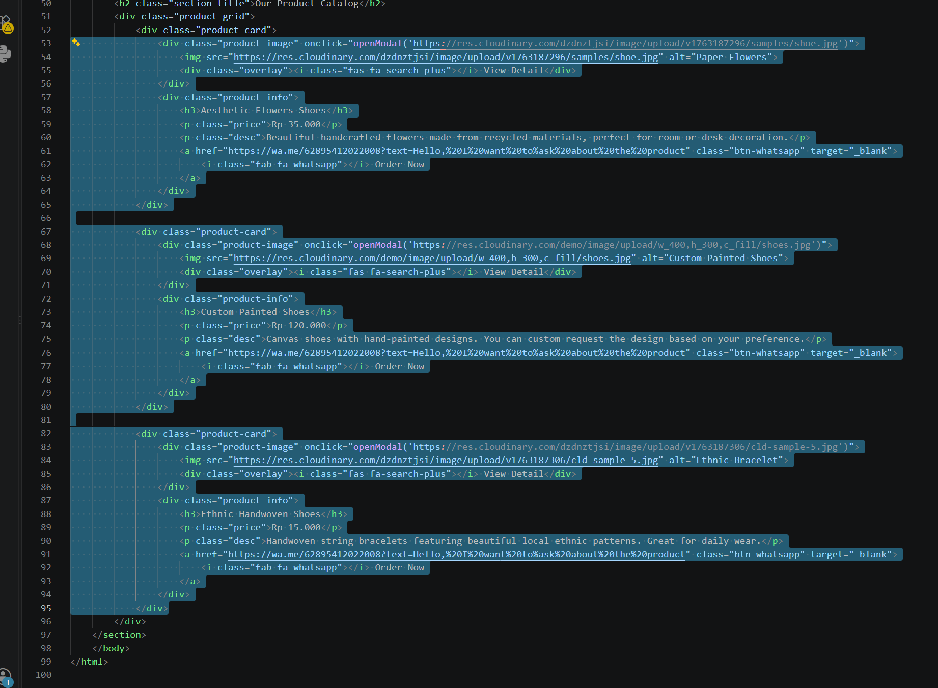
48 | You just need to update the content—change the product names, prices, and image links—and adjust the number of items you want to sell. | 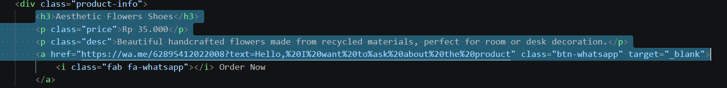
49 | Leave a blank line between the </section> and the </div> | 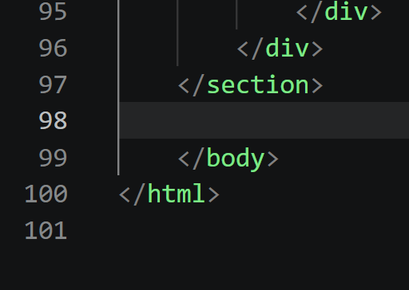
50 | Under the product catalog </section>, use the Emmet trick for the team structure: | section#team.section-container.bg-light>h2.section-title{Our Creative Team}+div.team-grid>div.team-card*3  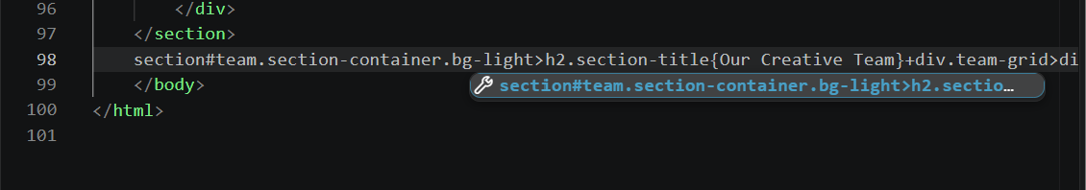  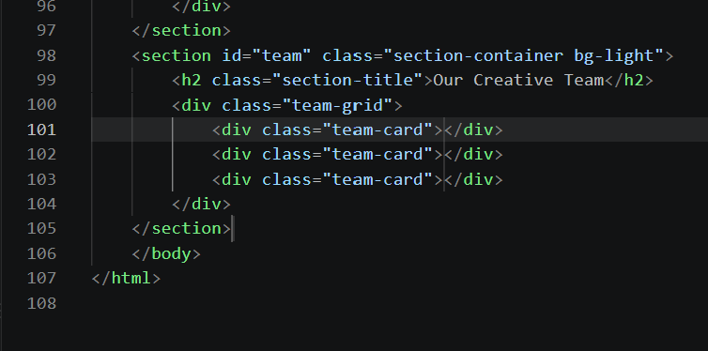
 | You will get three <div class="team-card"></div> elements. Fill each of these divs in order with this line of code: | 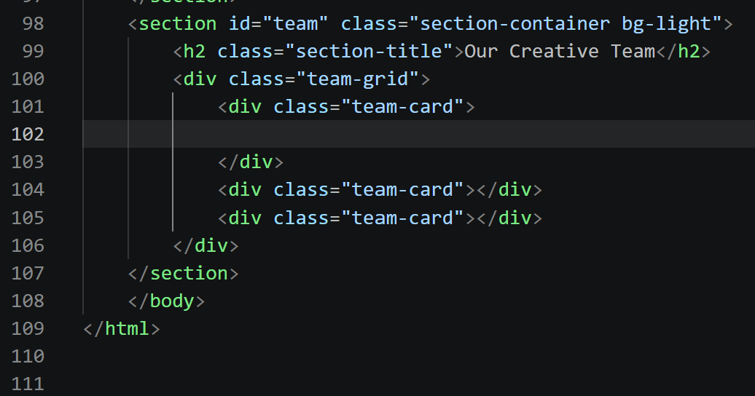
 | 1st member | <img src="https://res.cloudinary.com/demo/image/upload/w_150,h_150,c_thumb,g_face/face_left.png" alt="Student 1">  <h4>Budi Santoso</h4>  <p>Project Leader</p>  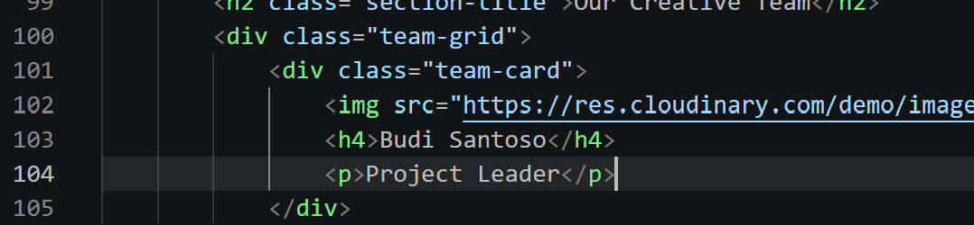
 | 2nd member | <img src="https://res.cloudinary.com/demo/image/upload/w_150,h_150,c_thumb,g_face/face_center.png" alt="Student 2">  <h4>Siti Aminah</h4>  <p>Production Manager</p>  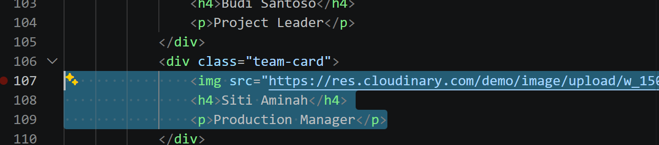
 | 3rd member | <img src="https://res.cloudinary.com/dzdnztjsi/image/upload/v1763187297/samples/smile.jpg" alt="Student 3">  <h4>Agus Pratama</h4>  <p>Marketing Manager</p>  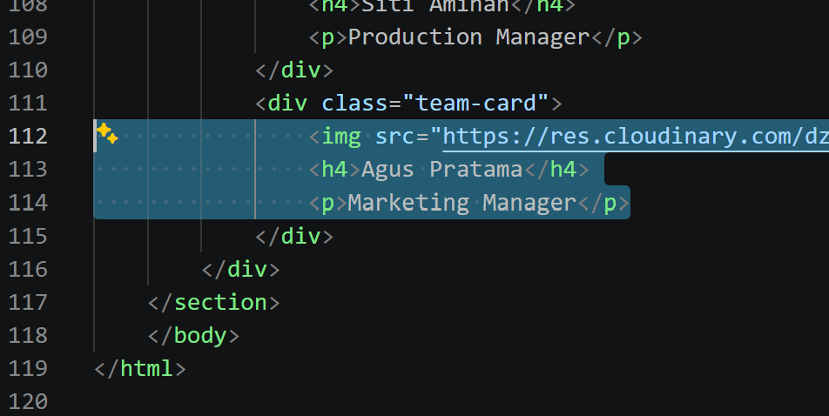
 | Creating the Footer (Bottom Section)  Use the Emmet trick below the closing `</section>` tag of the team section: | 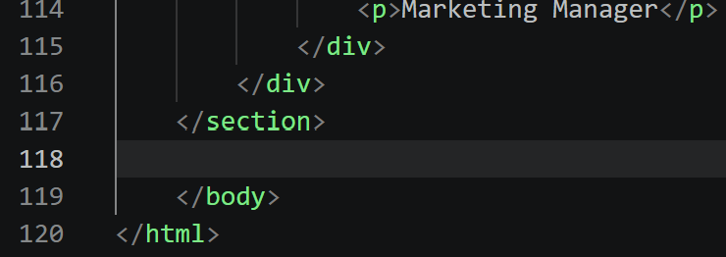
 | Use the Emmet trick below the closing `</section>` tag of the team section: | footer#contact>div.footer-content+div.footer-bottom  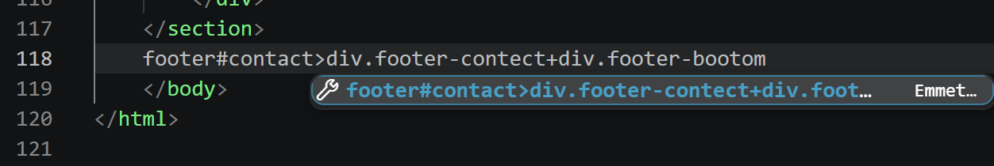
 |  | 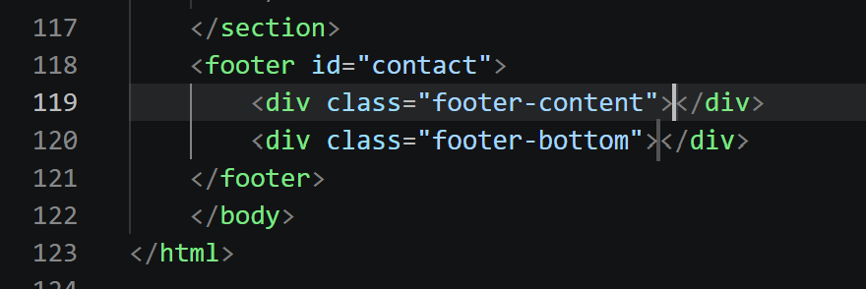
 | Fill the <div class="footer-content"> section with this. | 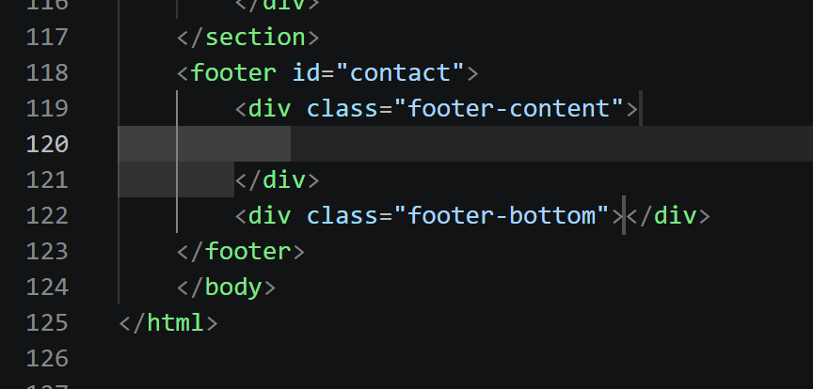  <h3>Contact & Follow Us</h3>  <p>Have questions or want to request a custom product? Reach out to us via social media.</p>  <div class="social-links">  <a href="https://wa.me/62895412022008" target="_blank" class="social-icon whatsapp"><i class="fab fa-whatsapp"></i> WhatsApp</a>  <a href="https://instagram.com/monicadyp" target="_blank" class="social-icon instagram"><i class="fab fa-instagram"></i> Instagram</a>  </div>  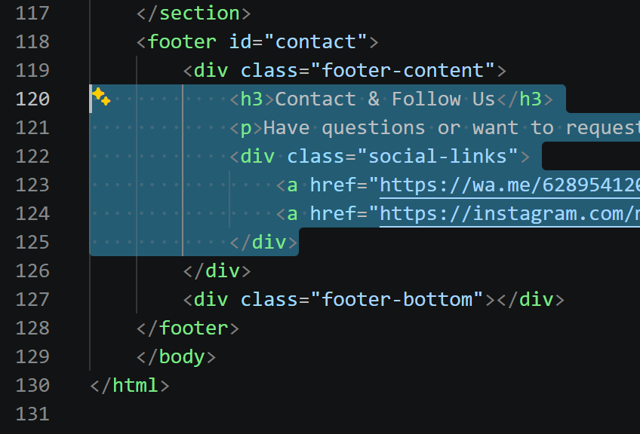
 | Fill the <div class="footer-bottom"> section with this. | 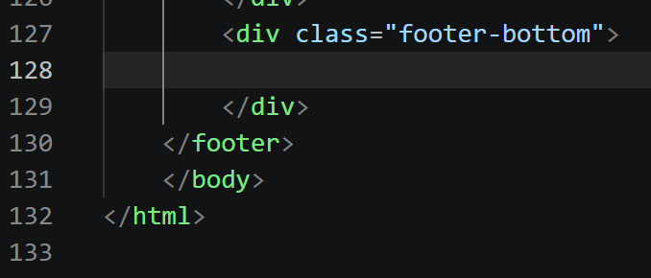
 | Fill the <div class="footer-bottom"> section with this. | <p>&copy; 2026 Entrepreneurship (PKWU) Class Project - Built with Pride</p>  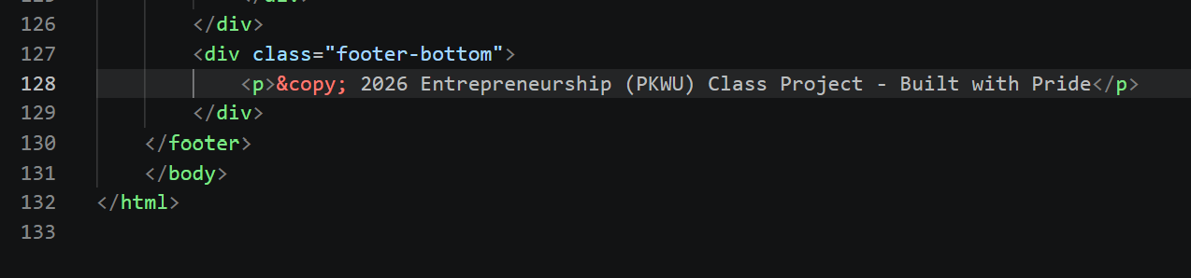
 | Right above the </body> closing tag, use the Emmet trick to create an image pop-up box: | 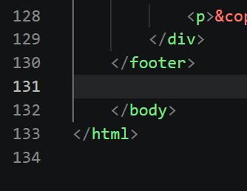
 | Right above the </body> closing tag, use the Emmet trick to create an image pop-up box: | div#imageModal.modal>span.close-modal{&times;}+img#modalImg.modal-content  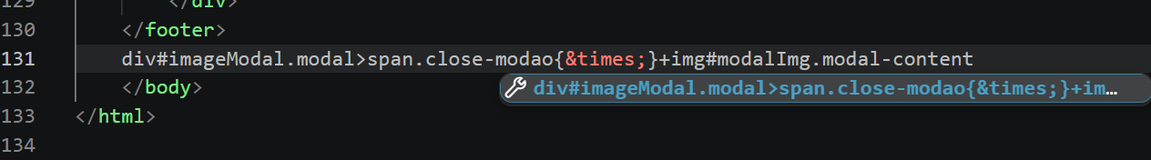  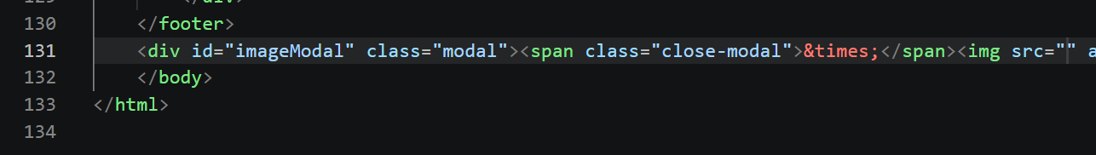
 | After that, leave some space below it and copy-paste this entire JavaScript code: | <script>  const modal = document.getElementById("imageModal");  const modalImg = document.getElementById("modalImg");  function openModal(imgSrc) {  modal.style.display = "flex";  modalImg.src = imgSrc;  setTimeout(() => { modal.classList.add("show"); }, 10);  }  function closeModal() {  modal.classList.remove("show");  setTimeout(() => { modal.style.display = "none"; }, 300);  }  modal.addEventListener('click', function(e) {  if (e.target === modal) { closeModal(); }  });  function toggleMenu() {  const navLinks = document.querySelector('.nav-links');  navLinks.classList.toggle('active');  }  document.querySelectorAll('.nav-links li a').forEach(link => {  link.addEventListener('click', () => {  document.querySelector('.nav-links').classList.remove('active');  });  });  </script>  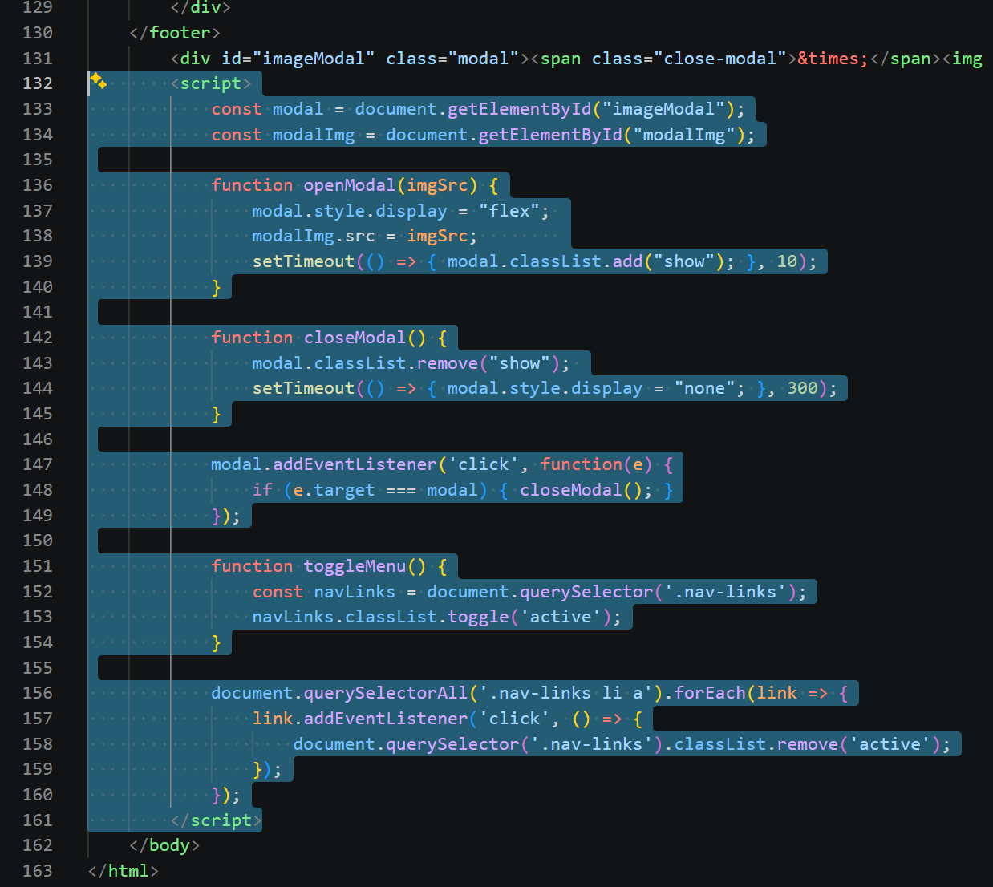
 | Go to file “style.css” | 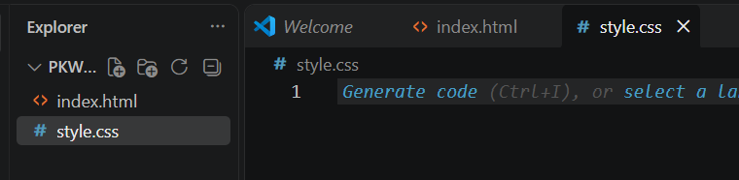
 | Copy paste style ini | /* === VARIABEL WARNA === */  :root {  --primary-color: #ff6b6b;  --secondary-color: #4ecdc4;  --dark-color: #2d3436;  --light-color: #f8f9fa;  --white: #ffffff;  --transition: all 0.3s cubic-bezier(0.25, 0.8, 0.25, 1);  }  * {  margin: 0;  padding: 0;  box-sizing: border-box;  font-family: 'Poppins', sans-serif;  }  body {  background-color: var(--light-color);  color: var(--dark-color);  line-height: 1.6;  }  /* FITUR AUTO-SCROLL (Smooth Scrolling) */  html {  scroll-behavior: smooth;  }  /* Memastikan saat link diklik, tidak tertutup oleh header/navbar */  section {  scroll-margin-top: 80px;  }  h1, h2, h3, h4 {  line-height: 1.2;  }  /* === NAVBAR / HEADER MENU === */  .navbar {  position: fixed;  top: 0; left: 0; right: 0;  background: rgba(255, 255, 255, 0.95);  backdrop-filter: blur(10px);  display: flex;  justify-content: space-between;  align-items: center;  padding: 15px 5%;  z-index: 999; /* Agar menu selalu berada di paling atas */  box-shadow: 0 2px 15px rgba(0,0,0,0.05);  }  .logo-container {  display: flex;  align-items: center;  gap: 15px;  }  .school-logo {  width: 45px;  height: 45px;  border-radius: 50%; /* Membuat logo sekolah menjadi bulat */  object-fit: cover;  border: 2px solid var(--secondary-color);  }  .logo-text {  font-size: 1.2rem;  font-weight: 700;  color: var(--dark-color);  letter-spacing: 1px;  }  .nav-links {  list-style: none;  display: flex;  gap: 25px;  }  .nav-links a {  text-decoration: none;  color: var(--dark-color);  font-weight: 600;  font-size: 0.95rem;  transition: var(--transition);  }  .nav-links a:hover {  color: var(--primary-color);  }  .menu-toggle {  display: none;  font-size: 1.5rem;  cursor: pointer;  color: var(--dark-color);  }  /* === HERO SECTION (BANNER) === */  .hero {  margin-top: 75px; /* Memberi jarak agar tidak tertutup navbar */  background: linear-gradient(135deg, rgba(45, 52, 54, 0.8), rgba(45, 52, 54, 0.9)),  url('https://res.cloudinary.com/dzdnztjsi/image/upload/v1763187289/samples/ecommerce/accessories-bag.jpg') center/cover;  height: 80vh;  display: flex;  align-items: center;  justify-content: center;  text-align: center;  color: var(--white);  padding: 0 20px;  }  .hero h1 {  font-size: 3.5rem;  margin-bottom: 15px;  letter-spacing: 2px;  }  .hero p {  font-size: 1.2rem;  margin-bottom: 30px;  max-width: 600px;  margin-left: auto;  margin-right: auto;  color: #dfe6e9;  }  .btn-primary {  display: inline-block;  background-color: var(--primary-color);  color: var(--white);  padding: 12px 35px;  border-radius: 30px;  text-decoration: none;  font-weight: 600;  transition: var(--transition);  box-shadow: 0 4px 15px rgba(255, 107, 107, 0.4);  }  .btn-primary:hover {  background-color: #ff5252;  transform: translateY(-4px);  }  /* === UMUM (SECTION & GRID) === */  .section-container {  padding: 80px 5%;  max-width: 1200px;  margin: 0 auto;  }  .bg-light {  background-color: var(--white);  }  .section-title {  text-align: center;  font-size: 2.5rem;  margin-bottom: 50px;  position: relative;  }  .section-title::after {  content: '';  width: 60px;  height: 4px;  background-color: var(--secondary-color);  display: block;  margin: 15px auto 0;  border-radius: 2px;  }  /* === ABOUT US === */  .about-content {  display: flex;  gap: 40px;  align-items: center;  }  .about-text {  flex: 1;  }  .about-text h3 {  font-size: 1.8rem;  margin-bottom: 20px;  color: var(--primary-color);  }  .about-text p {  margin-bottom: 15px;  font-size: 1.05rem;  color: #636e72;  }  .about-image {  flex: 1;  }  .about-image img {  width: 100%;  border-radius: 20px;  box-shadow: 0 10px 30px rgba(0,0,0,0.1);  }  /* === PRODUCTS === */  .product-grid {  display: grid;  grid-template-columns: repeat(auto-fit, minmax(300px, 1fr));  gap: 30px;  }  .product-card {  background: var(--white);  border-radius: 20px;  overflow: hidden;  box-shadow: 0 10px 20px rgba(0,0,0,0.06);  transition: var(--transition);  }  .product-card:hover {  transform: translateY(-10px);  box-shadow: 0 15px 30px rgba(0,0,0,0.15);  }  .product-image {  position: relative;  cursor: pointer;  overflow: hidden;  height: 250px;  }  .product-image img {  width: 100%;  height: 100%;  object-fit: cover;  transition: var(--transition);  }  .product-card:hover .product-image img {  transform: scale(1.1);  }  .overlay {  position: absolute;  top: 0; left: 0; right: 0; bottom: 0;  background: rgba(45, 52, 54, 0.7);  color: white;  display: flex;  align-items: center;  justify-content: center;  opacity: 0;  transition: var(--transition);  font-size: 1.2rem;  gap: 10px;  font-weight: 600;  }  .product-image:hover .overlay {  opacity: 1;  }  .product-info {  padding: 25px;  text-align: center;  }  .product-info h3 {  font-size: 1.4rem;  margin-bottom: 8px;  color: var(--dark-color);  }  .price {  color: var(--primary-color);  font-size: 1.4rem;  font-weight: 700;  margin-bottom: 12px;  }  .desc {  color: #636e72;  margin-bottom: 25px;  font-size: 0.95rem;  }  .btn-whatsapp {  display: block;  background-color: #25D366;  color: white;  padding: 12px;  text-decoration: none;  border-radius: 10px;  font-weight: 600;  transition: var(--transition);  }  .btn-whatsapp:hover {  background-color: #1ebe57;  transform: translateY(-2px);  }  /* === TEAM SECTION === */  .team-grid {  display: grid;  grid-template-columns: repeat(auto-fit, minmax(200px, 1fr));  gap: 40px;  text-align: center;  }  .team-card {  transition: var(--transition);  }  .team-card:hover {  transform: translateY(-5px);  }  .team-card img {  width: 130px;  height: 130px;  border-radius: 50%;  object-fit: cover;  margin-bottom: 15px;  border: 4px solid var(--secondary-color);  padding: 4px;  box-shadow: 0 5px 15px rgba(78, 205, 196, 0.3);  }  .team-card h4 {  font-size: 1.2rem;  margin-bottom: 5px;  }  .team-card p {  color: #777;  font-size: 0.9rem;  font-weight: 600;  }  /* === FOOTER === */  footer {  background-color: var(--dark-color);  color: var(--white);  text-align: center;  padding: 60px 20px 20px;  }  .footer-content h3 {  font-size: 2rem;  margin-bottom: 15px;  }  .footer-content p {  margin-bottom: 30px;  color: #b2bec3;  max-width: 500px;  margin-left: auto;  margin-right: auto;  }  .social-links {  display: flex;  justify-content: center;  gap: 20px;  margin-bottom: 40px;  flex-wrap: wrap;  }  .social-icon {  padding: 12px 25px;  border-radius: 30px;  text-decoration: none;  color: white;  font-weight: 600;  display: flex;  align-items: center;  gap: 10px;  transition: var(--transition);  }  .social-icon.whatsapp {  background-color: #25D366;  }  .social-icon.whatsapp:hover { background-color: #1ebe57; transform: scale(1.05); }  .social-icon.instagram {  background: linear-gradient(45deg, #f09433 0%, #e6683c 25%, #dc2743 50%, #cc2366 75%, #bc1888 100%);  }  .social-icon.instagram:hover { transform: scale(1.05); }  .footer-bottom {  border-top: 1px solid rgba(255,255,255,0.1);  padding-top: 25px;  color: #888;  font-size: 0.9rem;  }  /* === MODAL / LIGHTBOX GAMBAR === */  .modal {  display: none;  position: fixed;  z-index: 1000;  left: 0; top: 0;  width: 100%; height: 100%;  background-color: rgba(0, 0, 0, 0.85);  align-items: center;  justify-content: center;  opacity: 0;  transition: opacity 0.3s ease;  }  .modal.show { opacity: 1; }  .modal-content {  max-width: 90%;  max-height: 90%;  border-radius: 10px;  box-shadow: 0 10px 30px rgba(0,0,0,0.5);  transform: scale(0.7);  transition: transform 0.3s cubic-bezier(0.25, 0.8, 0.25, 1);  }  .modal.show .modal-content { transform: scale(1); }  .close-modal {  position: absolute;  top: 20px;  right: 35px;  color: #f1f1f1;  font-size: 50px;  font-weight: bold;  cursor: pointer;  transition: 0.3s;  }  .close-modal:hover { color: var(--primary-color); }  /* === TAMPILAN HP (RESPONSIVE) === */  @media (max-width: 768px) {  /* Desain menu di HP */  .menu-toggle { display: block; }  .nav-links {  position: absolute;  top: 70px;  left: 0;  right: 0;  background: var(--white);  flex-direction: column;  gap: 0;  text-align: center;  box-shadow: 0 10px 10px rgba(0,0,0,0.1);  display: none;  }  .nav-links.active {  display: flex;  }  .nav-links li {  border-top: 1px solid #eee;  }  .nav-links li a {  display: block;  padding: 15px;  }  .hero h1 { font-size: 2.3rem; }  .hero p { font-size: 1rem; }  .section-title { font-size: 2rem; }  /* About Us Stack Vertikal di HP */  .about-content {  flex-direction: column;  }  .social-links { flex-direction: column; align-items: center; }  .social-icon { width: 100%; max-width: 250px; justify-content: center; }  }  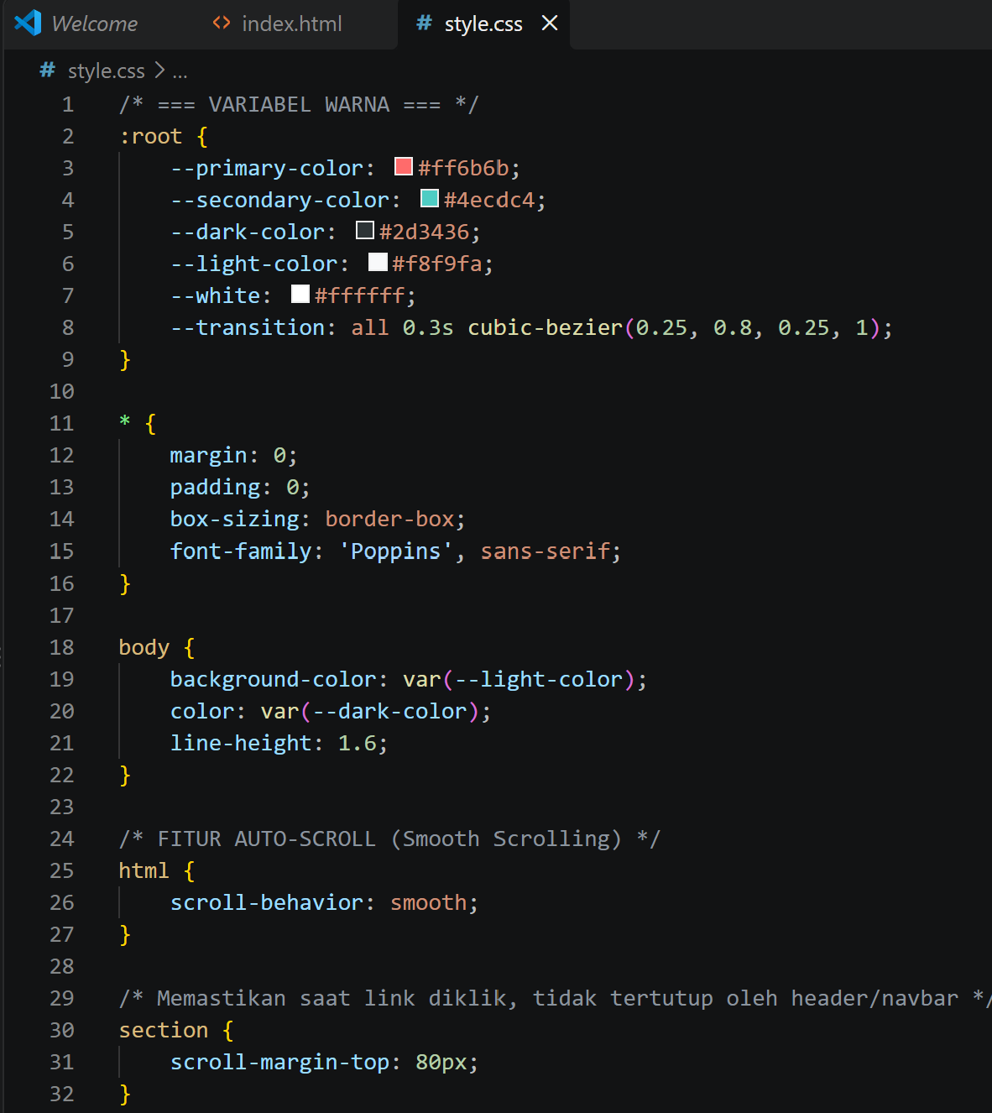

- Buka https://www.netlify.com/ login dengan akun Google anda (WAJIB LOGIN)
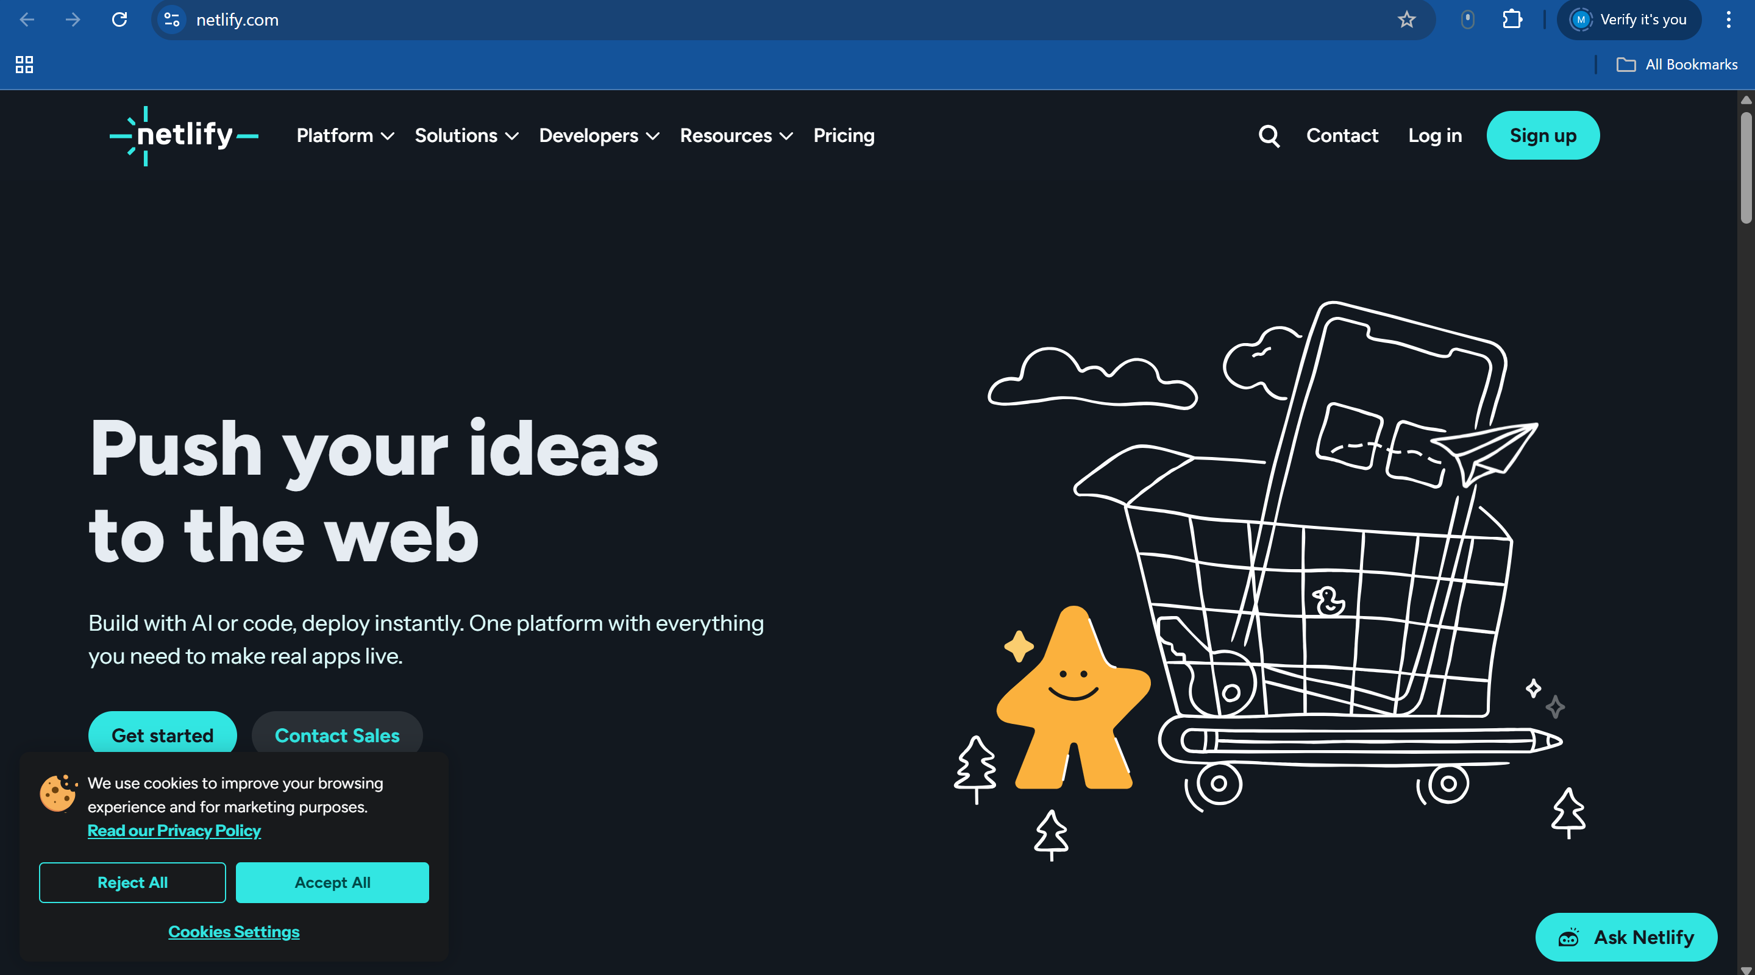
- Buka https://app.netlify.com/drop
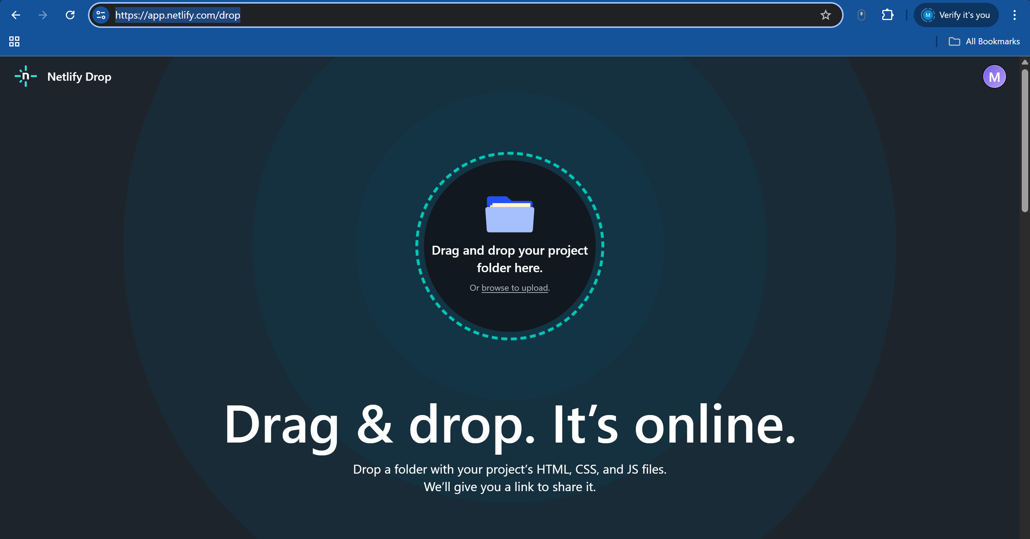
\atau scroll ke bawah sampai nemu ini
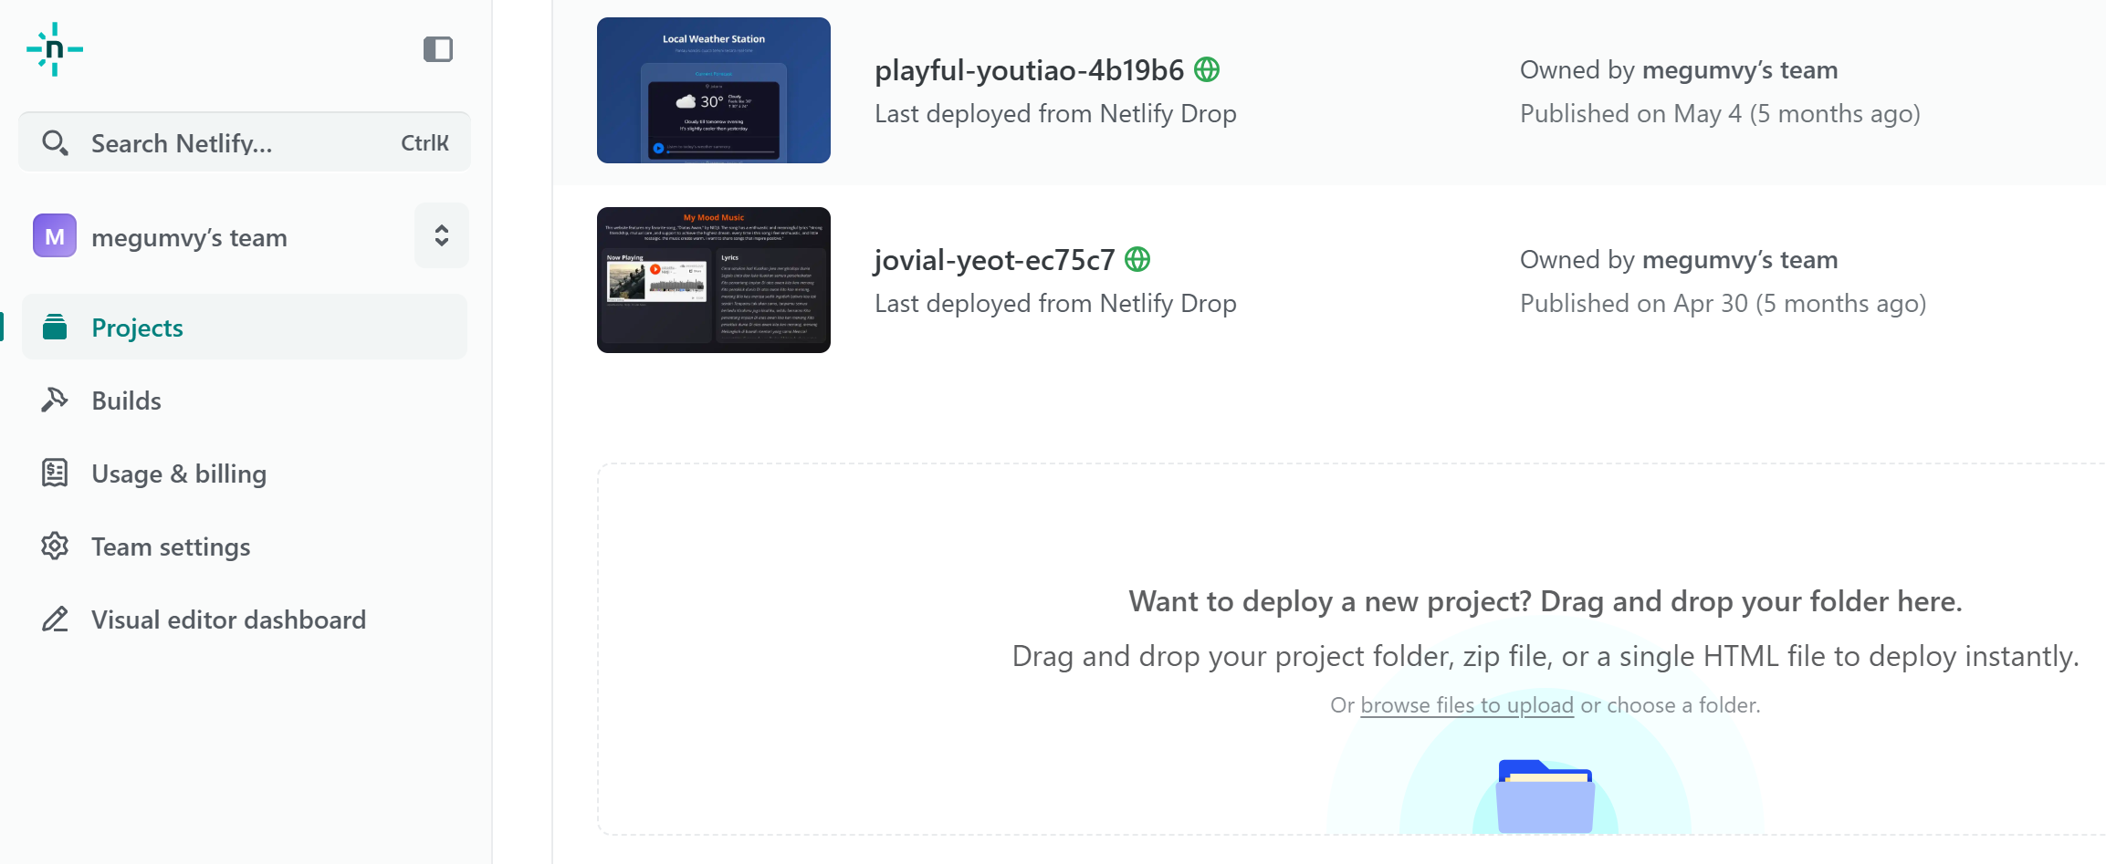
- Klik “browse” pada lingkaran
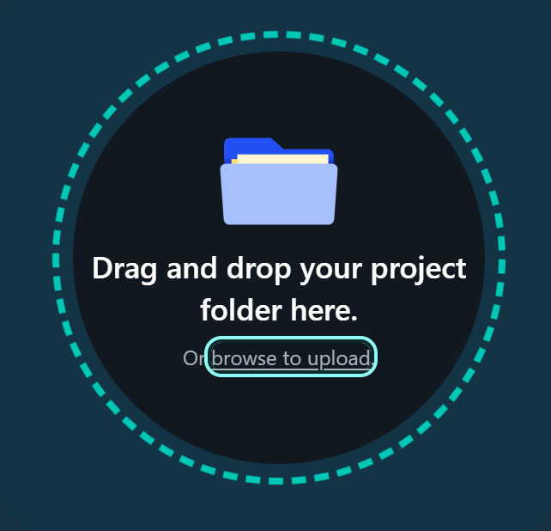
Atau pilih choose a folder

- Pilih folder “PKWU WEB” dan klik “Upload”
- saat folder “PKWU-WEB” dibuka memang tidak akan terlihat file index.html dan style.css nya, tetapi tetap Upload saja

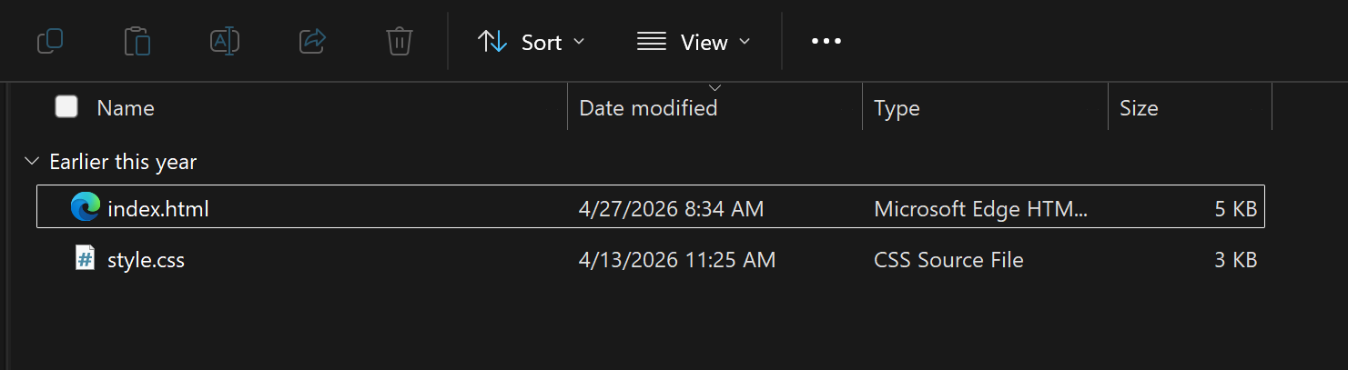
- Akan ada pop up seperti di bawah ini dan klik button “Upload”
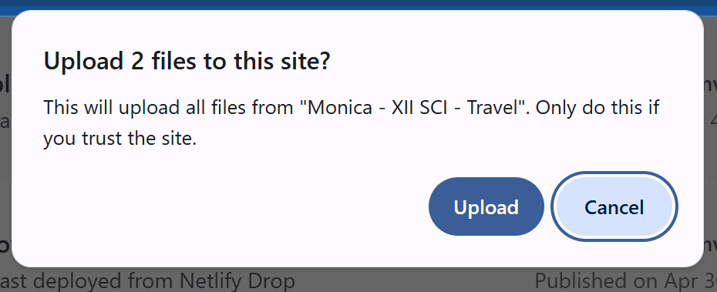
- Tampilan akan loading seperti di bawah ini
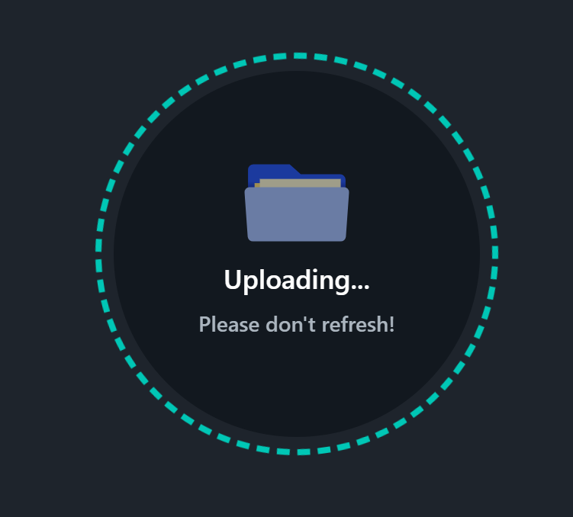
- Kamu akan mendapatkan tampilan berisi link hosting seperti ini dengan tulisan hijau https://delicate-pie-64ac50.netlify.app/ adalah link website kamu. Akan diberikan random gratis oleh Netlify
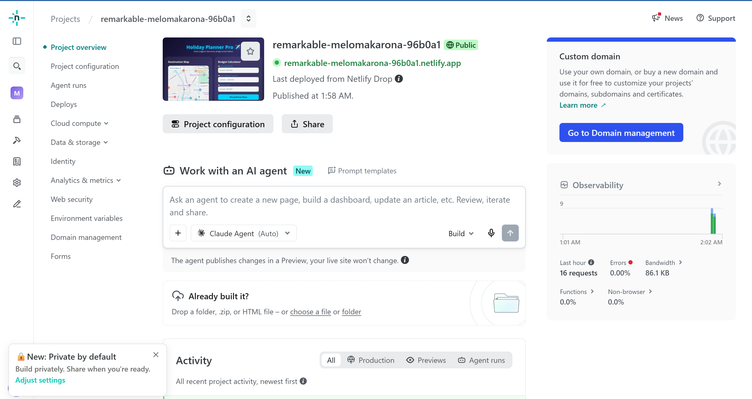
- Sehingga link tersebut bisa dibuka dan menampilkan website kamu serta dapat diakses publik lewat internet. Simpan link tersebut dan coba akses di handphone kalian.

- Final Task: Salin link website yang sudah selesai dan kumpulkann ke link = https://forms.gle/5TcRsDXFhq867BEm7
