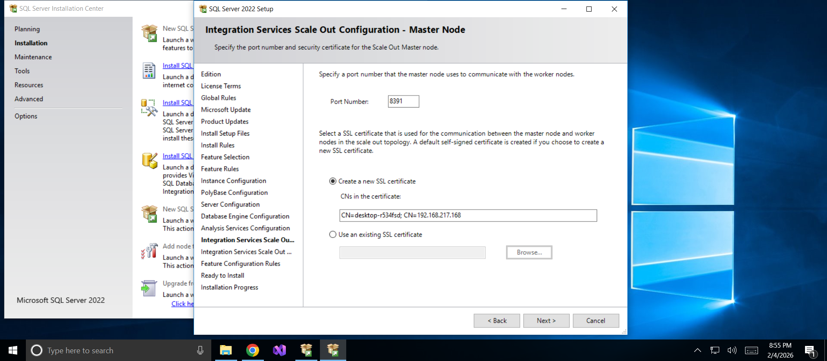

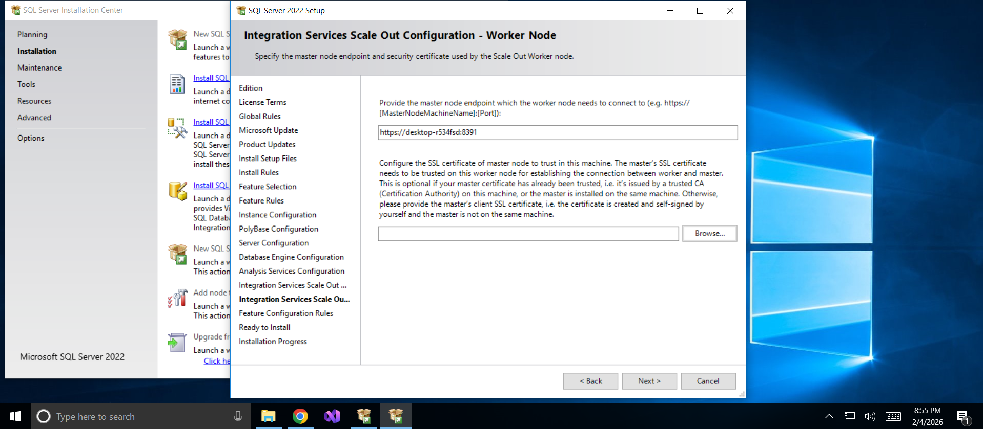
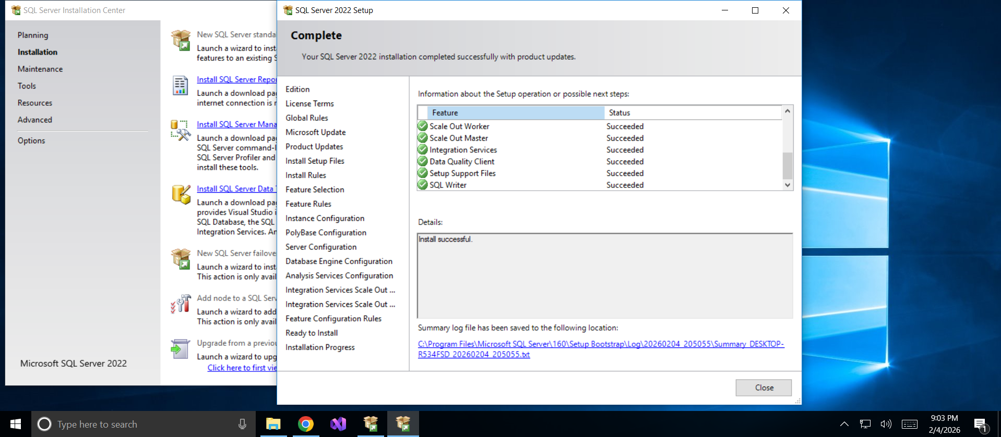

ADO.NET
- ADO.NET is a module of .Net Framework which is used to establish connection between application and data sources.
- Data sources can be such as SQL Server and XML. ADO.NET consists of classes that can be used to connect, retrieve, insert and delete data.
- All the ADO.NET classes are located into System.Data.dll

ADO.NET Data Access
- 1. Set up a Data Connection
  - – Establishes a link to the data source
- 2. Set up a DataAdapter
  - – Handles retrieving and updating the data
  - – Data adapter uses “Command” objects to retrieve/store records from/to the database and can be used to:
- 3. Create a DataSet:
  - A temporary set of data tables stored in the computer’s memory
  - ADO.NET datasets are disconnected
    - – So data in memory does not keep an active connection to data source
    - – Much better: Many more clients can connect and use the data server
  - DataAdapters’s Fill(-,-) method gets a data table into the DataSet
    - – Uses SQL in a “Command” object to specify data to retrieve/update
- 4.. Add controls on the Windows Form or Web Form
  - – Display the data from the DataSet and allow user interaction
- 5. Write C# code to put the data into the controls

Open SQL Server-> New Query window:

Create database training;
use training;
create table t(i int,j int);
insert into t values(2,5),(3,6),(5,5),(1,2),(8,9);
select * from t;

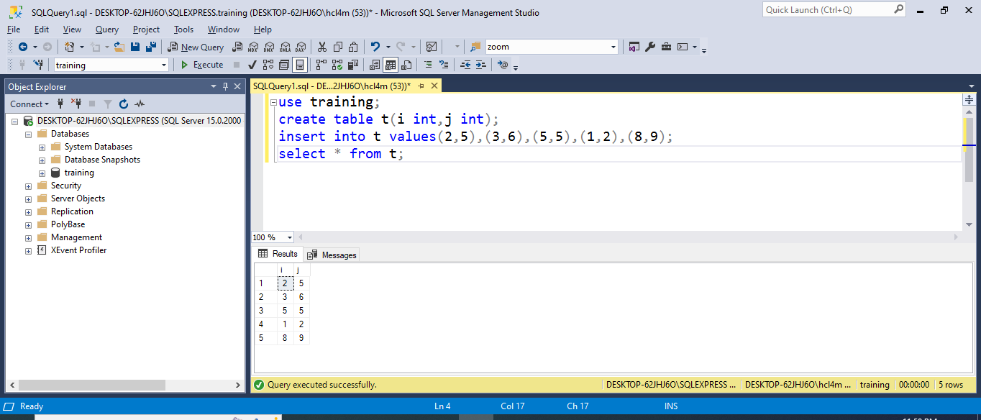

Install NuGet package
Using Visual Studio
- Right-click Project
- Manage NuGet Packages
- Search:
Microsoft.Data.SqlClient
- Install latest stable version

Change your using
using Microsoft.Data.SqlClient;
using System.Data;

Creating a Data Source
- Click on DataSources in the left most corner
- Add a new Connection
- Provide SqlServer Name from SQL Server
- Provide Credentials
- Choose Tables
- Test Connection
- Copy Connection String in Code
- Data Source=DESKTOP-O7LF2JA;Initial Catalog=training;Integrated Security=True
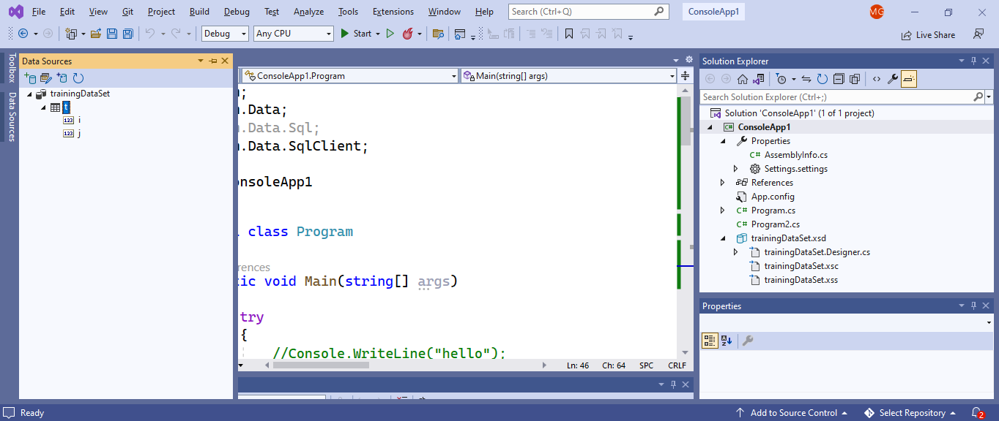

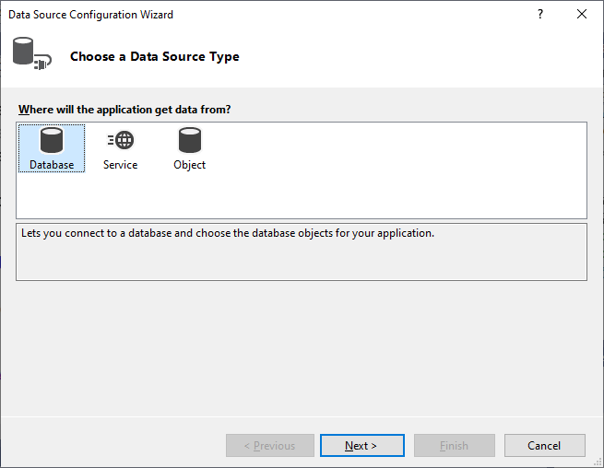
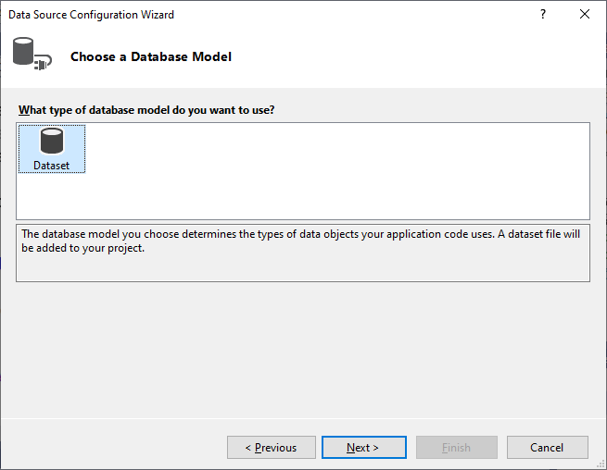
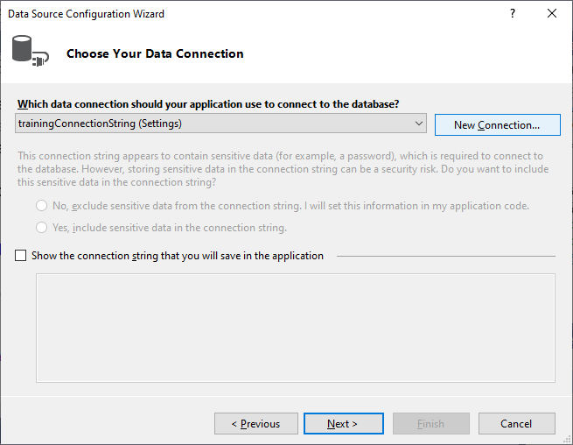
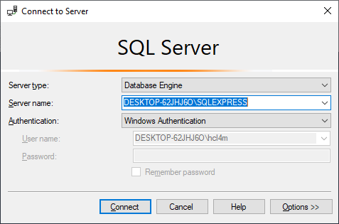
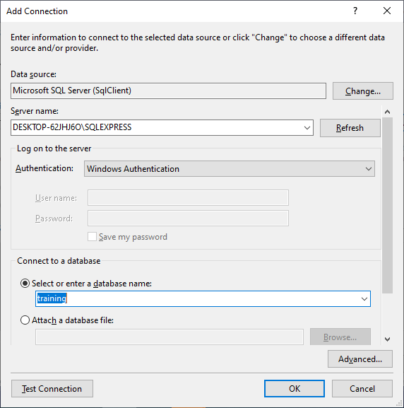
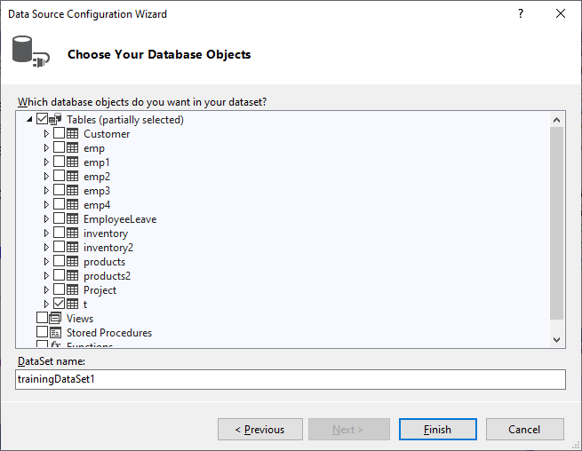

Copy the Connection String from the wizard
- Data Source=DESKTOP-62JHJ6O\SQLEXPRESS;Initial Catalog=training;Integrated Security=True

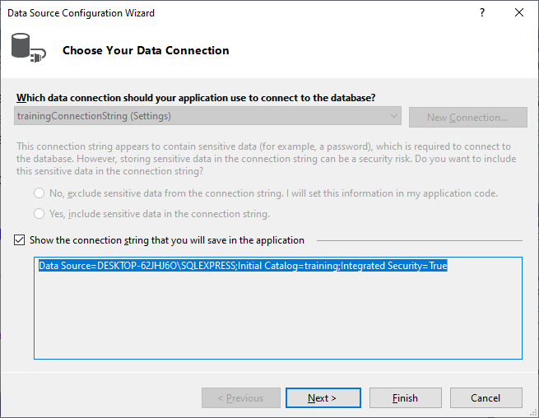

using System;
using System.Data;
using Microsoft.Data.SqlClient;

class Program
{
static void Main()
{
string connStr = @"Data Source=(localdb)\MSSQLLocalDB;Initial Catalog=training;Integrated Security=True;";

using (SqlConnection con = new SqlConnection(connStr))
{
con.Open();
//SqlCommand cmd = new SqlCommand("Select * from t", con);
//cmd.CommandType = CommandType.Text;
//SqlDataReader rdr = cmd.ExecuteReader();
//while (rdr.Read())
//{
// Console.Write(rdr.GetInt32(0) + " ");
// Console.WriteLine(rdr.GetInt32(1));
//}

////////Insert:
//SqlCommand cmd = new SqlCommand("Insert into t values(2,5)", con);
//cmd.CommandType = CommandType.Text;
//cmd.ExecuteNonQuery();
//Console.WriteLine("Data inserted");

////////Delete:
//SqlCommand cmd = new SqlCommand("Delete from t where i=2 and j=5", con);
//cmd.CommandType = CommandType.Text;
//cmd.ExecuteNonQuery();
//Console.WriteLine("Data deleted");

////Update:
//SqlCommand cmd = new SqlCommand("Update t set j=6 where i=5 and j=5", con);
//cmd.CommandType = CommandType.Text;
//cmd.ExecuteNonQuery();
//Console.WriteLine("Data updated");
}

Console.ReadLine();
}
}

Create a SQL Server connection
SqlConnection con = new SqlConnection(
@"Data Source = DESKTOP-62JHJ6O\SQLEXPRESS;
Initial Catalog = training;
Integrated Security = True");
What this does:
- SqlConnection is used to connect a C# application to SQL Server.
- Data Source = DESKTOP-62JHJ6O\SQLEXPRESS
Name of your SQL Server instance.
- Initial Catalog = training
Database name you want to connect to.
- Integrated Security = True
Uses Windows Authentication (no username/password needed).
At this point, the connection is defined, not opened yet.
What is SqlConnection?
SqlConnection represents a connection to a SQL Server database using a connection string.
SqlConnection con = new SqlConnection(connectionString);
Everything important is inside the connection string.

Structure of a SQL Server Connection String
Key = Value; Key = Value; Key = Value;
Each key is a parameter.

Most Common SqlConnection Parameters (Must Know)
1. Data Source (or Server)
Data Source = DESKTOP-62JHJ6O\SQLEXPRESS
Purpose:
- Specifies SQL Server name / instance
Examples:
Data Source=localhost
Data Source=.\SQLEXPRESS
Data Source=192.168.1.10

2. Initial Catalog (or Database)
Initial Catalog = training
Purpose:
- Specifies the database name to connect to.
Alternate name:
Database=training

3. Integrated Security
Integrated Security = True
Purpose:
- Uses Windows Authentication
- No username or password required.
Alternate values:
Integrated Security=SSPI
Integrated Security=False

4. User ID
User ID = sa
Purpose:
- SQL Server login username
- Used only when Integrated Security=False

5. Password
Password = mypassword
Purpose:
- Password for SQL login
Example (SQL Authentication):
Data Source=.;Initial Catalog=training;
User ID=sa;Password=1234;

Security & Encryption Parameters
6. Encrypt
Encrypt=True
Purpose:
- Encrypts data sent between app and SQL Server.

7. TrustServerCertificate
TrustServerCertificate=True
Purpose:
- Bypasses SSL certificate validation
- Common in local development

Connection Management Parameters
8. Connection Timeout
Connection Timeout = 30
Purpose:
- Time (in seconds) to wait before failing connection.
Default = 15 seconds

9. Pooling
Pooling=True
Purpose:
- Enables connection pooling for better performance.
Default = True

10. Max Pool Size
Max Pool Size = 100
Purpose:
- Maximum number of connections in the pool.

11. Min Pool Size
Min Pool Size = 5
Purpose:
- Minimum connections maintained in pool.

Advanced / Less Used Parameters
12. MultipleActiveResultSets (MARS)
MultipleActiveResultSets=True
Purpose:
- Allows multiple SqlDataReader objects on one connection.

13. Application Name
Application Name = MyApp
Purpose:
- Identifies application in SQL Server logs.

14. Persist Security Info
Persist Security Info=False
Purpose:
- Prevents sensitive data from being returned.

15. Packet Size
Packet Size=8192
Purpose:
- Size of network packets sent to SQL Server.

Connection String Explained
@"Data Source = DESKTOP-62JHJ6O\SQLEXPRESS;
Initial Catalog = training;
Integrated Security = True";
Parameter | Meaning
Data Source | SQL Server instance
Initial Catalog | Database name
Integrated Security | Windows authentication

Full Example (All Common Parameters)
string connStr =
@"Data Source=DESKTOP-62JHJ6O\SQLEXPRESS;
Initial Catalog=training;
Integrated Security=True;
Encrypt=False;
TrustServerCertificate=True;
Connection Timeout=30;
Pooling=True;
Max Pool Size=100;
Min Pool Size=5;
Application Name=TrainingApp";

One-Liner
SqlConnection uses a connection string containing server name, database name, authentication method, security, and performance-related parameters to establish a connection with SQL Server.

Open the database connection
con.Open();
What this does:
- Physically opens the connection between your C# app and SQL Server.
- After this line, SQL commands can be executed.

Create SQL command
SqlCommand cmd = new SqlCommand("Select * from t", con);
What this does:
- Creates a SQL command object.
- "Select * from t" → SQL query to fetch all records from table t.
- con → connection on which this command will run.

Specify command type
cmd.CommandType = CommandType.Text;
What this does:
- Tells C# that this command is a plain SQL query.
- Other types could be:
  - StoredProcedure
  - TableDirect
Here, SELECT * FROM t is just text → so Text.

What is CommandType?
CommandType tells ADO.NET how to interpret the CommandText of a SqlCommand.
cmd.CommandType = CommandType.Text;

All Values of CommandType
CommandType is an enum with 3 values:
CommandType.Text
CommandType.StoredProcedure
CommandType.TableDirect
Let’s go one by one

CommandType.Text (Most Common)
cmd.CommandType = CommandType.Text;
Meaning
- CommandText contains raw SQL statements
Used for
- SELECT
- INSERT
- UPDATE
- DELETE
Example
SqlCommand cmd = new SqlCommand(
"SELECT * FROM Student WHERE Age > 18", con);
cmd.CommandType = CommandType.Text;
Default value (even if you don’t set it).

CommandType.StoredProcedure (Very Important)
cmd.CommandType = CommandType.StoredProcedure;
Meaning
- CommandText contains the name of a stored procedure
- SQL Server executes that procedure
Example (SQL)
CREATE PROCEDURE GetStudents
AS
BEGIN
SELECT * FROM Student
END

Example (C#)
SqlCommand cmd = new SqlCommand("GetStudents", con);
cmd.CommandType = CommandType.StoredProcedure;

SqlDataReader rdr = cmd.ExecuteReader();

With Parameters
cmd.Parameters.AddWithValue("@Age", 20);
Advantages
- Better performance
- More secure
- Reusable logic
- Reduced SQL injection risk

CommandType.TableDirect (Rarely Used )
cmd.CommandType = CommandType.TableDirect;
Meaning
- CommandText contains table name only
- Directly fetches all rows from the table
Example
SqlCommand cmd = new SqlCommand("Student", con);
cmd.CommandType = CommandType.TableDirect;

SqlDataReader rdr = cmd.ExecuteReader();
Limitations
- Works only with some providers
- Not recommended for SQL Server
- No WHERE, JOIN, ORDER BY
Almost never used in real applications.

Quick Comparison Table
CommandType | CommandText contains | Usage
Text | SQL query | Most common
StoredProcedure | Procedure name | Recommended
TableDirect | Table name | Rare

Q&A:
Q: What happens if you don’t set CommandType?
A: Default is CommandType.Text.

One-liner
CommandType specifies whether a SqlCommand executes a SQL query, a stored procedure, or directly accesses a table.

Execute the command and get data
SqlDataReader rdr = cmd.ExecuteReader();
What this does:
- Executes the SQL query.
- Returns a SqlDataReader, which:
  - Reads data row by row
  - Is forward-only and read-only
  - Very fast and memory-efficient

Read data row by row
while (rdr.Read())
What this does:
- Moves to the next record in the result set.
- Returns true if a row exists.
- Loop continues until all rows are read.

Read column values from each row
Console.Write(rdr.GetInt32(0) + " ");
Console.WriteLine(rdr.GetInt32(1));
What this does:
- rdr.GetInt32(0)
Reads 1st column (index starts from 0) as an int
- rdr.GetInt32(1)
Reads 2nd column as an int
- Prints values to the console.
This assumes:
- Column 1 and Column 2 are of type INT in the database.
Example table t:
id | age
1 | 22
2 | 25
Output:
1 22
2 25

What is SqlDataReader?
SqlDataReader rdr = cmd.ExecuteReader();
SqlDataReader is used to:
- Read data row by row
- In forward-only
- Read-only
- Very fast & memory-efficient
Best for SELECT queries.

How SqlDataReader Works
- Query is executed
- Data stays on SQL Server
- Rows are fetched one at a time
- Only one row is in memory

Core SqlDataReader Methods (Must Know)
Read()
while (rdr.Read())
Purpose:
- Moves to the next row
- Returns true if row exists

GetInt32(index)
int id = rdr.GetInt32(0);
Reads an INT column by index.

GetString(index)
string name = rdr.GetString(1);
Reads a VARCHAR / NVARCHAR column.

GetBoolean(index)
bool status = rdr.GetBoolean(2);

GetDateTime(index)
DateTime dob = rdr.GetDateTime(3);

GetDecimal(index)
decimal salary = rdr.GetDecimal(4);

GetDouble(index)
double marks = rdr.GetDouble(5);

GetValue(index)
object value = rdr.GetValue(0);
- Returns data as object
- Useful when data type is unknown

GetName(index)
string columnName = rdr.GetName(0);
Returns column name.

GetOrdinal(columnName)
int index = rdr.GetOrdinal("StudentName");
Returns column index from name.

Reading Data by Column Name
string name = rdr["StudentName"].ToString();
Slower than index-based access but easier to read.

Handling NULL Values (Very Important )
IsDBNull()
if (!rdr.IsDBNull(2))
{
string email = rdr.GetString(2);
}
Prevents runtime exceptions.

SqlDataReader Properties
HasRows
if (rdr.HasRows)
Checks if result contains rows.

FieldCount
int cols = rdr.FieldCount;
Number of columns.

IsClosed
bool closed = rdr.IsClosed;

RecordsAffected
int count = rdr.RecordsAffected;
Mostly used for INSERT / UPDATE / DELETE.

Closing SqlDataReader
rdr.Close();
Must be closed before closing connection.

CommandBehavior Options (Advanced)
SqlDataReader rdr = cmd.ExecuteReader(
CommandBehavior.CloseConnection);
Common Behaviors
Behavior | Meaning
Default | Normal
CloseConnection | Closes connection automatically
SingleRow | Only one row
SingleResult | Only one result set
SequentialAccess | Large data (BLOB)

Full Example (Best Practice)
using (SqlConnection con = new SqlConnection(cs))
{
SqlCommand cmd = new SqlCommand("SELECT * FROM Student", con);
con.Open();

using (SqlDataReader rdr = cmd.ExecuteReader())
{
while (rdr.Read())
{
Console.WriteLine(
rdr.GetInt32(0) + " " +
rdr.GetString(1));
}
}
}

SqlDataReader vs Others
Feature | DataReader | DataSet
Connectedow-by-row | Yes | No
Read-only | Yes | No
Fast | ⭐⭐⭐⭐⭐ | ⭐⭐⭐
Disconnected | No | Yes

One-Liners
- SqlDataReader is forward-only, read-only, connected architecture.
- Best for large result sets.
- Faster than DataSet.

Complete List Summary
Methods
- Read()
- GetInt32()
- GetString()
- GetBoolean()
- GetDateTime()
- GetDecimal()
- GetDouble()
- GetValue()
- GetName()
- GetOrdinal()
- IsDBNull()
- Close()
Properties
- HasRows
- FieldCount
- IsClosed
- RecordsAffected

Important Notes (Best Practice)
You should always close:
- SqlDataReader
- SqlConnection

rdr.Close();
con.Close();
Or best practice using using block:
using (SqlConnection con = new SqlConnection(connectionString))
{
con.Open();
SqlCommand cmd = new SqlCommand("Select * from t", con);
SqlDataReader rdr = cmd.ExecuteReader();

while (rdr.Read())
{
Console.WriteLine(rdr.GetInt32(0) + " " + rdr.GetInt32(1));
}
}

Thus,
This code connects to SQL Server, executes a SELECT query, reads each row using SqlDataReader, and prints integer column values to the console.

ExecuteScalar() (Very Important)
What it does
- Returns only ONE value
- Specifically: first column of first row
Return Type
object
Used for
- COUNT
- SUM
- MAX / MIN
- Single value queries
Example
SqlCommand cmd = new SqlCommand(
"SELECT COUNT(*) FROM Student", con);

object result = cmd.ExecuteScalar();
int count = Convert.ToInt32(result);
If query returns:
Result | Returned
Multiple rows | Only first row
Multiple columns | Only first column
No rows | Null

Code Example:

using System;
using System.Data.SqlClient;

class Program
{
static void Main()
{
string connStr =
@"Data Source=(localdb)\MSSQLLocalDB;
Initial Catalog=training;
Integrated Security=True";

using (SqlConnection con = new SqlConnection(connStr))
{
con.Open();

SqlCommand cmd = new SqlCommand(
"SELECT COUNT(*) FROM Student", con);

int count = Convert.ToInt32(cmd.ExecuteScalar());

Console.WriteLine("Total Students = " + count);
}
}
}

ExecuteNonQuery()
What it does
- Executes queries that do NOT return data
- Returns number of rows affected
Return Type
int
Used for
- INSERT
- UPDATE
- DELETE
- CREATE / DROP
- Stored procedures without result sets
Example
SqlCommand cmd = new SqlCommand(
"UPDATE Student SET Age = 25 WHERE Id = 1", con);

int rows = cmd.ExecuteNonQuery();
Console.WriteLine(rows + " row(s) updated");

Side-by-Side Comparison Table
Method | Returns | Used For | Example Query
ExecuteReader | SqlDataReader | Multiple rows | SELECT *
ExecuteScalar | Object | Single value | SELECT COUNT(*)
ExecuteNonQuery | Int | Rows affected | INSERT / UPDATE

When to Use What (Rule of Thumb)
Need rows? → ExecuteReader()
Need one value? → ExecuteScalar()
Need to modify data? → ExecuteNonQuery()

Questions & Answers
Q: Which is fastest?
ExecuteScalar() (least data transfer)
Q: Can ExecuteNonQuery return data?
No, only number of rows affected
Q: What does ExecuteReader return?
SqlDataReader
Q: Can ExecuteScalar return null?
Yes, if no rows

One-Liner
ExecuteReader reads rows, ExecuteScalar returns a single value, and ExecuteNonQuery executes commands that change data and returns affected rows.

CRUD in Console: Code

using System;
using System.Data;
using System.Data.Sql;
using Microsoft.Data.SqlClient;

namespace ConsoleApp1
{
internal class Program
{
static void Main(string[] args)
{
try
{
//Console.WriteLine("hello");
SqlConnection con = new SqlConnection(@"Data Source = DESKTOP-62JHJ6O\SQLEXPRESS; Initial Catalog = training; Integrated Security = True");
con.Open();
//SqlCommand cmd = new SqlCommand("Select * from t", con);
//cmd.CommandType = CommandType.Text;
//SqlDataReader rdr = cmd.ExecuteReader();
//while (rdr.Read())
//{
// Console.Write(rdr.GetInt32(0) + " ");
// Console.WriteLine(rdr.GetInt32(1));
//}

////////Insert:
//SqlCommand cmd = new SqlCommand("Insert into t values(2,5)", con);
//cmd.CommandType = CommandType.Text;
//cmd.ExecuteNonQuery();
//Console.WriteLine("Data inserted");

////////Delete:
//SqlCommand cmd = new SqlCommand("Delete from t where i=2 and j=5", con);
//cmd.CommandType = CommandType.Text;
//cmd.ExecuteNonQuery();
//Console.WriteLine("Data deleted");

//////Update:
SqlCommand cmd = new SqlCommand("Update t set j=5 where i=2 and j=4", con);
cmd.CommandType = CommandType.Text;
cmd.ExecuteNonQuery();
Console.WriteLine("Data updated");
}
//catch (Exception e) { Console.WriteLine(e.ToString()); }

Console.ReadLine();
}
}
}

Exercise: project C# + SQL Server
- ORM for Employee:
- class Employee{int Eid, string Ename, int Esal;} : all properties; Override toString()
- Table Employee[Eid:int, Ename: varchar(25);Esal:int]
- class EmployeeDAO{sqlConnection, employee, insert(), update(),delete(), listEmp()}
- Main() :
  - Menu driven :
  - 1. Add Employee
  - 2. Update existing Employee based on Eid
  - 3. Delete existing Employee based on Eid
  - 4. List All Employees
  - 5. Exit

SQL SERVER PART
Create Database (optional)
CREATE DATABASE training;
GO
USE training;

Create Employee Table
CREATE TABLE Employee
(
Eid INT PRIMARY KEY,
Ename VARCHAR(25),
Esal INT
);

Insert 5 Records
INSERT INTO Employee VALUES (1, 'Ravi', 25000);
INSERT INTO Employee VALUES (2, 'Anil', 30000);
INSERT INTO Employee VALUES (3, 'Sita', 28000);
INSERT INTO Employee VALUES (4, 'Amit', 32000);
INSERT INTO Employee VALUES (5, 'Neha', 35000);

2️⃣ C# PART (Console Application)
Namespace imports:
using System;
using System.Data;
using System.Data.SqlClient;
using System.Collections.Generic;

//Employee (ORM / Model Class)
class Employee
{
public int Eid { get; set; }
public string Ename { get; set; }
public int Esal { get; set; }

public override string ToString()
{
return $"{Eid}\t{Ename}\t{Esal}";
}
}
//Properties
//ORM style
//ToString() overridden

//EmployeeDAO (Data Access Object)
class EmployeeDAO
{
SqlConnection con;

public EmployeeDAO()
{
con = new SqlConnection(
@"Data Source=(localdb)\MSSQLLocalDB;
Initial Catalog=training;
Integrated Security=True");
}
public void Insert(Employee emp)
{
con.Open();

SqlCommand cmd = new SqlCommand(
"INSERT INTO Employee VALUES (@id, @name, @sal)", con);

cmd.Parameters.AddWithValue("@id", emp.Eid);
cmd.Parameters.AddWithValue("@name", emp.Ename);
cmd.Parameters.AddWithValue("@sal", emp.Esal);

cmd.ExecuteNonQuery();
con.Close();

Console.WriteLine("Employee Added");
}
public void Update(Employee emp)
{
con.Open();

SqlCommand cmd = new SqlCommand(
"UPDATE Employee SET Ename=@name, Esal=@sal WHERE Eid=@id", con);

cmd.Parameters.AddWithValue("@id", emp.Eid);
cmd.Parameters.AddWithValue("@name", emp.Ename);
cmd.Parameters.AddWithValue("@sal", emp.Esal);

int rows = cmd.ExecuteNonQuery();
con.Close();

Console.WriteLine(rows > 0 ? "Employee Updated" : "Employee Not Found");
}
public void Delete(int eid)
{
con.Open();

SqlCommand cmd = new SqlCommand(
"DELETE FROM Employee WHERE Eid=@id", con);

cmd.Parameters.AddWithValue("@id", eid);

int rows = cmd.ExecuteNonQuery();
con.Close();

Console.WriteLine(rows > 0 ? "Employee Deleted" : "Employee Not Found");
}
public List<Employee> ListEmp()
{
List<Employee> list = new List<Employee>();

con.Open();
SqlCommand cmd = new SqlCommand("SELECT * FROM Employee", con);
SqlDataReader rdr = cmd.ExecuteReader();

while (rdr.Read())
{
Employee emp = new Employee
{
Eid = rdr.GetInt32(0),
Ename = rdr.GetString(1),
Esal = rdr.GetInt32(2)
};
list.Add(emp);
}

con.Close();
return list;
}
}
}//class closed

//MAIN CLASS (Menu Driven)

class Program
{
static void Main()
{
EmployeeDAO dao = new EmployeeDAO();
int choice;

do
{
Console.WriteLine("\n--- EMPLOYEE MENU ---");
Console.WriteLine("1. Add Employee");
Console.WriteLine("2. Update Employee");
Console.WriteLine("3. Delete Employee");
Console.WriteLine("4. List All Employees");
Console.WriteLine("5. Exit");
Console.Write("Enter choice: ");
choice = int.Parse(Console.ReadLine());

switch (choice)
{
case 1:
Employee e1 = new Employee();
Console.Write("Enter Eid: ");
e1.Eid = int.Parse(Console.ReadLine());
Console.Write("Enter Name: ");
e1.Ename = Console.ReadLine();
Console.Write("Enter Salary: ");
e1.Esal = int.Parse(Console.ReadLine());
dao.Insert(e1);
break;

case 2:
Employee e2 = new Employee();
Console.Write("Enter Eid to Update: ");
e2.Eid = int.Parse(Console.ReadLine());
Console.Write("Enter New Name: ");
e2.Ename = Console.ReadLine();
Console.Write("Enter New Salary: ");
e2.Esal = int.Parse(Console.ReadLine());
dao.Update(e2);
break;

case 3:
Console.Write("Enter Eid to Delete: ");
int id = int.Parse(Console.ReadLine());
dao.Delete(id);
break;

case 4:
Console.WriteLine("\nEid\tName\tSalary");
foreach (Employee emp in dao.ListEmp())
{
Console.WriteLine(emp);
}
break;
}

} while (choice != 5);
}
}

A complete example of stored procedure with parameters in SQL server being called from a C# application

STEP 1: Create Table (SQL Server)
CREATE TABLE Student
(
StudentId INT IDENTITY PRIMARY KEY,
StudentName NVARCHAR(50),
Age INT,
Marks INT
);
Insert sample data:
INSERT INTO Student (StudentName, Age, Marks)
VALUES
('Ravi', 20, 85),
('Anita', 22, 90),
('Kiran', 21, 78);

STEP 2: Create Stored Procedure with Parameters
Stored Procedure:
- Input parameter → @MinMarks
- Output parameter → @TotalStudents
CREATE PROCEDURE GetStudentsByMarks
(
@MinMarks INT, -- INPUT
@TotalStudents INT OUTPUT -- OUTPUT
)
AS
BEGIN
SELECT StudentId, StudentName, Age, Marks
FROM Student
WHERE Marks >= @MinMarks;

SELECT @TotalStudents = COUNT(*)
FROM Student
WHERE Marks >= @MinMarks;
END

STEP 3: C# Console Application Code
Connection String
string connStr =
@"Data Source=DESKTOP-62JHJ6O\SQLEXPRESS;
Initial Catalog=training;
Integrated Security=True";

Call Stored Procedure from C#
using System;
using System.Data;
using System.Data.SqlClient;

class Program
{
static void Main()
{
string connStr = @"Data Source=(localdb)\MSSQLLocalDB;Initial Catalog=training;Integrated Security=True;";
using (SqlConnection con = new SqlConnection(connStr))
{
SqlCommand cmd = new SqlCommand("GetStudentsByMarks", con);
cmd.CommandType = CommandType.StoredProcedure;

// INPUT parameter
cmd.Parameters.AddWithValue("@MinMarks", 80);

// OUTPUT parameter
SqlParameter outputParam = new SqlParameter(
"@TotalStudents", SqlDbType.Int);
outputParam.Direction = ParameterDirection.Output;
cmd.Parameters.Add(outputParam);

con.Open();

// Execute
SqlDataReader rdr = cmd.ExecuteReader();

Console.WriteLine("Students with Marks >= 80");
Console.WriteLine("--------------------------------");

while (rdr.Read())
{
Console.WriteLine(
$"{rdr["StudentId"]} " +
$"{rdr["StudentName"]} " +
$"{rdr["Age"]} " +
$"{rdr["Marks"]}");
}

rdr.Close();

// Read OUTPUT parameter
int total = Convert.ToInt32(cmd.Parameters["@TotalStudents"].Value);
Console.WriteLine("\nTotal Students: " + total);
}
}
}

OUTPUT (Console)
Students with Marks >= 80
--------------------------------
1 Ravi 20 85
2 Anita 22 90

Total Students: 2

OPTIONAL: Stored Procedure with RETURN VALUE
SQL Stored Procedure
CREATE PROCEDURE GetStudentCountByAge
(
@Age INT
)
AS
BEGIN
RETURN (SELECT COUNT(*) FROM Student WHERE Age >= @Age);
END

C# Code to Read RETURN VALUE
SqlCommand cmd = new SqlCommand("GetStudentCountByAge", con);
cmd.CommandType = CommandType.StoredProcedure;

cmd.Parameters.AddWithValue("@Age", 21);

// Return parameter
SqlParameter returnParam = new SqlParameter();
returnParam.Direction = ParameterDirection.ReturnValue;
cmd.Parameters.Add(returnParam);

con.Open();
cmd.ExecuteNonQuery();

int count = (int)returnParam.Value;
Console.WriteLine("Student Count: " + count);

Parameter Types Summary
Type | SQL | C# Direction
Input | @param INT | Input (default)
Output | @param INT OUTPUT | Output
Return | RETURN INT | ReturnValue

One-Liners
- Stored procedures are executed using CommandType.StoredProcedure
- Input parameters pass data to SQL
- Output parameters return values from SQL
- Return value is accessed via ParameterDirection.ReturnValue

Assumption: Table t
CREATE TABLE t
(
i INT,
j INT
);

Menu-Driven Connected ADO.NET Program:

using System;
using System.Data;
using System.Data.SqlClient;

class Program
{
static string connStr =
@"Data Source=(localdb)\MSSQLLocalDB;
Initial Catalog=training;
Integrated Security=True";

static void Main()
{
int choice;

do
{
Console.WriteLine("\n--- MENU ---");
Console.WriteLine("1. Display");
Console.WriteLine("2. Insert");
Console.WriteLine("3. Update");
Console.WriteLine("4. Delete");
Console.WriteLine("5. Exit");
Console.Write("Enter choice: ");
choice = int.Parse(Console.ReadLine());

switch (choice)
{
case 1: Display(); break;
case 2: Insert(); break;
case 3: Update(); break;
case 4: Delete(); break;
}

} while (choice != 5);
}
static void Display()
{
using (SqlConnection con = new SqlConnection(connStr))
{
con.Open();

SqlCommand cmd = new SqlCommand("SELECT * FROM t", con);
cmd.CommandType = CommandType.Text;

SqlDataReader rdr = cmd.ExecuteReader();

Console.WriteLine("\ni\tj");
while (rdr.Read())
{
Console.WriteLine($"{rdr.GetInt32(0)}\t{rdr.GetInt32(1)}");
}
}
}
static void Insert()
{
Console.Write("Enter i: ");
int i = int.Parse(Console.ReadLine());

Console.Write("Enter j: ");
int j = int.Parse(Console.ReadLine());

using (SqlConnection con = new SqlConnection(connStr))
{
con.Open();

SqlCommand cmd = new SqlCommand(
"INSERT INTO t VALUES (@i, @j)", con);

cmd.Parameters.AddWithValue("@i", i);
cmd.Parameters.AddWithValue("@j", j);

cmd.ExecuteNonQuery();
Console.WriteLine("Data inserted");
}
}
static void Update()
{
Console.Write("Enter i to update: ");
int i = int.Parse(Console.ReadLine());

Console.Write("Enter new j value: ");
int j = int.Parse(Console.ReadLine());

using (SqlConnection con = new SqlConnection(connStr))
{
con.Open();

SqlCommand cmd = new SqlCommand(
"UPDATE t SET j=@j WHERE i=@i", con);

cmd.Parameters.AddWithValue("@i", i);
cmd.Parameters.AddWithValue("@j", j);

int rows = cmd.ExecuteNonQuery();
Console.WriteLine(rows > 0 ? "Data updated" : "Record not found");
}
}
static void Delete()
{
Console.Write("Enter i to delete: ");
int i = int.Parse(Console.ReadLine());

using (SqlConnection con = new SqlConnection(connStr))
{
con.Open();

SqlCommand cmd = new SqlCommand(
"DELETE FROM t WHERE i=@i", con);

cmd.Parameters.AddWithValue("@i", i);

int rows = cmd.ExecuteNonQuery();
Console.WriteLine(rows > 0 ? "Data deleted" : "Record not found");
}
}

What is Disconnected Architecture in ADO.NET?
In disconnected architecture:
- Data is fetched from the database once
- Connection is closed immediately
- Data is stored in memory
- Application works on data without database connection
This is opposite of SqlDataReader (connected architecture).
Key Components Used
Disconnected architecture mainly uses:
- DataSet
- DataTable
- SqlDataAdapter
Flow of Disconnected Architecture
Database
↓
SqlDataAdapter
↓
DataSet / DataTable (Connection CLOSED here)
↓
Application logic

Why Disconnected Architecture?
Reduces database load
Better scalability
Works well in web applications
Allows offline data manipulation

Connected vs Disconnected (Quick Comparison)
Feature | Connected | Disconnected
Connection open | Yes | No
Components | SqlDataReader | DataSet / DataTable
Performance | Faster | Slightly slower
Memory usage | Low | Higher
Best for | Large read-only data | Multi-user apps

COMPLETE EXAMPLE (Disconnected Architecture)
Scenario:
Fetch student data, close connection, then work with data.

STEP 1: Database Table (SQL Server)
CREATE TABLE Student
(
Id INT IDENTITY PRIMARY KEY,
Name NVARCHAR(50),
Age INT
);

INSERT INTO Student (Name, Age) VALUES ('Amit', 20);
INSERT INTO Student (Name, Age) VALUES ('Neha', 22);
INSERT INTO Student (Name, Age) VALUES ('Rahul', 21);
INSERT INTO Student (Name, Age) VALUES ('Priya', 23);
INSERT INTO Student (Name, Age) VALUES ('Karan', 19);

STEP 2: C# Code Using Disconnected Architecture
//using Microsoft.Data.SqlClient;
using System;
using System.Data;
using System.Data.SqlClient;

class Program
{
static void Main()
{
string cs =
@"Data Source=(localdb)\MSSQLLocalDB;Initial Catalog=training;Integrated Security=True;";

DataSet ds = new DataSet();

using (SqlConnection con = new SqlConnection(cs))
{
SqlDataAdapter da =
new SqlDataAdapter("SELECT * FROM Student", con);

// Fill DataSet (connection opens & closes automatically)
da.Fill(ds, "Student");
}

// DATABASE CONNECTION IS CLOSED HERE

Console.WriteLine("Disconnected Mode Output:");
Console.WriteLine("-------------------------");

foreach (DataRow row in ds.Tables["Student"].Rows)
{
Console.WriteLine(
row["Id"] + " " +
row["Name"] + " " +
row["Age"]);
}
}
}

da.Fill(ds, "Student") fetches data from SQL Server and stores it as an in-memory DataTable named "Student" inside a DataSet, then closes the connection.
Later it can be accessed by ds.Tables["Student"].Rows returning a collection of DataRow object

What Happens Internally?
- SqlDataAdapter opens the connection
- Executes SELECT query
- Loads data into DataSet
- Automatically closes connection
- App works with in-memory data
This is disconnected architecture

Updating Database in Disconnected Mode
Modify data locally
ds.Tables["Student"].Rows[0]["Age"] = 25;
Send changes back to DB
SqlCommandBuilder cb = new SqlCommandBuilder(da);
da.Update(ds, "Student");
Connection opens only during Update, then closes again.
CRUD in Disconnected Architecture:

using System;
using System.Data;
using System.Data.SqlClient;

class Program
{
static void Main()
{
string cs =
@"Data Source=(localdb)\MSSQLLocalDB;
Initial Catalog=training;
Integrated Security=True";

DataSet ds = new DataSet();

SqlDataAdapter da =
new SqlDataAdapter("SELECT * FROM Student", cs);

// Automatically generates INSERT, UPDATE, DELETE commands
SqlCommandBuilder cb = new SqlCommandBuilder(da);

// READ (SELECT)
da.Fill(ds, "Student");

Console.WriteLine("Initial Data:");
Display(ds);

// CREATE (INSERT)
//DataTable dt = ds.Tables["Student"];
//int lastId = Convert.ToInt32(dt.Rows[dt.Rows.Count - 1]["Id"]);
DataRow newRow = ds.Tables["Student"].NewRow();
//newRow["id"] = lastId+1;
newRow["Name"] = "Rahul";
newRow["Age"] = 23;
ds.Tables["Student"].Rows.Add(newRow);

// UPDATE
ds.Tables["Student"].Rows[0]["Age"] = 30;

// DELETE
ds.Tables["Student"].Rows[1].Delete();

// Push changes back to database
da.Update(ds, "Student");

Console.WriteLine("\nAfter CRUD Operations:");
Display(ds);
}

static void Display(DataSet ds)
{
foreach (DataRow row in ds.Tables["Student"].Rows)
{
if (row.RowState != DataRowState.Deleted)
{
Console.WriteLine(
row["Id"] + " " +
row["Name"] + " " +
row["Age"]);
}
}
}
}

DataSet vs DataTable
Feature | DataSet | DataTable
Tables | Multiple | Single
Relations | Yes | No
XML support | Yes | Limited

One-Liners
- Disconnected architecture uses DataSet and DataAdapter
- Connection is opened only when required
- Ideal for web & multi-user applications
- Supports offline data processing

Advantages of Disconnected CRUD
Fewer DB connections
Better performance in web apps
Offline editing
Scalable

Summary
Disconnected architecture in ADO.NET allows applications to work with data without maintaining a continuous database connection, improving scalability and reducing server load.

Exercise:
Create a Menu Driven C# Program for the above CRUD operation.

Solution:
Menu Driven Program:

Complete Menu-Driven C# Program:

using System;
using System.Data;
using System.Data.SqlClient;

class Program
{
static SqlConnection con;
static SqlDataAdapter da;
static DataSet ds;

static void Main()
{
string cs =
@"Data Source=(localdb)\MSSQLLocalDB;
Initial Catalog=training;
Integrated Security=True";
con = new SqlConnection(cs);

da = new SqlDataAdapter("SELECT * FROM Student", con);
SqlCommandBuilder cb = new SqlCommandBuilder(da);

ds = new DataSet();
da.Fill(ds, "Student");

int choice;
do
{
Console.WriteLine("\n--- MENU ---");
Console.WriteLine("1. Insert");
Console.WriteLine("2. Display");
Console.WriteLine("3. Update");
Console.WriteLine("4. Delete");
Console.WriteLine("5. Exit");
Console.Write("Enter choice: ");
choice = int.Parse(Console.ReadLine());

switch (choice)
{
case 1: Insert(); break;
case 2: Display(); break;
case 3: Update(); break;
case 4: Delete(); break;
}

} while (choice != 5);
}
static void Insert()
{
DataRow row = ds.Tables["Student"].NewRow();

Console.Write("Enter Name: ");
row["Name"] = Console.ReadLine();

Console.Write("Enter Age: ");
row["Age"] = int.Parse(Console.ReadLine());

ds.Tables["Student"].Rows.Add(row);
da.Update(ds, "Student");

Console.WriteLine("Record Inserted");
}
static void Display()
{
Console.WriteLine("\nID\tName\tAge");

foreach (DataRow row in ds.Tables["Student"].Rows)
{
if (row.RowState != DataRowState.Deleted)
{
Console.WriteLine($"{row["Id"]}\t{row["Name"]}\t{row["Age"]}");
}
}
}
static void Update()
{
Console.Write("Enter ID to update: ");
int id = int.Parse(Console.ReadLine());

DataRow[] rows = ds.Tables["Student"]
.Select("Id=" + id);

if (rows.Length > 0)
{
Console.Write("Enter New Name: ");
rows[0]["Name"] = Console.ReadLine();

Console.Write("Enter New Age: ");
rows[0]["Age"] = int.Parse(Console.ReadLine());

da.Update(ds, "Student");
Console.WriteLine("Record Updated");
}
else
{
Console.WriteLine("Record Not Found");
}
}
static void Delete()
{
Console.Write("Enter ID to delete: ");
int id = int.Parse(Console.ReadLine());

DataRow[] rows = ds.Tables["Student"]
.Select("Id=" + id);

if (rows.Length > 0)
{
rows[0].Delete();
da.Update(ds, "Student");
Console.WriteLine("Record Deleted");
}
else
{
Console.WriteLine("Record Not Found");
}
}

Important Points to remember:
To use the .NET Framework Data Provider for SQL Server, an application must reference the
System.Data.SqlClient namespace.
There are three are the Command Object Methods: ExecuteNonQuery, ExecuteReader, ExecuteScalar.

