Java If-else Statement

The Java *if statement* is used to test the condition. It checks boolean condition: *true* or *false*. There are various types of if statement in Java.

* if statement
* if-else statement
* if-else-if ladder
* nested if statement

Java if Statement

The Java if statement tests the condition. It executes the *if block* if condition is true.

**Syntax:**

1. **if**(condition){
2. //code to be executed
3. }

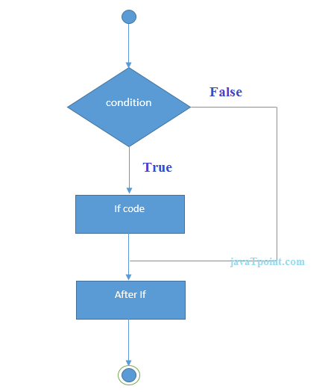

**Example:**

1. //Java Program to demonstate the use of if statement.
2. **public** **class** IfExample {
3. **public** **static** **void** main(String[] args) {
4. //defining an 'age' variable
5. **int** age=20;
6. //checking the age
7. **if**(age>18){
8. System.out.print("Age is greater than 18");
9. }
10. }
11. }

Output:

Age is greater than 18

Java if-else Statement

The Java if-else statement also tests the condition. It executes the *if block* if condition is true otherwise *else block* is executed.

**Syntax:**

1. **if**(condition){
2. //code if condition is true
3. }**else**{
4. //code if condition is false
5. }

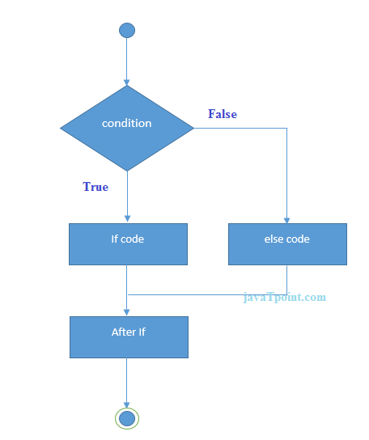

**Example:**

1. //A Java Program to demonstrate the use of if-else statement.
2. //It is a program of odd and even number.
3. **public** **class** IfElseExample {
4. **public** **static** **void** main(String[] args) {
5. //defining a variable
6. **int** number=13;
7. //Check if the number is divisible by 2 or not
8. **if**(number%2==0){
9. System.out.println("even number");
10. }**else**{
11. System.out.println("odd number");
12. }
13. }
14. }

Output:

odd number

**Leap Year Example:**

A year is leap, if it is divisible by 4 and 400. But, not by 100.

1. **public** **class** LeapYearExample {
2. **public** **static** **void** main(String[] args) {
3. **int** year=2020;
4. **if**(((year % 4 ==0) && (year % 100 !=0)) || (year % 400==0)){
5. System.out.println("LEAP YEAR");
6. }
7. **else**{
8. System.out.println("COMMON YEAR");
9. }
10. }
11. }

Output:

LEAP YEAR

Java if-else-if ladder Statement

The if-else-if ladder statement executes one condition from multiple statements.

**Syntax:**

1. **if**(condition1){
2. //code to be executed if condition1 is true
3. }**else** **if**(condition2){
4. //code to be executed if condition2 is true
5. }
6. **else** **if**(condition3){
7. //code to be executed if condition3 is true
8. }
9. ...
10. **else**{
11. //code to be executed if all the conditions are false
12. }

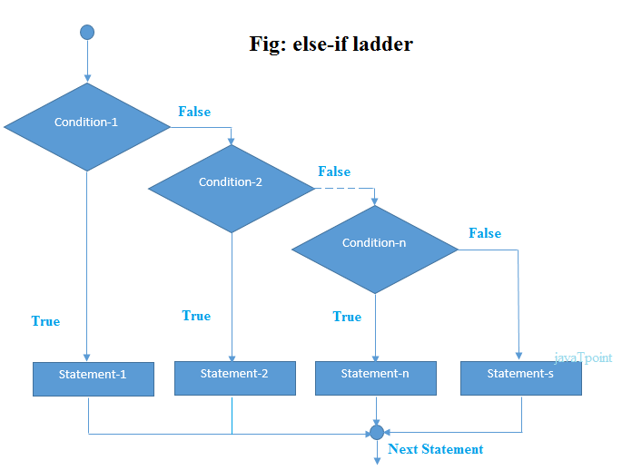

**Example:**

1. //Java Program to demonstrate the use of If else-if ladder.
2. //It is a program of grading system for fail, D grade, C grade, B grade, A grade and A+.
3. **public** **class** IfElseIfExample {
4. **public** **static** **void** main(String[] args) {
5. **int** marks=65;
7. **if**(marks<50){
8. System.out.println("fail");
9. }
10. **else** **if**(marks>=50 && marks<60){
11. System.out.println("D grade");
12. }
13. **else** **if**(marks>=60 && marks<70){
14. System.out.println("C grade");
15. }
16. **else** **if**(marks>=70 && marks<80){
17. System.out.println("B grade");
18. }
19. **else** **if**(marks>=80 && marks<90){
20. System.out.println("A grade");
21. }**else** **if**(marks>=90 && marks<100){
22. System.out.println("A+ grade");
23. }**else**{
24. System.out.println("Invalid!");
25. }
26. }
27. }

Output:

C grade

**Program to check POSITIVE, NEGATIVE or ZERO:**

1. **public** **class** PositiveNegativeExample {
2. **public** **static** **void** main(String[] args) {
3. **int** number=-13;
4. **if**(number>0){
5. System.out.println("POSITIVE");
6. }**else** **if**(number<0){
7. System.out.println("NEGATIVE");
8. }**else**{
9. System.out.println("ZERO");
10. }
11. }
12. }

Output:

NEGATIVE

Java Nested if statement

The nested if statement represents the *if block within another if block*. Here, the inner if block condition executes only when outer if block condition is true.

**Syntax:**

1. **if**(condition){
2. //code to be executed
3. **if**(condition){
4. //code to be executed
5. }
6. }

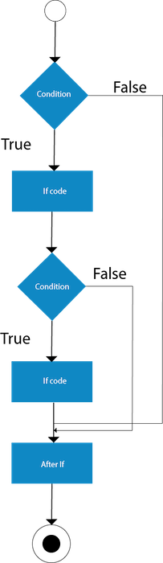

**Example:**

1. //Java Program to demonstrate the use of Nested If Statement.
2. **public** **class** JavaNestedIfExample {
3. **public** **static** **void** main(String[] args) {
4. //Creating two variables for age and weight
5. **int** age=20;
6. **int** weight=80;
7. //applying condition on age and weight
8. **if**(age>=18){
9. **if**(weight>50){
10. System.out.println("You are eligible to donate blood");
11. }
12. }
13. }}

Output:

You are eligible to donate blood

**Example 2:**

1. //Java Program to demonstrate the use of Nested If Statement.
2. **public** **class** JavaNestedIfExample2 {
3. **public** **static** **void** main(String[] args) {
4. //Creating two variables for age and weight
5. **int** age=25;
6. **int** weight=48;
7. //applying condition on age and weight
8. **if**(age>=18){
9. **if**(weight>50){
10. System.out.println("You are eligible to donate blood");
11. } **else**{
12. System.out.println("You are not eligible to donate blood");
13. }
14. } **else**{
15. System.out.println("Age must be greater than 18");
16. }
17. }  }

Output:

You are not eligible to donate blood