this keyword in Java

There can be a lot of usage of **Java this keyword**. In Java, this is a **reference variable** that refers to the current object.

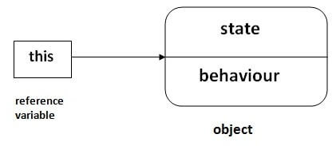

Usage of Java this keyword

Here is given the 6 usage of java this keyword.

1. this can be used to refer current class instance variable.
2. this can be used to invoke current class method (implicitly)
3. this() can be used to invoke current class constructor.
4. this can be passed as an argument in the method call.
5. this can be passed as argument in the constructor call.
6. this can be used to return the current class instance from the method.

**Suggestion:** If you are beginner to java, lookup only three usages of this keyword.

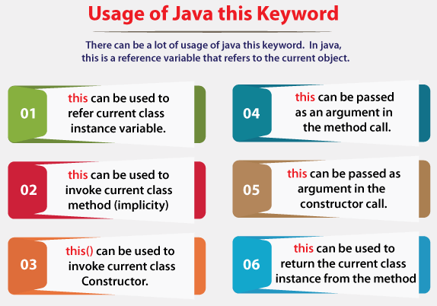

1) this: to refer current class instance variable

The this keyword can be used to refer current class instance variable. If there is ambiguity between the instance variables and parameters, this keyword resolves the problem of ambiguity.

Understanding the problem without this keyword

Let's understand the problem if we don't use this keyword by the example given below:

1. **class** Student{
2. **int** rollno;
3. String name;
4. **float** fee;
5. Student(**int** rollno,String name,**float** fee){
6. rollno=rollno;
7. name=name;
8. fee=fee;
9. }
10. **void** display(){System.out.println(rollno+" "+name+" "+fee);}
11. }
12. **class** TestThis1{
13. **public** **static** **void** main(String args[]){
14. Student s1=**new** Student(111,"ankit",5000f);
15. Student s2=**new** Student(112,"sumit",6000f);
16. s1.display();
17. s2.display();
18. }}

**Output:**

0 null 0.0

0 null 0.0

In the above example, parameters (formal arguments) and instance variables are same. So, we are using this keyword to distinguish local variable and instance variable.

Solution of the above problem by this keyword

1. **class** Student{
2. **int** rollno;
3. String name;
4. **float** fee;
5. Student(**int** rollno,String name,**float** fee){
6. **this**.rollno=rollno;
7. **this**.name=name;
8. **this**.fee=fee;
9. }
10. **void** display(){System.out.println(rollno+" "+name+" "+fee);}
11. }
13. **class** TestThis2{
14. **public** **static** **void** main(String args[]){
15. Student s1=**new** Student(111,"ankit",5000f);
16. Student s2=**new** Student(112,"sumit",6000f);
17. s1.display();
18. s2.display();
19. }}

**Output:**

111 ankit 5000.0

112 sumit 6000.0

If local variables(formal arguments) and instance variables are different, there is no need to use this keyword like in the following program:

Program where this keyword is not required

1. **class** Student{
2. **int** rollno;
3. String name;
4. **float** fee;
5. Student(**int** r,String n,**float** f){
6. rollno=r;
7. name=n;
8. fee=f;
9. }
10. **void** display(){System.out.println(rollno+" "+name+" "+fee);}
11. }
13. **class** TestThis3{
14. **public** **static** **void** main(String args[]){
15. Student s1=**new** Student(111,"ankit",5000f);
16. Student s2=**new** Student(112,"sumit",6000f);
17. s1.display();
18. s2.display();
19. }}

**Output:**

111 ankit 5000.0

112 sumit 6000.0

It is better approach to use meaningful names for variables. So we use same name for instance variables and parameters in real time, and always use this keyword.

2) this: to invoke current class method

You may invoke the method of the current class by using the this keyword. If you don't use the this keyword, compiler automatically adds this keyword while invoking the method. Let's see the example

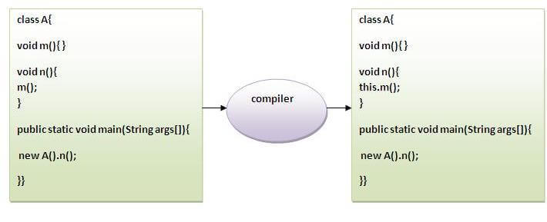

1. **class** A{
2. **void** m(){System.out.println("hello m");}
3. **void** n(){
4. System.out.println("hello n");
5. //m();//same as this.m()
6. **this**.m();
7. }
8. }
9. **class** TestThis4{
10. **public** **static** **void** main(String args[]){
11. A a=**new** A();
12. a.n();
13. }}

**Output:**

hello n

hello m

3) this() : to invoke current class constructor

The this() constructor call can be used to invoke the current class constructor. It is used to reuse the constructor. In other words, it is used for constructor chaining.

**Calling default constructor from parameterized constructor:**

1. **class** A{
2. A(){System.out.println("hello a");}
3. A(**int** x){
4. **this**();
5. System.out.println(x);
6. }
7. }
8. **class** TestThis5{
9. **public** **static** **void** main(String args[]){
10. A a=**new** A(10);
11. }}

**Output:**

hello a

10

**Calling parameterized constructor from default constructor:**

1. **class** A{
2. A(){
3. **this**(5);
4. System.out.println("hello a");
5. }
6. A(**int** x){
7. System.out.println(x);
8. }
9. }
10. **class** TestThis6{
11. **public** **static** **void** main(String args[]){
12. A a=**new** A();
13. }}

**Output:**

5

hello a

Real usage of this() constructor call

The this() constructor call should be used to reuse the constructor from the constructor. It maintains the chain between the constructors i.e. it is used for constructor chaining. Let's see the example given below that displays the actual use of this keyword.

1. **class** Student{
2. **int** rollno;
3. String name,course;
4. **float** fee;
5. Student(**int** rollno,String name,String course){
6. **this**.rollno=rollno;
7. **this**.name=name;
8. **this**.course=course;
9. }
10. Student(**int** rollno,String name,String course,**float** fee){
11. **this**(rollno,name,course);//reusing constructor
12. **this**.fee=fee;
13. }
14. **void** display(){System.out.println(rollno+" "+name+" "+course+" "+fee);}
15. }
16. **class** TestThis7{
17. **public** **static** **void** main(String args[]){
18. Student s1=**new** Student(111,"ankit","java");
19. Student s2=**new** Student(112,"sumit","java",6000f);
20. s1.display();
21. s2.display();
22. }}

**Output:**

111 ankit java 0.0

112 sumit java 6000.0

Rule: Call to this() must be the first statement in constructor.

1. **class** Student{
2. **int** rollno;
3. String name,course;
4. **float** fee;
5. Student(**int** rollno,String name,String course){
6. **this**.rollno=rollno;
7. **this**.name=name;
8. **this**.course=course;
9. }
10. Student(**int** rollno,String name,String course,**float** fee){
11. **this**.fee=fee;
12. **this**(rollno,name,course);//C.T.Error
13. }
14. **void** display(){System.out.println(rollno+" "+name+" "+course+" "+fee);}
15. }
16. **class** TestThis8{
17. **public** **static** **void** main(String args[]){
18. Student s1=**new** Student(111,"ankit","java");
19. Student s2=**new** Student(112,"sumit","java",6000f);
20. s1.display();
21. s2.display();
22. }}

**Output:**

Compile Time Error: Call to this must be first statement in constructor

4) this: to pass as an argument in the method

The this keyword can also be passed as an argument in the method. It is mainly used in the event handling. Let's see the example:

1. **class** S2{
2. **void** m(S2 obj){
3. System.out.println("method is invoked");
4. }
5. **void** p(){
6. m(**this**);
7. }
8. **public** **static** **void** main(String args[]){
9. S2 s1 = **new** S2();
10. s1.p();
11. }
12. }

**Output:**

method is invoked

Application of this that can be passed as an argument:

In event handling (or) in a situation where we have to provide reference of a class to another one. It is used to reuse one object in many methods.

5) this: to pass as argument in the constructor call

We can pass the this keyword in the constructor also. It is useful if we have to use one object in multiple classes. Let's see the example:

1. **class** B{
2. A4 obj;
3. B(A4 obj){
4. **this**.obj=obj;
5. }
6. **void** display(){
7. System.out.println(obj.data);//using data member of A4 class
8. }
9. }
11. **class** A4{
12. **int** data=10;
13. A4(){
14. B b=**new** B(**this**);
15. b.display();
16. }
17. **public** **static** **void** main(String args[]){
18. A4 a=**new** A4();
19. }
20. }

Output:10

6) this keyword can be used to return current class instance

We can return this keyword as an statement from the method. In such case, return type of the method must be the class type (non-primitive). Let's see the example:

Syntax of this that can be returned as a statement

1. return_type method_name(){
2. **return** **this**;
3. }

Example of this keyword that you return as a statement from the method

1. **class** A{
2. A getA(){
3. **return** **this**;
4. }
5. **void** msg(){System.out.println("Hello java");}
6. }
7. **class** Test1{
8. **public** **static** **void** main(String args[]){
9. **new** A().getA().msg();
10. }
11. }

**Output:**

Hello java

Proving this keyword

Let's prove that this keyword refers to the current class instance variable. In this program, we are printing the reference variable and this, output of both variables are same.

1. **class** A5{
2. **void** m(){
3. System.out.println(**this**);//prints same reference ID
4. }
5. **public** **static** **void** main(String args[]){
6. A5 obj=**new** A5();
7. System.out.println(obj);//prints the reference ID
8. obj.m();
9. }
10. }

**Output:**

A5@22b3ea59

A5@22b3ea59

Super Keyword in Java

The **super** keyword in Java is a reference variable which is used to refer immediate parent class object.

Whenever you create the instance of subclass, an instance of parent class is created implicitly which is referred by super reference variable.

Usage of Java super Keyword

1. super can be used to refer immediate parent class instance variable.
2. super can be used to invoke immediate parent class method.
3. super() can be used to invoke immediate parent class constructor.

Backward Skip 10sPlay VideoForward Skip 10s

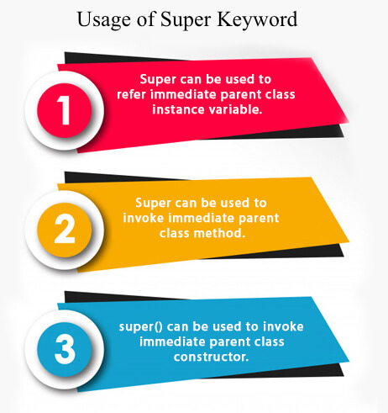

1) super is used to refer immediate parent class instance variable.

We can use super keyword to access the data member or field of parent class. It is used if parent class and child class have same fields.

1. **class** Animal{
2. String color="white";
3. }
4. **class** Dog **extends** Animal{
5. String color="black";
6. **void** printColor(){
7. System.out.println(color);//prints color of Dog class
8. System.out.println(**super**.color);//prints color of Animal class
9. }
10. }
11. **class** TestSuper1{
12. **public** **static** **void** main(String args[]){
13. Dog d=**new** Dog();
14. d.printColor();
15. }}

Output:

black

white

In the above example, Animal and Dog both classes have a common property color. If we print color property, it will print the color of current class by default. To access the parent property, we need to use super keyword.

2) super can be used to invoke parent class method

The super keyword can also be used to invoke parent class method. It should be used if subclass contains the same method as parent class. In other words, it is used if method is overridden.

1. **class** Animal{
2. **void** eat(){System.out.println("eating...");}
3. }
4. **class** Dog **extends** Animal{
5. **void** eat(){System.out.println("eating bread...");}
6. **void** bark(){System.out.println("barking...");}
7. **void** work(){
8. **super**.eat();
9. bark();
10. }
11. }
12. **class** TestSuper2{
13. **public** **static** **void** main(String args[]){
14. Dog d=**new** Dog();
15. d.work();
16. }}

Output:

eating...

barking...

In the above example Animal and Dog both classes have eat() method if we call eat() method from Dog class, it will call the eat() method of Dog class by default because priority is given to local.

To call the parent class method, we need to use super keyword.

3) super is used to invoke parent class constructor.

The super keyword can also be used to invoke the parent class constructor. Let's see a simple example:

1. **class** Animal{
2. Animal(){System.out.println("animal is created");}
3. }
4. **class** Dog **extends** Animal{
5. Dog(){
6. **super**();
7. System.out.println("dog is created");
8. }
9. }
10. **class** TestSuper3{
11. **public** **static** **void** main(String args[]){
12. Dog d=**new** Dog();
13. }}

Output:

animal is created

dog is created

Note: super() is added in each class constructor automatically by compiler if there is no super() or this().

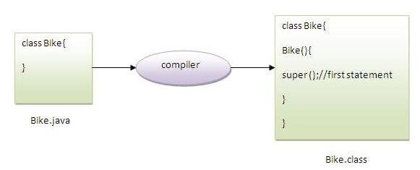

As we know well that default constructor is provided by compiler automatically if there is no constructor. But, it also adds super() as the first statement.

**Another example of super keyword where super() is provided by the compiler implicitly.**

1. **class** Animal{
2. Animal(){System.out.println("animal is created");}
3. }
4. **class** Dog **extends** Animal{
5. Dog(){
6. System.out.println("dog is created");
7. }
8. }
9. **class** TestSuper4{
10. **public** **static** **void** main(String args[]){
11. Dog d=**new** Dog();
12. }}

Output:

animal is created

dog is created

super example: real use

Let's see the real use of super keyword. Here, Emp class inherits Person class so all the properties of Person will be inherited to Emp by default. To initialize all the property, we are using parent class constructor from child class. In such way, we are reusing the parent class constructor.

1. **class** Person{
2. **int** id;
3. String name;
4. Person(**int** id,String name){
5. **this**.id=id;
6. **this**.name=name;
7. }
8. }
9. **class** Emp **extends** Person{
10. **float** salary;
11. Emp(**int** id,String name,**float** salary){
12. **super**(id,name);//reusing parent constructor
13. **this**.salary=salary;
14. }
15. **void** display(){System.out.println(id+" "+name+" "+salary);}
16. }
17. **class** TestSuper5{
18. **public** **static** **void** main(String[] args){
19. Emp e1=**new** Emp(1,"ankit",45000f);
20. e1.display();
21. }}

Output:

1 ankit 45000