Name: Shivam

Email ID: [shivam@timesinternet.in](mailto:shivam@timesinternet.in)

Topic: Project on Movie Review Application Using Java, JDBC, and Relational Database

**1. Code:**

**Package 1 = daos**

**File 1 = DAOForMovie.java**

**package** daos;

**import** java.sql.*;

**import** java.util.*;

**import** dtoForPrj.MovieDTO;

**import** dtoForPrj.RatingDTO;

**import** dtoForPrj.ReviewDTO;

**public** **class** DAOForMovie {

Connection con;

**public** DAOForMovie(){

con=**null**;

**try** {

Class.*forName*("com.mysql.jdbc.Driver");

con = DriverManager.*getConnection*(

"jdbc:mysql://localhost:3306/MovieDB", "root", "password");

// here MovieDB is database name, root is username and password

}

**catch**(Exception e)

{}

}

**public** **int** addMovie(MovieDTO mvi) {

// **TODO** Auto-generated method stub

Statement stmt;

**int** s = 0;

String query = "insert into movie ( movie_name, Summary, cast, Genre, Average_rating, user_id) values ( "+

mvi.beautify(mvi.getMovie_name())

+ ", " + mvi.beautify(mvi.getSummary()) + ", "+mvi.beautify(mvi.getCast())+ ", " + mvi.beautify(mvi.getGenre())+

", "+ mvi.getAverage_rating() + ", "+ mvi.getUser_id() + ")";

//System.out.println(query);

**try** {

stmt = con.createStatement();

s = stmt.executeUpdate(query);

}

**catch**(Exception e){

}

**return** s;

}

**public** **int** updateMovie(MovieDTO e)

{

Statement stmt;

**int** s=0;

**try** {

//

String query = ("Update movie set movie_name ="+e.beautify(e.getMovie_name()) + ", Summary = "+ e.beautify(e.getSummary()) + ", cast = "+ e.beautify(e.getCast())+", Genre = " + e.beautify(e.getGenre()) + ", Average_rating = "+e.getAverage_rating()+", user_id = " +e.getUser_id()+ " where movie_id="+e.getMovie_id());

stmt = con.createStatement();

s = stmt.executeUpdate(query);

} **catch** (Exception e1) {

System.***out***.print(e1);

}

**return** s;

}

**public** **int** addReview(ReviewDTO rvd) {

// **TODO** Auto-generated method stub

Statement stmt;

**int** s = 0;

String query = "insert into review ( movie_id, Review, user_id ) values ( "+

rvd.getMovie_id()

+ ", " + rvd.beautify(rvd.getReview()) + ", "+rvd.getUser_id() + ")";

**try** {

stmt = con.createStatement();

s = stmt.executeUpdate(query);

}

**catch**(Exception e){

}

**return** s;

}

**public** **int** addRating(RatingDTO rtd) {

Statement stmt;

**int** s = 0;

String query = "insert into rating ( movie_id, Rating, user_id ) values ( "+

rtd.getMovie_id()

+ ", " + rtd.getRating() + ", "+rtd.getUser_id() + ")";

String query2 = "update movie set Average_rating = (Select avg(Rating) from rating where movie_id = " + rtd.getMovie_id() + ")"

+ "where movie_id = " + rtd.getMovie_id();

**try** {

stmt = con.createStatement();

s = stmt.executeUpdate(query);

s = stmt.executeUpdate(query2);

}

**catch**(Exception e){

}

**return** s;

}

**public** List<MovieDTO> listMovieDTOForGenre(String gen){

List<MovieDTO> emps=**new** ArrayList<>();

**try** {

Statement stmt = con.createStatement();

ResultSet rs = stmt.executeQuery("select * from movie where Genre = "+ "'"+gen+"'");

**while** (rs.next()) {

// System.out.println(rs.getInt(1));

emps.add(**new** MovieDTO(rs.getString(2),rs.getString(3), rs.getString(4), rs.getString(5), rs.getInt(1), rs.getInt(7), rs.getDouble(6)));

}

} **catch** (Exception e) {}

**return** emps;

}

**public** List<MovieDTO> listMovieDTOOverall(){

List<MovieDTO> emps=**new** ArrayList<>();

**try** {

Statement stmt = con.createStatement();

ResultSet rs = stmt.executeQuery("select * from movie order by Average_rating desc limit 10");

**while** (rs.next()) {

// System.out.println(rs.getInt(1));

emps.add(**new** MovieDTO(rs.getString(2),rs.getString(3), rs.getString(4), rs.getString(5), rs.getInt(1), rs.getInt(7), rs.getDouble(6)));

}

} **catch** (Exception e) {}

**return** emps;

}

**public** List<MovieDTO> listMovieDTOByGenre(String st){

List<MovieDTO> emps=**new** ArrayList<>();

**try** {

Statement stmt = con.createStatement();

ResultSet rs = stmt.executeQuery("select * from movie where Genre = " + "'" + st + "'"+ "order by Average_rating desc limit 10");

**while** (rs.next()) {

// System.out.println(rs.getInt(1));

emps.add(**new** MovieDTO(rs.getString(2),rs.getString(3), rs.getString(4), rs.getString(5), rs.getInt(1), rs.getInt(7), rs.getDouble(6)));

}

} **catch** (Exception e) {}

**return** emps;

}

**public** List<MovieDTO> listMovieDTOName(String st){

List<MovieDTO> emps=**new** ArrayList<>();

**try** {

Statement stmt = con.createStatement();

ResultSet rs = stmt.executeQuery("select * from movie where movie_name = " + "'" + st + "'");

**while** (rs.next()) {

// System.out.println(rs.getInt(1));

emps.add(**new** MovieDTO(rs.getString(2),rs.getString(3), rs.getString(4), rs.getString(5), rs.getInt(1), rs.getInt(7), rs.getDouble(6)));

}

} **catch** (Exception e) {}

**return** emps;

}

**public** List<MovieDTO> listMovieDTOGenre(String st){

List<MovieDTO> emps=**new** ArrayList<>();

**try** {

Statement stmt = con.createStatement();

ResultSet rs = stmt.executeQuery("select * from movie where Genre = " + "'" + st + "'");

**while** (rs.next()) {

// System.out.println(rs.getInt(1));

emps.add(**new** MovieDTO(rs.getString(2),rs.getString(3), rs.getString(4), rs.getString(5), rs.getInt(1), rs.getInt(7), rs.getDouble(6)));

}

} **catch** (Exception e) {}

**return** emps;

}

**public** String utilForMovie(**int** choice, **int** mvid) **throws** SQLException {

Statement stmt = con.createStatement();

**if**(choice==1) {

String query = "Select Summary from movie where movie_id = "+ mvid;

ResultSet rs = stmt.executeQuery(query);

String ans = "";

**while**(rs.next()) {

ans = rs.getString(1);

**break**;

}

**return** ans;

}

**else** **if**(choice==2) {

String query = "Select cast from movie where movie_id = "+ mvid;

ResultSet rs = stmt.executeQuery(query);

String ans = "";

**while**(rs.next()) {

ans = rs.getString(1);

**break**;

}

**return** ans;

}

**else** {

String query = "Select Genre from movie where movie_id = "+ mvid;

ResultSet rs = stmt.executeQuery(query);

String ans = "";

**while**(rs.next()) {

ans = rs.getString(1);

**break**;

}

**return** ans;

}

}

**public** List<ReviewDTO> utilForMovieForReview(**int** mvid) **throws** SQLException {

Statement stmt = con.createStatement();

String query = "Select * from review where movie_id = "+ mvid;

ResultSet rs = stmt.executeQuery(query);

List<ReviewDTO> lst = **new** ArrayList<>();

**while**(rs.next()) {

lst.add(**new** ReviewDTO(rs.getInt(1), rs.getInt(2), rs.getInt(4), rs.getString(3)));

}

**return** lst;

}

**public** List<MovieDTO> listMovieDTO(){

List<MovieDTO> emps=**new** ArrayList<>();

**try** {

Statement stmt = con.createStatement();

ResultSet rs = stmt.executeQuery("select * from movie");

**while** (rs.next()) {

System.***out***.println(rs.getInt(1));

}

} **catch** (Exception e) {}

**return** emps;

}

**public** List<MovieDTO> listMovieByOverall(){

List<MovieDTO> emps=**new** ArrayList<>();

**try** {

Statement stmt = con.createStatement();

ResultSet rs = stmt.executeQuery("select * from movie order by Average_rating desc");

**while** (rs.next()) {

System.***out***.println(rs.getInt(1));

}

} **catch** (Exception e) {}

**return** emps;

}

**public** **void** finalise(){

**try** {

con.close();

} **catch** (SQLException e) {}

}

}

**2. Package 2 = dtoForPrj**

**File 1 = MovieDTO.java**

**package** dtoForPrj;

**public** **class** MovieDTO {

String movie_name, summary, cast, genre, review;

**int** movie_id, user_id;

**double** Average_rating = 0.0;

**public** String getMovie_name() {

**return** movie_name;

}

**public** **void** setMovie_name(String movie_name) {

**this**.movie_name = movie_name;

}

**public** String getSummary() {

**return** summary;

}

**public** **void** setSummary(String summary) {

**this**.summary = summary;

}

**public** String getCast() {

**return** cast;

}

**public** **void** setCast(String cast) {

**this**.cast = cast;

}

**public** String getGenre() {

**return** genre;

}

**public** **void** setGenre(String genre) {

**this**.genre = genre;

}

**public** String getReview() {

**return** review;

}

**public** **void** setReview(String review) {

**this**.review = review;

}

**public** **int** getMovie_id() {

**return** movie_id;

}

**public** **void** setMovie_id(**int** movie_id) {

**this**.movie_id = movie_id;

}

**public** **int** getUser_id() {

**return** user_id;

}

**public** **void** setUser_id(**int** user_id) {

**this**.user_id = user_id;

}

**public** MovieDTO() {

**super**();

// **TODO** Auto-generated constructor stub

}

@Override

**public** String toString() {

**return** "Movie details are [movie_name=" + movie_name + ", summary=" + summary + ", cast=" + cast + ", genre=" + genre

+ ", review=" + review + ", movie_id=" + movie_id + ", user_id=" + user_id

+ ", Average_rating=" + Average_rating + "]";

}

**public** MovieDTO(String movie_name, String summary, String cast, String genre,

**int** movie_id, **int** user_id, **double** average_rating) {

**super**();

**this**.movie_name = movie_name;

**this**.summary = summary;

**this**.cast = cast;

**this**.genre = genre;

**this**.movie_id = movie_id;

**this**.user_id = user_id;

Average_rating = average_rating;

}

**public** **double** getAverage_rating() {

**return** Average_rating;

}

**public** **void** setAverage_rating(**double** average_rating) {

Average_rating = average_rating;

}

**public** String beautify(String s) {

**return** "'"+s+"'";

}

}

**File 2 = RatingDTO.java**

**package** dtoForPrj;

**public** **class** RatingDTO {

**int** rating_id, movie_id, rating, user_id;

**public** **int** getRating_id() {

**return** rating_id;

}

**public** **void** setRating_id(**int** rating_id) {

**this**.rating_id = rating_id;

}

**public** **int** getMovie_id() {

**return** movie_id;

}

**public** **void** setMovie_id(**int** movie_id) {

**this**.movie_id = movie_id;

}

**public** RatingDTO(**int** rating_id, **int** movie_id, **int** rating, **int** user_id) {

**super**();

**this**.rating_id = rating_id;

**this**.movie_id = movie_id;

**this**.rating = rating;

**this**.user_id = user_id;

}

@Override

**public** String toString() {

**return** "Rating details are [rating_id=" + rating_id + ", movie_id=" + movie_id + ", rating=" + rating + ", user_id="

+ user_id + "]";

}

**public** **int** getRating() {

**return** rating;

}

**public** **void** setRating(**int** rating) {

**this**.rating = rating;

}

**public** **int** getUser_id() {

**return** user_id;

}

**public** RatingDTO() {

**super**();

// **TODO** Auto-generated constructor stub

}

**public** **void** setUser_id(**int** user_id) {

**this**.user_id = user_id;

}

**public** String beautify(String s) {

**return** "'"+s+"'";

}

}

**File 3 = ReviewDTO.java**

**package** dtoForPrj;

**public** **class** ReviewDTO {

**int** review_id, movie_id, user_id;

String review;

**public** **int** getReview_id() {

**return** review_id;

}

**public** **void** setReview_id(**int** review_id) {

**this**.review_id = review_id;

}

**public** ReviewDTO() {

**super**();

// **TODO** Auto-generated constructor stub

}

@Override

**public** String toString() {

**return** "Review details are [review_id=" + review_id + ", movie_id=" + movie_id + ", user_id=" + user_id + ", review="

+ review + "]";

}

**public** **int** getMovie_id() {

**return** movie_id;

}

**public** ReviewDTO(**int** review_id, **int** movie_id, **int** user_id, String review) {

**super**();

**this**.review_id = review_id;

**this**.movie_id = movie_id;

**this**.user_id = user_id;

**this**.review = review;

}

**public** **void** setMovie_id(**int** movie_id) {

**this**.movie_id = movie_id;

}

**public** **int** getUser_id() {

**return** user_id;

}

**public** **void** setUser_id(**int** user_id) {

**this**.user_id = user_id;

}

**public** String getReview() {

**return** review;

}

**public** **void** setReview(String review) {

**this**.review = review;

}

**public** String beautify(String s) {

**return** "'"+s+"'";

}

}

**File 4 = UserDTO.java**

**package** dtoForPrj;

**public** **class** UserDTO {

**int** ID;

String Name, EmailID;

**public** **int** getID() {

**return** ID;

}

**public** **void** setID(**int** iD) {

ID = iD;

}

@Override

**public** String toString() {

**return** "User details are [ID=" + ID + ", Name=" + Name + ", EmailID=" + EmailID + "]";

}

**public** String getName() {

**return** Name;

}

**public** UserDTO(**int** iD, String name, String emailID) {

**super**();

ID = iD;

Name = name;

EmailID = emailID;

}

**public** **void** setName(String name) {

Name = name;

}

**public** String getEmailID() {

**return** EmailID;

}

**public** **void** setEmailID(String emailID) {

EmailID = emailID;

}

**public** String beautify(String s) {

**return** "'"+s+"'";

}

}

**Package = main**

**File 1 = Main.java**

**package** main;

**import** java.sql.Connection;

**import** java.sql.DriverManager;

**import** java.sql.ResultSet;

**import** java.sql.SQLException;

**import** java.sql.Statement;

**import** java.util.Scanner;

**import** java.sql.*;

**import** java.util.*;

**import** daos.DAOForMovie;

**import** dtoForPrj.MovieDTO;

**import** dtoForPrj.RatingDTO;

**import** dtoForPrj.ReviewDTO;

**public** **class** Main {

**public** **static** **void** main(String[] args) **throws** SQLException, ClassNotFoundException {

DAOForMovie daomovie = **new** DAOForMovie();

**while**(**true**) {

System.***out***.println("Please find below the applicable choices: ");

System.***out***.println("Following features are available for only registered users and you will be asked to give your user id.");

System.***out***.println("Enter 1 for adding a movie.");

System.***out***.println("Enter 2 for editing a current movie entry.");

System.***out***.println("Enter 3 for adding a review for a movie.");

System.***out***.println("Enter 4 for adding a rating for a movie.");

System.***out***.println("Following features are available publicly.");

System.***out***.println("Enter 5 to view all the movies from a particular genre.");

System.***out***.println("Enter 6 to view the top 10 movies overall.");

System.***out***.println("Enter 7 to view the top 10 moview from a particulare genre.");

System.***out***.println("Enter 8 to search for a particular movie by name.");

System.***out***.println("Enter 9 to search movie by genre.");

System.***out***.println("Enter 10 to view particular details of a movie such as summary, cast, genre, reviews.");

System.***out***.println("Enter -1 to quit.");

// as soon as a new a rating is added for a movie its average rating should also be updated by default it will be 0.0

**int** choice = 0;

Scanner sc = **new** Scanner(System.***in***);

choice = sc.nextInt();

**if**(choice==-1) {

daomovie.finalise();

System.***out***.println("Bye.");

}

**else** **if**(choice<=4) {

System.***out***.println("Please enter your user_id");

**int** user_id = sc.nextInt();

**if**(choice==1) {

MovieDTO mvi = **new** MovieDTO();

String content = sc.nextLine();

System.***out***.println("Enter movie name.");

content = sc.nextLine();

mvi.setMovie_name(content);

System.***out***.println("Enter movie summary.");

content = sc.nextLine();

mvi.setSummary(content);

System.***out***.println("Enter movie cast.");

content = sc.nextLine();

mvi.setCast(content);

System.***out***.println("Enter movie genre.");

content = sc.nextLine();

mvi.setGenre(content);

mvi.setUser_id(user_id);

daomovie.addMovie(mvi);

}

**else** **if**(choice==2) {

MovieDTO mvi = **new** MovieDTO();

String content = sc.nextLine();

System.***out***.println("Enter movie name.");

content = sc.nextLine();

mvi.setMovie_name(content);

System.***out***.println("Enter movie summary.");

content = sc.nextLine();

mvi.setSummary(content);

System.***out***.println("Enter movie cast.");

content = sc.nextLine();

mvi.setCast(content);

System.***out***.println("Enter movie genre.");

content = sc.nextLine();

mvi.setGenre(content);

System.***out***.println("Enter movie id.");

**int** id = sc.nextInt();

mvi.setMovie_id(id);

mvi.setUser_id(user_id);

daomovie.updateMovie(mvi);

}

**else** **if**(choice==3)

{

ReviewDTO rvd = **new** ReviewDTO();

String content = sc.nextLine();

System.***out***.println("Enter review content.");

content = sc.nextLine();

rvd.setReview(content);

System.***out***.println("Enter the movie id.");

**int** mvid = sc.nextInt();

rvd.setUser_id(user_id);

daomovie.addReview(rvd);

}

**else** **if**(choice==4) {

RatingDTO rtd = **new** RatingDTO();

System.***out***.println("Enter movie id");

**int** mvid = sc.nextInt();

rtd.setMovie_id(mvid);

System.***out***.println("Enter rating");

**int** rating = sc.nextInt();

rtd.setRating(rating);

rtd.setUser_id(user_id);

daomovie.addRating(rtd);

}

}

**else** **if**(choice>4&&choice<=10) {

**if**(choice==5) {

String genr = sc.nextLine();

System.***out***.println("Enter Genre. ");

genr = sc.nextLine();

List <MovieDTO> lst = daomovie.listMovieDTOForGenre(genr);

**for**(MovieDTO s: lst) {

System.***out***.println(s);

}

}

**else** **if**(choice==6) {

List <MovieDTO> lst = daomovie.listMovieDTOOverall();

**for**(MovieDTO s: lst) {

System.***out***.println(s);

}

}

**else** **if**(choice==7)

{

System.***out***.println("Please enter the genre for which you want top 10 movies.");

String st = sc.next();

List <MovieDTO> lst = daomovie.listMovieDTOByGenre(st);

**for**(MovieDTO s: lst) {

System.***out***.println(s);

}

}

**else** **if**(choice==8) {

System.***out***.println("Enter the name of movie.");

String st = sc.next();

List <MovieDTO> lst = daomovie.listMovieDTOName(st);

**for**(MovieDTO s: lst) {

System.***out***.println(s);

}

}

**else** **if**(choice==9) {

System.***out***.println("Enter the genre of the movie.");

String st = sc.next();

List <MovieDTO> lst = daomovie.listMovieDTOGenre(st);

**for**(MovieDTO s: lst) {

System.***out***.println(s);

}

}

**else** **if**(choice==10) {

System.***out***.println("Enter movie id of the movie.");

**int** mvid = sc.nextInt();

System.***out***.println("Enter 1 for summary, 2 for cast, 3 for genre, and 4 for reviews.");

**int** nwchoice = sc.nextInt();

**if**(nwchoice<=3&&nwchoice>=1) {

System.***out***.println(daomovie.utilForMovie(nwchoice, mvid));

}

**else** **if**(nwchoice==4) {

List<ReviewDTO> lst = daomovie.utilForMovieForReview(mvid);

**for**(ReviewDTO rtd: lst) {

System.***out***.println(rtd);

}

}

**else** {

System.***out***.println("Invalid Choice.");

}

}

}

**else** {

System.***out***.println("Invalid Choice.");

}

}

}

}

**Now the screenshot of the achieved functionalities are attached :**

**Starting screen:**

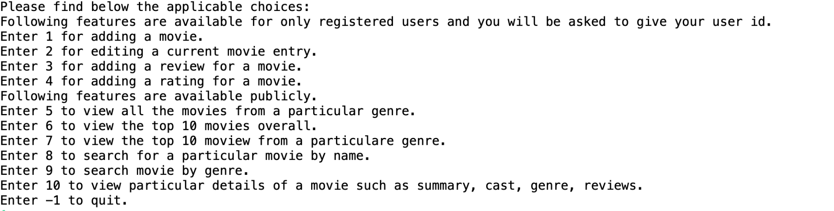

**SS for choice 1:**

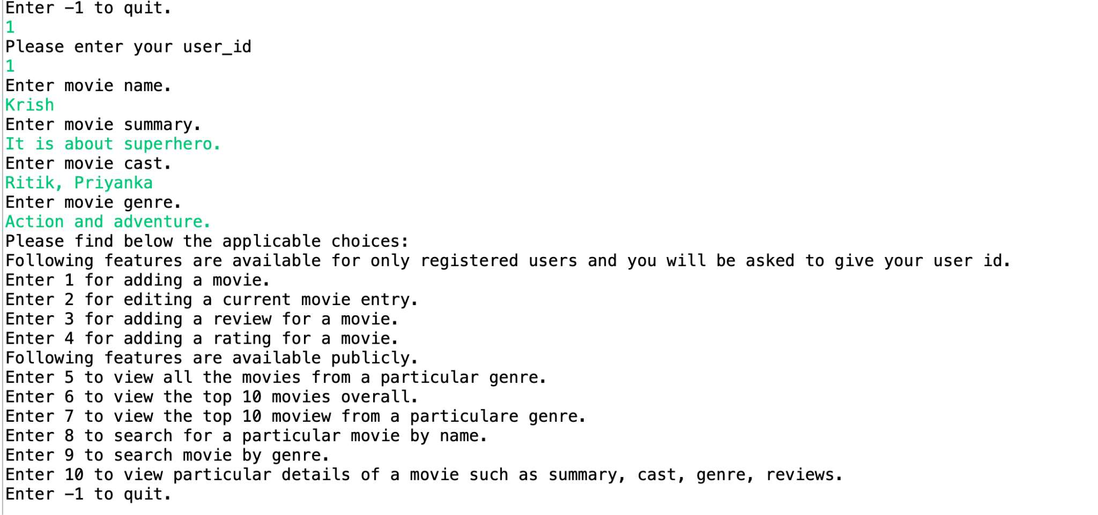

**SS for choice 2:**

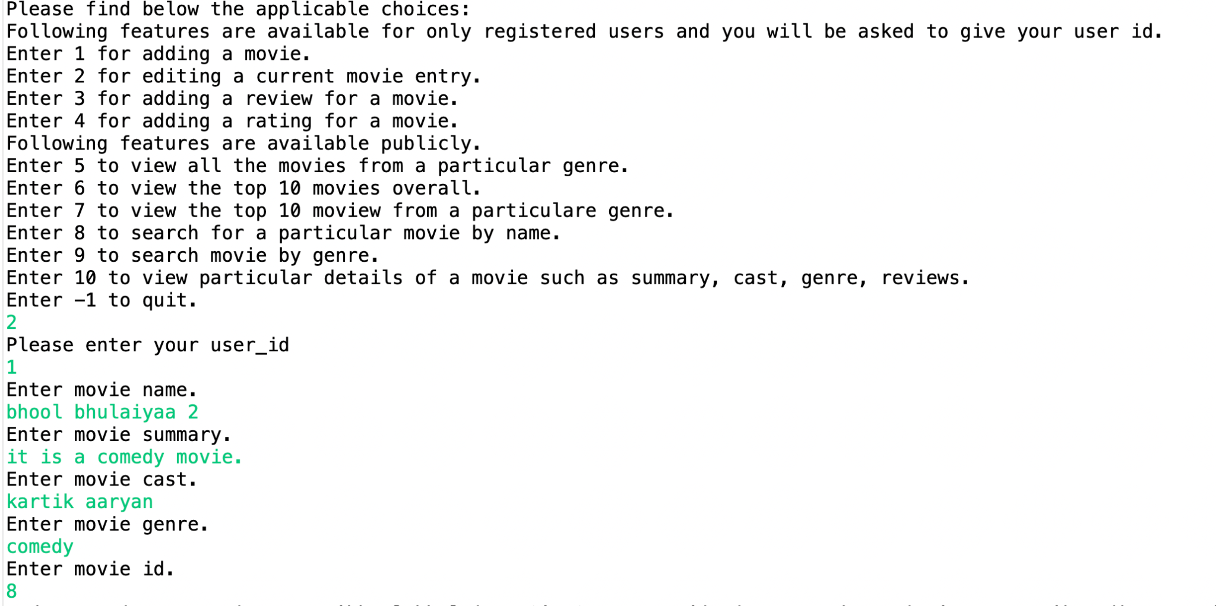

**SS for choice 3:**

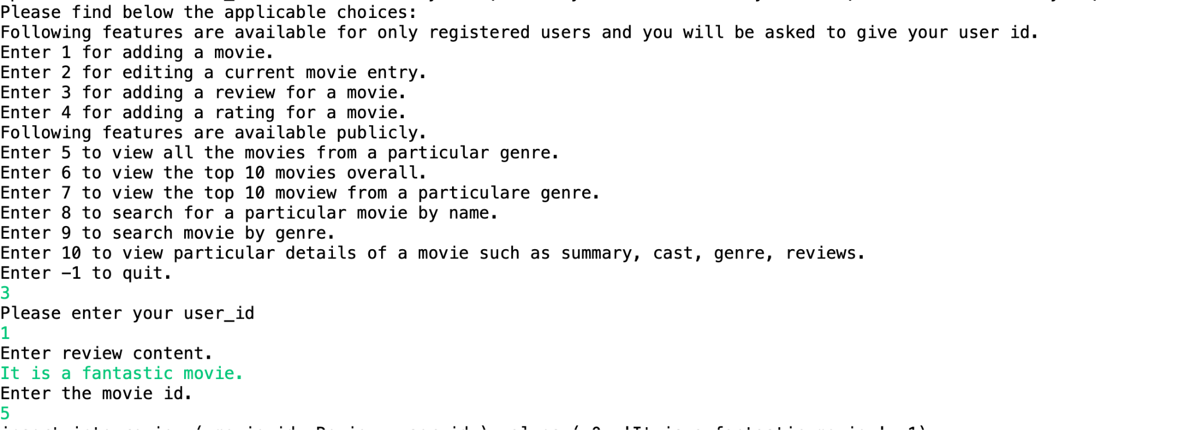

**SS for choice 4:**

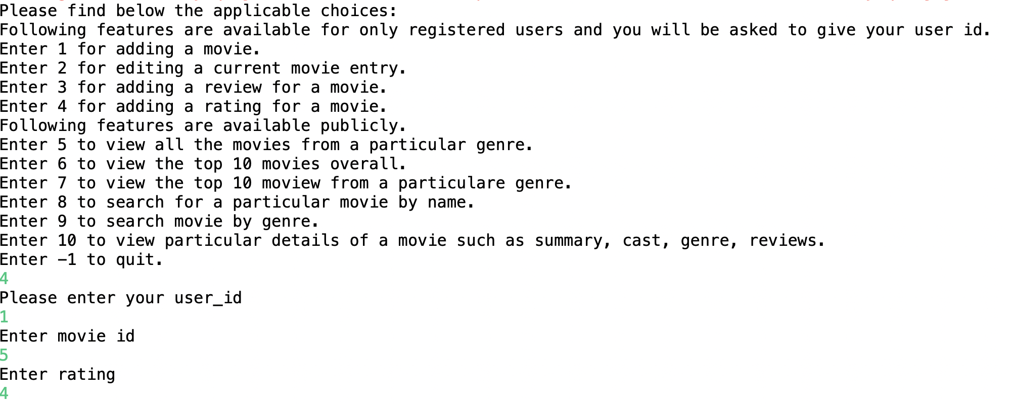

**SS for choice 5:**

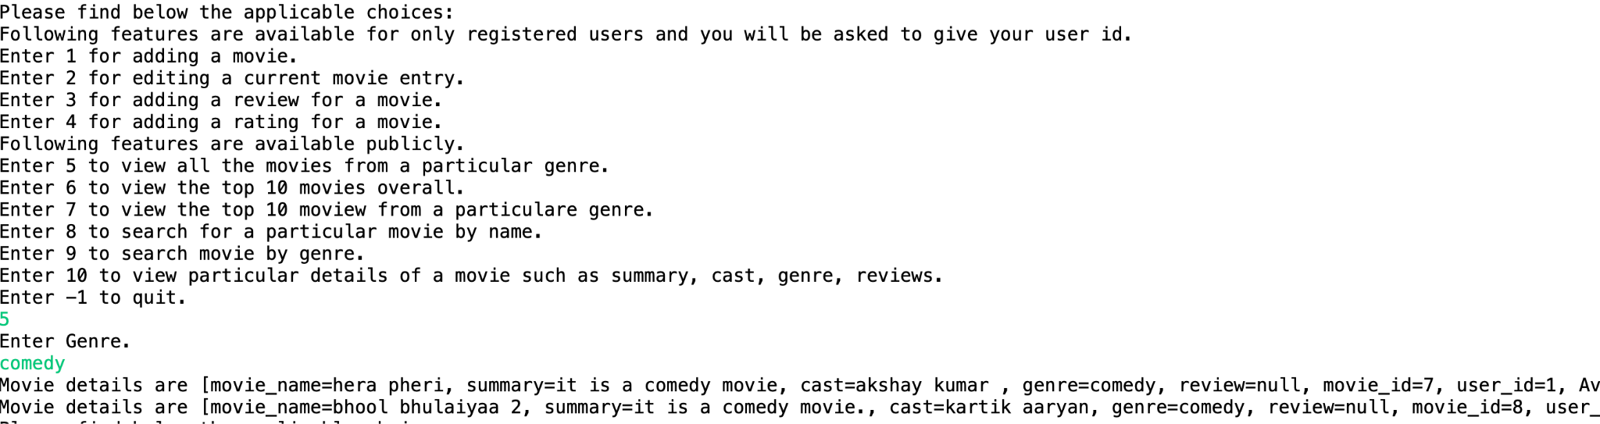

**SS for choice 6:**

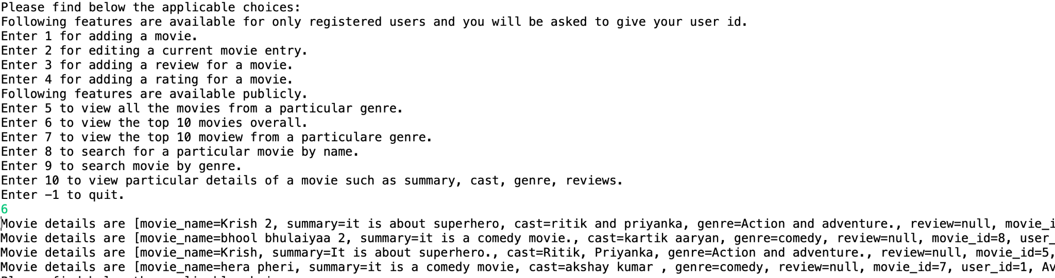

**SS for choice 7:**

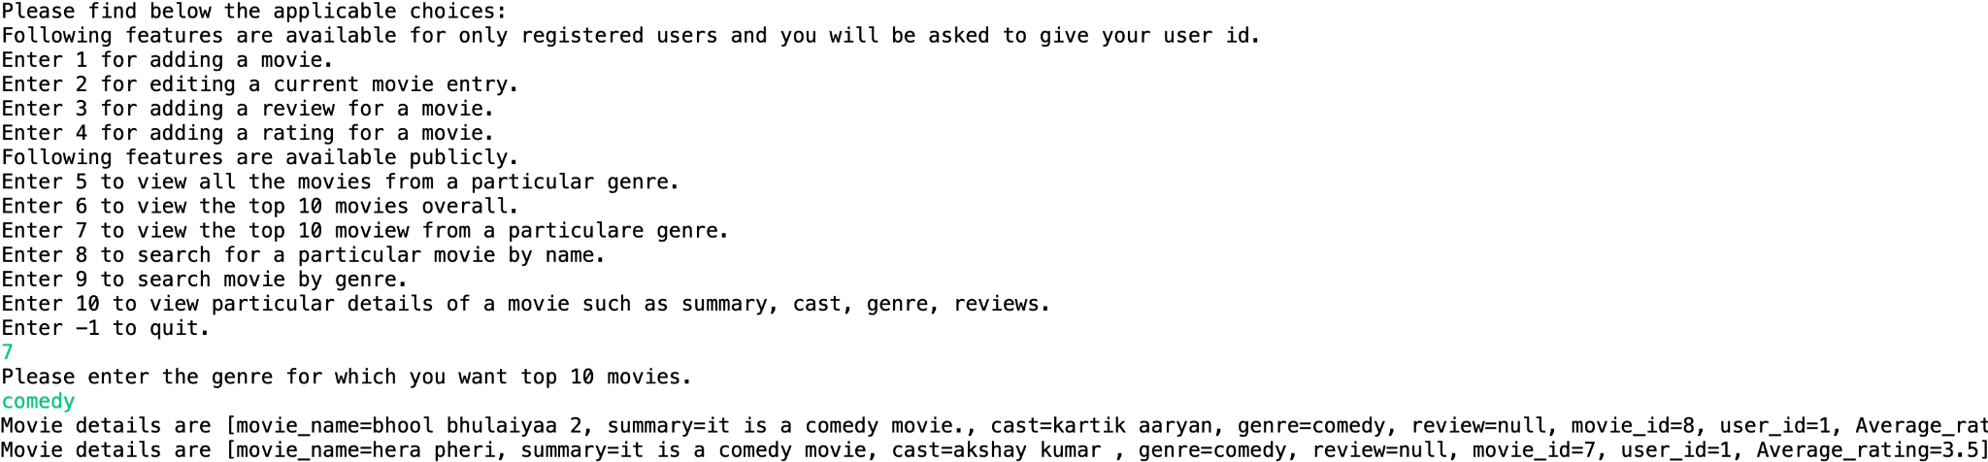

**SS for choice 8:**

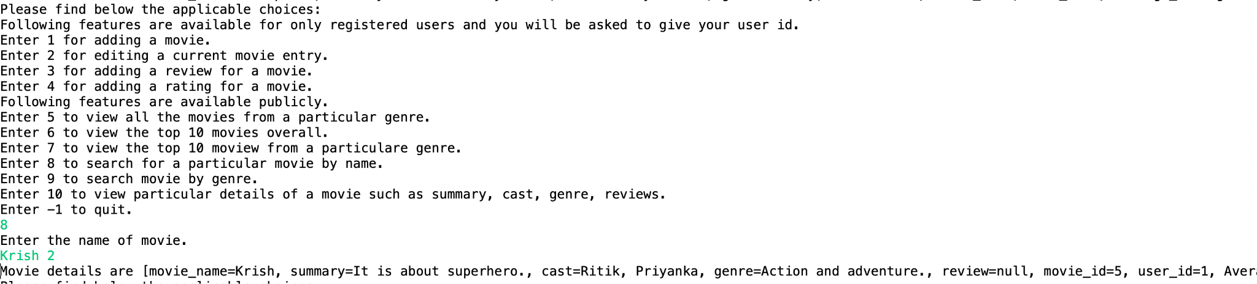

**SS for choice 9:**

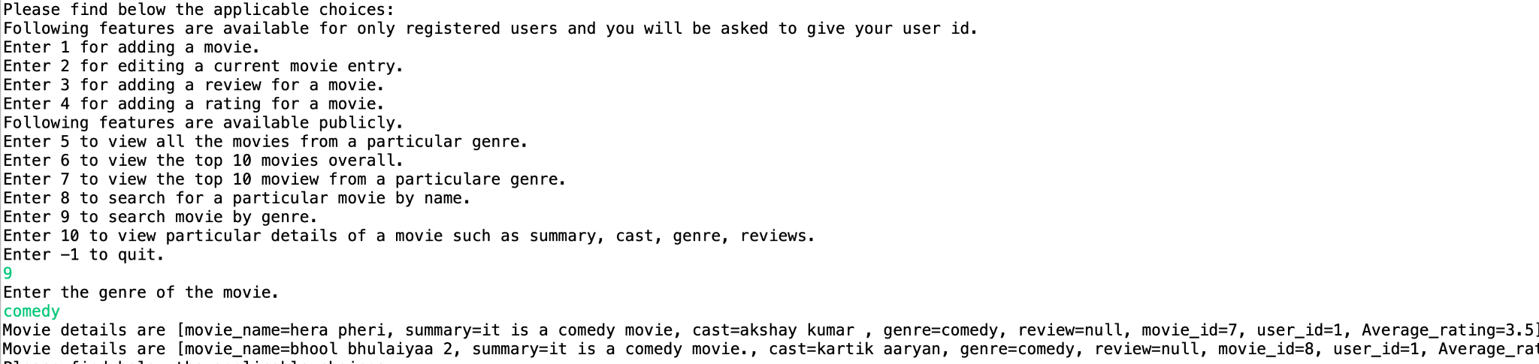

**SS for choice 10:**

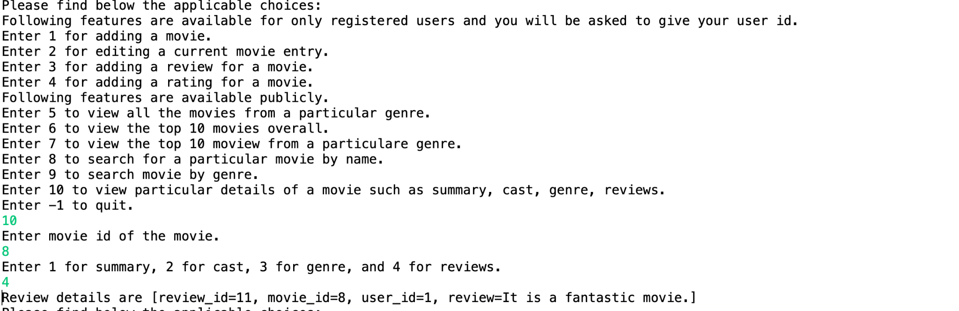

**SS if choice = -1:**

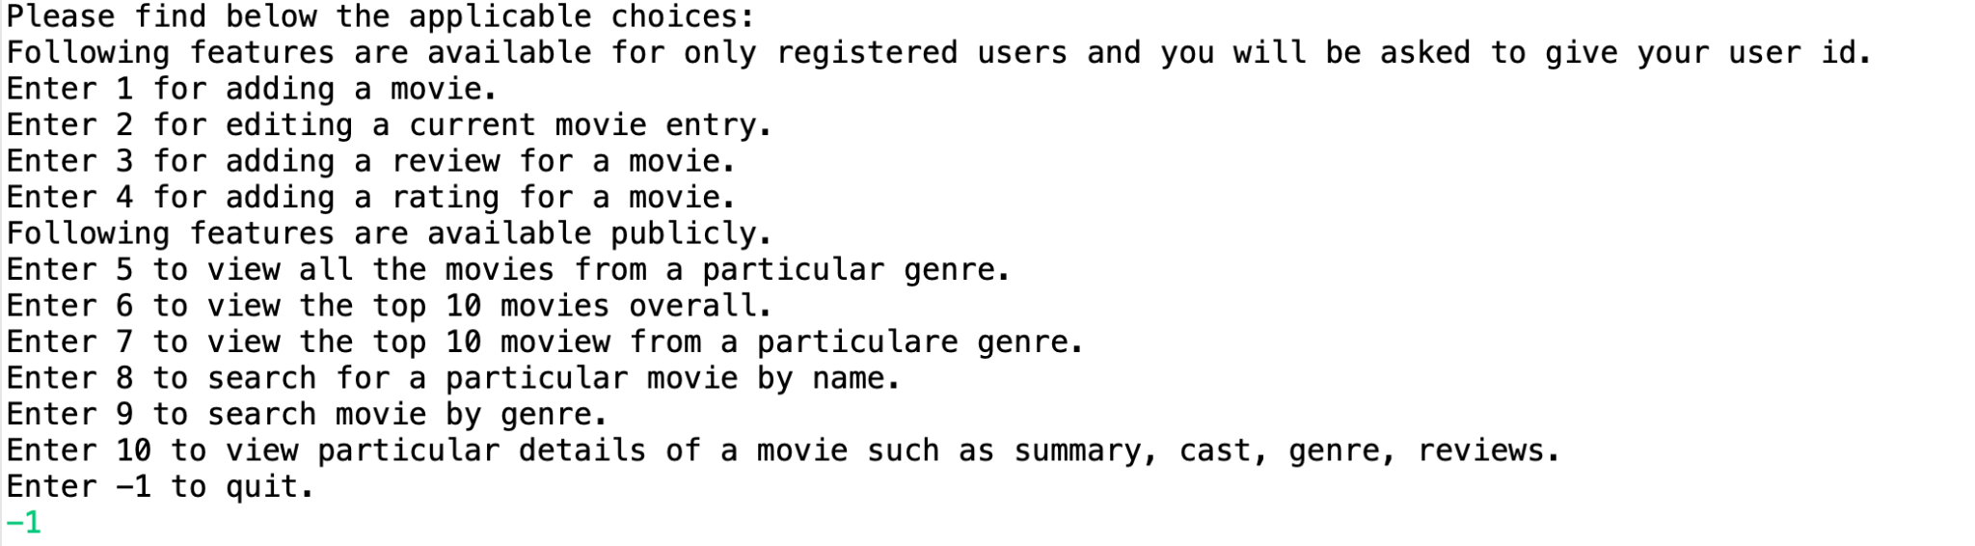

**Databases:**

**Database name = movie:**

# movie_id movie_name Summary cast Genre Average_rating user_id

5 Krish It is about superhero. Ritik, Priyanka Action and adventure. 4.33333 1

6 Krish 2 it is about superhero ritik and priyanka Action and adventure. 5 1

7 hera pheri it is a comedy movie akshay kumar comedy 3.5 1

8 bhool bhulaiyaa 2 it is a comedy movie. kartik aaryan comedy 4.5 1

**Database name = rating:**

# rating_id movie_id Rating user_id

21 5 4 1

22 5 5 1

23 5 4 1

24 6 5 1

25 7 3 1

26 7 4 1

27 8 5 1

28 8 4 1

**Database name = review:**

# review_id movie_id Review user_id

8 5 It is a fantastic movie. 1

9 6 It is a fantastic movie. 1

10 7 It is a fantastic movie. 1

11 8 It is a fantastic movie. 1

**Database name = users:**

# user_id user_name email_id

1 shivam shivam@timesinternet.in