ALL CHOICES MUST BE MADE MOBILE FIRST AND MUST ALSO INCLUDE A DESKTOP LAYOUT

Write a cash register or self-service application for some consumer-driven business.

Obvious choices include a small store, a coffee shop, or a fast food restaurant. At a

minimum, this should include:

● A list of products that have properties for name, category, description, and

price.

○ There must at least 10 different products.

● Present a menu to the user and let them choose an item or items to purchase.

How to do?

-on home page

Listed out, using flexbox, have array info on it, clicking on each item will bring pop

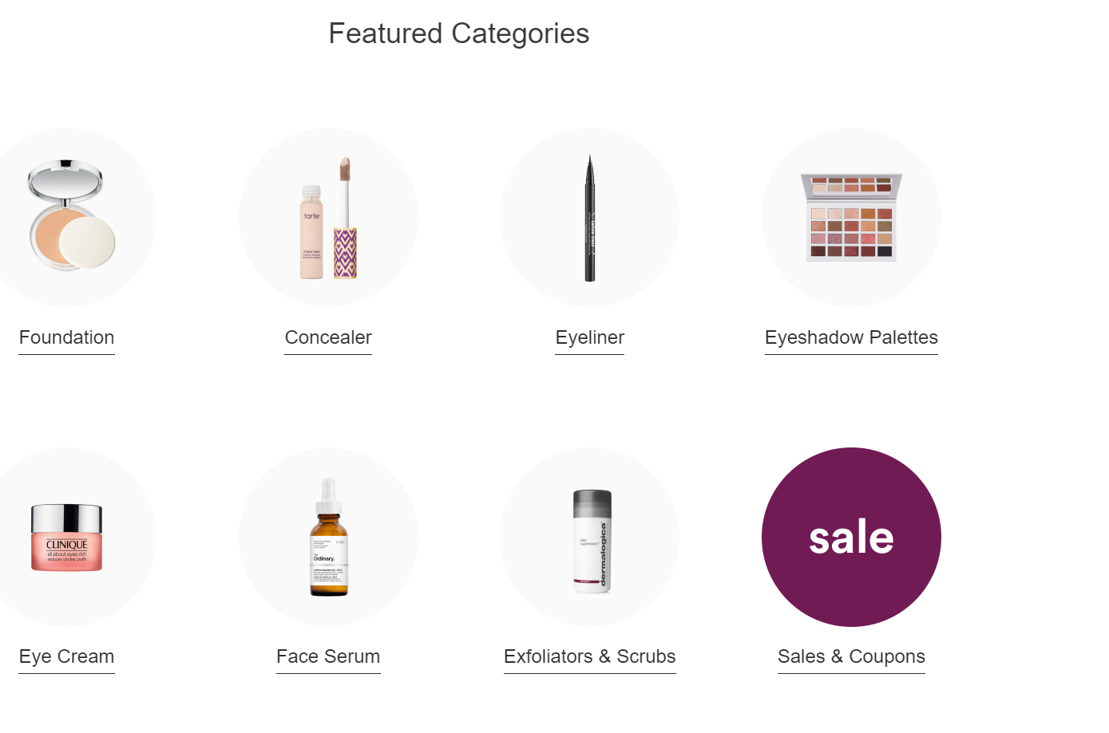

Add to cart by having functionality like on Dick’s website. ~~Have quantity drop-down,~~ then add to cart

Optional-have cart showing the number of items in cart to show in upper-right

When clicking on cart icon, it takes you to the cart

Adjust spacing on cart icon on header-flex-end?

Cart shows each item, you will be able to adjust quantity and remove from cart

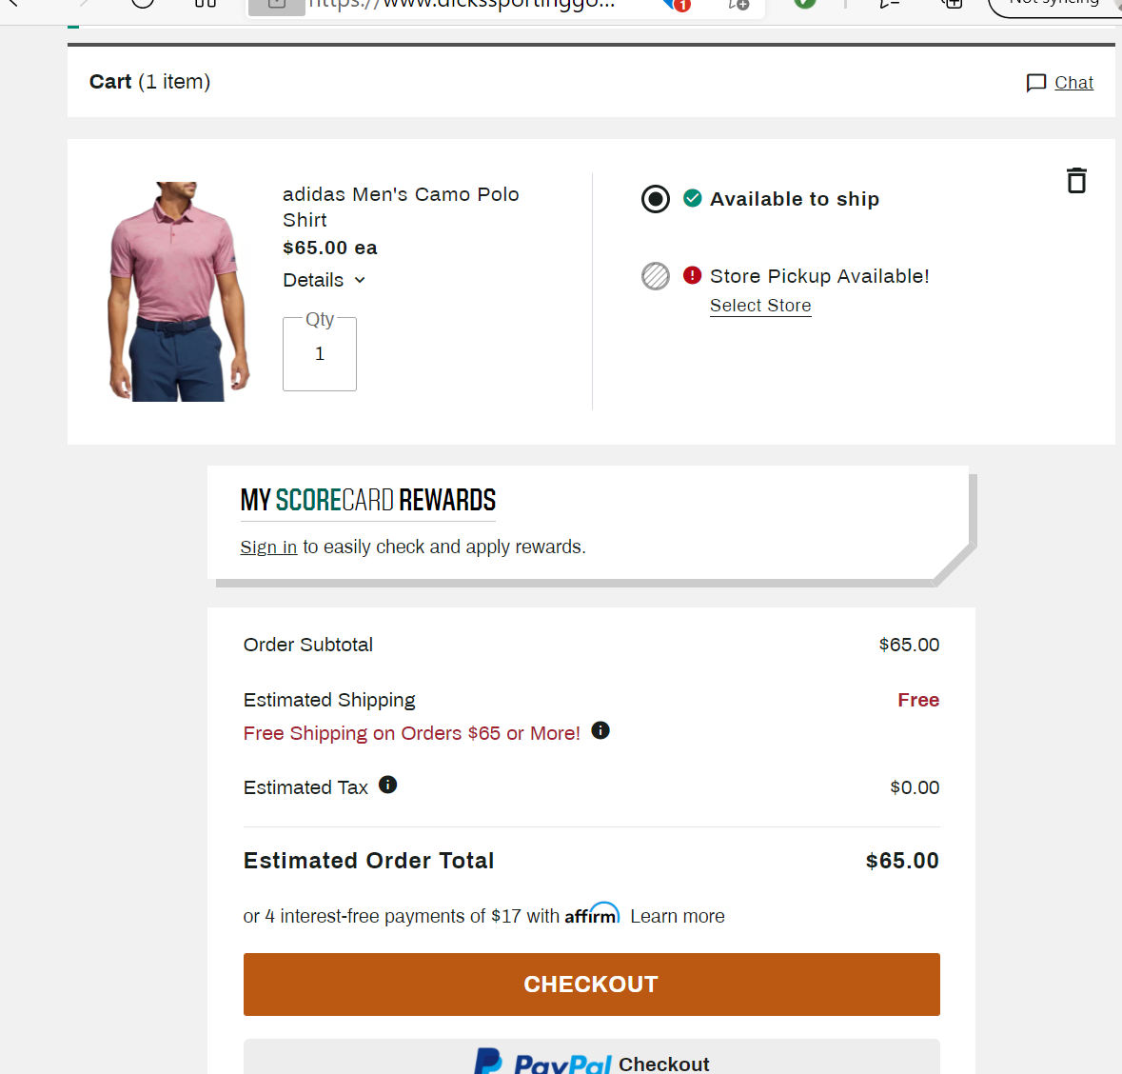

Just need to have:

subtotal, sales tax, and the total in cart.

Checkout:

Need to ask for customer info: name, (add this if wanted: address, city, state, zip). Maybe assume this is for store pickup.

If the user is paying in cash, ask for the amount tendered and provide change.

● If the user is paying with a card, ask for the card number, expiration, and CVV.

● Provide a receipt for the payment which includes the item(s) bought, the

subtotal, total, and anything else of interest.

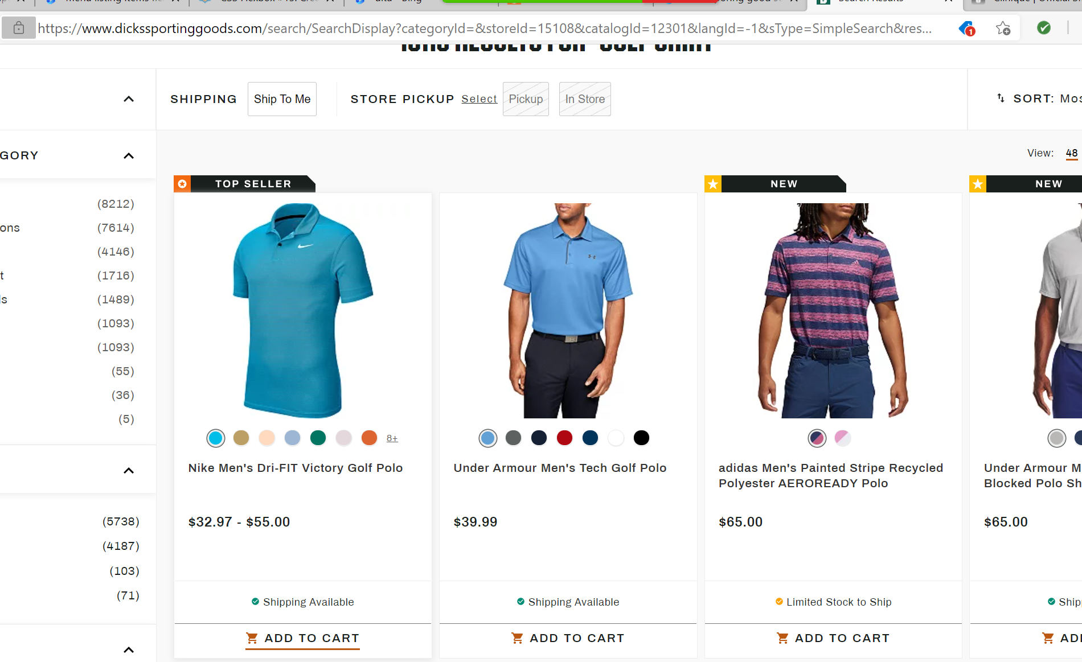

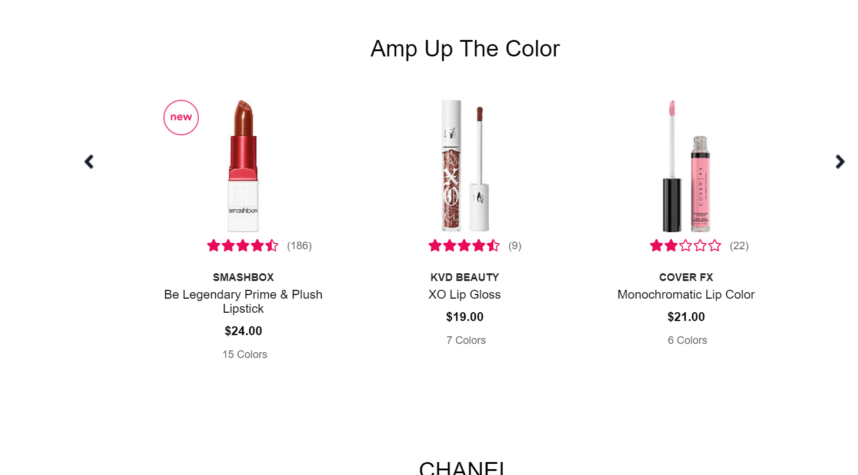

○ The item(s) the user will buy will be added to a cart until they are ready

for checkout.

● Provide a way for the user to check out and view their cart.

● Give the subtotal, sales tax, and the total.

● If the user is paying in cash, ask for the amount tendered and provide change.

● If the user is paying with a card, ask for the card number, expiration, and CVV.

-optional-PayPal

● Provide a receipt for the payment which includes the item(s) bought, the

subtotal, total, and anything else of interest.

Just have it pop up and say, print for your records

Bonus-have it check the credit card number for validity